# Introduction

## Problem statement

Hosting and facilitating a research conference requires a lot of paperwork and management. The coordination on reviewing papers requires precise organization. Due to papers having specific requirements on being reviewed, they will pass through multiple hands and has potential risk of being under-reviewed without constant up to date supervision of the process. To handle these problems, it would be a good idea to provide a system to manage these things. This system will need to provide interface for researchers to submit papers and register for conferences. It will have to allow reviewers to search and review these papers. The system will also have to provide an interface for the conference administrators to create and manage conferences, papers, and reviews.

## Proposal

We propose a software system to allow a research conference to be managed more efficiently. Registration will occur through the system, as well as the submission and reviewing of papers. The software will handle the restrictions and help reviewers make sure all papers are evenly reviewed. The system will also make advertising conferences more organized and available to the community.

# System Requirements

## Functional Requirements

1. The system shall allow a new user to create an account.
   1. The system shall display "Create new Account" button
   2. The user should select "Create Account"
   3. The system shall display a new user form
   4. The user shall enter their full name, password, e-mail, and confirm password
   5. The user shall click "Submit" button
   6. The system shall validate user inputs
      1. If all information isn't entered, the system shall highlight incomplete inputs in red and display error message.
   7. The system shall add new user account to the system, display "Account creation successful!", and return user to login page.
2. The system shall allow a registered user to log in.
   1. The system will provide text fields for email address and password.
   2. The user should input their email address and password.
   3. The system shall provide a log in button
   4. The user should press the login button
   5. The system will check the user information in the account database
      1. If the user account is not found in the database, then an error message will be displayed.
      2. If the user account is found, the system will open to the home page
3. The system shall allow "Researchers" and "Reviewers" to register for a conference.
   1. Then system shall provide a “Display Conference” button
   2. The user shall press the button.
   3. The system will display a list of all conferences.
   4. The system will provide search options for the conferences.
   5. The user shall select a conference from the list.
   6. The system shall provide a "Register as researcher" and "Register as reviewer" button.
   7. The user should select the register button.
   8. The system shall display a confirmation window to confirm that the researcher or reviewer wants to register.
   9. The user shall either select to confirm or cancel their registration.
   10. The system shall add the user's registration into the database.
4. The system shall allow "Researcher" and "Reviewer" to check in to a conference.
   1. The system shall allow the user to search and select a conference (See 3.1-3.5)
   2. The system shall provide a check in button to join a conference meeting.
   3. The user shall select the check in button.
   4. The system shall display the conference meeting window.
5. The system shall allow "Researcher" user to submit paper.
   1. The system shall provide a submit paper button.
   2. The user shall select the submit paper button.
   3. The system shall display a textbox for the user to type an abstract of their paper.
   4. The system shall display a place to attach the paper.
   5. The user should attach the paper being submitted.
   6. The system shall provide an “Upload” button.
   7. The user shall select the “Upload” button after they have attached the paper.
   8. The system shall store the paper and abstract in the database.
6. The system shall allow "Researcher" user to view their paper and associated reviews.
   1. Then system shall provide a “Display Paper Details” button
   2. The user shall press the button.
   3. The system shall display each paper submitted by the researcher in chronological order.
   4. The user shall select the paper they wish to view.
   5. The system shall provide a “Display Details” button.
   6. The user shall press the display details button.
      1. If a paper is not highlighted, an error message will appear.
   7. The system should open a new window to display reviews and attributes of the paper.
7. The system shall allow "Reviewer" user to review up to 7 papers per conference
   1. The system shall display a list of all papers.
   2. The system shall allow the reviewer to search these papers based on user or conference.
   3. The system shall provide a review button for users to select.
   4. The user should select the "review" button to review a paper.
   5. The system shall check which papers the user has reviewed for this conference.
      1. The system shall display an error window if the user has reviewed 7 papers.
      2. If the user has already reviewed this paper, the system will allow the user to write over previous review.
   6. The system will provide a download paper button
   7. The user should select that button
   8. The system will retrieve the paper from the database to be downloaded.
   9. The system will provide a “Review Paper” Button.
   10. The user shall press the button.
   11. The system shall display a new window with rating options (Strongly Decline / Decline / Neutral / Accept / Strongly Accept) and a text box for additional comments.
   12. The user shall select a rating options.
   13. The user shall select the submit button.
   14. The system will add the review to the selected paper in the database.
8. The system shall allow "Conference Administrator" user to Add a Conference
   1. The system shall display "Add Conference" button.
   2. The system shall allow admin user to select "Create Conference".
   3. The system shall display new event form.
   4. The user shall enter event information.
   5. The system shall provide a “Add Conference” button.
   6. The user should select “Add Conference”.
      1. If the data is not filled out completely, an error will be displayed.
   7. The system will add the conference to the database.
9. The system shall allow “Conference Administrator” user to Edit Upcoming Conferences.
10. The system shall display notification to "researcher" user when a paper has been reviewed.
    1. The system shall send a notification to conference users upon log in whenever a paper review has been submitted.
    2. The system shall provide a “Display Notifications” button for the user.
    3. The user shall press the button
    4. The system shall display notifications in chronological order
11. The system shall advertise upcoming events to users.
    1. The system shall determine randomly choose an event from the two most immediately upcoming events.
    2. The system shall display an image for the chosen event in a designated advertising area in the system window.
    3. The system shall allow user to click on the image to navigate to the conference registration page

## Non-Functional Requirements

## Use Case Diagrams

This system calls for three different user types and provides different functionality based on the type of user (Researcher, Reviewer, Conference Administrator.)

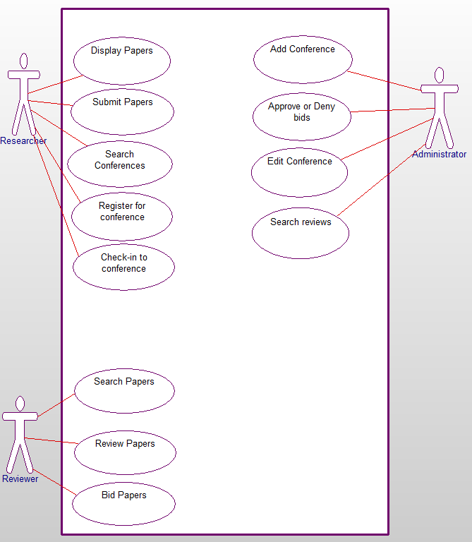

Use Case 1: Display Papers

This use case will allow researchers to see all the papers that they have submitted to the system.

Use Case 2: Submit Papers

This use case will allow researchers to submit their papers that they would like to be reviewed during a conference.

Use Case 3: Search Conferences

This use case will allow researcher users to find conferences they would like to attend or submit papers to.

Use Case 4: Register for Conference

This use case will allow researchers to take part in the conferences by putting their registration into the database.

Use Case 5: Check-In Conference

This use case will allow researcher users to check-in to the conference and tell the admin that they have arrived at the location the conference is being held.

Use Case 6: Search Papers

This use case will allow reviewers to search for papers that they would like to review.

Use Case 7: Review Papers

This use case will allow reviewers to review the papers that they have won their bids on.

Use Case 8: Bid Papers

This use case will allow reviewers to bid on papers that they would like to review.

Use Case 9: Add Conference

This use case will allow the Amin user to create a new conference.

Use Case 10: Approve or Deny bids

This use case will allow the admin user to approve or deny the bids that the reviewers have submitted.

Use Case 11: Edit Conference

This use case will allow the admin user to edit the conferences that have already been created.

Use Case 12: Search Reviews

This use case will allow the admin user to see the reviews that the reviewers have submitted.

# Sequence Diagram

## Sequence Diagram 1: Register

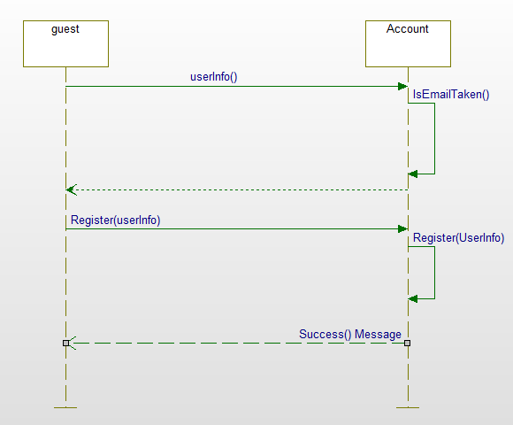

The register for a new user sequence diagram shows how the users can register an account for our website.

## Sequence Diagram 2: Login

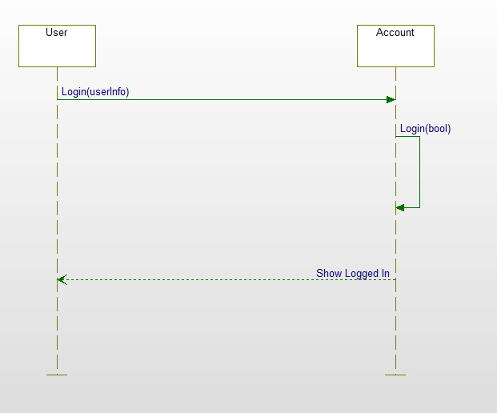

The login sequence diagram shows how users log in to our website

## Sequence Diagram 3: View listing of conferences

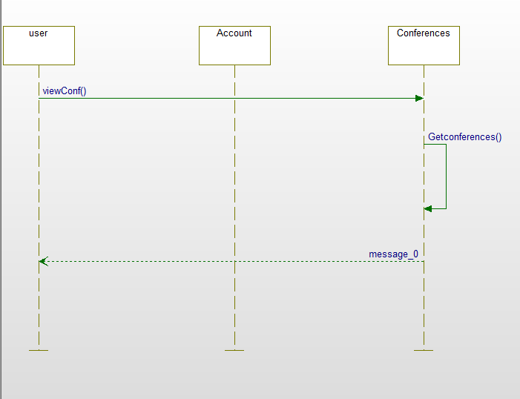

The view listing of conferences sequence diagram shows how the users view a listing of available conferences.

## Sequence Diagram 4: View conference details

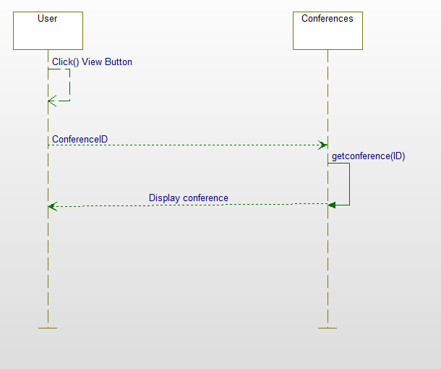

The view conference details sequence diagram shows how user will be able to view the details of any available conference.

## Sequence Diagram 5: Register for conference

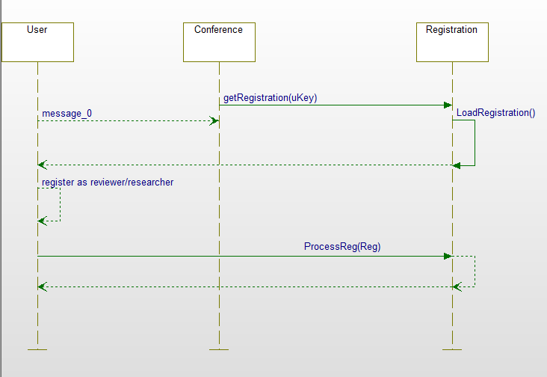

The register for conference sequence diagram shows how reviewers or researchers will be able to register for any available conferences.

## Sequence Diagram 6: Submit Papers

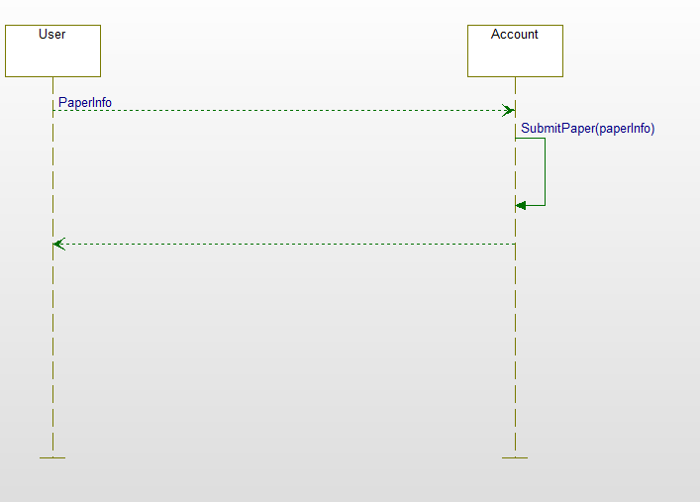

The submit paper sequence diagram shows how the researcher will be able to submit papers to the conference

## Sequence Diagram 7: Bid on Papers

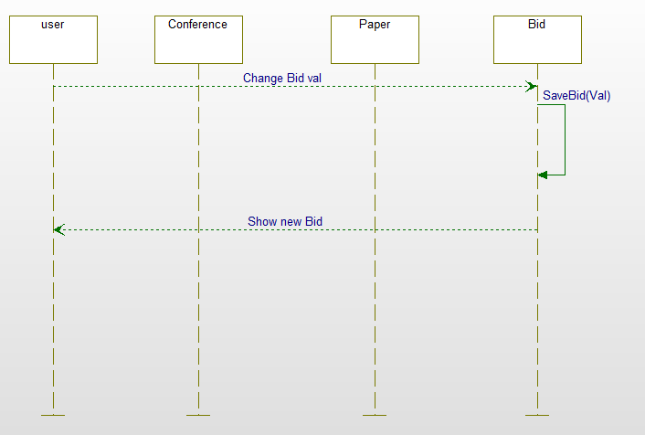

The bid on paper sequence diagram shows how the reviewer selects papers that they wish to review, and then bid against the other reviewers to see who has the most interest in the paper.

## Sequence Diagram 8: Review papers

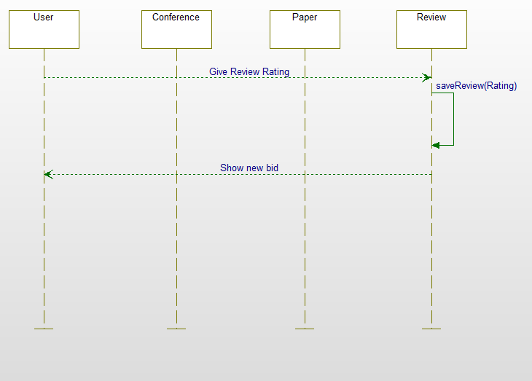

The review paper sequence diagram shows how a reviewer can review a paper that they have won the bid on.

## Sequence Diagram 9: View Reviews

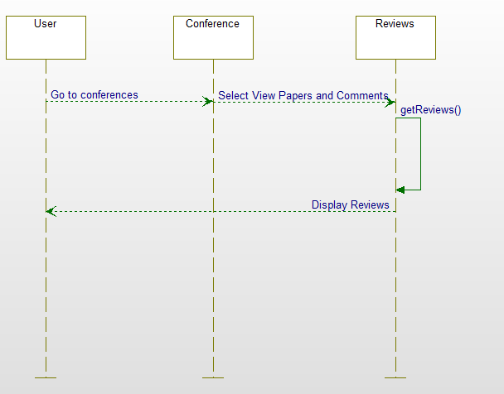

The view reviews sequence diagram shows how researchers can view the reviews given on their papers.

## Sequence Diagram 10: Admin Assign Reviews

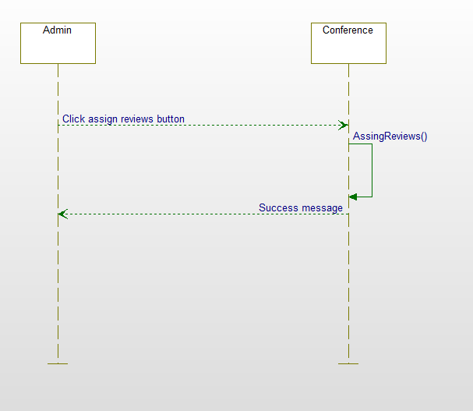

The Admin assign reviews sequence diagram shows how the admin will assign reviews to the reviewers based on their bids.

## Sequence Diagram 11: Admin Add Conferences

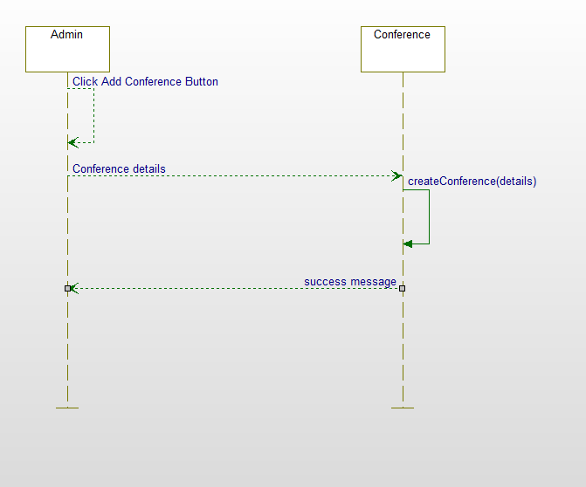

The Admin add conference sequence diagram shows how the admin user will add new conferences to the list of available conferences.

## Sequence Diagram 12: Check In To Conferences

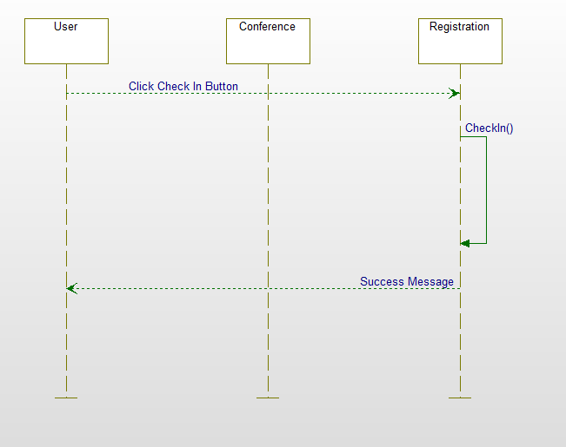

The check in to conference sequence diagram shows how researchers and reviewers check in to available conferences.

# State Diagram

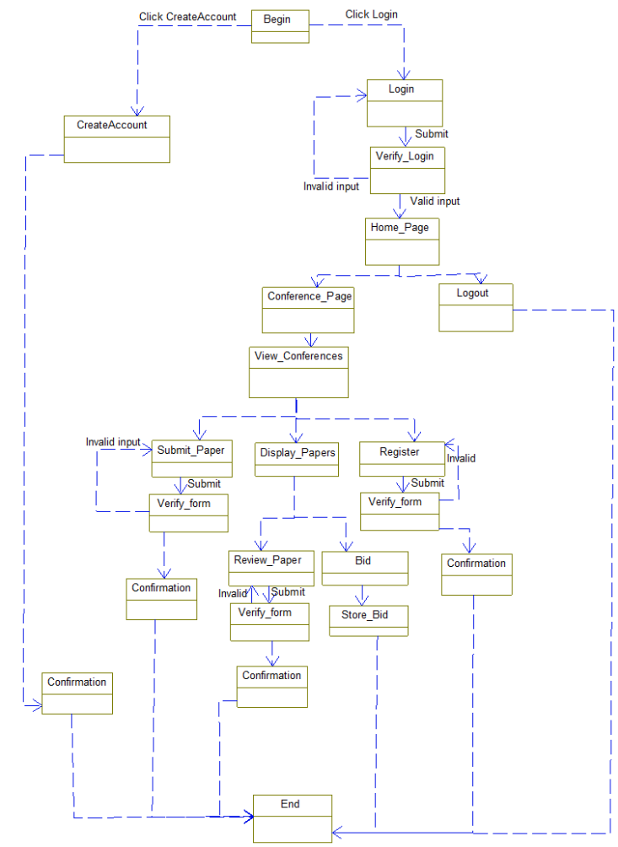

The state diagram represents the different conditions the system can be in. Covering all of the positions for every use case.

# Class Diagram

# Activity Diagrams

## Activity diagram 1: Create user

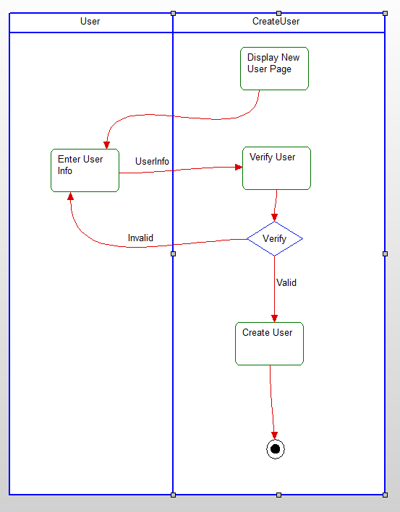

The create user activity diagram shows the design for creating a new user on our website.

## Activity Diagram 2: Submit paper

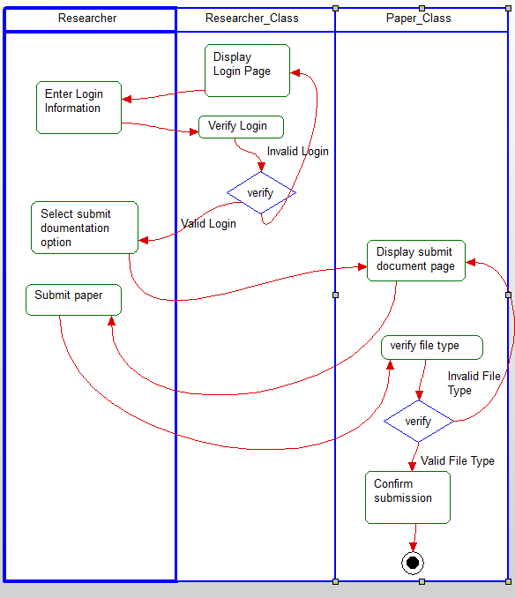

The submit paper activity diagram shows how a researcher can submit a paper to be reviewed in a conference by the registered reviewers.

## Activity Diagram 3: Check in to conference

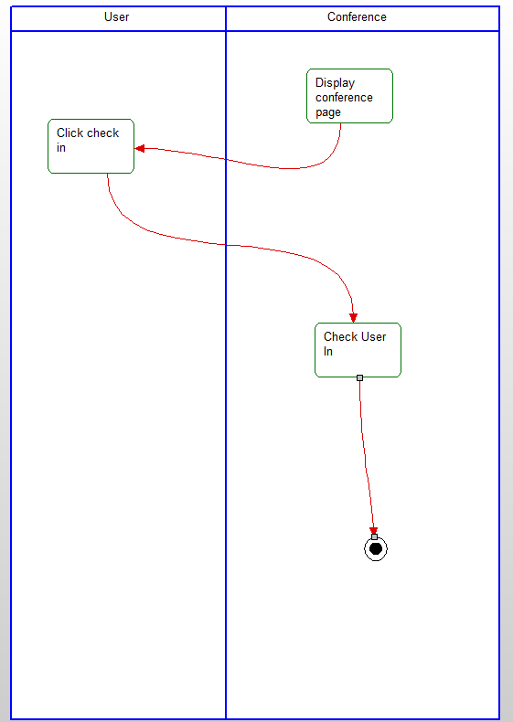

The check into conference activity diagram shows how researchers and reviewers tell the conference admin that they have checked in to the conference.

## Activity Diagram 4: Bidding on Papers

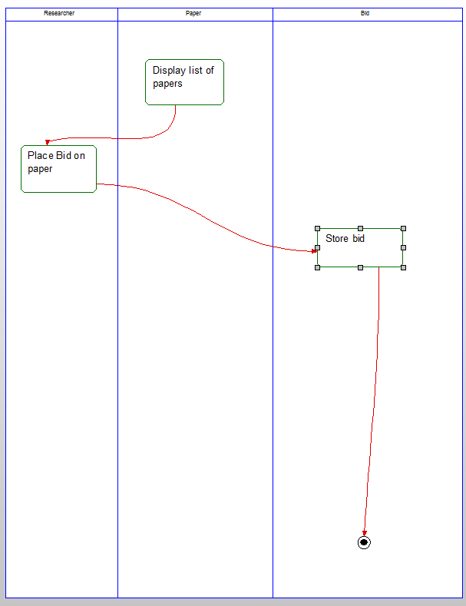

The bid paper activity diagram shows how a reviewer can bid on a paper submitted by the researcher.

## Activity Diagram 5: Review Paper

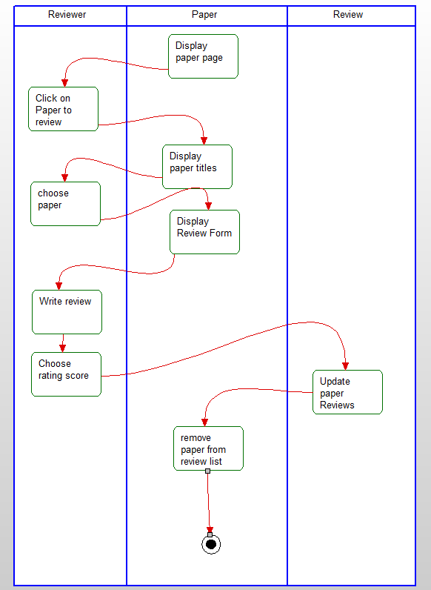

The review paper activity diagram shows how the reviewer can review their papers that they have won their bids on.

## Activity Diagram 6: Admin add new conference

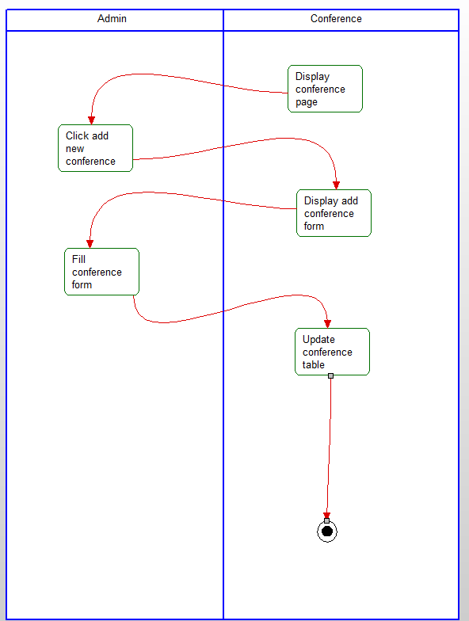

The Admin add new conference activity diagram shows how the Admin can add new conferences to the list of available conferences.

# User Manual

## Operation Instructions:

### Logging in:

Users must first log in to the system by selecting the Log in page in the top right. Then they must provide their user ID and Password. If the user Id or the Password is incorrect an error will occur.

### Account Creation:

If a user does not yet have a user ID, he/she may choose to create an account, by selecting the create account button. After the button is selected they will have to provide their email, username, and password.

### Add conference:

From the main menu the admin user must click the conference button to view the conference page, then he/she must select the add conference button and follow the prompt to add a new conference.

### Register for a conference:

From the main menu the user should select the conference button, once on the conference page the user should select the conference that they wish to attend, and then select the register for conference button.

### Check in to a conference:

From the main menu the user should select the conference button, once on the conference page the user should select the conference that they wish to check in to, and then select the check in button.

### Submit a paper:

From the main menu the user should select the conference button, once on the conference page the user should select the conference they wish to submit a paper to, then select the submit paper button and follow the prompt to submit the paper.

### Bid on paper:

From the main menu the user should select the conference button, once on the conference page the user should select the conference they wish to attend and select view papers. After the papers have been listed you may bid on any available paper by giving a bid of 0-5, 5 being the highest.

### Review paper:

From the main menu the user should select the conference button, once on the conference page the user should select the conference they wish to attend and select view papers. After you have been assigned a paper to review you may fill out the review form for that paper.

# Conclusion

We have proposed a software system that will: allow researchers to submit papers to be reviewed, view the feedback from reviewers, and check into conferences; allow reviewers to review the researcher's papers, but not allow more than 7 reviews; allow conference users to create events, change status of users (I.e. researcher to reviewer), view reviewers feedback, and advertise upcoming events.

# Data Dictionary

## Users

|  |  |  |  |  |
| --- | --- | --- | --- | --- |
| Field Name | Title | Data Type | Field size | P/F |
| user_id | ID | Autonumber |  | p |
| User_email | email | Text | 50 |  |
| User_password | Password | Text | 50 |  |
| User_access | AccessLevel | Integer | 3 |  |
| User_name | Name | Text | 70 |  |

## Papers

|  |  |  |  |  |
| --- | --- | --- | --- | --- |
| Field Name | Title | Data Type | Field Size | P/F |
| Paper_id | ID | Autonumber |  | P |
| Author_id | AuthorID | Integer | 11 | F |
| Doc_path | DocPath | .doc |  |  |
| Conference_id | ConfID | Integer | 11 | F |
| Paper_title | title | text | 50 |  |
| Paper_description | description | text |  |  |

## Bids

|  |  |  |  |  |
| --- | --- | --- | --- | --- |
| Field Name | Title | Data Type | Field Size | P/F |
| Bid_id | ID | Autonumber |  | P |
| Reviewer_id | ReviewerID | Integer | 11 | F |
| Paper_id | PaperID | Integer | 11 | F |
| Paper_rating | Rating | Integer | 5 |  |

## Reviews

|  |  |  |  |  |
| --- | --- | --- | --- | --- |
| Field Name | Title | Data Type | Field Size | P/F |
| Review_id | ID | autonumber |  | P |
| Paper_id | PaperID | integer | 11 | F |
| reviewer | reviewer | text | 50 |  |
| review_privCom | PrivateComment | text |  |  |
| review_comment | comment | text |  |  |
| Review_complete | Completed | Boolean | 1 |  |
| Review_rating | Rating | integer | 5 |  |

## Registration

|  |  |  |  |  |
| --- | --- | --- | --- | --- |
| Field Name | Title | Data Type | Field Size | P/F |
| Register_id | RID | integer | Autonumber | P |
| User_id | UserID | integer | 11 | F |
| Conf_id | ConfID | integer | 11 | F |
| privelege | Privelege | integer | 3 |  |
| checkedin | checkdin | Boolean | 1 |  |

## Conference

|  |  |  |  |  |
| --- | --- | --- | --- | --- |
| Field Name | Title | Data Type | Field Size | P/F |
| Conference_id | ID | Autonumber |  | P |
| Conference_name | Name | text | 50 |  |
| Conf_description | Description | text |  |  |
| Conf_paperlimit | PaperLimit | integer | 11 |  |
| Conf_imagePath | ImagePath | text |  |  |
| Conf_datetime | DateTime | DateTime |  |  |
| Conf_reviewphase | reviewPhase | Boolean | 1 |  |

## Alerts

|  |  |  |  |  |
| --- | --- | --- | --- | --- |
| Field Name | Title | Data Type | Field Size | P/F |
| Alert_id | ID | Autonumber |  | P |
| User_id | userID | integer | 11 | F |
| Alert_message | alertMsg | text | 100 |  |
| Alert_viewed | viewed | Boolean | 1 |  |