Ryan Goettl

Requirement Specifications Report

Goettl, Ryan A.

2016

Andrew Burden

Team Project

CSC 340 Fall 2016

# Table of Contents

Contents

Table of Contents 1

I. Introduction 2

II. System Description 3

III. System Requirements 4

IV. Use Case Diagram 16

V. Domain Diagram 19

VI. Sequence Diagrams 20

VII. State Diagrams 27

VIII. Database Design 32

IX. Activity diagram 32

X. Conclusion 33

XI. Data Dictionary 34

# Introduction

1. Problem Statement - This pizza restaurant is wanting to have a system that allows customers to create and edit an account and can order a pizza from them online. This system would require a facility where customers can either log in to or create a new account. It will also need to display all the information the customer needs to create the pizza they want and can confirm their order. The system will also need to be able to take payments from the customer and store the Information. The system will also be able to trace the status of the order and display the status to the customer on request. For the backend of the system it will need to assign an employee to deliverer the pizza. Allow an employee to search customers profile and list their order history. The system will need to update the stock database after an order can keep track and display business volume of a day or month.
2. Proposal – After weighing various options our team felt that employees and customers could use the same system to reduce redundancy in design. Both employees and customers will be able to create accounts and login using their generated ID numbers. Depending on the type of account, the user will be directed to either a customer or an employee main menu. An employee will be able to edit their profile, search for and edit customer profiles, as well as search and edit orders. Customers are presented with the ability to create custom pizzas, add items to a shopping cart, view their order history, and edit their profile. The system will be implemented with the focus of simplicity and ease of usability. Buttons and lists shall be labeled in a clear manner enabling customers and employees to use the program with little to no training.

# System Description

1. System Description – The focus of this system was to create an easy to use and easy to navigate system for both the customer and the employee. The ability to expand and handle flexibility was also a top priority in the design of the system. The system allows a customer to create a profile for themselves to make ordering easier. It allows a customer to create the pizza they want to order, pay for the pizza, and track the status all online easily. The system will assign a deliverer to take the pizza to the customer. It will update the stock information in the database. For Employees, they will be able to search a customer’s profile, list the order history of the customer, and list the business volume of a day or month.

# System Requirements

1. The system shall allow the guest to log in to the system
   1. The system will provide to text boxes one for username and one for password
   2. The user will enter their username and password
   3. The user will click log in
   4. The system will display the appropriate screen if the user is an employee or customer
   5. The user will click the button create account if they don’t have a log in

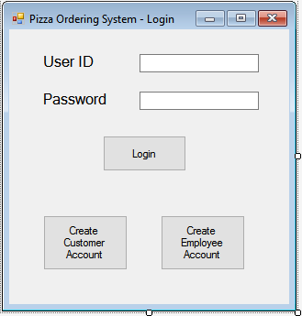

1. The shall allow the customer to create an account
   1. The system will provide 4 text boxes for Username, password, address, and phone number
   2. The user will enter their information in to the text boxes
   3. The system will check that the username isn’t the same as any other username in the database
   4. The system will check the password meets the requirements of character length
   5. The system will check the phone number has enough digits

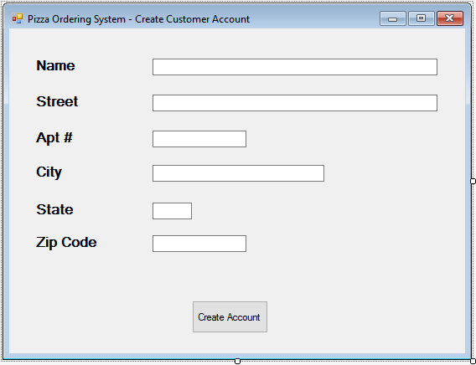

1. The shall allow a customer to edit their account
   1. The system will have a button for the user account
   2. The user will click on the account button
   3. The system will display the customer’s information in their profile
   4. The system will have an edit button
   5. The user will click the edit button
   6. The system will display the user information in text boxes
      1. The user will type the new information into the text boxes

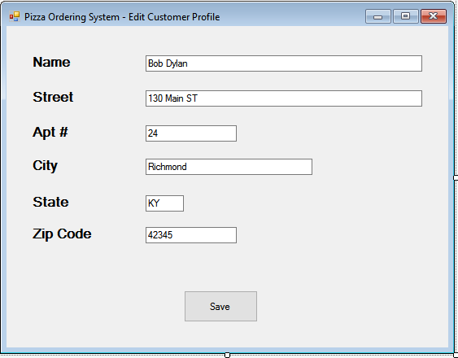

* 1. The customer will click the save button
  2. The system will save new information to the database

1. The system shall allow an employee to search a customer’s profile
   1. The employee will click on the customer tab
   2. The system will have a text box
   3. The system will have a search button
   4. The employee will enter the customer name and click search

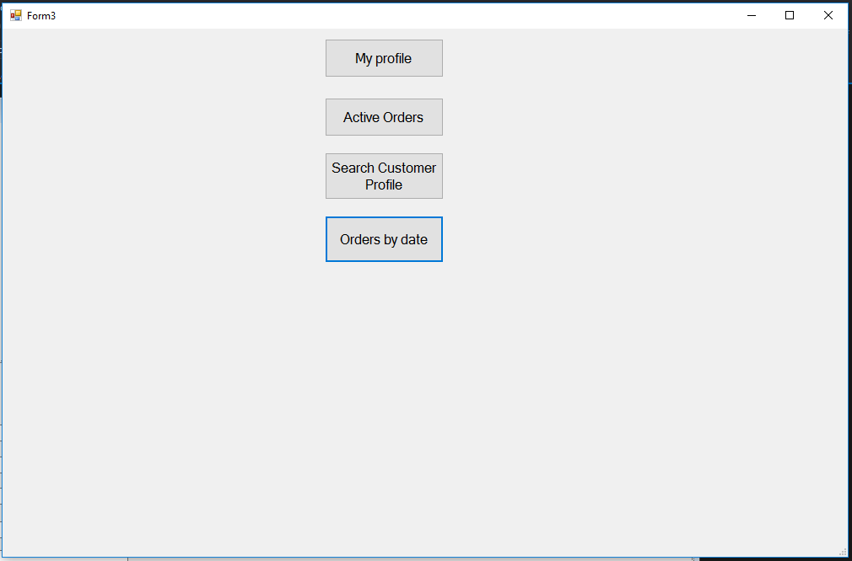

* 1. The employee will search on the customer name

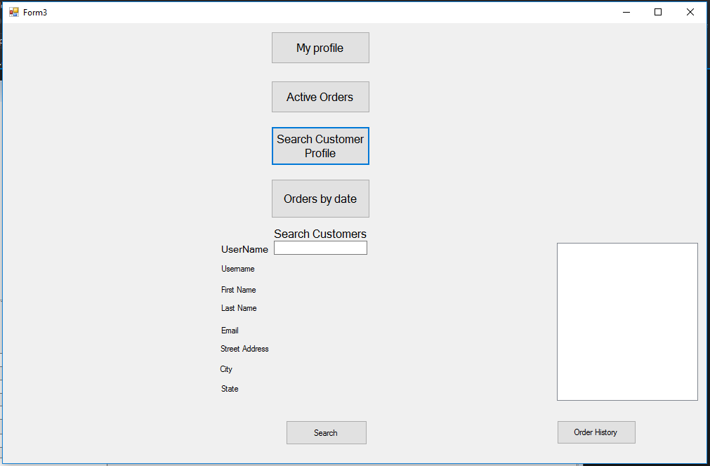

* 1. The system will display the customers profile



1. The system shall allow an employee to create an employee account
   1. The user will click create employee account on login screen
   2. The user will enter their name, address, social security, position, manager verification code
   3. The system will check the manager verification code
      1. If the system verifies the code, it will save the account information
      2. If the code doesn’t match it will not create the profile

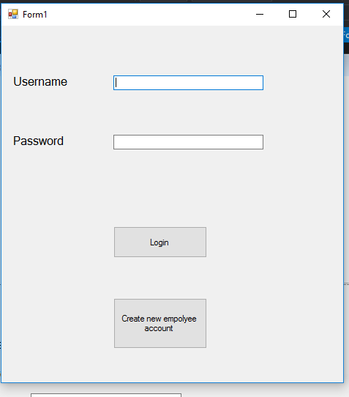



* 1. The system will save the information to the database
  2. The system will create a new employee user

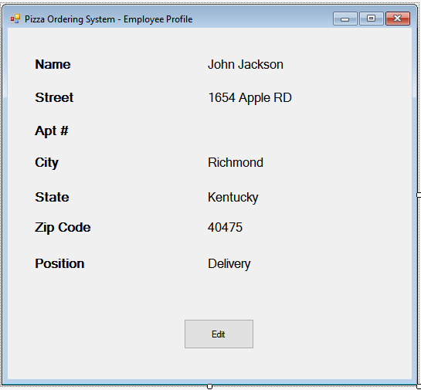

1. The system shall allow an employee to edit their account
   1. The system will have a button for the employee account
   2. The employee will click on the account button
   3. The system will display the Employees information in their profile



* 1. The system will have an edit button
  2. The employee will click the edit button
  3. The system will display the employee information in text boxes
     1. The employee will type the new information into the text boxes
  4. The employee will click the save button
  5. The system will save new information to the database

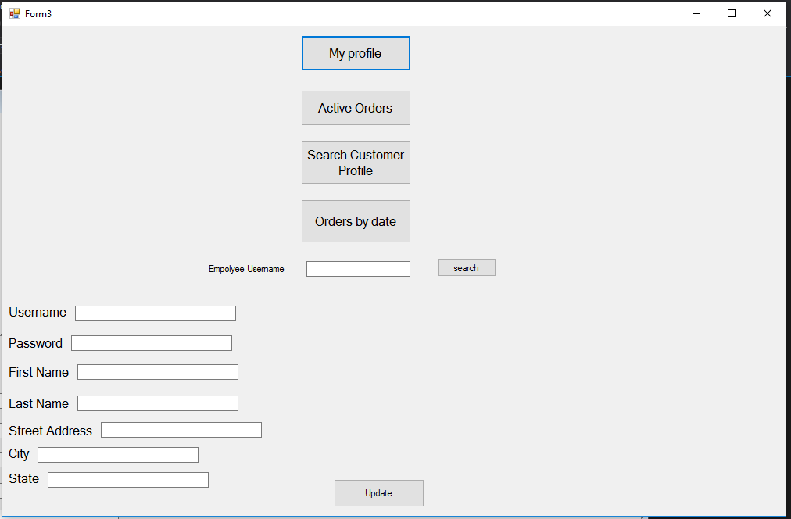

1. The System shall allow the customer to build their own pizza
   1. The system will display the base choices for pizza (i.e. cheese or pepperoni)
   2. The customer will click on the base option they want

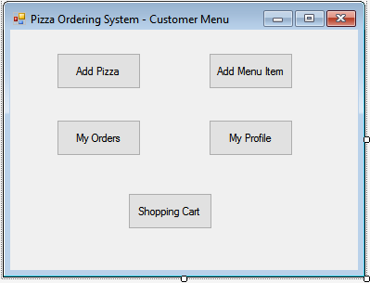

* 1. The system will display a panel with all the options
  2. 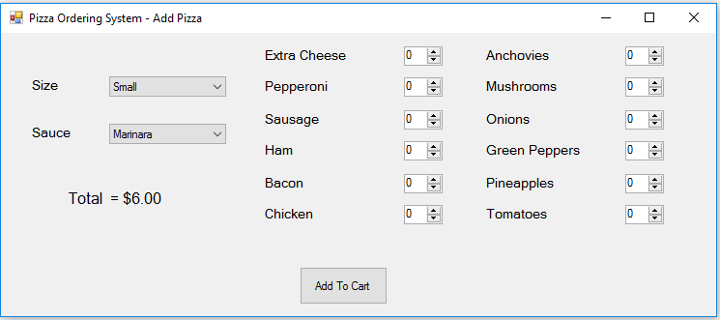
     1. The display will have added toppings
     2. The display will have size options
     3. The display will have added to cart
  3. The user will click the toppings they want
     1. The system will check that the topping is in stock
     2. The system will add this topping to the pizza
  4. The user will click the size they want
     1. The system will add the size to the pizza order
  5. The user will click add to cart
  6. The system will add the order and total to the customer’s cart

1. The system shall enable the customer to purchase pizza and other items
   1. The user will click on cart
   2. The system will display all items added by the customer
   3. The system will display the total price of the order
   4. The system will display all the payment information needed
   5. The user will enter the information
   6. The system will display a check box for delivery (otherwise considered pick up)
      1. The customer will check the box
      2. The system will display the address information needed
      3. The system will display a check box to use address saved in profile
      4. The customer will enter the information or check the box
   7. The customer will click submit
   8. The system will verify the payment information is valid
   9. The system will send the order to be fulfilled
   10. The system will update the stock information

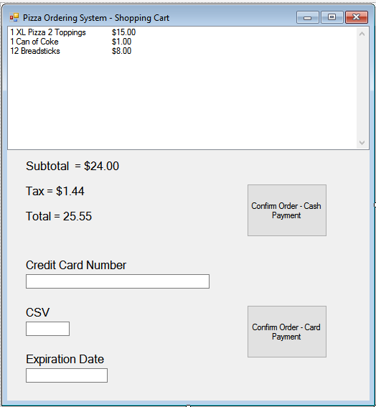

1. The system shall assign an employee to deliverer the customer’s order
   1. The system will check the employee database for a deliverer
      1. The system will check the employee is logged in
   2. The system will add the deliverer to the order information
      1. This will also be able to be seen by the customer and employee

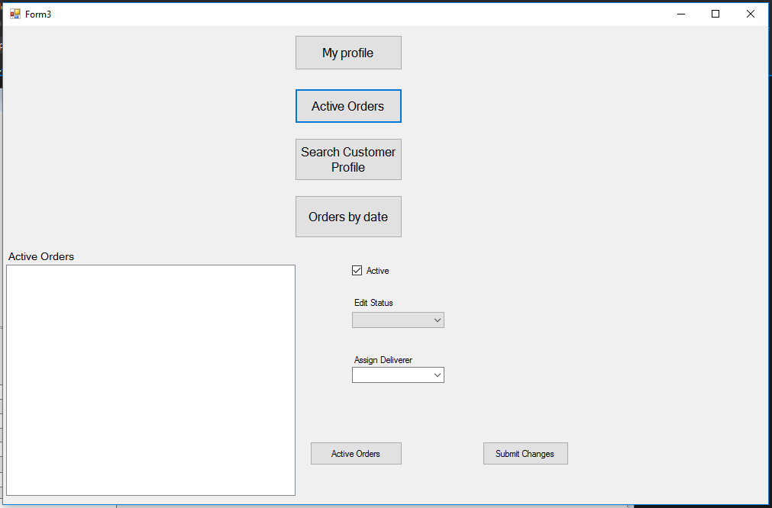

1. The System shall update the current stock after a customer places an order
   1. The system will verify the order information
      1. See in R 8.9
   2. The system will update the stock based on the order
   3. The system will save these changes to the database
2. The System shall allow an employee to edit the status of an order
   1. The system will display all active orders
      1. After information, has been verified the active order will start at “making pizza”
   2. The employee will click making pizza
      1. A drop down menu will appear with options of pizza made, on the way, delivered
   3. The employee will click apply
   4. The system will save the change
      1. These changes will be able to be viewed by the customer

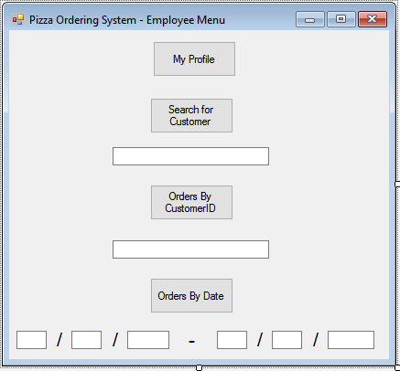

1. The system shall allow the customer to track the status of an order
   1. The system will display active orders in a panel
      1. The system will show all items in the order
      2. The system will show the status of the order

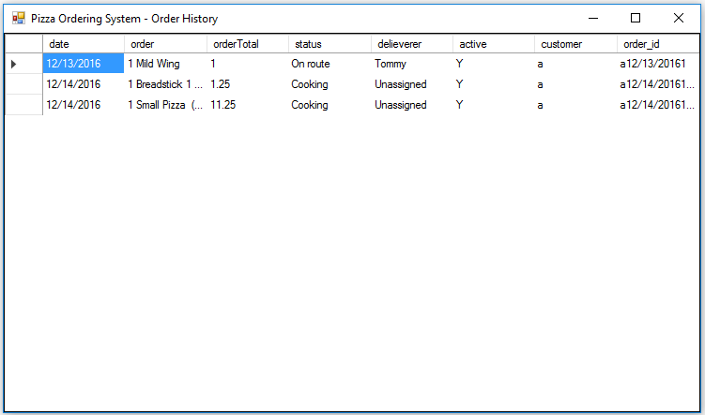

1. The system shall allow the customer to view information of their previous orders
   1. The customer will click on my orders



* 1. The system will pull the all previous order information from the database
  2. The system will display both active order and their previous orders



1. The system shall allow an employee display business data for a day, month, or year
   1. The employee will click the business data button
   2. The system will display three options for day, month, or year
      1. The employee will click on day
      2. The system will display a text box requiring a day month and year
      3. The employee will enter the date desired
      4. The system will pull the total orders, amount of money paid to them and number of items sold



* + 1. The system will display this information

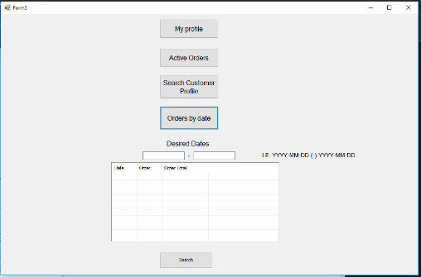

* 1. The customer will click on month
     1. The system will display a textbox requiring a month and year
     2. The employee will enter the date desired
     3. The system will pull the total orders, amount of money paid to them and number of items sold
     4. The system will display this information
  2. The customer will click year
     1. The system will display a textbox requiring a year
     2. The employee will enter the date desired
     3. The system will pull the total orders, amount of money paid to them and number of items sold
     4. The system will display this information

1. The system shall allow a customer to add a menu item
   1. The customer shall click the add menu item button
   2. The system will display the menu item form

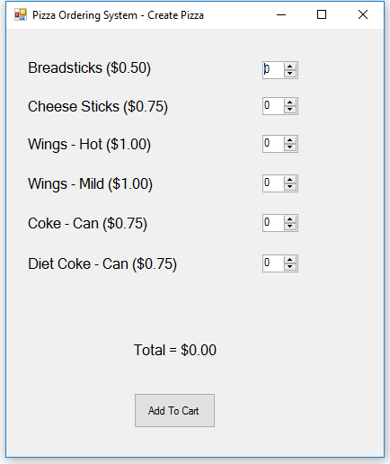

* + 1. The employee will update the total count for each item
    2. The system will display a total price after each change
  1. The customer will click on Add to Cart
     1. The system will track the count of all menu items
     2. The system will update the current count for all menu items

# Use Case Diagram

This diagram shows the interaction of the customers with the system when logging in such as:

creating and editing their account, building, and purchasing, and viewing their order history.

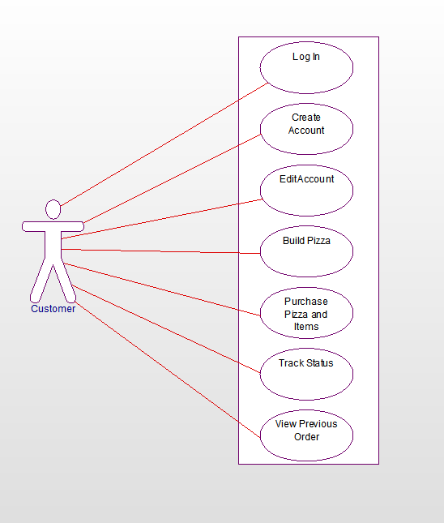

Use cases descriptions for online order management

1. Log In the user will enter their username and password the system will check the database if correct it will hide the login form and show the second form.
2. On the login form, there is also a second button to create an account the user will click on this and fill in their information. Once they click submit the user will check if the username is already in use if it isn’t it will create the account
3. If the user wants the edit their account, they can log in then click my profile this will open another form with their information they can then change it and resubmit it to the database
4. When the customer wants to create their pizza, they’ll click on create pizza this will bring up the form with all their pizza options including size toppings and sauce once they created the pizza it will show the total on the side they can then click add to cart adding the pizza to their cart.
5. The can also add other menu items such as soda or breadsticks by clicking menu items and adding the menu items they wanted to their cart as well
6. Once they are satisfied with their order they can then click on shopping cart this will bring up their order showing their total also all their payment options once they clicked on how they are going to pay and enter the information they can click order this will submit their order to the database that the employees will see
7. If the customer wishes to track the status of their order, then they can click on my orders this will show all their previous orders plus their active ones and what it’s status is.
8. To see all their previous orders, they can click on my orders and it will display all previous orders

This diagram shows the interaction of the employee with the system when logging in such as: creating and editing the employee's account, searching the customer's profile, editing the customer's order status, and checking the business history.

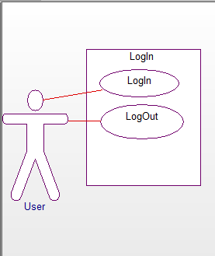

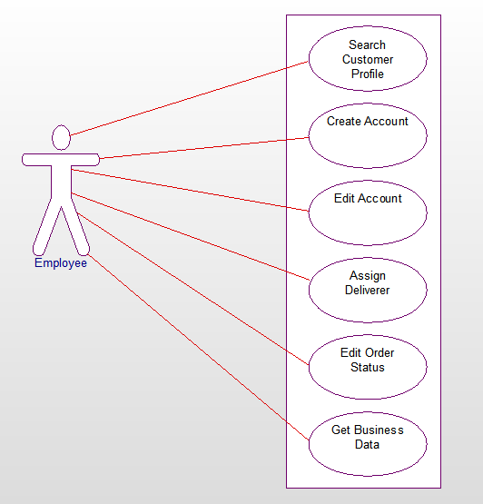

Use Case Descriptions for employee/order management

1. logging into the employee management system this checks the username and password typed in to the database if correct it hides the login in form and shows the employee form
2. logout the user clicks the logout button hiding the employee form and showing the login form once again
3. On the login in screen there is a second button labeled create employee account the user will click on this. It will open a second form with textboxes that can be filled with their information plus a manager code that they would have to know for it to accept the information, the system will check there is no one else with that username and the code is correct and add them to the database
4. Once logged in the employee can also edit their information by clicking on the My profile button this shows textboxes with their information filled in them which they can change and update the database by clicking the update button.
5. Searching for a customer profile the user will click on the button labeled search for customer the system will show a text box and search button the employee can type in the username of a customer and this will display their information in labels, the employee can then click on order history to see all the previous orders
6. The employee will need to assign a deliverer to any active orders so they click on the button labeled active orders this shows a panel with a list box and a button labeled active orders when they click on this it will display all active orders in the database this panel also has a drop down box that has all the deliverers they can click on an order click on the dropdown list of delivers click on one then click submit and it will assign that deliverer.
7. The employee will need to change the status to any active orders so they click on the button labeled active orders this shows a panel with a list box and a button labeled active orders when they click on this it will display all active orders in the database this panel also has a drop down box that has the different statuses an order can have they can click on an order click on the dropdown list of statuses click on one then click submit and it will change the status of the order.
8. To change if an order is active you can follow the steps above and then click the check box and submit the change no longer making the order active.
9. To see the business volume for a certain amount of time the user will click on orders by date this will bring up a list view and 2 textboxes the user will enter their desired dates and the list view will show the order and its total in grid view.

# Domain Diagram

This diagram shows the interaction of the customer with the menu, which will give the customer the option to create the pizza, then paying for the created pizza and other items, and finally the employee's role when the customer has paid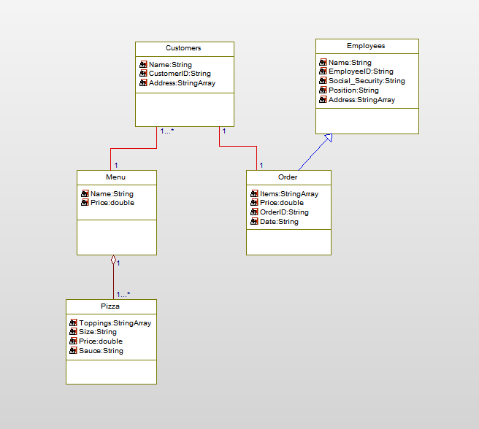

# Sequence Diagrams

**These are the Sequence diagrams for Employee/Order Management Subsystem**

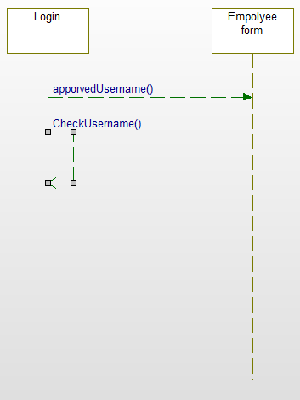

This sequence diagram is for the Login Use case

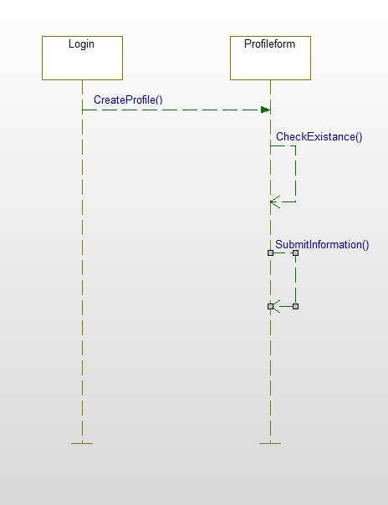

This sequence diagram is for the create profile use case

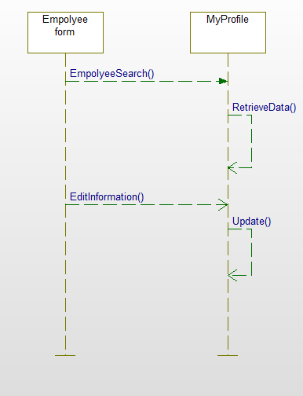

This sequence diagram is for the editing employee profile use case

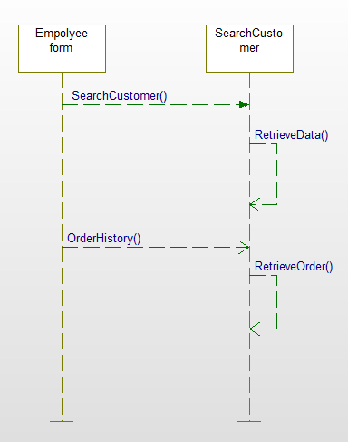

This sequence diagram is for searching customer information diagram

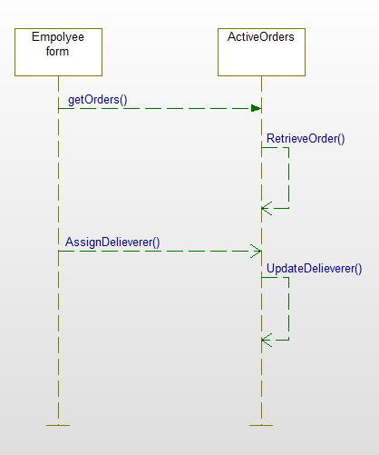

This sequence diagram is for assigning deliverer to an order use case

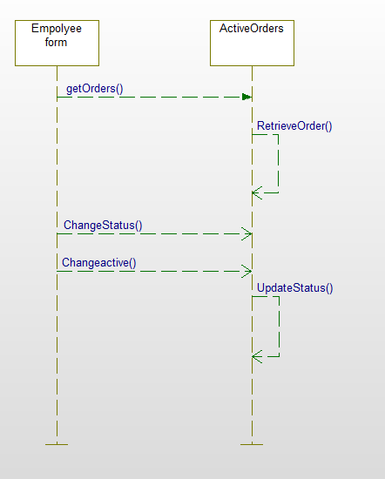

This sequence diagram is for changing the status of an order use case

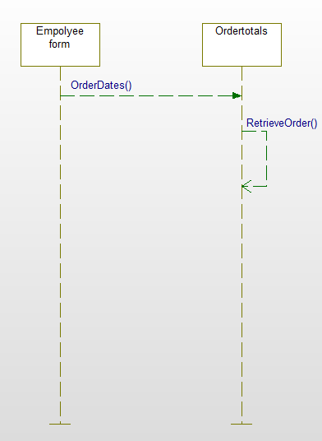

This sequence diagram is for retrieving order totals based on dates use case

**These are the sequence diagrams for the online order management Subsystem**

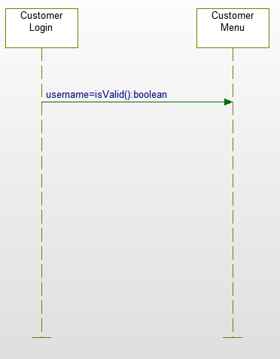

This is the sequence diagram for customer login.

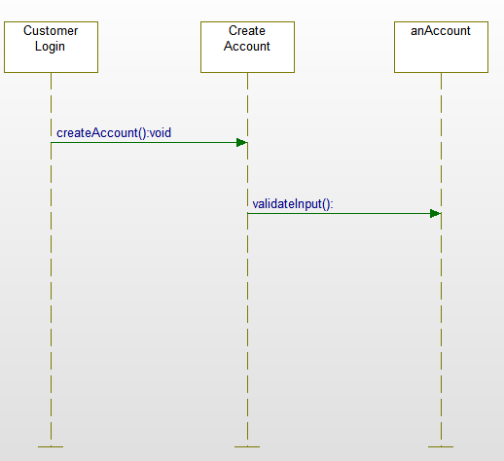

This is the sequence diagram for creating a customer account.

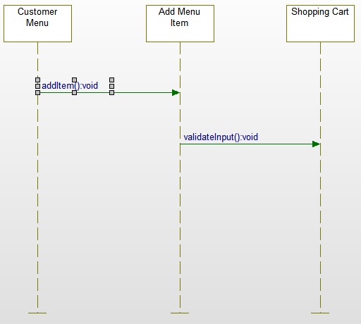

This is a sequence diagram for adding a Menu Item to the shopping cart

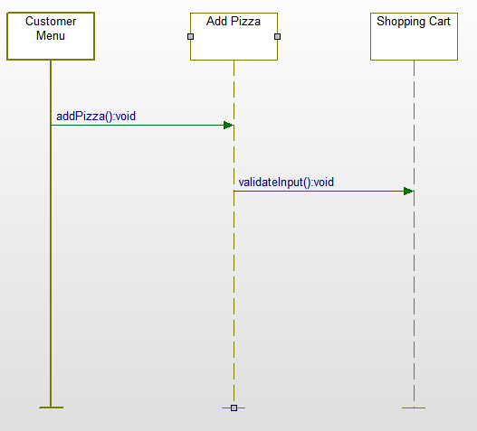

This is a sequence diagram for adding pizza to the shopping cart

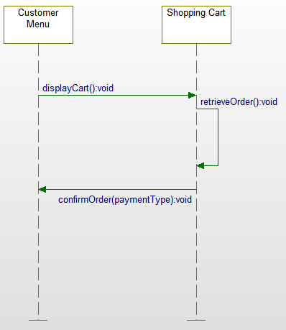

This is a sequence diagram for confirming an order in the shopping cart

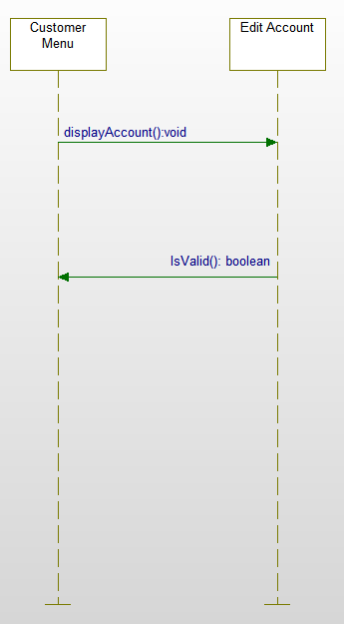

This is the sequence diagram for editing a customer account.

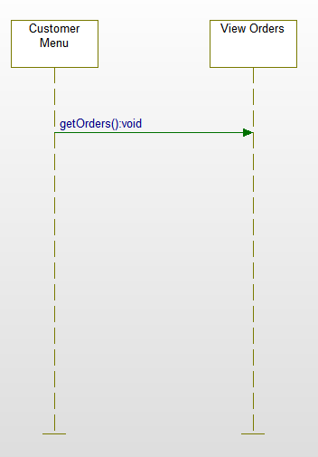

This is the sequence diagram for viewing a customer’s orders

# State Diagrams

**These are the state diagrams for the employee/order management subsystem**

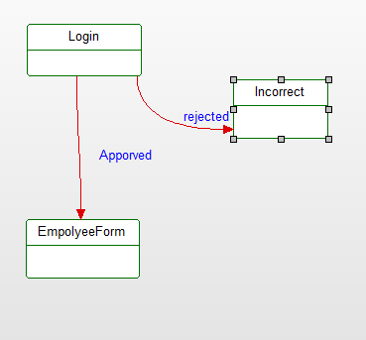

This is the state diagram for logging in use case

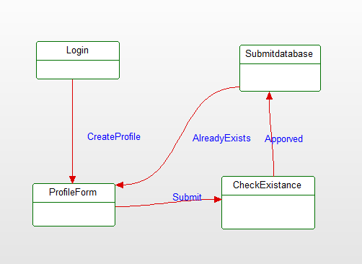

This is the state diagram for creating a profile use case

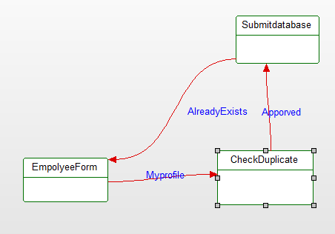

This is the state diagram for updating employee information use case

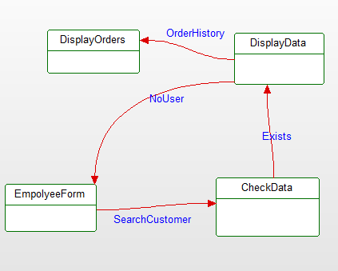

This is the state diagram for searching for a customer profile use case

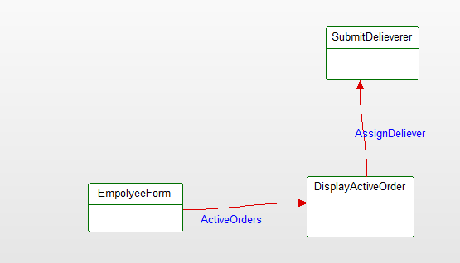

This is the state diagram for assigning the deliverer use case

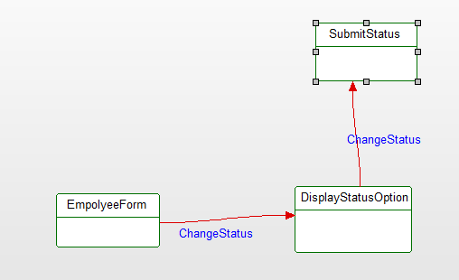

This is the state diagram for changing the status of an order use case

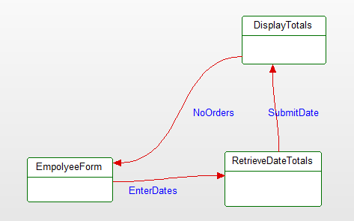

This is the state diagram for retrieving order information use case

**These are the state diagrams for the employee/order management subsystem**

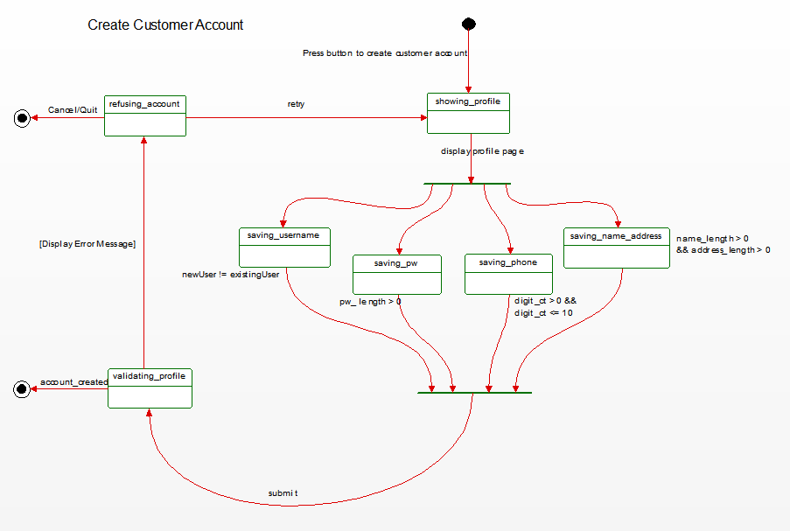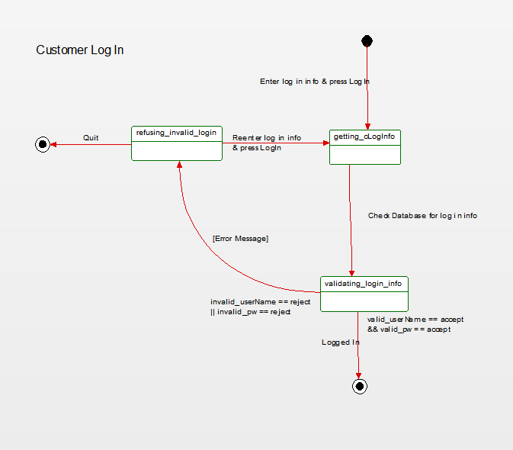This is the state diagram for customer login

This is the state diagram for creating a customer account

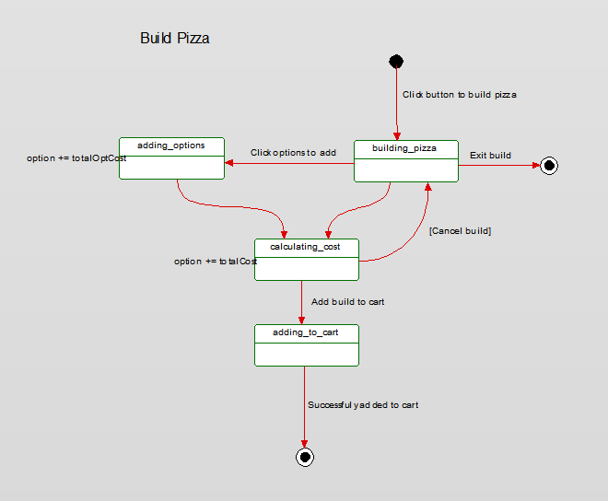This is the state diagram for adding a pizza to an order.

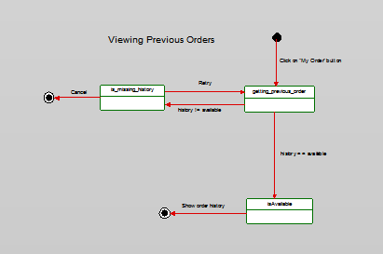

This is the state diagram for a customer to view their order history.

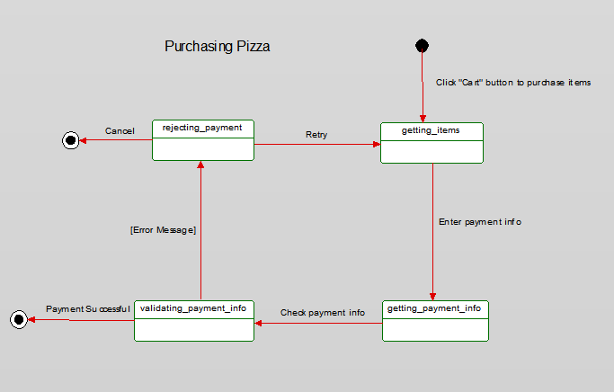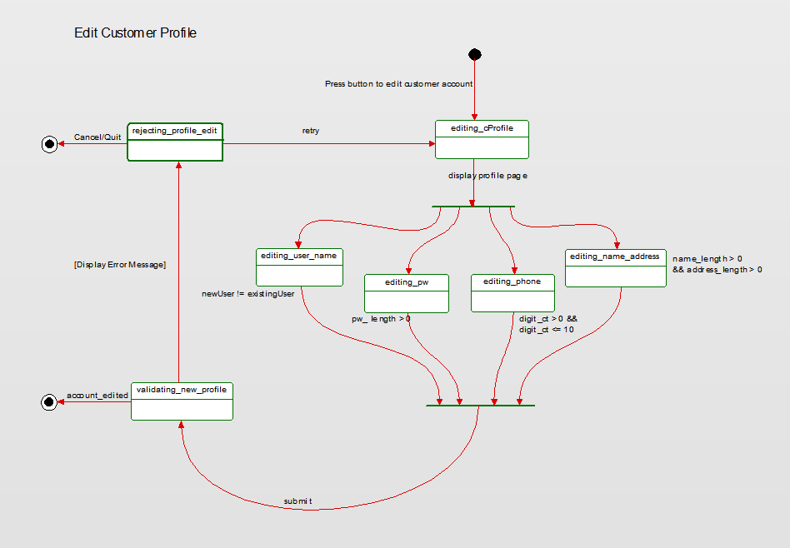 This is the state diagram for editing a customer profile.

This is a state diagram for purchasing an order from the shopping cart.

# Database Design

Relational tables:

goettl_customer (username, password, name, street, city, state, apt, zip)

This table in the database is used to store the information of the customer created accounts its primary key is their username and is the foreign key in the goettl_orders table. It holds their location information, name, and password

goettl_empolyee (username, password, fname, lname, street, city, state, position)

This table is in the database is used to store the information for the employee created accounts. Its primary key is their username and position is foreign key in orders so it can assign deliverers to an order. It holds their location information, their name, password, and position.

goettl_items (itemName, itemNumber, Supplier, quantity, warninglevel)

This table is used for storing the information of our stock including their name, supplier, quantity, and warning level to let the employees know the stock is low. Its primary key is the order number.

goettl_orders (date, order, orderTotal, status, delieverer, active, customer, order_id)

This tables holds the information for the orders placed it has the date it was order, what items were ordered, the total amount of the order, the status of the order, who is delivering the order, whether the order has been completed and who the customer was that ordered it. Its primary key is an order ID.

# Activity diagram

This is the activity diagram for the employee/order subsystem

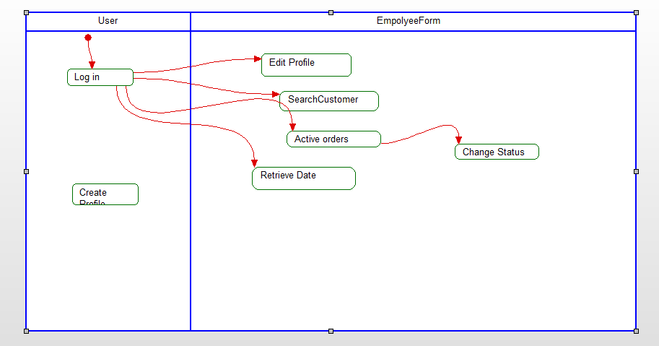

This is the activity diagram for the online order subsystem

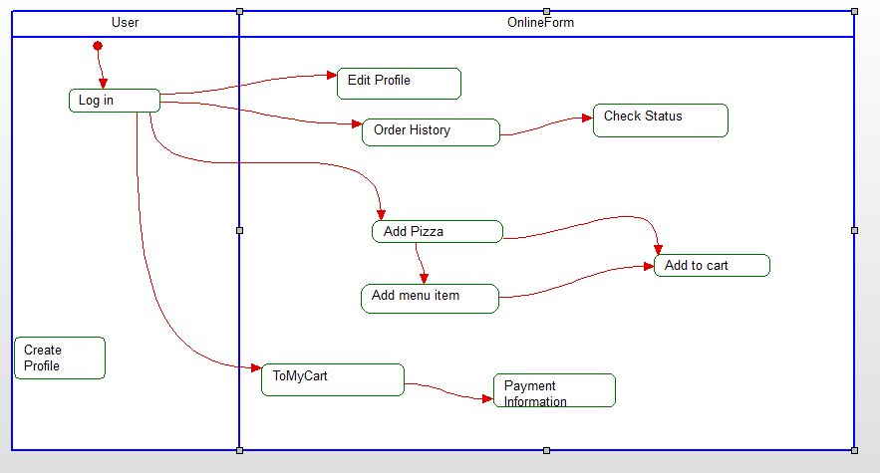

# Conclusion

The system we designed reduced redundancy by having the customers using the same system. Both the customer and employee will be able to log in and create a n account from the same login form but the system will be able to direct the them to their appropriate home page by the type of their account an employee will be able to search for customer’s profiles, order history, and order information. The customers will be able to edit their profile create and customize their own pizza, they’ll be able to order set menu items, they can pay for the pizza and items they ordered and can track the order and status of the delivery.

Our system is designed for a small pizza shop and does not allow for expandability but does keep things simple for the customer and employee. The simplicity allows for a customer to create and order a pizza easily with no frustration about where to find things and easy delivery. The employee is clearly labeled to make it simple to complete tasks needed such as changing the order status or looking up the order history.

# Data Dictionary

**Account:** Allows the customer to access the services of the company's website.

**Address:** Address information of the customer.

**Apply:** Button that allows the customer to choose their pizza choice.

**Cart:** Contains the customer's items.

**Check Box:** A box that allows the customer to choose if the pizza should be delivered.

**Create:** Button that allows the customer and the employee to create an account.

**Customer:** A person or organization that buys the pizza and/or items.

**Database:** A collection of information that is organized so that it can easily be accessed, managed, and updated.

**Deliverer:** An employee who delivers the customer's items.

**Edit:** Allows the customer or an employee to change their profile.

**Employee:** A paid worker for the company.

**Menu:** Contains the items available for purchase.

**Payment Information:** The way that a buyer chooses to compensate the seller of a good or service that is also acceptable to the seller.

**Password:** Customer defined. Allows the customer to log into the system.

**Pay Now:**  A button that allows the customer to pay for the items in the cart.

**Profile:** Customer or employee information.

**Save:** A button that allows the customer to save the items and their information to the database.

**Search:** Button that searches for the customer's profile.

**Size:** The size of the pizza.

**Status:** The status of an order.

**Stock:** Shows the quantity of items left in the inventory.

**Submit:** Button that allows the customer to purchase his or her order.

**Text Box:** Allows the customer to type in needed information.

**Topping:** Ingredients for the pizza.

**Total Price:** Total cost of items in the cart.

**Track Order:** Allows the customer to track their pizza's completion.

**User Name:** User assigned name. Used for logging into the system.