|  |  |  |  |  |  |
| --- | --- | --- | --- | --- | --- |
| Number | Test | Tools Used | Expected | Pass Fail | Ref |
| 1 | File Loading to Buffer | Visual Studio Debugger | Complete File In Queue | PASS | 1 |
| 2 | Input Read From Comm | Visual Studio Debugger | SYN-SOT-data in input buff | PASS | 2 |
| 3 | Received Data Ack'd and displayed | BCP Program | Data Fully Displayed | PASS | 3 |
| 4 | Sent Data Ack'd and Received | BCP Program | Ack received after data sent | PASS | 4 |
| 5 | Wireless Retransmissions | BCP Program | Failed data resent to limit | Buggy | 5 |

ref 1

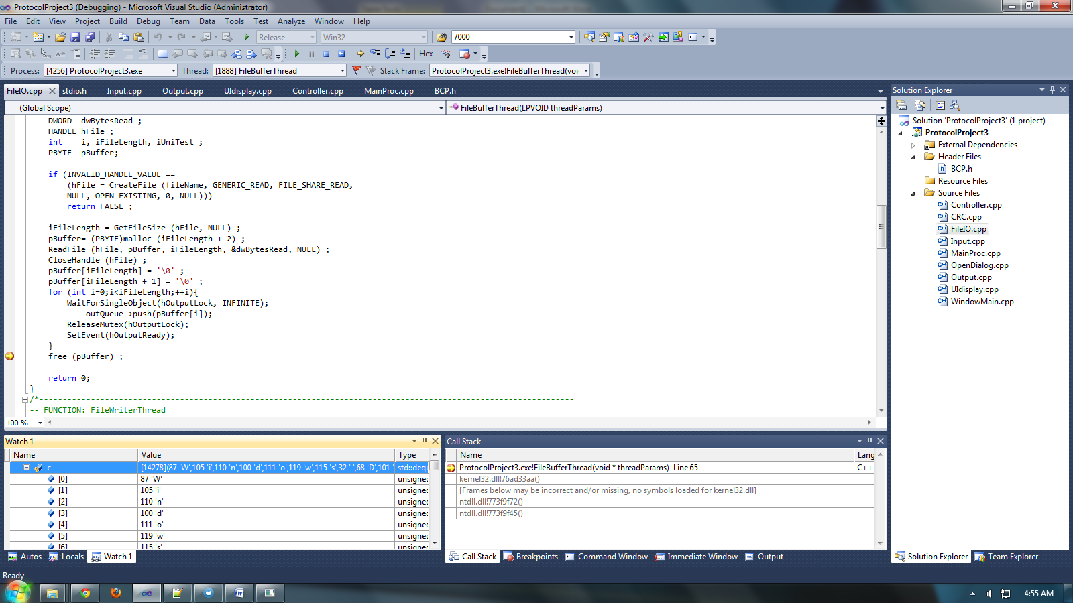

ref 2

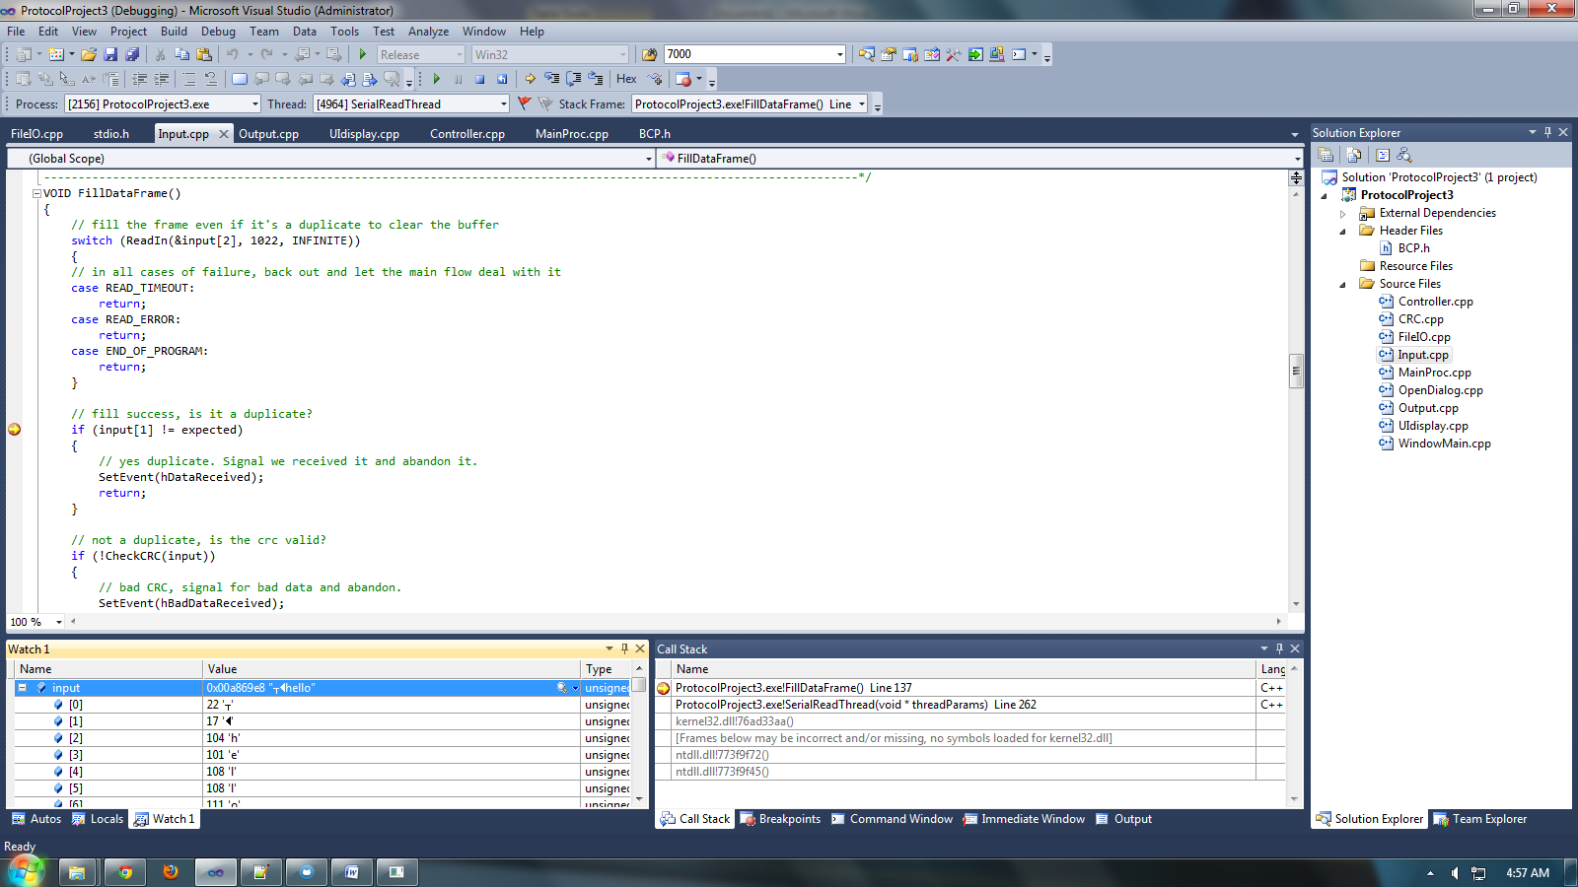

ref 3

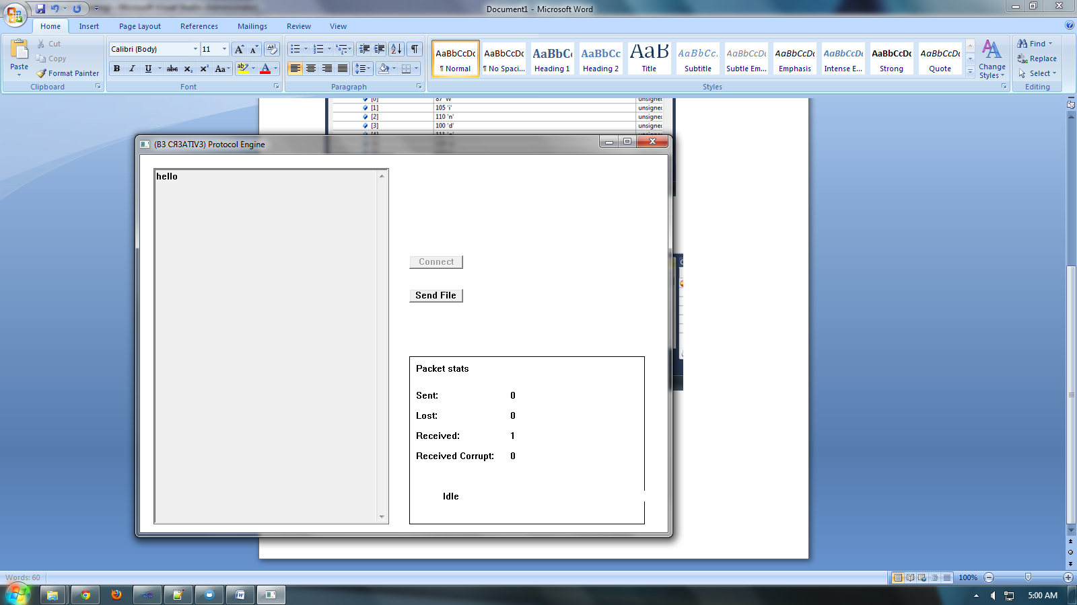

ref 4

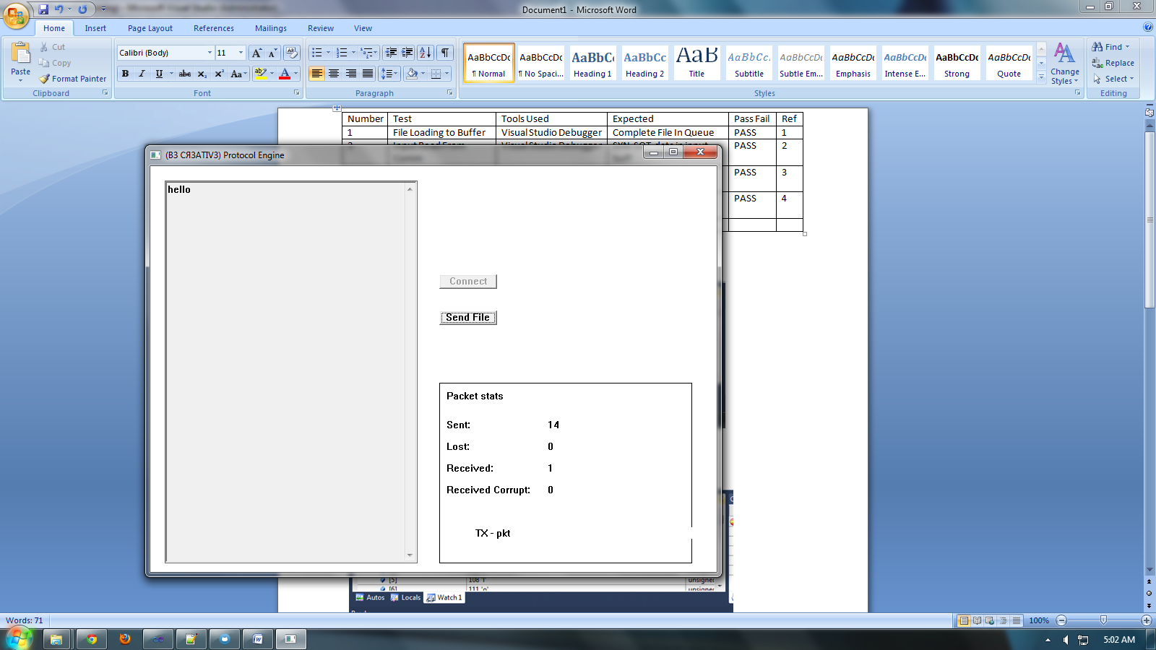

ref 5

