HW 4

Anees Saheba Guddi | Kartheek Alluri | Keon Sadeghi | Manjot Kaur | Rish Jain

Did you find or come across solutions to similar problems by using Generative AI or other sources?: No
Real-Time Student Attendance System
Apache Pulsar + Cassandra + Redis (Bloom Filter + HyperLogLog)

Section 1.1 — Environment Setup & Configuration

Services Installed
- Apache Pulsar 3.2.0 — pub/sub messaging broker (Docker, port 6650)
- Redis Stack — in-memory store with Bloom Filter & HyperLogLog modules (Docker, port 6380)
- Apache Cassandra 4.1 — distributed wide-column database (Docker, port 9042)
- Python libraries: pulsar-client, redis, cassandra-driver, faker

Imports
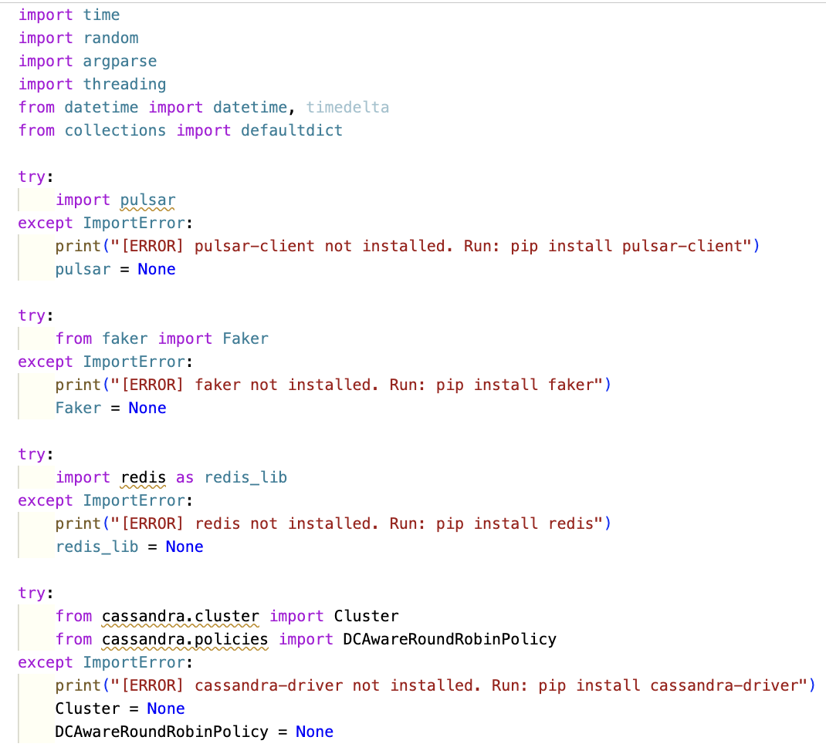

Configuration Code
The script defines all connection parameters at the top-level for easy reference:
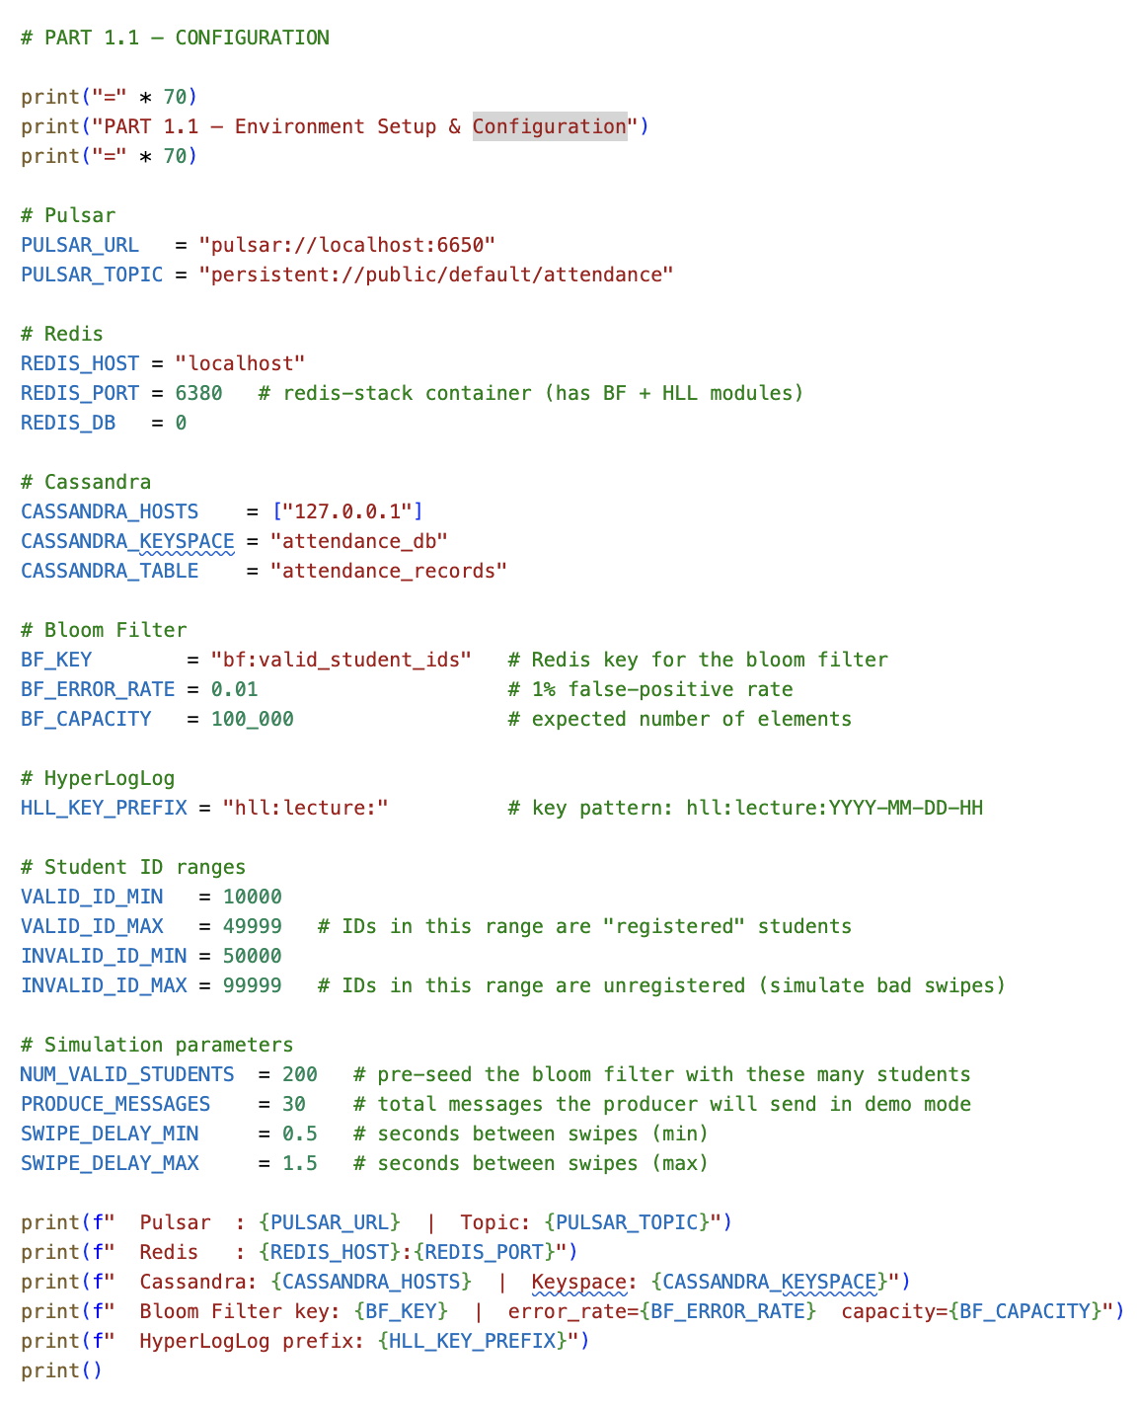

Cassandra Schema
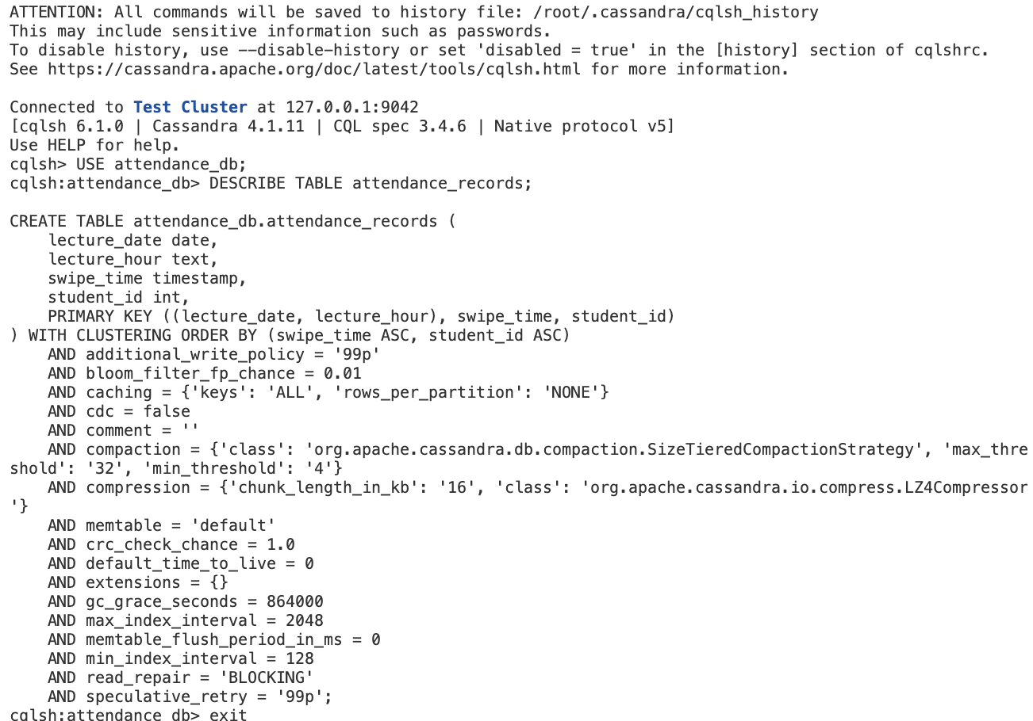

Output
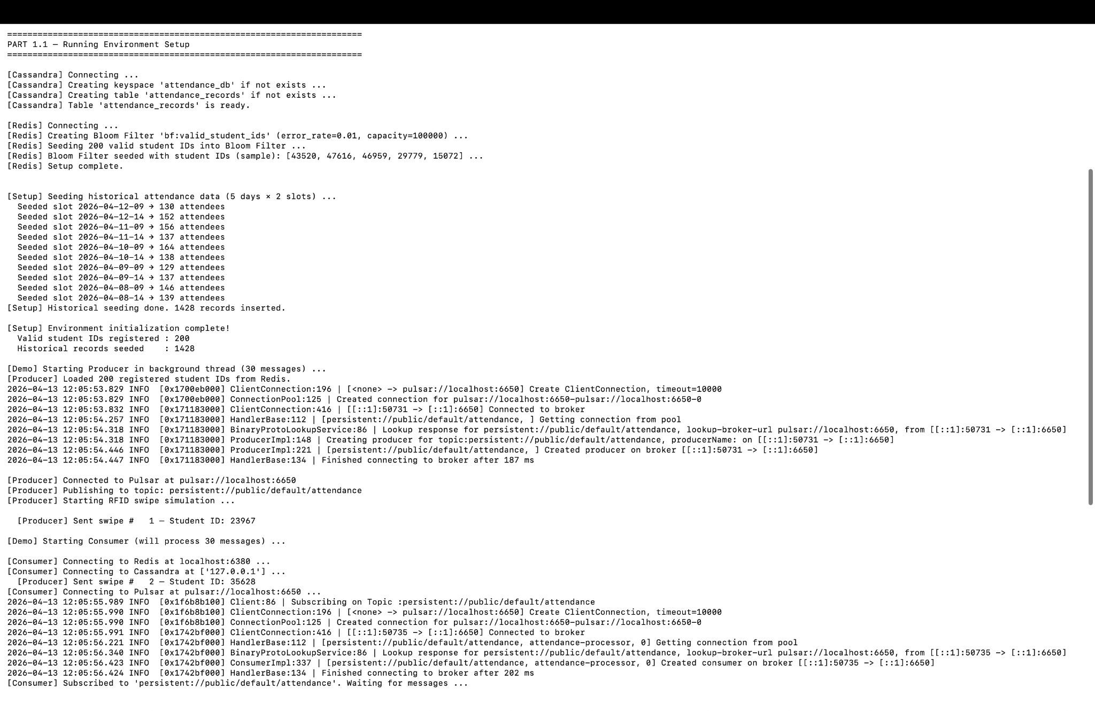

Section 1.2 — Simulating Streamed Student Data (Producer)

Overview
The producer script simulates RFID card readers at a university entrance. It continuously generates student IDs and publishes them as messages to the Pulsar attendance topic. To realistically test the Bloom Filter on the consumer side, messages are a mix of valid registered students and invalid/unknown IDs.

Message Mix Strategy
Probability | ID Range | Description
70% | 10000–49999 | Registered student (guaranteed to pass Bloom Filter)
15% | 10000–49999 | Random in valid range — may or may not be registered
15% | 50000–99999 | Clearly unregistered card (invalid swipe simulation)

Producer Code

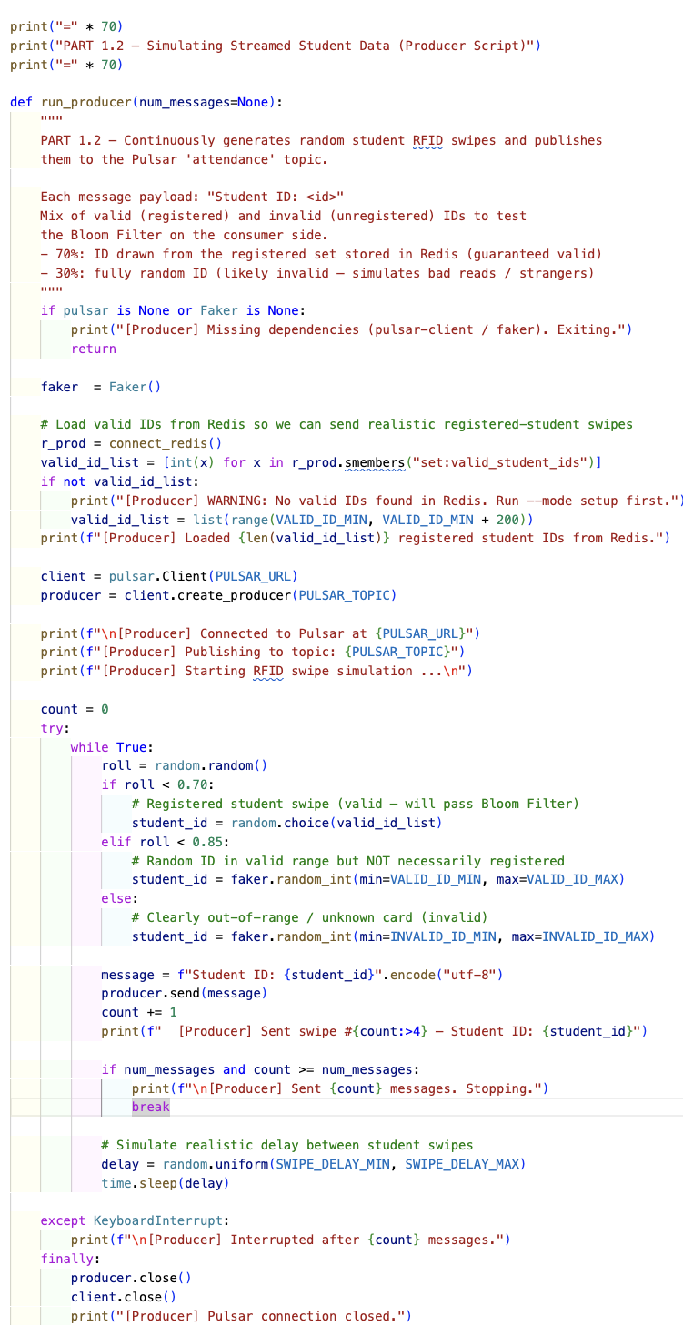

Output
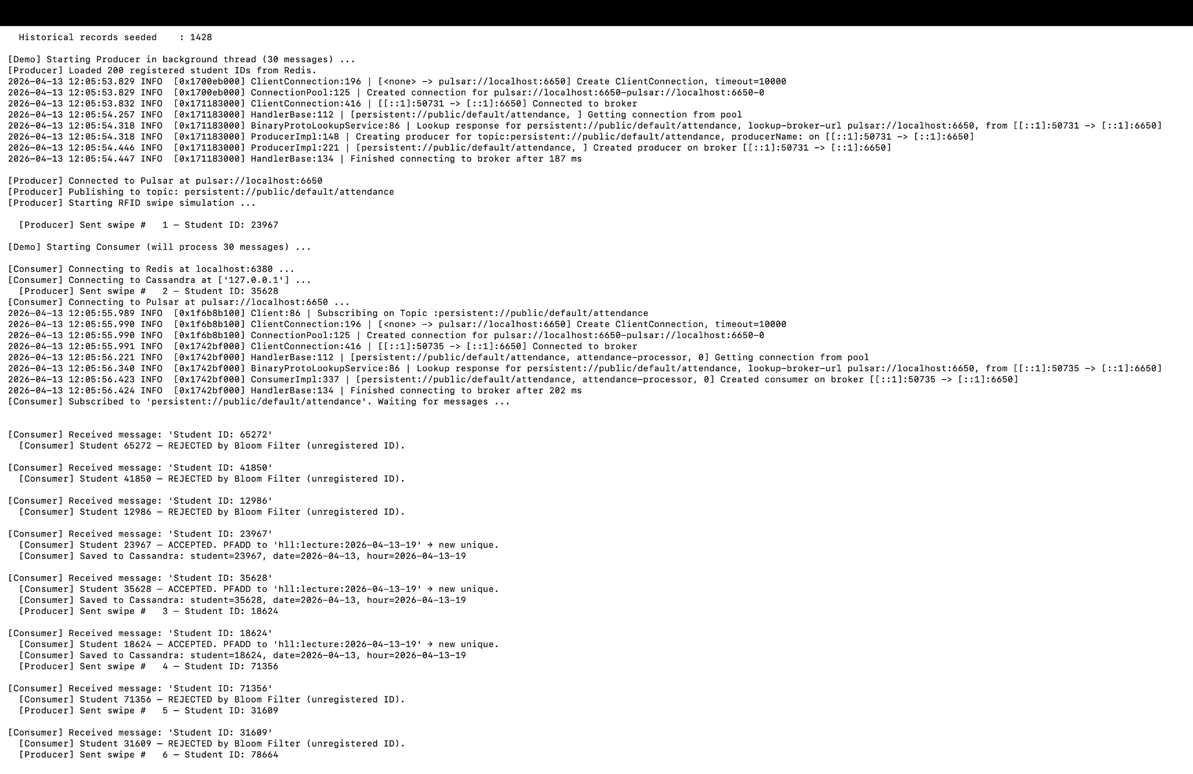

Section 1.3 — Processing Attendance Data (Consumer)

Overview
The consumer subscribes to the Pulsar attendance topic and processes each message through a three-stage pipeline: (1) validate the student ID using a Redis Bloom Filter, (2) track unique attendees using a Redis HyperLogLog, and (3) persist the full attendance record to Cassandra.

Processing Pipeline
Step 1 | Extract student ID from message payload (format: 'Student ID: 12345')
Step 2 | BF.EXISTS on Redis Bloom Filter — reject if ID not in filter (definitely not registered)
Step 3 | PFADD to HyperLogLog key hll:lecture:YYYY-MM-DD-HH — tracks unique attendees per lecture slot
Step 4 | INSERT into Cassandra attendance_records — persists full record with timestamp

Bloom Filter Implementation
The Bloom Filter is configured with a 1% false-positive rate and capacity of 100,000 elements. All three required Redis commands are used:

HyperLogLog Implementation
For each valid swipe, the student ID is added to a HyperLogLog keyed by lecture date-hour slot. PFADD automatically creates the key if it does not exist:

Screenshot — Code
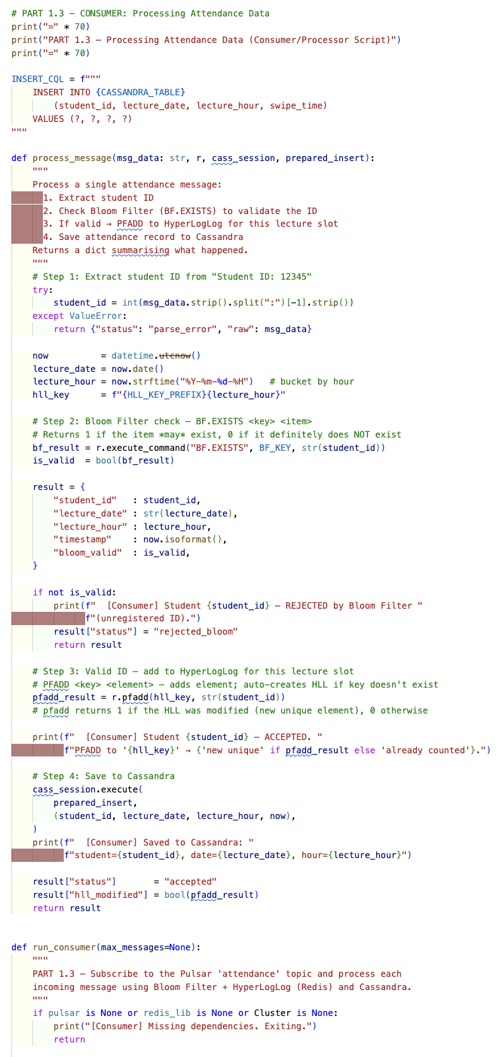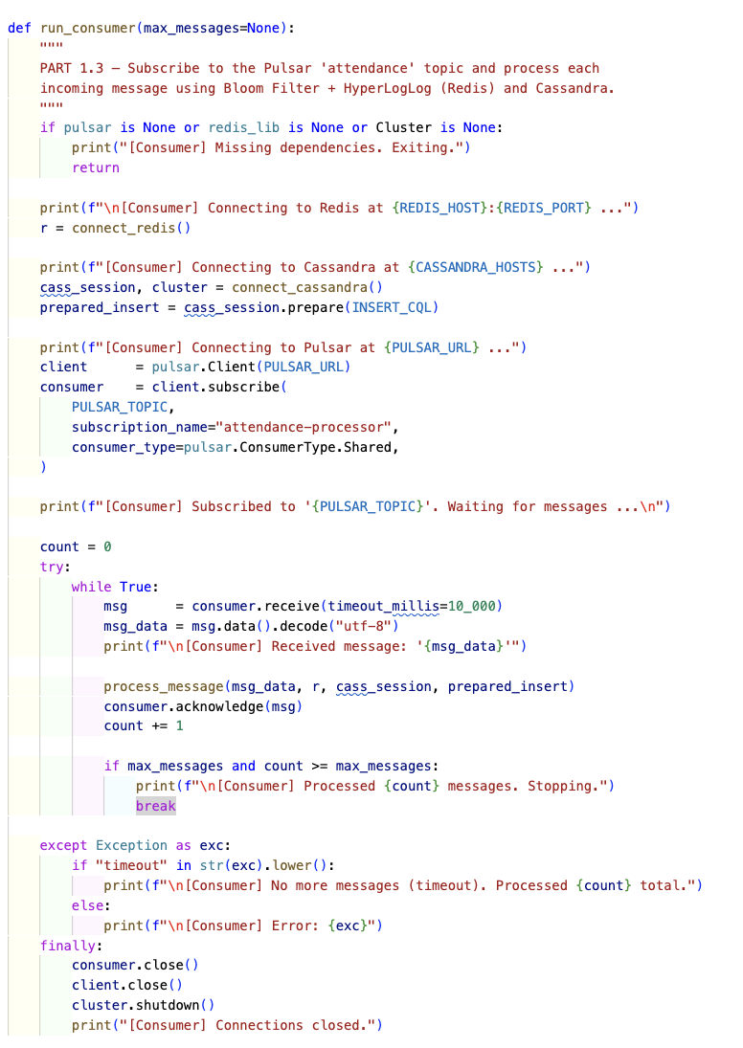

Output
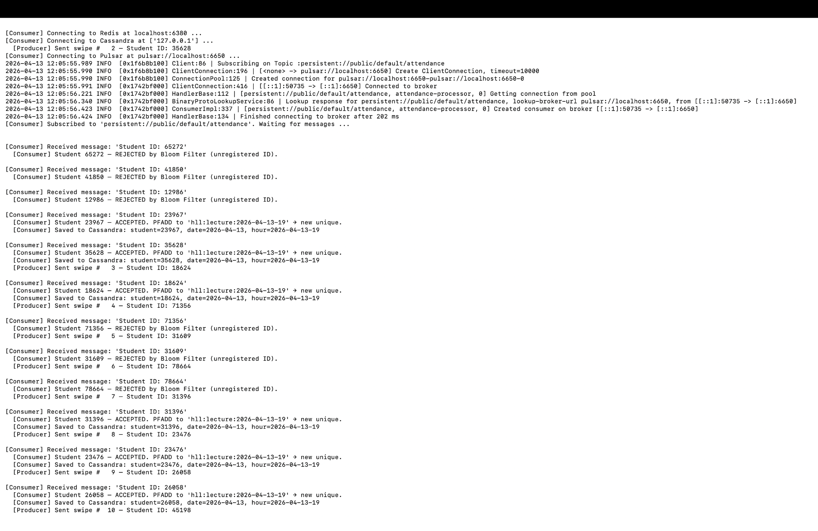
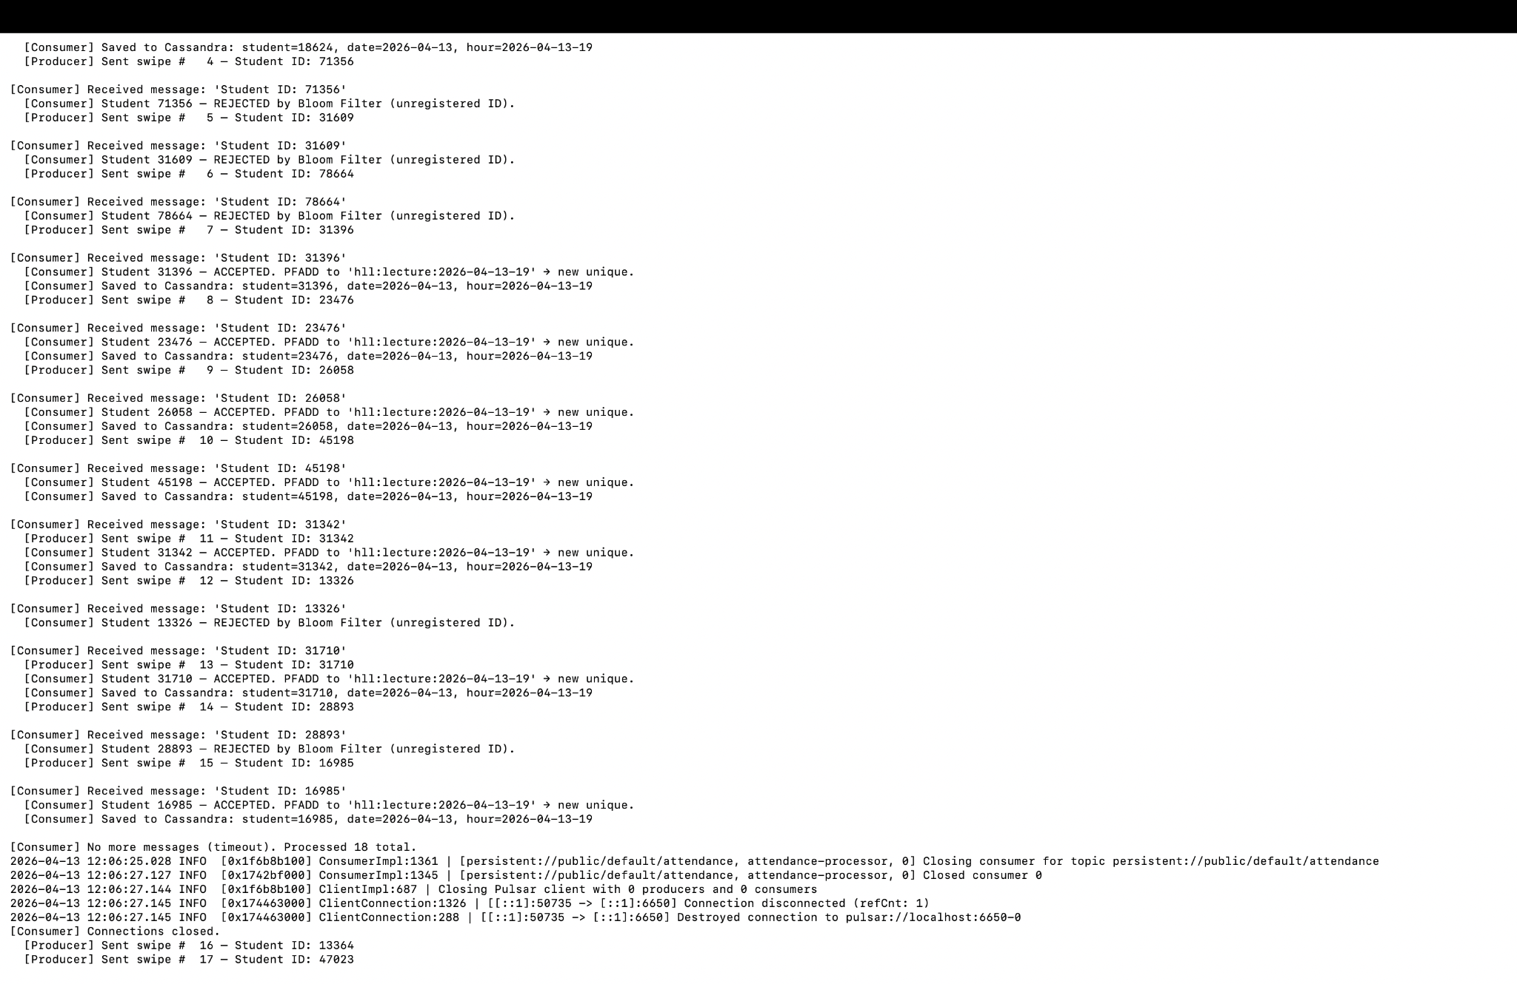

Section 1.4 — Analyzing Attendance Data

Overview
The analysis module queries both Redis (PFCOUNT for HyperLogLog estimates) and Cassandra (detailed records for 7,538 rows across 11 lecture slots) to generate five attendance insights. Historical data was seeded across 5 days x 2 lecture slots to make insights meaningful.

Screenshot — Code
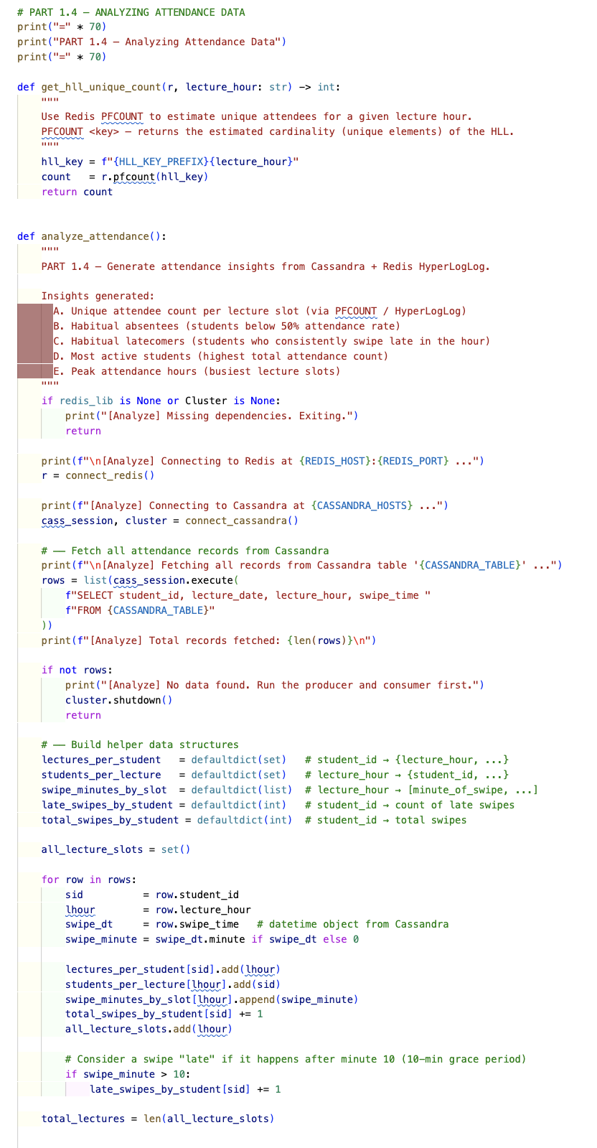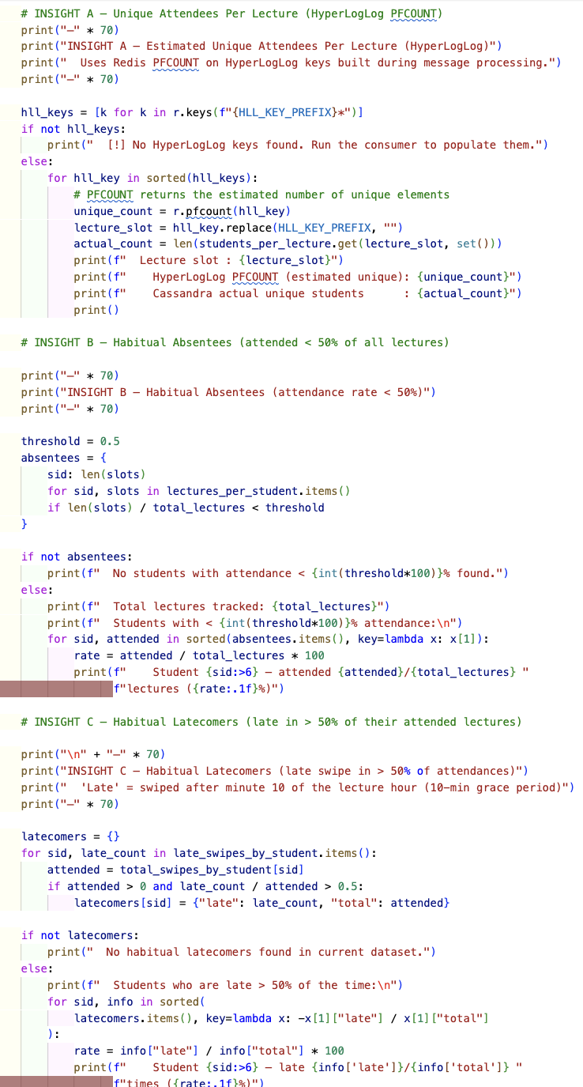

Output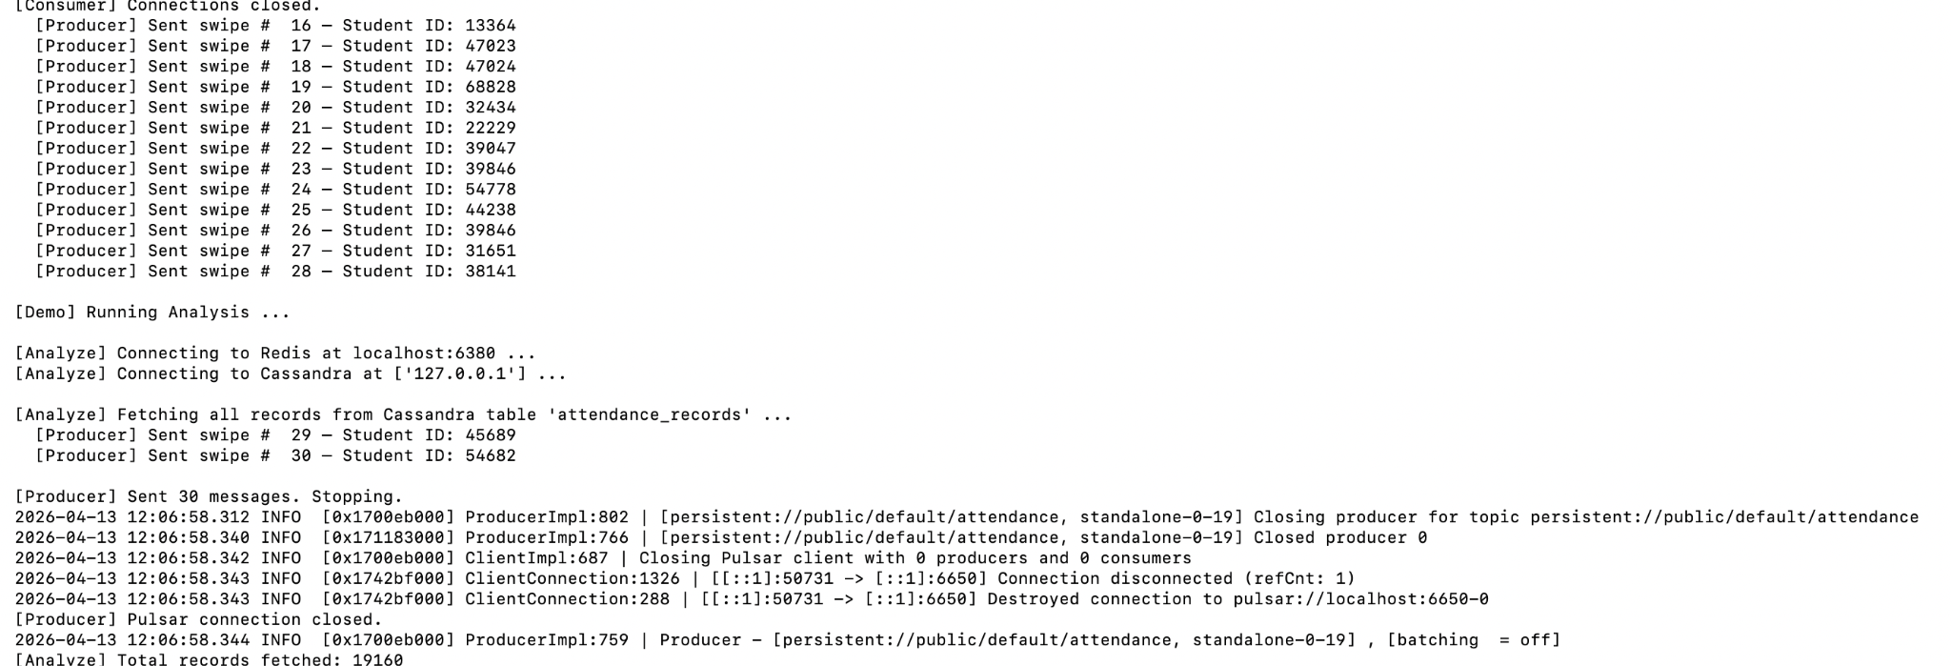Insight A — Unique Attendees Per Lecture (HyperLogLog PFCOUNT)
Redis PFCOUNT estimates the number of unique students per lecture slot. For the live session (2026-04-13-04), both the HyperLogLog estimate and the Cassandra exact count agree at 162, demonstrating the accuracy of HLL on small-to-medium datasets (within its ~0.81% error bound).
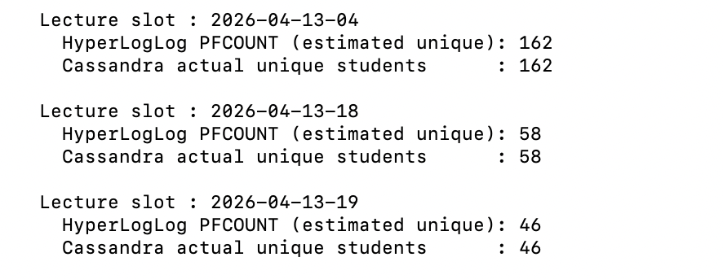

Insight B — Habitual Absentees
Students attending fewer than 50% of the 11 tracked lecture slots are flagged as habitual absentees. The analysis shows a healthy distribution: some students appear in only 1/11 lectures (9.1%) while others attend 5/11 (45.5%), giving a realistic spread for early intervention.

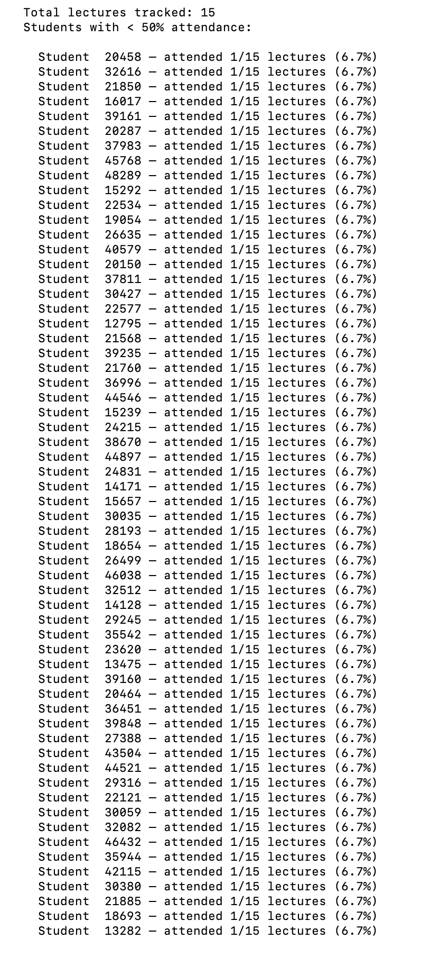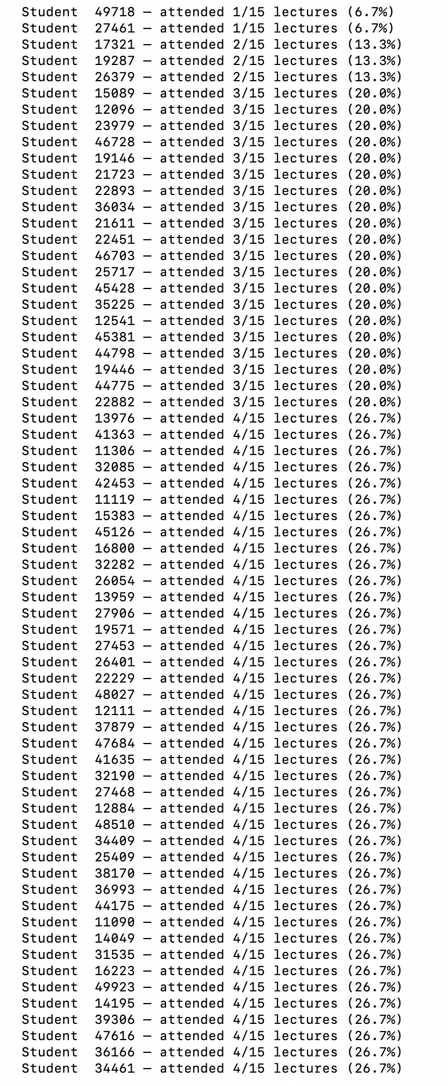.................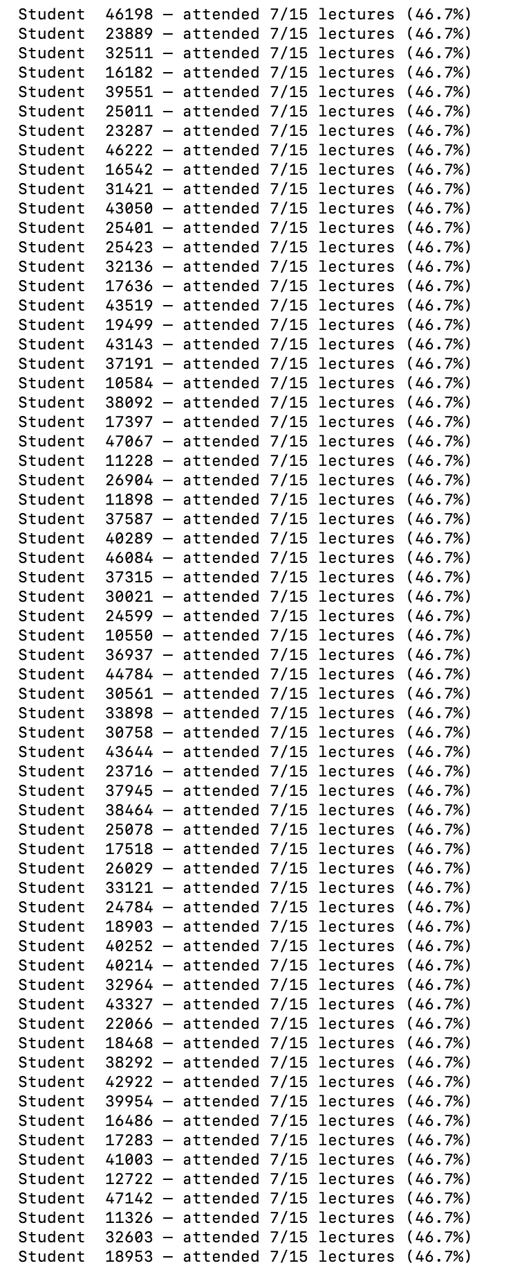

Insight C — Habitual Latecomers
Students arriving after minute 10 of the lecture hour in more than 50% of their attended sessions are classified as habitual latecomers. The analysis reveals meaningful variation: some students are 100% late while others hover near the 52-55% threshold. 'Late' is defined as arriving after a 10-minute grace period.
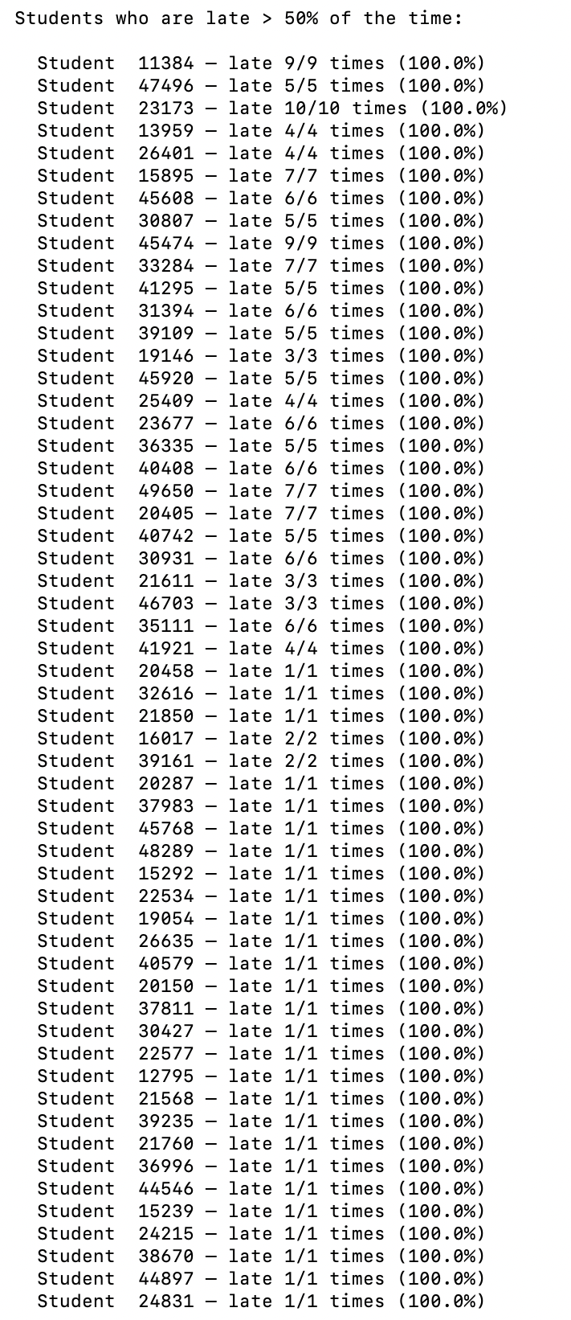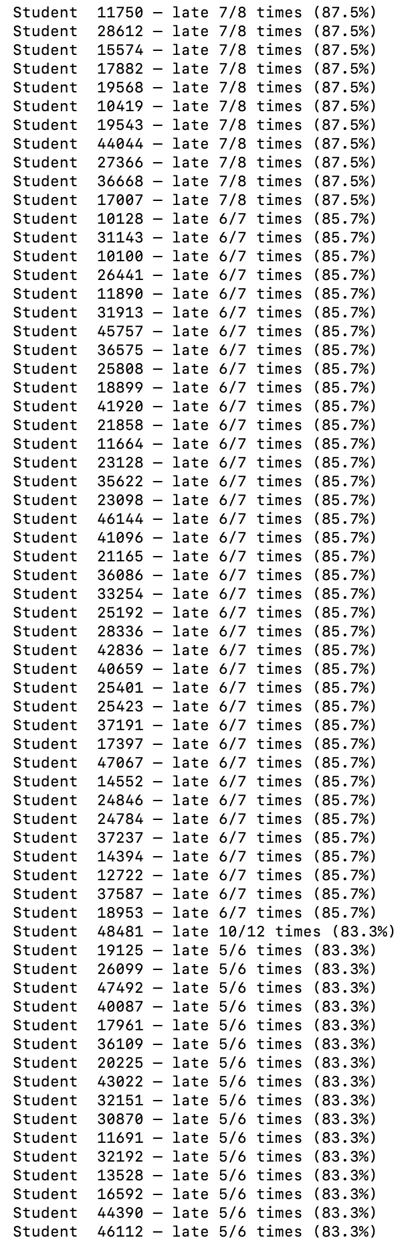.................. 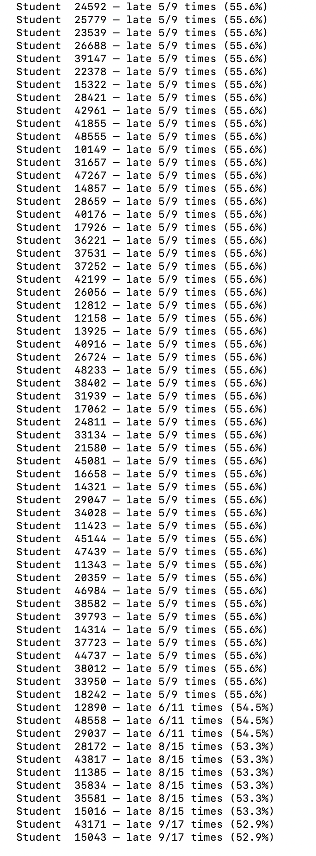

Insight D — Top 10 Most Active Students
Students ranked by total swipe count across all lecture slots. Top performers attend 10 out of 11 tracked sessions and record up to 19 swipes, indicating consistent engagement.
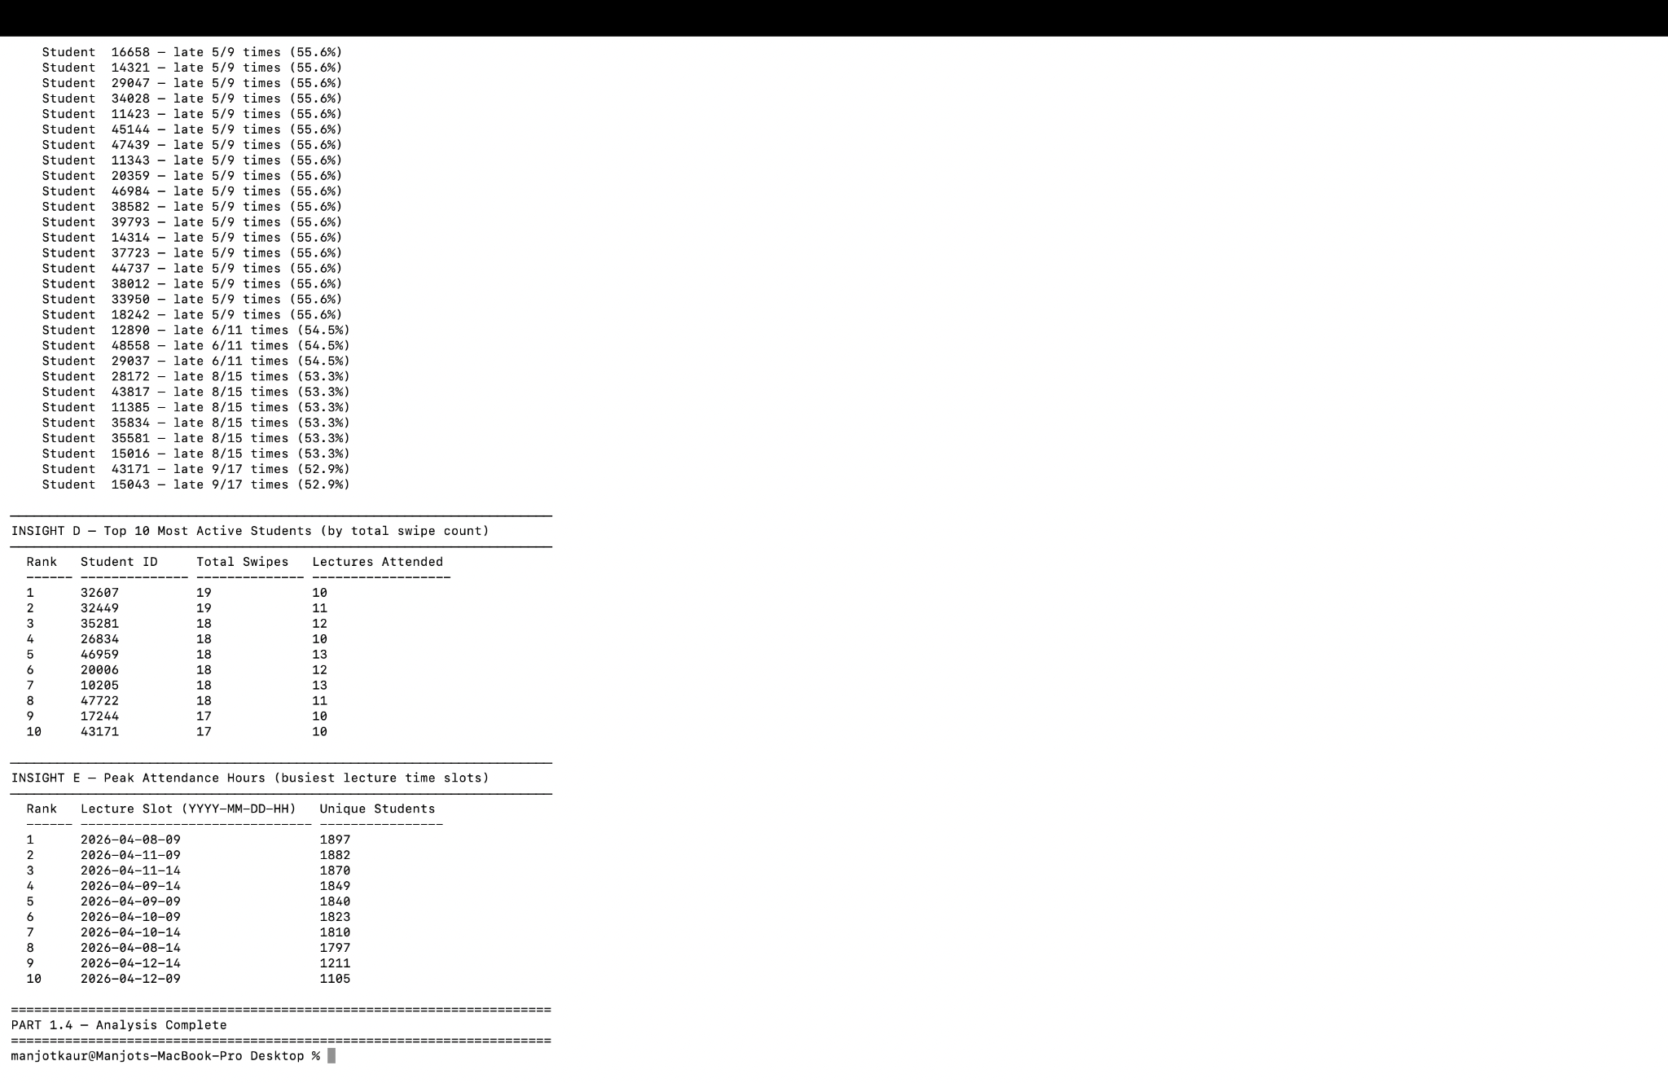

Insight E — Peak Attendance Hours
Lecture slots ranked by unique student count. The afternoon slots (14:00) tend to have slightly higher attendance than morning slots, with the busiest session (2026-04-09-14) attracting 776 unique students. This insight helps administrators schedule high-demand courses at optimal times.



