Web Design Report

Git Hub Link: <https://github.com/AndrewC20/MyWebsite_Project>

Preview of Main Page: <https://htmlpreview.github.io/?https://github.com/AndrewC20/MyWebsite_Project/blob/master/Index.html>

As we were to create and design a website of our own from scratch, I decided to create a Game Review website with the target audience of collage students to anyone older (Target ages: 18-above) I Called my website GAME spot. Where I would review not only games but also PC’s old and new.

The site would have a dedicated page for both games and PC’s and a game of the week page, Adding a contact us page and a more page. The Home page Index would contain information of all areas of the site, games, PC’s, an Aside with links to all pages and a news feed.

The other pages would be called:

Top Game and would focus on providing information on new games with images and a brief on the game followed by a video link to ex. YouTube for a trailer of the game.

Game of the Week page would consist of a singular game chosen by the moderator, a type of focused review on what the website feels is a deserving game of the week.

Top PC would give reviews of PC builds and some old PC’s and their performance in today’s gaming society. I would plan on adding a PC parts section here to but for project purposes I’d rather stick to my original planed website.

More The more page is not implemented as of yet and may not be. The project is meant to consist of an Index page and 3 other pages (I have 4 other pages and an Index).

Contact Us I used what I learned from a previous exercise to add a contact us page with some filler data that people could sign up for a newsletter by adding ex. Email, Gender, Heard of us etc.

The process of finding appropriate images to use for my site:

I used Google advanced search images under the usage rights (free to use or share, even commercially). This way I knew I could use my chosen images ex. The Witcher 3, images without any concern of copyright.

The original draft sketch from my original proposal:

Starting with a draft drawing to give me the idea of what I should progress toward making. I took the Knowledge I was obtaining from our weekly classes and adding what I learned to my project. Week by week I would have more progress on what I feel would be a good website to do as a project. Until Covid-19 had halted all college activity the website was going good but progress halted on all course subjects and I focused on prioritising whatever was to be needed to be done first. I feel that class time over home study is key to progressing.

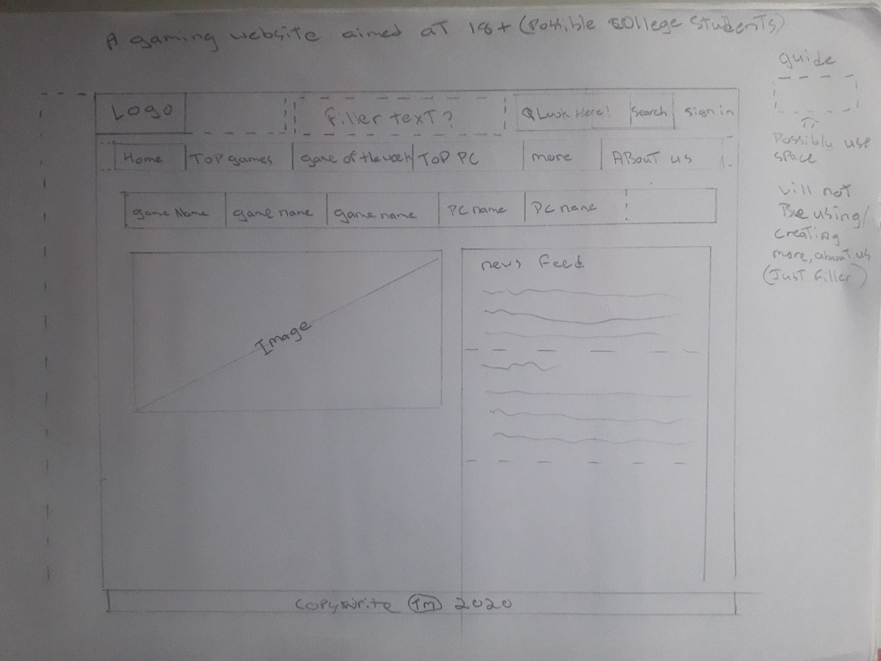

HTML And CSS Validation:

Added are the validation results for every one of my HTML and CSS files:

Index:

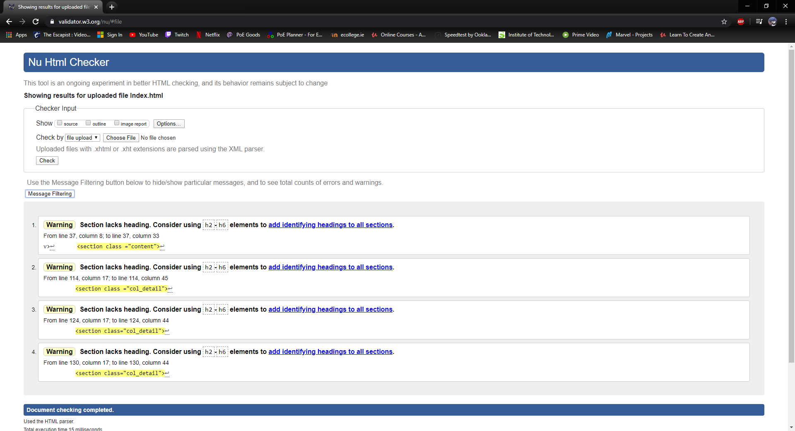

Top Game:

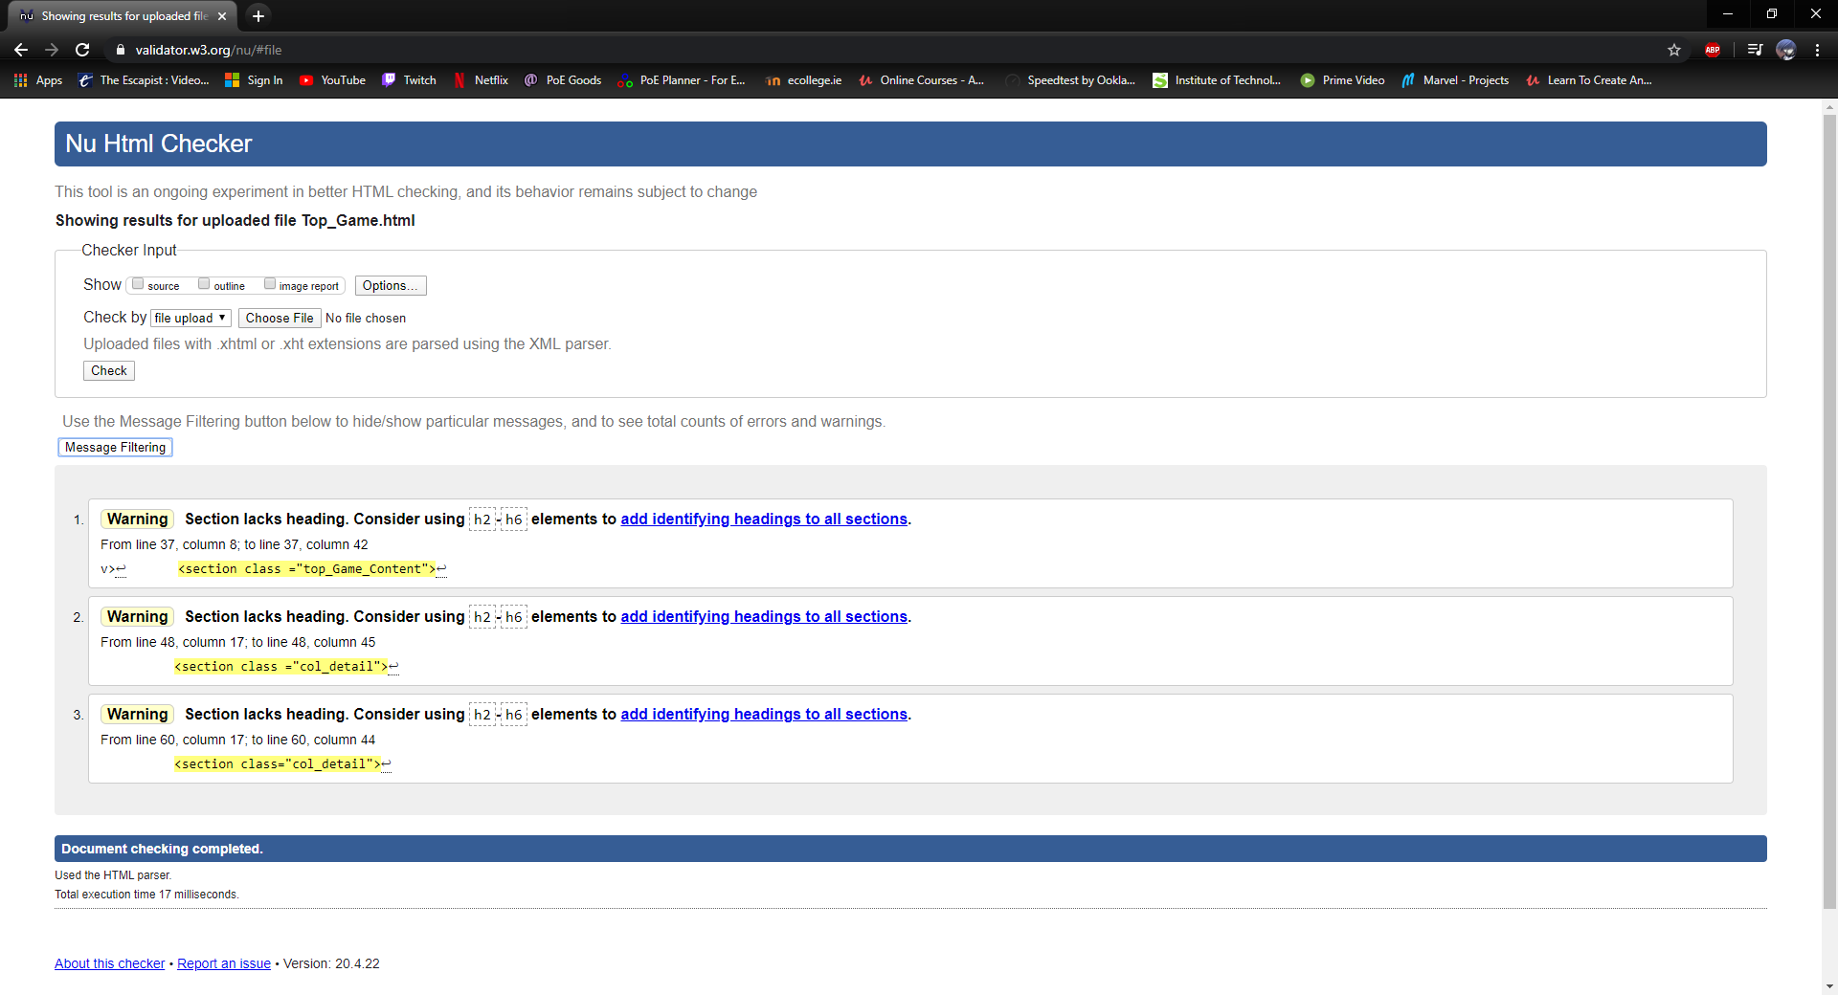

Top PC:

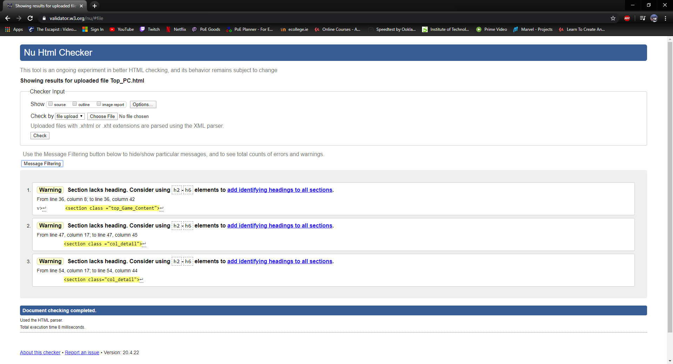

Game of the Week:

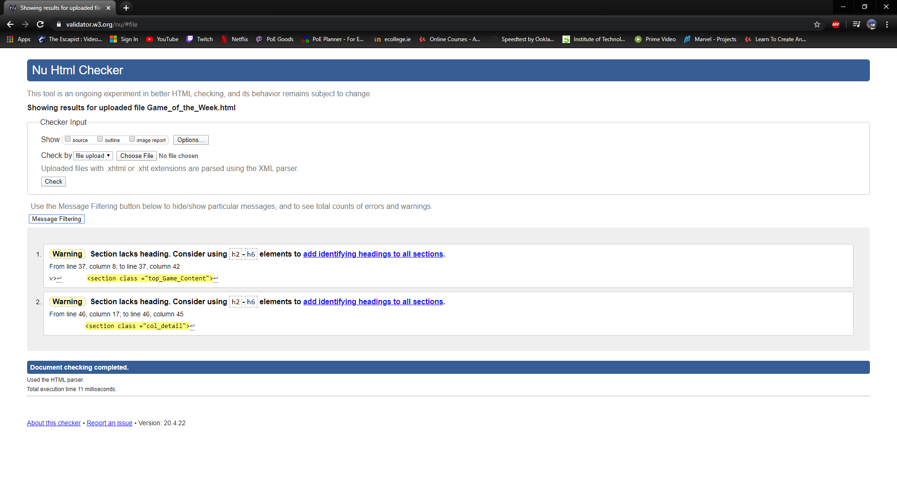

Contact Us:

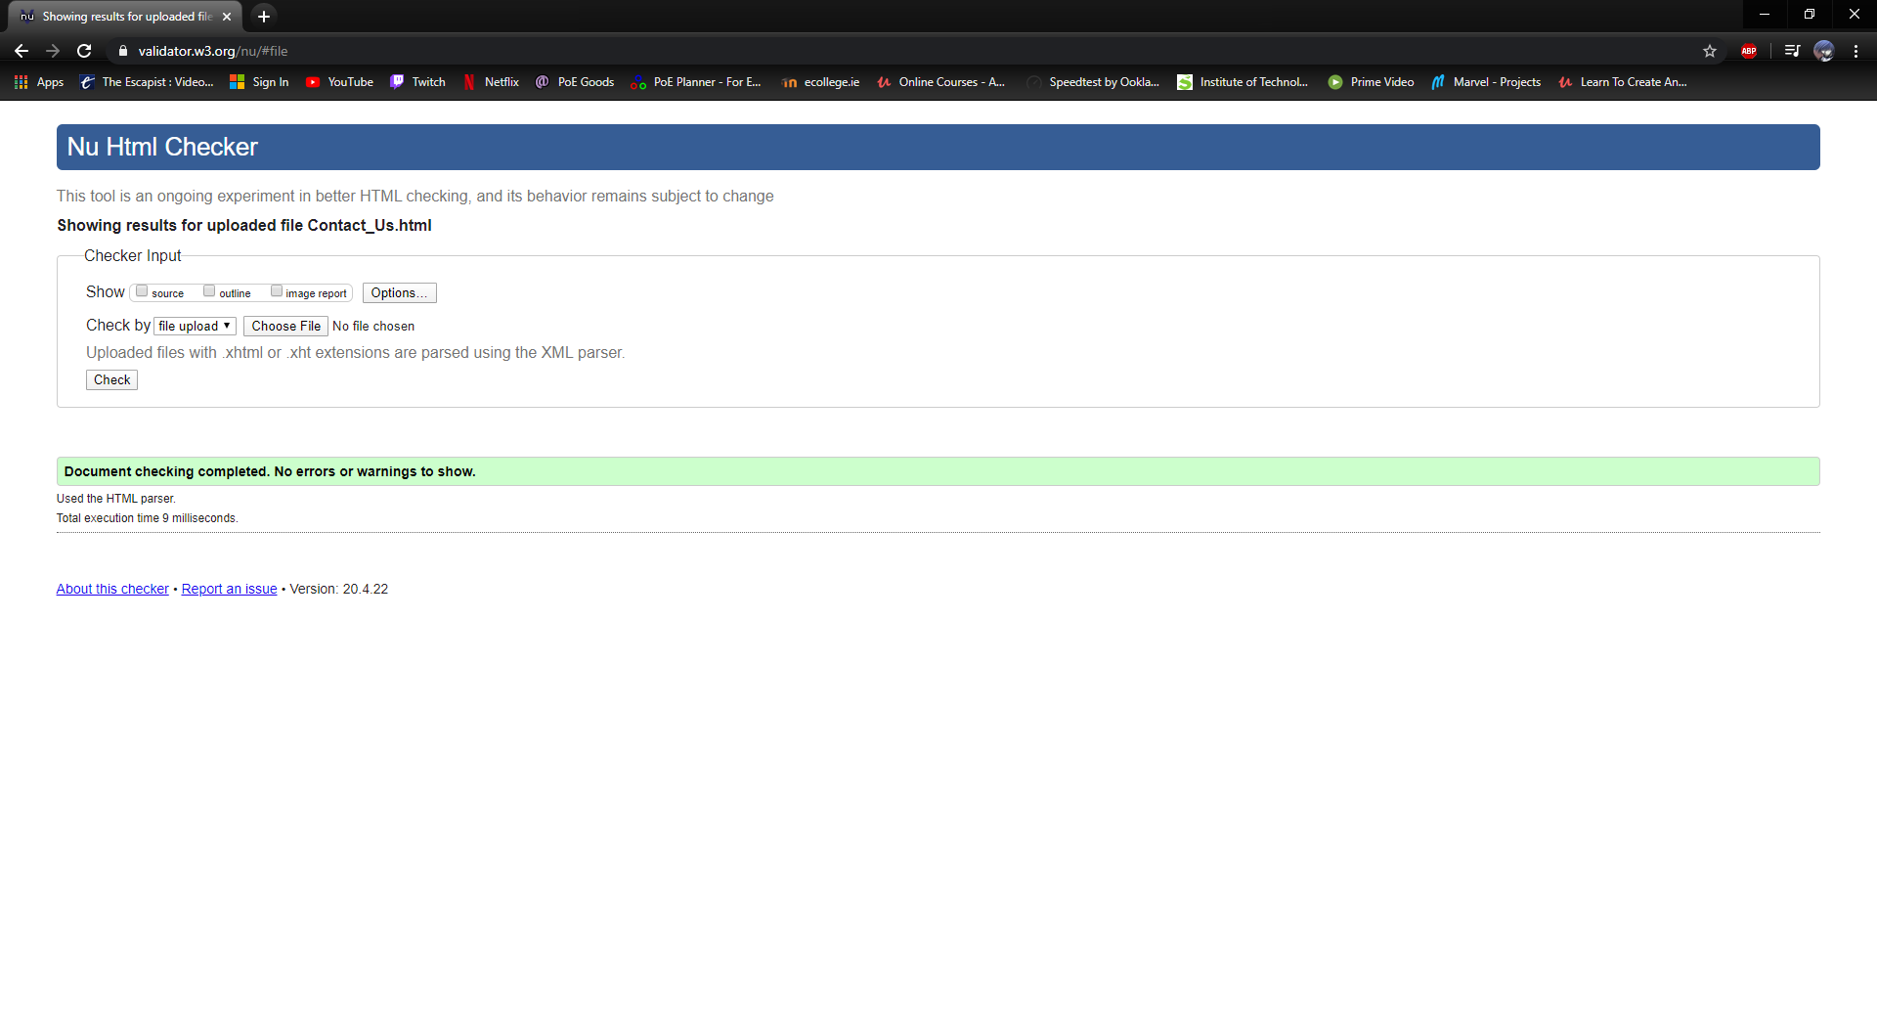

Finally, the CSS:

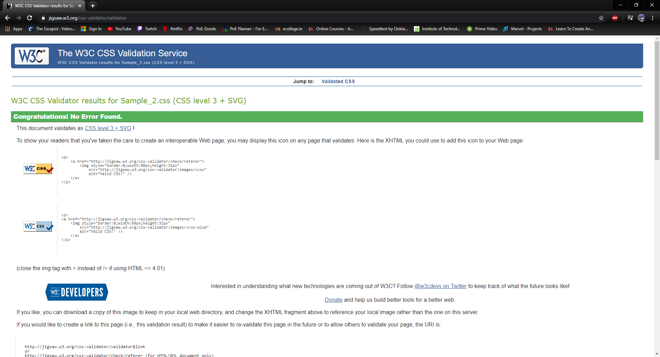



I Feel if we had more class time the project could have been better but for the amount of classes we had compared to the amount we should have had I feel I done as much as I can for what we had learned. Also, the Covid-19 did not help by slowing if not halting all education.