TUTORIAL LAYOUT HOME BENGKEL

Step 1. Design UI aplikasi

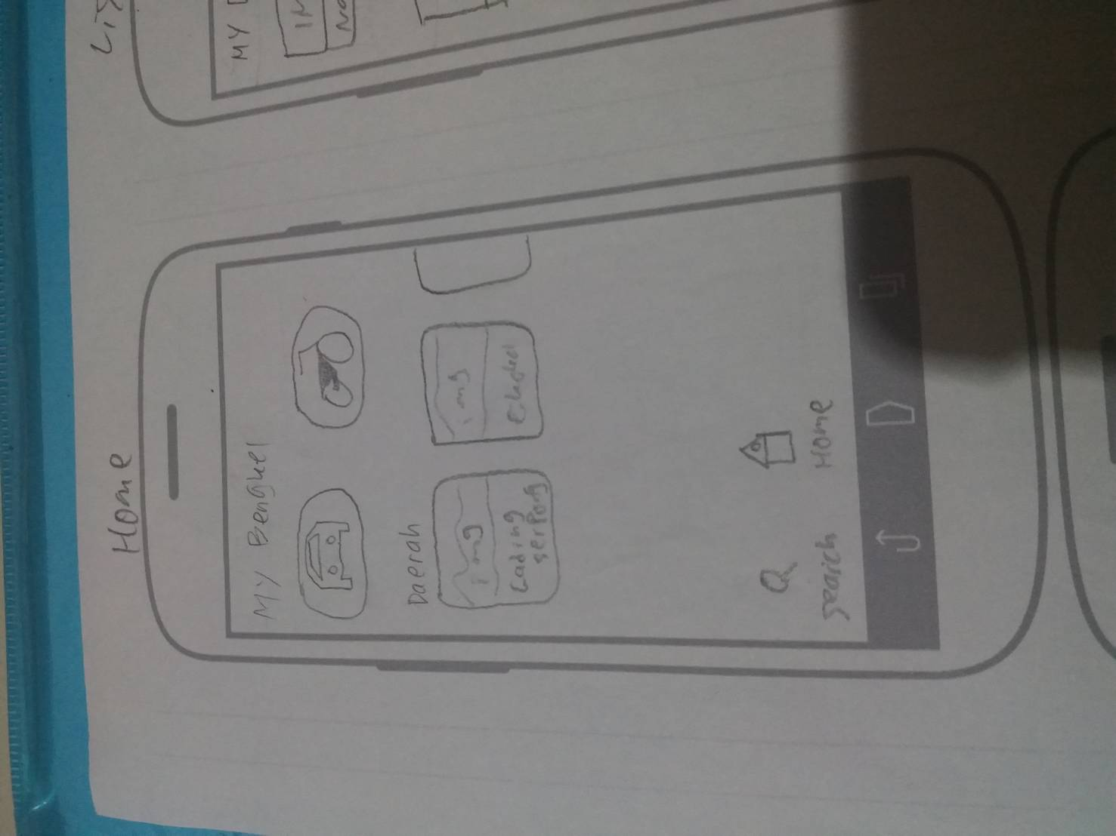

Rancangan Ui Home Aplikasi Bengkel

Step 2. Create folder App

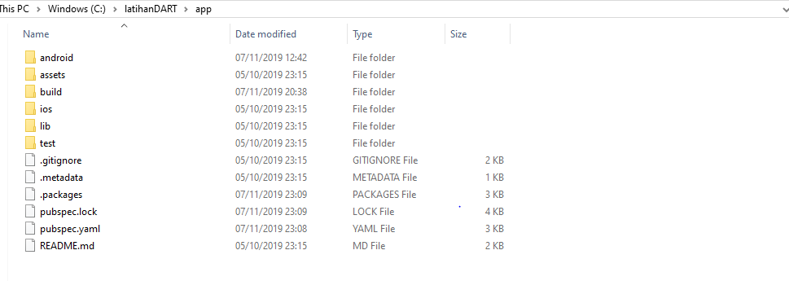

Step 3. Identifikasi penempatan Text, Icon, Gambar



bottomNavigationBar: BottomNavigationBar(

items: const <BottomNavigationBarItem>[

BottomNavigationBarItem(

icon: Icon(Icons.home),

title: Text('Home'),

),

BottomNavigationBarItem(

icon: Icon(Icons.directions_car),

title: Text(''),

),

BottomNavigationBarItem(

icon: Icon(Icons.motorcycle),

title: Text(''),

),

],

),

Menambahkan Bottom Navigation pada Aplikasi Bengkel Berupa icons.Home,icons.directions_car,icon.motorcycle di letakan setelah *return Scaffold(*

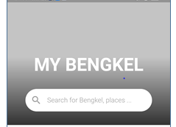

child: Column(

mainAxisAlignment: MainAxisAlignment.end,

children: <Widget>[

FadeAnimation(1, Text("MY BENGKEL", textAlign: TextAlign.center, style: TextStyle(color: Colors.white, fontSize: 40, fontWeight: FontWeight.bold),)),

SizedBox(height: 30,),

FadeAnimation(1.3, Container(

padding: EdgeInsets.symmetric(vertical: 3),

margin: EdgeInsets.symmetric(horizontal: 40),

height: 50,

decoration: BoxDecoration(

borderRadius: BorderRadius.circular(50),

color: Colors.white,

),

child: TextField(

decoration: InputDecoration(

border: InputBorder.none,

prefixIcon: Icon(Icons.search, color: Colors.grey,),

hintStyle: TextStyle(color: Colors.grey, fontSize: 15),

hintText: "Search for Bengkel..."

),

),

)),

SizedBox(height: 30,)

],

Menambahkan Judul Aplikasi dan Icon Search yang difungsikan untuk mencari bengkel

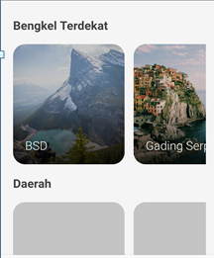

SizedBox(height: 30,),

Container(

padding: EdgeInsets.symmetric(horizontal: 20),

child: Column(

crossAxisAlignment: CrossAxisAlignment.start,

children: <Widget>[

FadeAnimation(1, Text("Bengkel Terdekat", style: TextStyle(fontWeight: FontWeight.bold, color: Colors.grey[800], fontSize: 20),)),

SizedBox(height: 20,),

FadeAnimation(1.4, Container(

height: 200,

child: ListView(

scrollDirection: Axis.horizontal,

children: <Widget>[

makeItem(image: 'assets/images/canada.jpg', title: 'BSD'),

makeItem(image: 'assets/images/Italy.jpg', title: 'Gading Serpong'),

makeItem(image: 'assets/images/greece.jpg', title: 'Cikokol'),

makeItem(image: 'assets/images/united-states.jpg', title: 'Karawaci')

],

),

)),

Menambahkan sidebox untuk list Bengkel di daerah tertentu

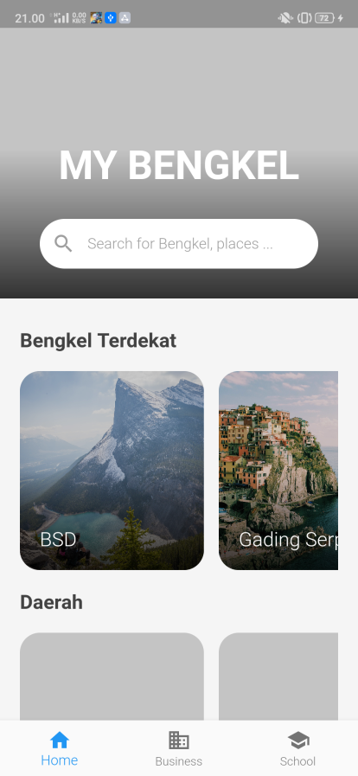

HOME UI