|  |  |
| --- | --- |
| ***Key*** | ***H(key)*** |
| 0 | 0 |
| 1 | 1 |
| 19 | 19 |
| 200 | 0 |
| 201 | 1 |
| 219 | 19 |
| 220 | 0 |
| 820 | 0 |
| 821 | 1 |
| 839 | 19 |

**Question 1:**

**Question 2:**

1. b. c.

|  |  |
| --- | --- |
| ***Key*** | ***H(key)*** |
| 55 | 15 |
| 415 | 15 |
| 75 | 15 |

|  |  |
| --- | --- |
| ***Key*** | ***H(key)*** |
| 43 | 3 |
| 403 | 3 |
| 63 | 3 |

|  |  |
| --- | --- |
| ***Key*** | ***H(key)*** |
| 40 | 0 |
| 400 | 0 |
| 60 | 0 |

**Question 3:**

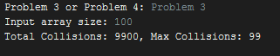3a.

3b.

* Total number of colissions decreased
* Max number of colissions decreased
* The total number of colissions decreased because the increase in array size means there are more possible index values and there would be less colissions. The same reasoning applies to max collissions decreasing. More key indexes, means there would be fewer values colliding

**Question 4:**

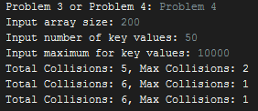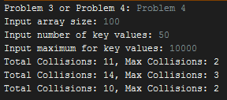

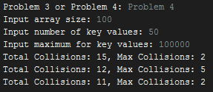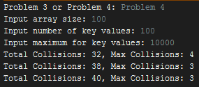

4b.

* Total collisions decreased
* Max collisions decreased
* Total collisions decreased because the total number of array indexes increased meaning they are less likely to have the same index values. Max collisions decreased for the same reasoning, an increase array size allowed for the values to spread out among the key indexes which would reduce the likelihood of one index getting multiple values

4c.

* Total collisions increased
* Max collisions increased
* Total collisions increased because there were more key values which means more numbers to take up the same amount of key indexes. Max collisions increased because the higher the key values the more likely they are to have the same key index values which causes higher max collisions

4d.

* Total collisions stayed the same
* Max collisions stayed the same
* Total collisions and max collisions stayed the same because they are essentially the same as part a. The only change was the maximum key values. The max key value does not affect collision number because the collision number is bounded as a part of the index values or the number of key values.