BookStack
Support Model
November 2024

Contents
1. Document Control 3
1.1. Revision History 3
1.2. Document Review and Approval 3
1.3. Acronyms 3
1.4. References 3
2. Introduction 3
2.1. Document Purpose 3
2.2. Support Overview 4
2.3. Support Tiers 4

Document Control

Revision History
Version | Author | Date (dd/mm/yyyy) | Summary of change
1.0 | Ivan Ivanov | 24.11.2024 | Initial version
1.1 | Ivan Ivanov | 27.12.2024 | Updated support overview

Document Review and Approval
Version | Approved by | Date (dd/mm/yyyy)
1.0 | Petr Petrov | 22.11.2024
1.1 | Petr Petrov | 23.12.2024

Acronyms
Acronym | Definition
ADFS | Active Directory Federation Service

References
Item no. | Document title | Version or date
1 | Source repository README | Managed by vendor
2

Introduction

Document Purpose
The document is intended as a reference on the system availability and support providers.

Support Overview
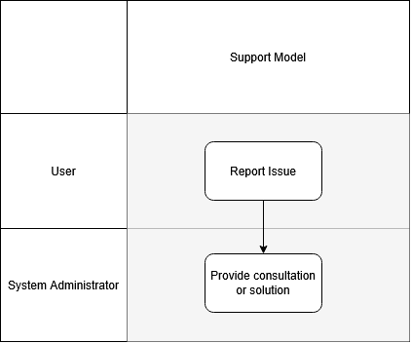

Support Tiers
Support Tier | Definition
User | Report issue
System Administrator | Provide consultation or fix deployment-related problems

