E-Staff
Solution Architecture
February 2025

Contents
1. Document Control 3
1.1. Revision History 3
1.2. Document Review and Approval 3
1.3. Acronyms 3
1.4. References 3
2. Introduction 3
2.1. Document Purpose 3
2.2. Solution Overview 3
2.3. Architecture Overview 4
2.4. Responsibility Matrix 4

Document Control

Revision History
Version | Author | Date (dd/mm/yyyy) | Summary of change
1.0 | Ivan Ivanov | 08.02.2025 | Initial version
1.1 | Ivan Ivanov | 20.02.2025 | Updated architecture overview (section 2.5)

Document Review and Approval
Version | Approved by | Date (dd/mm/yyyy)
1.0 | Petr Petrov | 11.02.2025
1.1 | Petr Petrov | 22.02.2025

Acronyms
Acronym | Definition
Vendor | Datex Software, LLC

References
Item no. | Document title | Version or date
1 | E-Staff product homepage | Managed by vendor
2

Introduction

Document Purpose
The document is intended as a reference for system administrators and support engineers in charge of the system deployment and maintenance.

Solution Overview
E-Staff is a system for automatization of corporate recruitment process.
E-Staff enables api integration with HeadHunter (https://dev.hh.ru/).

Architecture Overview
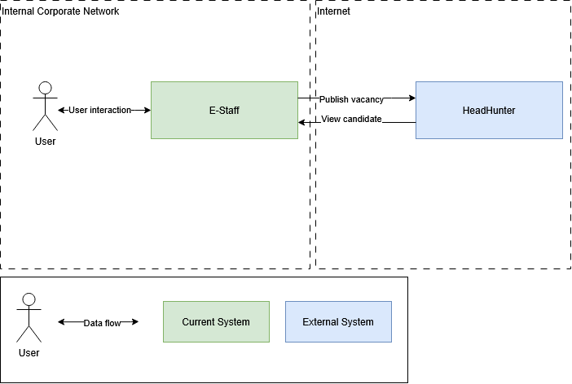

Data flow description:

Data flow | Source | Destination | Schedule
User interaction | User | E-Staff | On user query
User interaction | E-Staff | User | On user query
Publish vacancy | E-Staff | HeadHunter | On user query
Get candidate data | HeadHunter | E-Staff | On user query

Responsibility Matrix
System | Vendor | Administrator
E-Staff | Datex Software | Ivan Ivanov
Headhunter | HeadHunter | HeadHunter

