**1) Define the Problem**

a) Do this in *your own words.*

b) What insight can you offer into the problem that is not immediately visible from the word problem alone?

c) What is the overall goal?

**2) Break the Problem Apart**

a) What are the constraints?

b) What are the sub-goals?

**3) Identify Potential Solutions**

a) For each of the sub-problems you’ve discussed in #2, what is a possible solution?

**4) Evaluate Each Potential Solution**

a) Does each solution meet the goals?

b) Will each solution work for ALL cases?

**5) Choose a Solution and Develop a Plan to Implement it.**

a) Explain the solution in full.

b) Describe some test cases you tried out to make sure it works. (You can include drawings and diagrams as part of your explanation as long as they are clearly communicating the solution.

**A Cat, A Parrot, and a Bag of Seed:**

A man finds himself on a riverbank with a cat, a parrot, and a bag of seed. He needs to transport all three to the other side of the river in his boat. However, the boat has room for only the man himself and the one other item (either the cat, parrot, or seed). In his absence, the cat could eat the parrot, and the parrot would eat the bag of seed. Show how he can get all the passengers to the other side, without leaving the wrong ones alone together.

**1. Define the Problem:**

The problem is that the man needs to transport a cat, a parrot, and a bag of seed across a river. The goal is for the man to transport each of the three without leaving any behind that could harm the one it is waiting with.

**2. Break the Problem Apart:**

The man is limited to one passenger per boat trip so he must make multiple trips to successfully get everything to the other side of the river. Also, He cannot leave the cat and parrot alone or the cat could eat the parrot and he cannot leave the parrot and the bag of seed alone or the parrot would eat the bag of seed. The sub-goal would be to get each one across safely by avoiding leaving a couple behind that can cause harm to one another between trips.

**3. Identify Potential Solutions:**

Potentially, the best solution is for the man to make four trips. Switching items as he goes about each riverbank side with his boat.

**4. Evaluate Each Solution:**

The proposed solution meets the goal and sub-goal. The man transports each item across the river safely and he did not leave any item behind that could potentially cause harm to another item.

**5. Choose a Solution and Develop a Plan to Implement It:**

The solution that meets the needs of keeping each item safe from the other is for the man to take the parrot with him the first trip. By doing this, the cat is left alone with the seed and it is highly unlikely that the cat will eat the seed. Then, he must go back and get the seed the second trip and when dropping the seed off on the other side of the bank, take the parrot back to the original side again. This ensures that the parrot is not left alone to eat the seed. Once there, drop the parrot off and bring the cat with him to the goal side. This once again leaves the parrot alone on one side and leaves the cat with the seed and no potential harm to any item. Finally, the man makes one more trip to get the parrot and brings it back to the goal bank side and the man and all three items are now safely at their destination. Taking the cat the second trip, then bringing the parrot back to the original side, and bringing the seed back the third trip, and returning for the parrot on the last trip once again, can also do this.

**Illustration:**

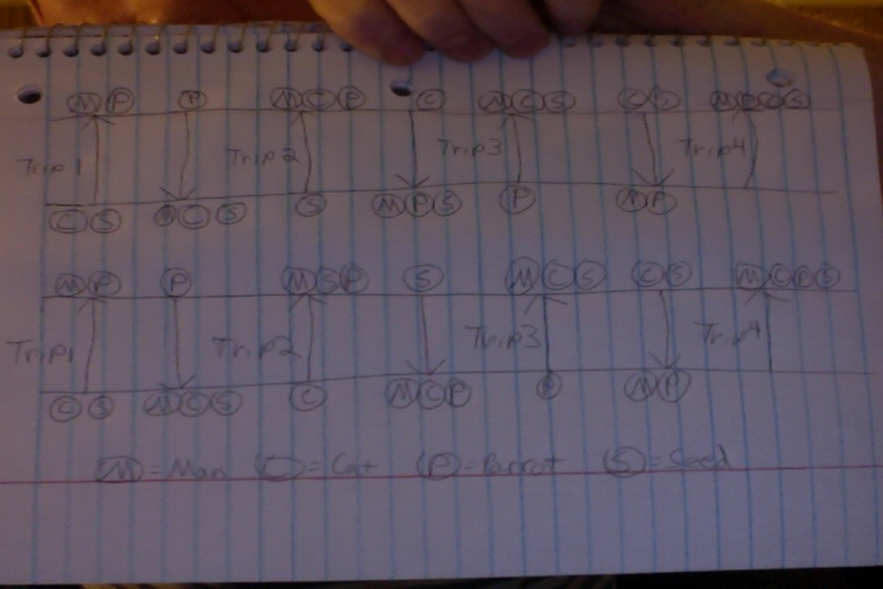

**Socks in the Dark:**

There are 20 socks in a drawer: 5 pairs of black socks, 3 pairs of brown and 2 pairs of white. You select the socks in the dark and can check them only after a selection has been made. What is the smallest number of socks you need to select to guarantee getting the following?

1. At least one matching pair
2. At least one matching pair of *each color.*

**1. Define the Problem:**

The problem is selecting the smallest number of socks from 20 socks and 3 different colors of socks to meet the goal of guaranteeing at least one matching pair and at least one matching pair of each color. There are a total of 10 black socks, 6 brown socks, and 4 white socks to total the 20 socks in the drawer.

**2. Break the Problem Apart:**

The constraints are that you must select the socks in the dark and cannot see them until after selection and that there are 3 possible color choices to pick from rather than 1 single color sock. The sub-goal is to select the fewest number of socks to match the two criteria.

**3. Identify Potential Solutions:**

For part a, the smallest number of socks to grab would be 4. As for part b, the smallest number to grab would be 18.

**4. Evaluate Each Solution:**

The proposed solution for a guarantees the goal because there are 3 different colored socks and by grabbing 4 you can possible get one of each, but definitely get a matching pair. The proposed solution gives the same result for part b. By grabbing 18, you are guaranteed 3 matching pairs based on each colors’ probability.

**5. Choose a Solution and Develop a Plan to Implement It:**

For part a, each sock has a 1/3 chance of being black, brown, or white. By grabbing 4, that exceeds the number of possibilities and guarantees a matching pair of one color. For part b, black socks have a pair ratio of 5/10 (10 socks) for the total number of socks, brown has a 3/10 (6 socks) pair ratio, and white has a 2/10 pair ratio (4 socks). By grabbing 18, the plan is as follows: 10 socks would cover the 5/10 probability of the black pairs leaving a remaining 3/5 brown pair and 2/5 white pair probability. Then grabbing 6 socks covers the now changed 3/5 pair brown sock probability, leaving only the 2/2 (1:1) ratio or 4 white socks. By grabbing an additional 2 socks that guarantees the final matching pair by exceeding the remaining ratio.

**Math Work:**

Total pairs = T

Black pairs = Bl

Brown pairs = Br

White pairs = W

T = Bl + Br + W

10 = 5 + 3 + 2 or 10/10 = 5/10 + 3/10 +2/10

Subtract the black pairs from the equation

5 = 3 + 2 or 5/5 = 3/5 + 2/5

Then subtract the brown pairs

2 = 2 or 1:1 ratio

Therefore, by grabbing one more pair, or two socks, there is a 1:1 ratio of getting the final matching pair of socks.

**Predicting Fingers:**

A little girl counts using the fingers of her left hand as follows: She starts by calling her thumb 1, the first finger 2, middle finger 3, ring finger 4, and little finger 5. Then she reverses direction, calling the ring finger 6, middle finger 7, first finger 8, and thumb 9, after which she calls her first finger 10 and so on. If she continues in this manner, on which finger will she stop?

1. What if the girl counts from 1 to 10
2. What if the girl counts from 1 to 100
3. What if the girl counts from 1 to 1000

**1. Define the Problem:**

The problem is determining which finger the little girl will stop on based on how far she counts as set by a, b, and c.

**2. Break the Problem Apart:**

The constraints are that the counting is not uniform and must be done the exact way she calls it. Rather than starting over at the thumb, she reverses the direction and continues counting. The sub-goal is to maintain that same counting method while reaching higher numbers and to find the answers without actually counting each number on your finger to reach the goal.

**3. Identify Potential Solutions:**

Potentially, there are different solutions for part a, in comparison to parts b and c. The answer to part a is given in the problem and could be counted on one’s hand as well. For part b and c, counting fingers until reaching the number does work, but is a tedious solution. For part b and c, the better solution is to divide the goal numbers 100 and 1000 by 8 and then use the remainder to count starting at the thumb.

**4. Evaluate Each Solution:**

The solution for part a will meet the goal, however, it is slightly more difficult to apply to part b, and highly difficult and tedious to apply to part c. The pattern is that the thumb begins on 1 and ends on 9. Therefore, there are 8 numbers in between each cycle from and to the thumb. By dividing the numbers by 8, whatever remainder you have left is the same as counting from the corresponding number from the original 1 – 10 count.

**5. Choose a Solution and Develop a Plan to Implement It:**

Solution for part a decided because it is part of the problem itself as well. So therefore the answer is clear. For parts b and c, for the better solution, division must occur to show its accuracy.

**Part b and c Pattern Proof:**

Thumb corresponds to: 1, 9, 17

First Finger corresponds to: 2, 10, 18

Middle Finger corresponds to: 3, 11, 19

Third (Ring) Finger corresponds to: 4, 12, 20

Little Finger corresponds to: 5, 13, 21

Reversing order

Third (Ring) Finger corresponds to: 6, 14, 22

Middle Finger corresponds to: 7, 15, 23

First Finger corresponds to: 8, 16, 24

**Part b according to the proved pattern:**

100/8

Gives us a remainder of 4

Count 4 fingers starting at the thumb

The answer is the Ring Finger

**Part c according to the proved pattern:**

1000/8

Gives a remainder of 0

Since this number is divisible completely by 8, the answer is the First Finger

This is because all numbers completely divisible by 8 fall on the First Finger