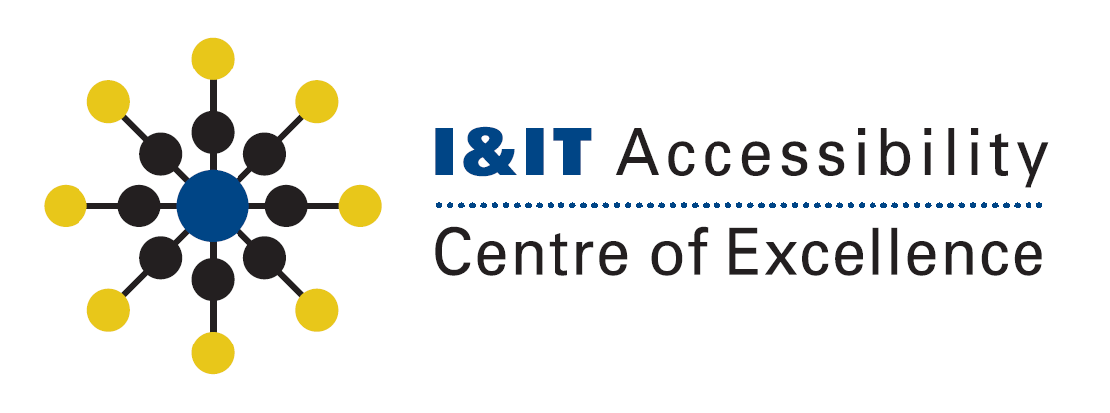

| Creating Accessible Emailsin Outlook |
| --- |

| **Cluster:** | Children, Youth and Social Services I&IT Cluster |
| --- | --- |
| **Version Date:** | January 21, 2014 |
| **Document Version No:** | V1.0 |
| **Document Owner:** | I&IT Accessibility Center of Excellence |
| **Prepared By:** | Andrew Cumming |

# Revision Log

| **Version** | **Date** | **Author(s)** | **Comments** |
| --- | --- | --- | --- |
| V1.0 | August 25, 2014 | Andrew Cumming | Initial draft of document. |

## Introduction

Emails are the most common form of communication among employees in the OPS so it is important to make the emails readable by as many people as possible. This quick guide will explain and show you how the basics of how to make your emails more accessible.

Note: This guide was created using outlook 2013 but it is very similar to outlook 2010. All functions used and their placement in the 2013 version are the same as in the 2010 version.

## Terms of Use

This guide was made to outline to demonstrate some of the best practices that should be observed in order to increase the accessibility of your emails. However you should keep in mind that following this guide will not ensure that your email is accessible to all forms of accessible technology.

## 1. Choosing the Email Text Format

The email format is important because it will alter the code behind the scenes and has a huge impact on how readable the email is. Currently we recommend that you use Html for your email format. By default the html format option is selected unless chosen otherwise. To select a text format for the email click the **Format Text** tab on the **Ribbon Bar** and in the **Format** group select one of the text formats.

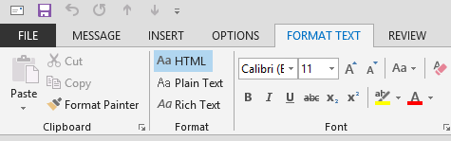

You may notice that if you select a different format some changes may occur to your email. This happens because not all features are supported in all the formats. For example plain text doesn’t support styling your text using heading styles, bold, italics, or different text colours.

## 2. Attachments

To demonstrate our leadership in accessibility we ask that all email attachments be made accessible if possible. If not you may want to inform the reader about an accessible alternative they can read should you provide one.

To attach a document to your email click the **Message** tab in the **Ribbon Bar** and under the **Include** group select **Attach File**.

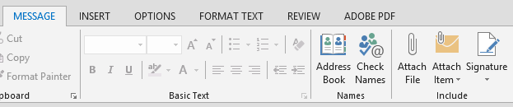

If your attachment has been properly attached you should see the filename in an edit field called **Attached**. It is important that your attachment goes here to ensure that it is easy for assistive technology user to find and download.

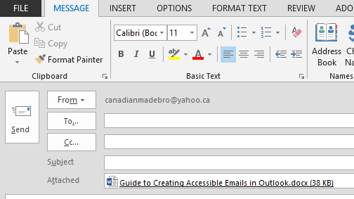

If you have chosen the rich text format option, which is not recommended, and you try to attach a file you may notice that the file will be embedded in the body of the document as depicted in the image below.

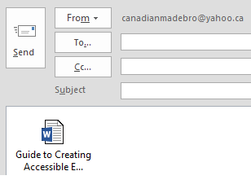

This method of attaching files is not recommended because it can be difficult for users to navigate and open this attachment.

## 3. Choosing the Right Font

By default the font and font size chosen in outlook is Calibri 11pt. This is a good font face choice to use because it is a sans-serif font. A sans-serif font is a simple font that doesn’t have any fancy accent pieces and is not cursive. Common example of sans-serif fonts are Arial, Calibri, and Verdana. Common example of serif fonts are Times New Roman, and any other cursive looking font.

The current recommended size for emails, however, font is 12pt or higher. So to fix this there are two different options you can follow. You could either change the font size to be 12pt or larger in every email that you write or you could change the default font size.

### 3.1 Changing the Default Font

To change the default font for new message start by clicking the **File Tab** on the left hand side of the **Ribbon Bar** then click the **Options** button.

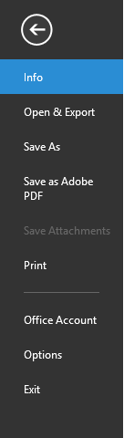

In the dialog that appears click **Mail** on the left hand side navigation then click the **Stationery and Fonts** button under the **Compose Messages** group.

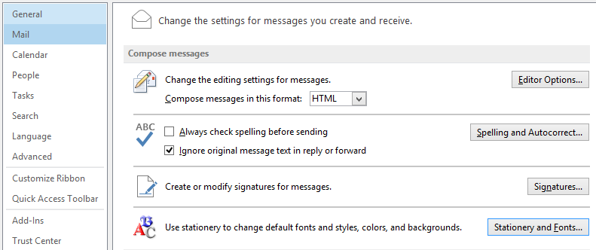

In the dialog that appear, under the **New mail messages** and **Replying or forwarding messages** headings select the **Font** buttons and select the font you want to be used.

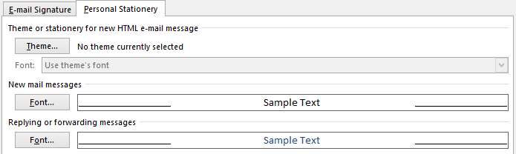

### 3.2 Colour Contrast

One of the other important factors for text is the colour contrast. The colour contrast is obtained by taking the text colour and the background colour and calculating a ratio based on luminance between the two.

A way to do this is through the [Colour Contrast Analyzer](http://www.paciellogroup.com/resources/contrastanalyser/) tool provided by Paceillo Group. This tool can be used to select and examine two colours for you and provide an accurate contrast ratio.

The tool is simple to use. Just download the tool, unzip all the components and use the eye dropper tools to select the colours you would like to examine.

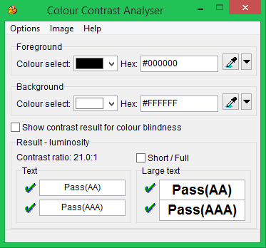

## 4. Using Images

Because of the nature of an image it is generally not considered that accessible on its own. It requires some form of an alternative text that can be read and understood by an assistive technology and its user.

### 4.1 Inserting an image

To insert an image click the **Insert Tab** on the **Ribbon Bar** and in the **Illustrations** group select **Pictures**. Now you can navigate to the image that you would like to insert into the email.

**Note**: If you chose to use the rich text or plain text format options then you can’t insert an image. Instead you will have to attach the image to the email.

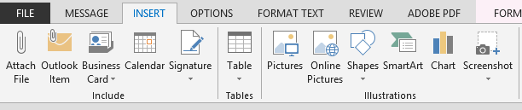

### 4.2 Aligning the Image

Now we have to make sure the image is properly aligned with the text so that a user can properly navigate to the image and so it won’t impact the internal structure of the email.

To set the alignment of the image: **Right Click the Image**, go to the **Wrap Text** option and from the menu that appears make sure that **In Line with Text** has been selected. This is currently the only valid option that you may choose in order to make your document as accessible as possible.

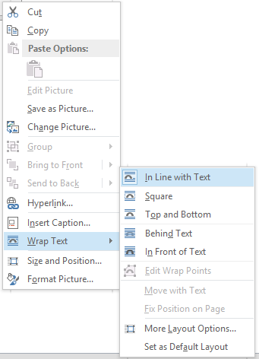

### 4.3 Adding Alt Text

As stated previously the image will need an alternative text that will allow an assistive tech user to be able to understand the information that is provided in the image.

To add an alternative text **Right Click the Image** and select **Format Picture**. A dialog will appear and on the left hand side of the dialog there is an option **Alt Text**. Select this option and in the dialog that appears enter what will be the name of the image in the title field and a description of the image in the description field.

## 5. Using Tables

Tables should only be used when trying to format and associate specific pieces of information rather than trying to achieve a specific layout.

To insert a table click the **Insert Tab** on the **Ribbon Bar** and in the **Tables** group select **Table**. You should get a dropdown menu that will allow you to select the number of rows/columns that you would like your table to have though you can always add or remove some later.

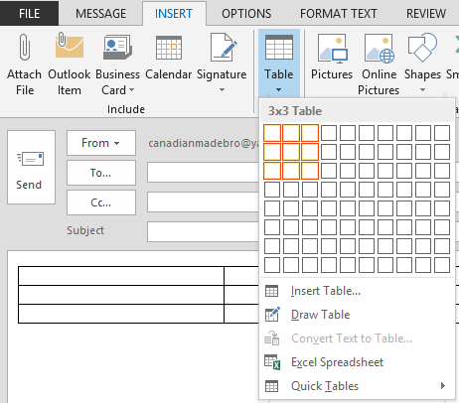

**Note:** Make sure that you never merge or split cells. Tables need to be as simple as possible and the added complexities of merged/split cells can cause many issues with a screen reading device.

## 6. Links

When using links be sure to make the link text understandable. A user who looks at a link in an email for the first should be able to understand the general purpose and function of that link even before they interact with it. So avoid links that read “Click Here”, “Here”, or “Read More” as they are not very descriptive and don’t provide much information.

To insert a click the **Insert Tab** on the **Ribbon Bar** and under the **Links** group select **Hyperlink**.

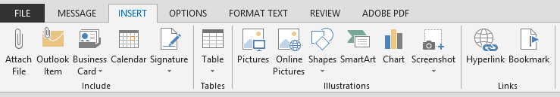

Once you do this a dialog should appear, prompting you for the URL for the link and the link text to be display. In the **Address** enter the intended URL and in the **Text to Display** edit enter in the link text that will be visible to the user.

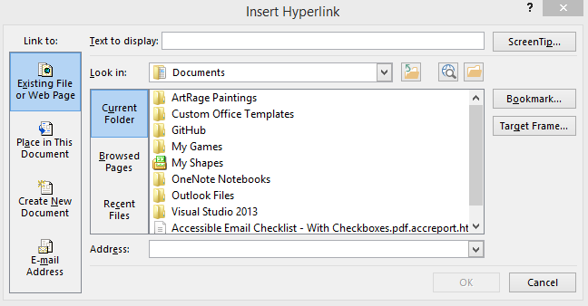

## 7. A Few Things to Remember

Though this guide went over some of the things that you should do when creating an accessible email here is a quick list of the things that you should not do:

1. Do not use text boxes as most assistive technologies have difficulty interpreting them
2. Do not use Word Art or shapes for the same reason as text boxes
3. Avoid using the enter or space keys to space out your content. Often assistive technologies will read out blank lines or spaces as blank. This may make a user think they have reached the end of the document when they actually haven’t.