**Sensor name : Ultrasonic**

**Sensor use:**

**1-**People detection for counting

**2-**Robotic sensing

**3-Detect distance**

**Digram:**

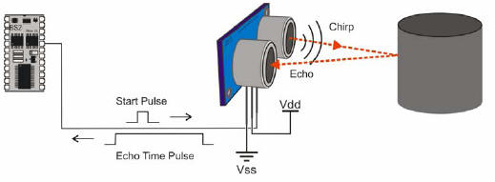

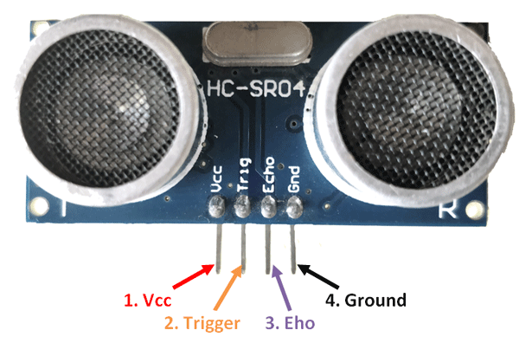

**Sensor From:**

[**https://www.tehnomagazin.com/Sensors/Ultrasonic-sensor.htm**](https://www.tehnomagazin.com/Sensors/Ultrasonic-sensor.htm)

[**https://www.migatron.com/ultrasonic-detections-and-control-applications/**](https://www.migatron.com/ultrasonic-detections-and-control-applications/)

**sensor code:**

const int trigerpin=2;

const int echopin=4;

vois setup(){

serial .availble(9600);

}

Void loop (){

PinMode (trigerpin,OUTPUT);

digitalWrite(trigerpin,LOW);

delay(2);

digitalWrite(trigerpin,HIGH );

delay(10);

digitalWrite(trigerpin,LOW );

long duration , inch,cm;

pinMode(echopin,INPUT);

duration = pulseIn(echopin,HIGH);

digital Write(echopin,HIGH);

inche=microsecondsToInches(duration);

cm==microsecondsToCentimeters(duration);

seral.print(“inche=”);

serial.print(inche);

serial.print(“cm”);

serial.print(cm)

serial.print(“”);

delay(100);

}

Long microsecondsToInches(long microseconds);

{

return microseconds /74/2;

//put your main code here to run

}

Long microsecondsToCentimeters(long microseconds);

{

return microseconds /94/2;

}