**2.7 PIR sensor**

-Basically motion detection use light sensors to detect either the presence of infrared light emitted from a warm object or absence of infrared light when a object interrupts a beam emitted by another part of the device.

-A PIR sensor detects the infrared light radiated by a warm object. It consists of pyro electric sensors which introduce changes in their temperature (due to incident infrared radiation) into electric signal. When infrared light strikes a crystal, it generates an electrical charge.

Thus a PIR sensor can be used to detect presence of human beings within a detection area of approximately 14 meters.

### 

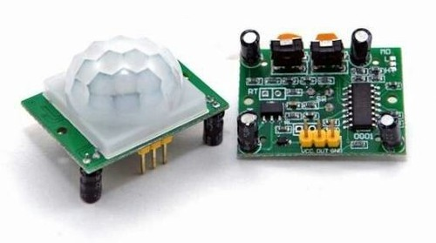

### Figure 2.7 PIR sensor

### PIR Sensor Features

* Wide range on input voltage varying from 4.V to 12V (+5V recommended)
* Output voltage is High/Low (3.3V TTL)
* Can distinguish between object movement and human movement
* Has to operating modes - Repeatable(H) and Non- Repeatable(H)
* Cover distance of about 120° and 7 meters
* Low power consumption of 65mA
* Operating temperature from -20° to +80° Celsius

### ****2.7.1 How to use PIR Motion Sensor****

The PIR sensor stands for Passive Infrared sensor. It is a low cost sensor which can detect the presence of Human beings or animals. This sensor has three output pins Vcc, Output and Ground . Since the output pin is 3.3V TTL logic it can be used with any platforms like Arduino, Raspberry, [PIC](https://components101.com/pic16f877a-pin-diagram-description-features-datasheet), ARM, 8051 etc..

The module can be powered from voltage 4.5V to 20V but, typically 5V is used. Once the module is powered allow the module to calibrate itself for few minutes, 2 minutes is a well settled time. Then observe the output on the output pin. Before we analyses the output we need to know that there are two operating modes in this sensor such as Repeatable(H) and Non- Repeatable(L) and mode. The Repeatable mode is the default mode.

The output of the sensor can be set by shorting any two pins on the left of the module as shown below. You can also notice two orange color potentiometers that can be used to set the sensitivity and time which will be explained further below.

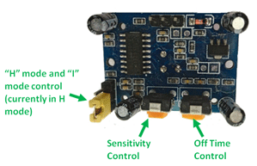

Figure 2.7.1 Use PIR Senor

### Repeatable(H) mode

In Repeatable(H) mode the output pin Dout will go high (3.3V) when a person is detected within range and goes low after a particular time (time is set by “Off time control” potentiometer). In this mode the output pin will go high irrespective of whether the person is still present inside the range or has left the area. The sensitivity can be set using the “sensitivity control” potentiometer

### Non- Repeatable(L) mode

In “I” mode the output pin Dout will go high (3.3V) when  a person is detected within range and will stay high as long as he/she stays within the limit of the Sensors range. Once the person has left the area the pin will go low after the particular time which can be set using the potentiometer. The sensitivity can be set using the “sensitivity control” potentiometer.

-There are two important materials present in the sensor one is the pyroelectric crystal which can detect the heat signatures from a living organism (humans/animals)   and the other is a Fresnel lenses which can widen the range of the sensor. Yes the white color things is just a lense that is used to widen the range of the sensor, if you remove the lense you can find the Pyroelectric sensor inside it covered inside a protective metal casing as shown in figure. *G*  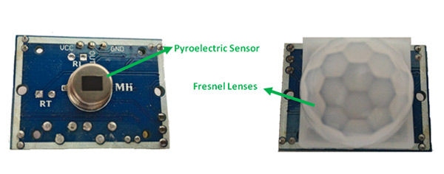

*Fugure*

### 2.7.2 PIR Sensor’s Working Principle

The PIR sensors are more complicated than the other sensors as they consists of two slots. These slots are made of a special material which is sensitive to IR. The Fresnel lens is used to see that the two slots of the PIR can see out past some distance. When the sensor is inactive, then the two slots sense the same amount of IR .The ambient amount radiates from the outdoors, walls or room, etc.

When a human body or any animal passes by, then it intercepts the first slot of the PIR sensor. This causes a positive differential change between the two bisects. When a human body leaves the sensing area, the sensor generates a negative differential change between the two bisects. The infrared sensor itself is housed in a hermetically sealed metal to improve humidity/temperature/noise/immunity. There is a window which is made of typically coated silicon material to protect the sensing element.

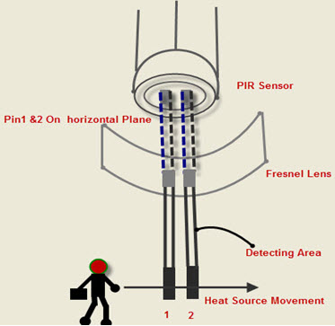

Figure2.7.2 PIR Sensor’s Working Principle