Test order:

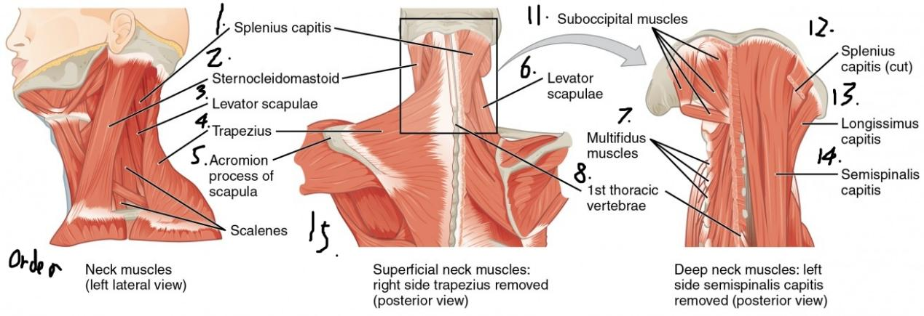

Reason of Pattern: The muscle stretches increase the readings, the relaxation decreases the readings.

EMG Readings Chart:

1. Success,left pattern significantly
2. Success,get clear readings around 600 max to 300 min

Untested: small muscles(3,15,8(includes 11,12,13,14))

4.Trapezius, located in the back. Forward, maximum 700~600 (instantaneously)

6. FAILED, numbers are too close

Turning head can increase the readings.

EMG Readings Chart(7/13):

|  |  |  |  |  |  |
| --- | --- | --- | --- | --- | --- |
| Name | Turn Left(not tilt) | Turn Right(not tilt) | Forward | Backward | Normal |
| Splenius capitis(right side) | 600~260 | 350~260 | 340~260 | 340~260 | 320~270 |
| Sternocleidomastoid(right side) | 350~260 | 350~260 | 350~260 | 350~260 | 350~260 |
| Trapezius(right side) |  |  |  | 285~272 | 254~234 |
|  |  |  |  |  |  |
| Levator scapulae(right side) | 295~292 | 300~292 | 300~292 | 300~293 | 294~292 |
|  |  |  |  |  |  |
|  |  |  |  |  |  |
|  |  |  |  |  |  |

Two side set: placed two pairs of nodes on the Left hand side and right hand side muscle for detecting rotating and turning of head.(7/14)

|  |  |  |  |  |  |  |
| --- | --- | --- | --- | --- | --- | --- |
| Name | Normal(head stay in the middle) | Turn Left(not tilt) | Turn Right(not tilt) | Forward | Backward |  |
| Splenius capitis Left | 315~295 | 317~295 | 350~260 | 350~260 | 350~260 |
| Splenius capitis Right | 316~300 | 309~300 | 350~260 | 350~260 | 350~260 |
| Sternocleidomastoid Left | 314~292 | 306~280 | 305~290 | 306~280 | 306~287 |
| Sternocleidomastoid Right | 304~294 | 305~295 | 305~290 | 306~280 | 306~287 |
| Trapezius Left | N/A | N/A | N/A | 285~272 | 254~234 |
| Trapezius Right | N/A | N/A | N/A | 285~272 | 254~234 |
| Levator scapulae Left | 295~292 | 300~292 | 320~295 | 300~293 | 294~292 |
| Levator scapulae Right | 295~292 | 300~292 | 300~292 | 300~293 | 294~292 |

In order to detect two data from two pairs of EMG, we need to create a connection between two arduino board

<https://www.makeuseof.com/arduino-connect-boards-using-i2c/>

Result:

There is not significant pattern in the EMG image for neck muscles, we will change it to gyroscope to measure the tilt and degree of rotation.