Andrew Giardina 5/21/2021

Language Study

Homework 11

**Problem 1**

Here is my modified Partition & regular Quicksort:  
The file is also included.

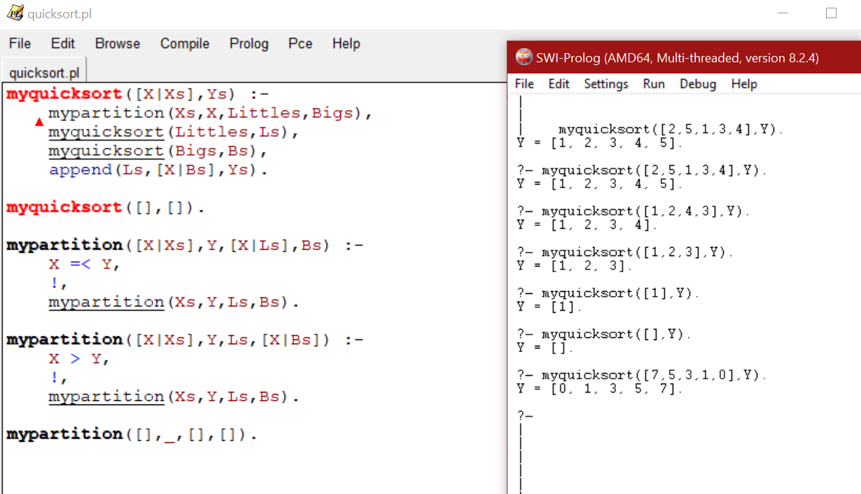

**Problem 2**

I added several cuts that seemed to improve some of the queries I had made without them.

* The first cut is useful because there is no sense in backtracking to check if both *Term* & *Term1* succeed with functor (and having the same amount of args N).  
* Notably, the second helps with queries such as *substitute(cat, dog, owns(jane, cat), X).* This is because there should not be any backtracking once *Arg* & *Arg1* are processed through *substitute/4*.  
* The third cut could be redundant, but I figured there is no sense in backtracking once the accumulator has been incremented (meaning all other goals succeed for that index N)

As for adding cut-fails, regarding *substitute/4* I could see it being used if *Term* & *Term1* had different N args, putting that into its own rule and then removing those goals from the original rule.

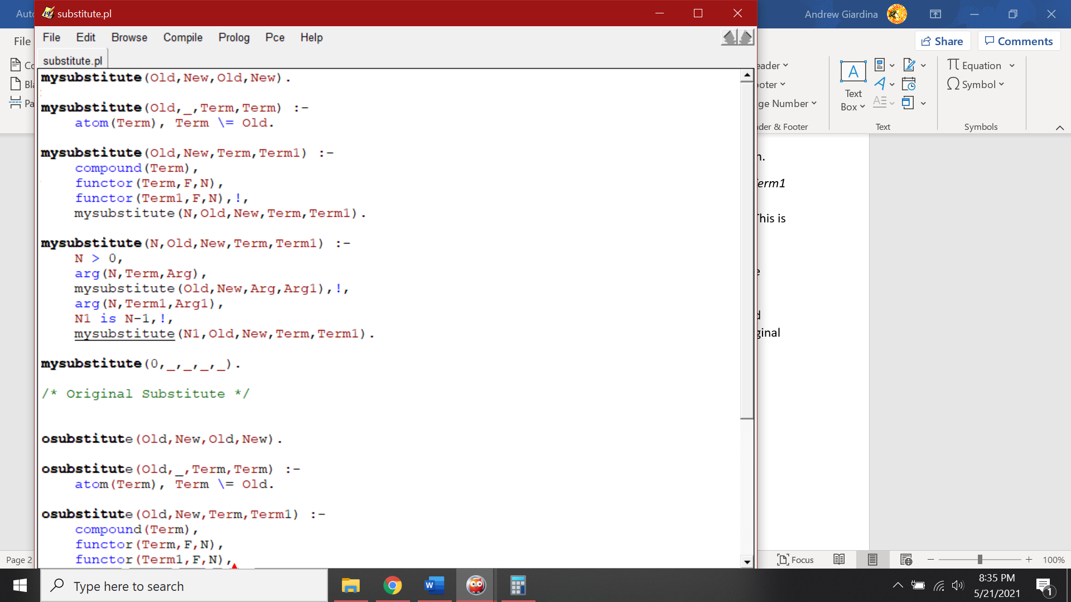Code:

Example queries (with cuts)

