Web Page | Response time without Proxy Server (no cache) | Response time with Proxy Server (cached)
http://gaia.cs.umass.edu/wireshark-labs/HTTP-wireshark-file2.html | 0.986692 | 0.4545109
http://gaia.cs.umass.edu/wireshark-labs/HTTP-wireshark-  file3.html | 1.0395131 | 0.4773401
http://gaia.cs.umass.edu/wireshark-labs/HTTP-wireshark-  file4.html | 1.2827349 | 0.9977525

File2 - uncached
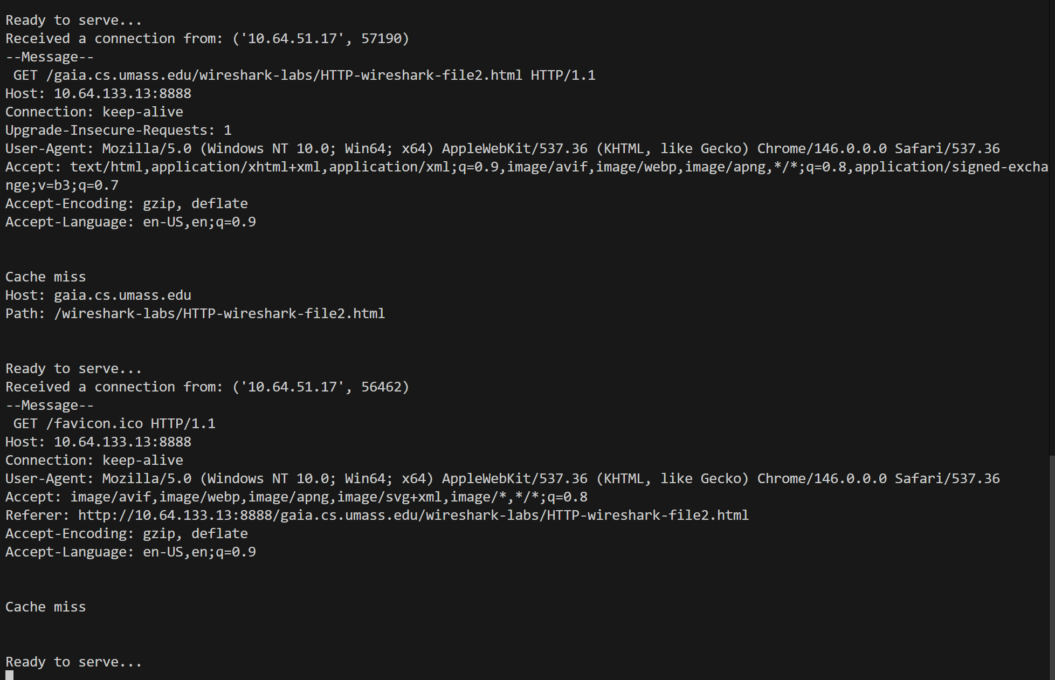

File2 - cached
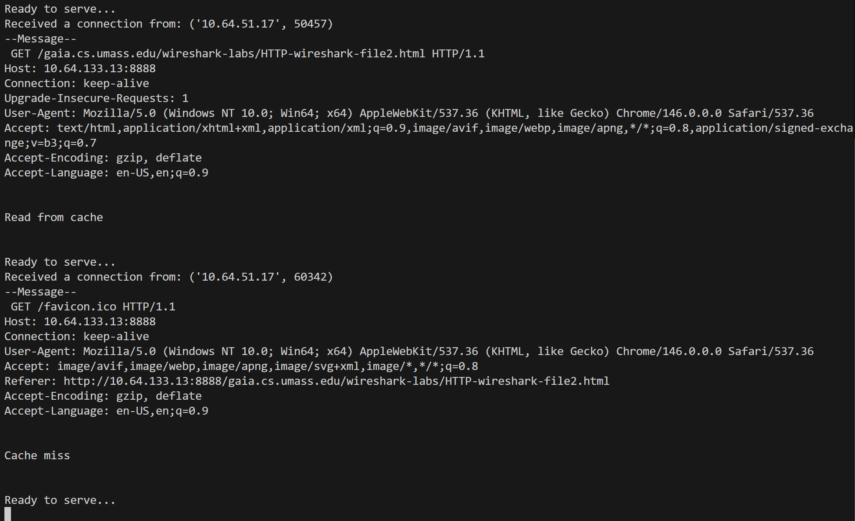
File3 - uncached
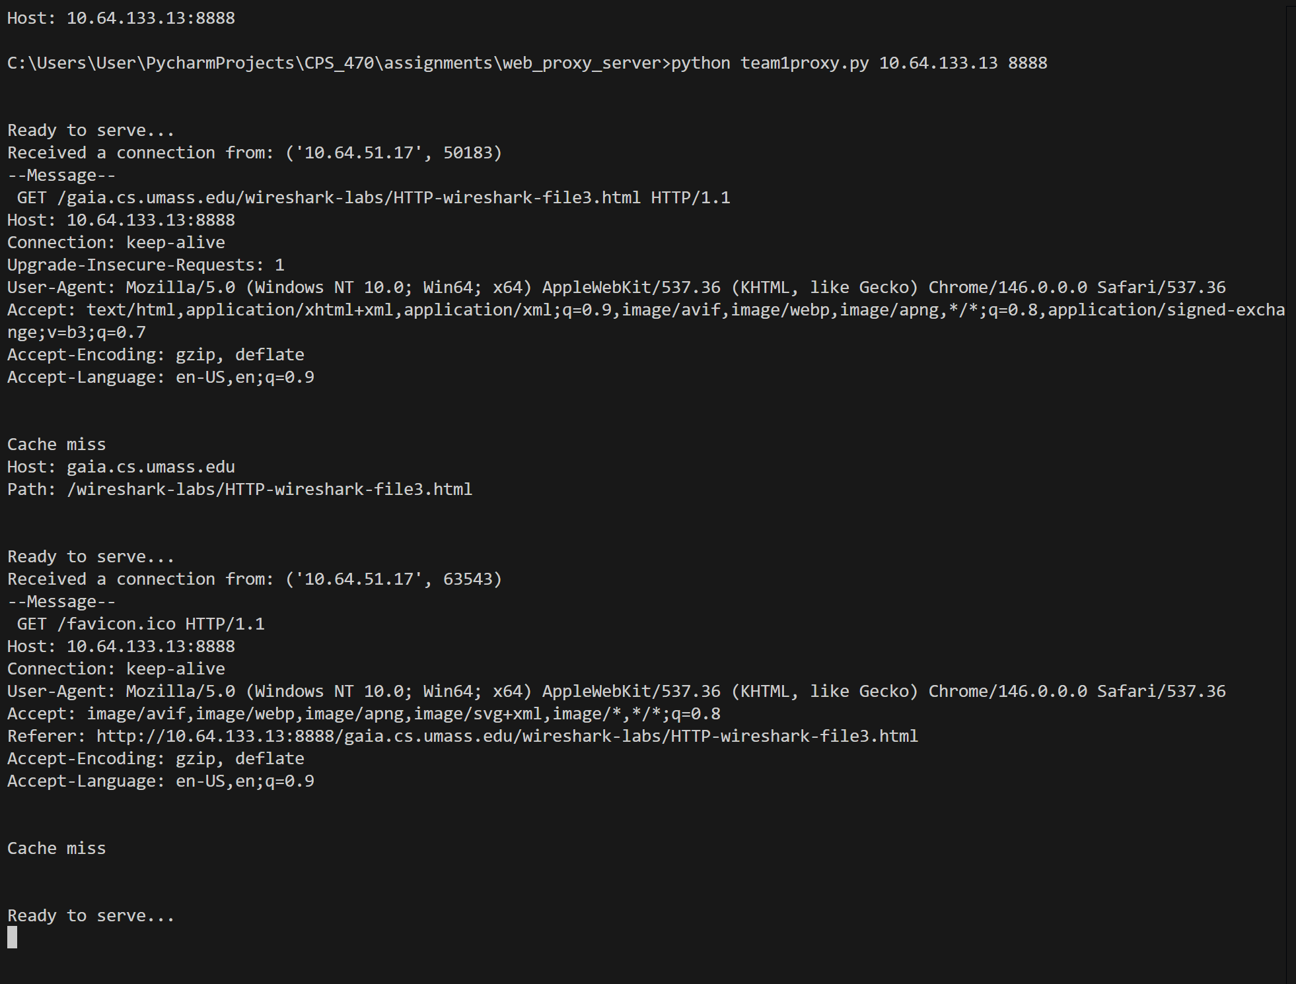
File3 - cached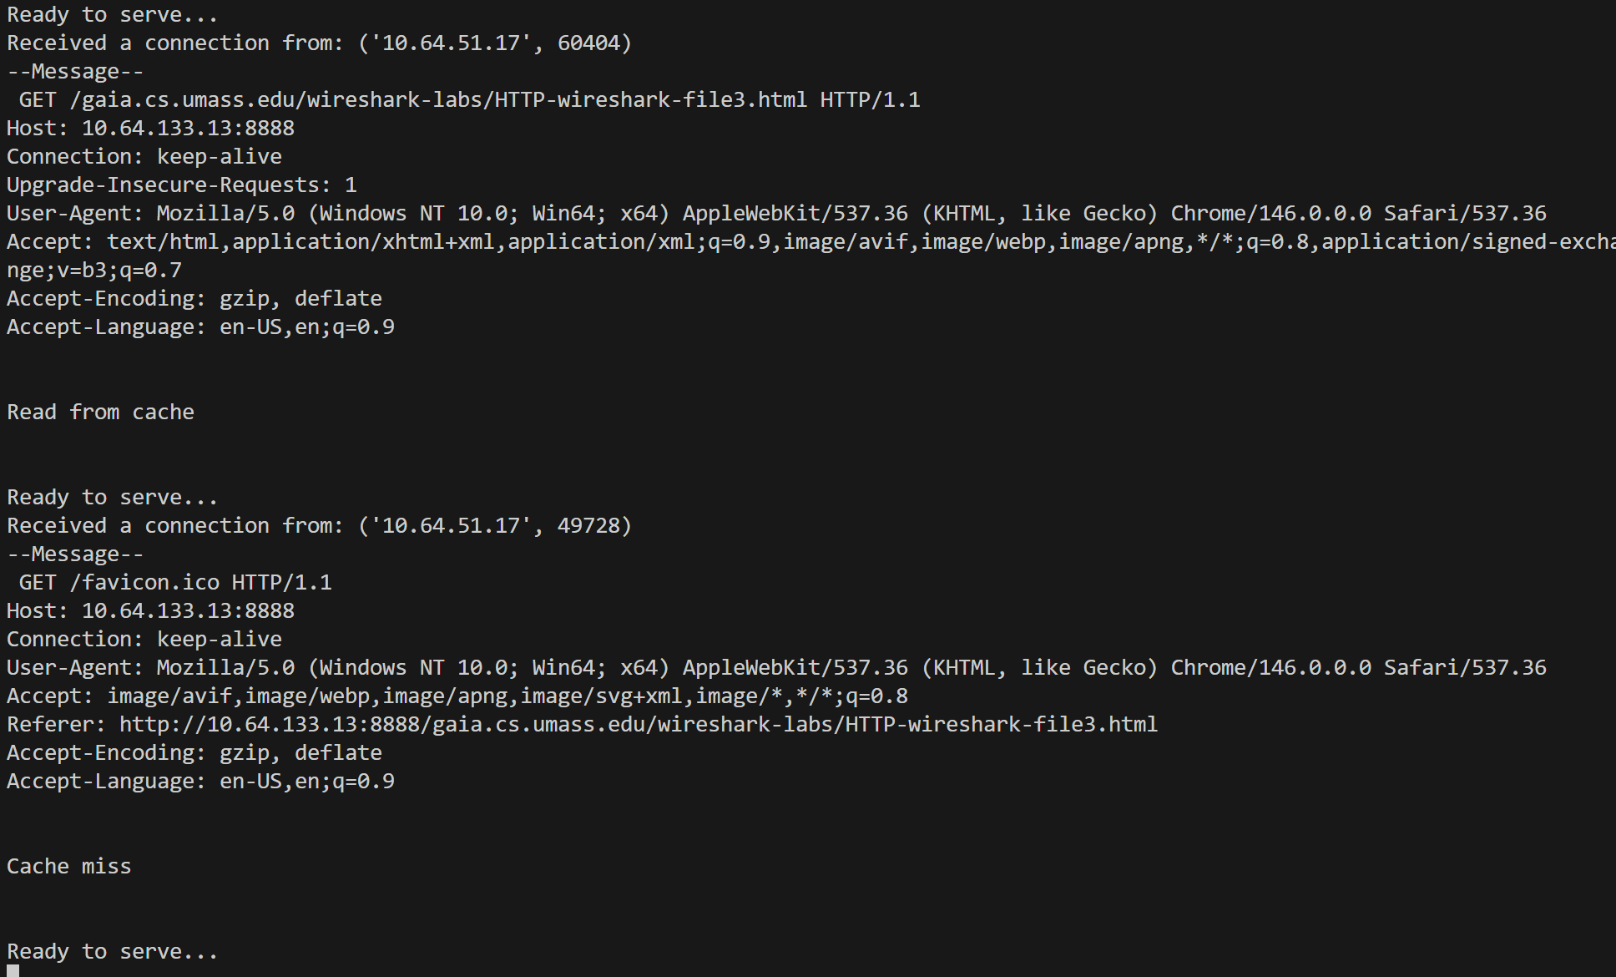

File4 - uncached
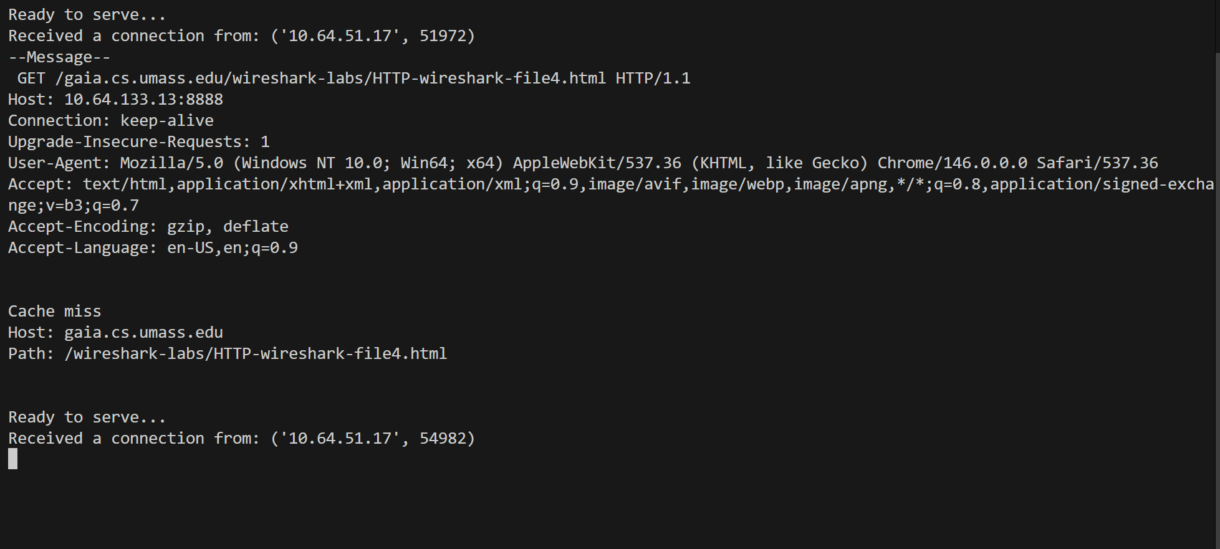

File4 - cached
