**IT based Inventory system**

**Purpose:**

This system will give IT based companies an inventory system focused for their needs. Companies need an efficient way to keep track of inventory into a database, instead of manually typing it. What our system will provide is a way for companies to scan in items, add them into the database automatically, and effectively keep track of where items are and how long they have been with a company.

**Audience/Stakeholders:**

The target audience of this product will be people and companies that have large number of technology assets that they will like to keep track of in an inventory system.

**Overview:**

This system will be geared for companies that have large assets of tech related items. It will use a web based user-interface where user will use a barcode scanner to scan their items in and fill out the remaining fields. It will allow users to add items such as laptops, desktops, mobile devices, projectors and printers. Once the user scanned the item in and filled in the appropriate fields and submits a request to add an item the system will verify the fields then add it to SQL database. Once the data is added to the database base the user will be able query the database for items that are stored within. The user will have the option to delete data when necessary.

**Functional Requirements:**

* The user will login into the system
* The user will be able to add items to the database through a web form
* The user will be able to remove items from the database through a web form
* The user will be able to search for items that are already in the database
* The user will be able to view all the entries within the database from single page

**Non-Functional Requirements:**

* Must be simple to use for everyone
* The GUI must be clean and easy to read
* Must perform all tasks within a reasonable amount of time
* Must be secure from non authorized users
* Must be complete and correct

**User Stories:**

* As a user I want to easily view all the items in the database to ensure I know what I have.
* As a user I want a way to easy way to add items to the database so that I can be efficient.
* As a user I want to be able to remove items from the database based on serial and inventory number.
* As a user I want to be able to search for items in the database based on serial and inventory number

**Use Cases:**

**Use Case:** Login to inventory system

**Actor:** User

**Flow of Events:**

1. The user will enter Username and Password
2. The user will click the login button to be authenticated

**Use Case:** Add item to inventory

**Actor:** User

**Flow of Events:**

1. The user will enter a serial number with a barcode scanner or manually
2. The user will enter an inventory number with a barcode scanner or manually
3. The user will select the items location from a drop down menu
4. The user will enter the lab number if applicable
5. The user will select the make from a drop down menu
6. The user will select the model from a drop down me

**Use Case:** Search inventory **Actor:** User

**Flow of Events:**

1. The user will enter a serial number with a barcode scanner or manually
2. Or the user will enter a inventory number with a barcode scanner or manually
3. Or search for an lab by lab number
4. User will click the search button to search for the item in the inventory system
5. On the items data page the user can click the remove button to remove it from the inventory, click the edit button to make changes to the item or click the search button to search for another item.

**Use Case:** Data page

**Actor:** User

**Flow of Events:**

1. The user can click the remove button to remove the item from the database
2. The user can click the edit button to edit the database entry

**Use Case:** Login to inventory system

**Actor:** System

**Flow of Events:**

1. The system will take the user's credentials and verify that the user has privileges to use the system.
2. If not a privileged user the system will display an error message stating “Username and/or password incorrect”.
3. If a privileged user the system will redirect the user to the Add page.

**Use Case:** Add item to the inventory

**Actor:** System

**Flow of Events:**

1. When the user clicks the add buttonthe system takes the user’s input and creates a SQL entry into the database.

**Use Case:** Search

**Actor:** System

**Flow of Events:**

1. When the user clicks the search button the system will take the data and search the SQL database for it
2. If it exist the system will show the data page for it to the user
3. If not it will display the error “Item not found”

**Use Case:** Data page

**Actor:** System

**Flow of Events:**

1. If the user clicks the remove button the system will remove that item from the database
2. If the user clicks the edit button the system will allow the user to edit the fields.

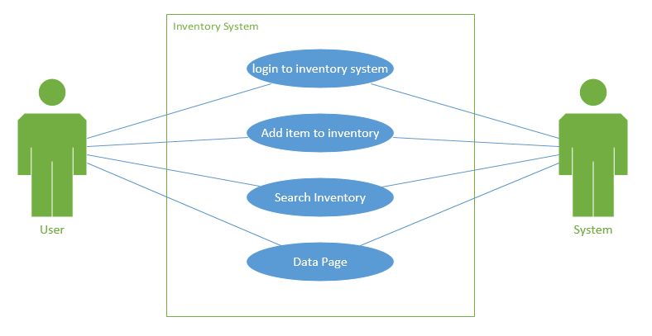

**Gantt Chart:**

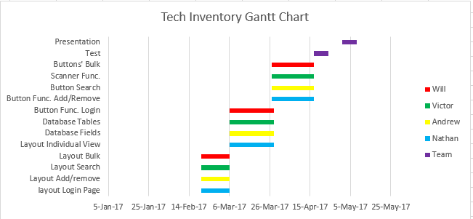

**Prototype:**

