**DECLARATION**

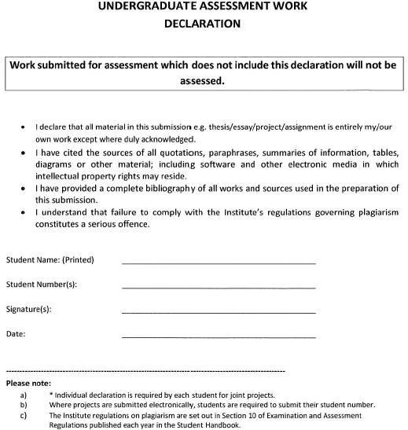

17/05/2023

Andrew Greenslade

C00246189

Andrew Greenslade