***Sprint 1***

Spawn the obstacles that can kill player [RWMPC22-4]

**Link to JIRA:** https://jira.itcarlow.ie/browse/RWMPC22-4

**Description:** Obstacle is spawning in front of the player on top of the freshly generated map

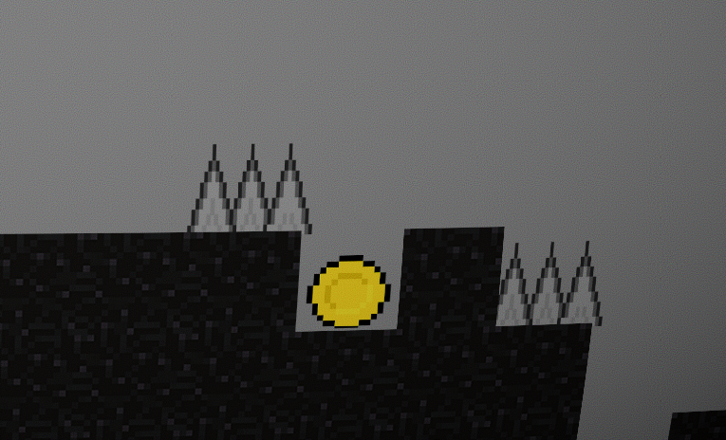

**Conditions of Satisfaction:**

1. Obstacles spawn in the right side of the screen
2. Obstacles spawn in the same position as the map generates(same Y axis)
3. Obstacles take out player life if collided

***Sprint 2***

PlayTesting [RWMPC22-30]

**Link to JIRA:** https://jira.itcarlow.ie/browse/RWMPC22-30

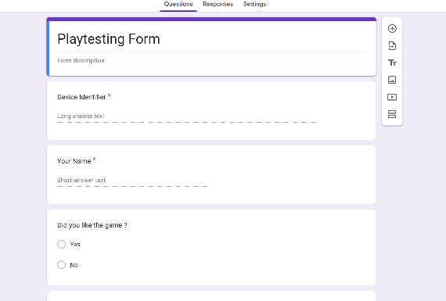**Description:** A player presses “L” key and is being sent to the browser form that will display certain information and will ask player some questions about his experience in the game

Figure 1: A simple sketch of a the form

**Conditions of Satisfaction:**

1. When the “L” key is pressed, opens browser and displays the form
2. Certain details are being recorded such as death counter and sent to form
3. Certain details such as death count is being displayed on the form.

Open Browser form while in the gam e [PL-2] (2 points)

**Link to JIRA:** [http://jira.itcarlow.ie/…](http://jira.itcarlow.ie/%E2%80%A6)

**Condition(s) of Satisfaction**:   
Browser form opens when player presses “L” key

**Link to the git commit:** https://github.com/...

**Steps to Test:**

1. Press “L”
2. Check if Boolean is true
3. Yield to the Unity engine for 0.1 seconds.
4. If true then website opened