**PhotoRegGraphql**

**Introduction:**

This word document will explain the purpose of this app and how to use it. This is a graphql API used to store a user’s photos. It is recommended that the application Postman is used to send the API queries. The application can be download.

**Creating a User:**

When creating a user, you will want to enter the following command into postman.

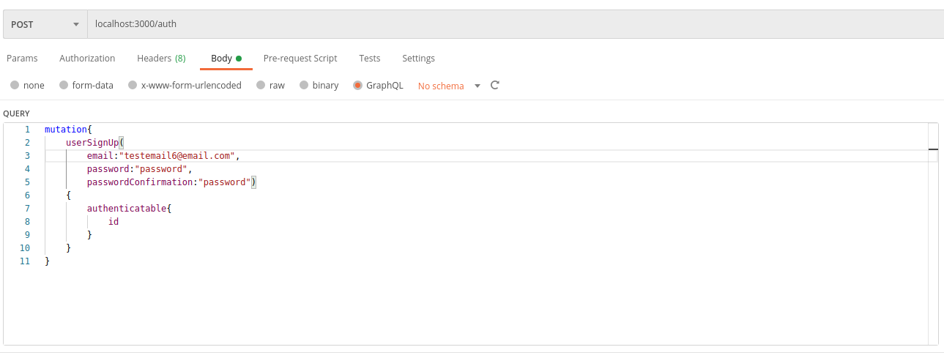

**Signing In:**

It is important you make sure to sign in, otherwise you will not be able to access the API’s functionality. You can sign in with the following command.

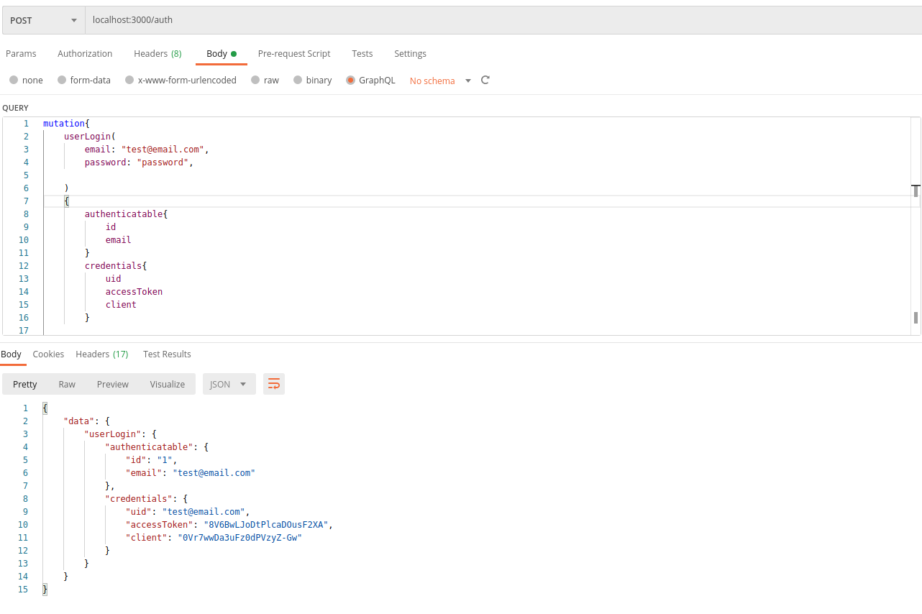

After running this operation three things are returned, uid, accessToken and client. These are important, they will allow you to use the API’s functions. You need to enter them into the headers of all your operations. It is important to note the accessToken must be written as access_token in the header.

More operations for user management can be found here <https://github.com/graphql-devise/graphql_devise>

**Sending an Image:**

To send an image the following postman command can be run, not tags is optional.

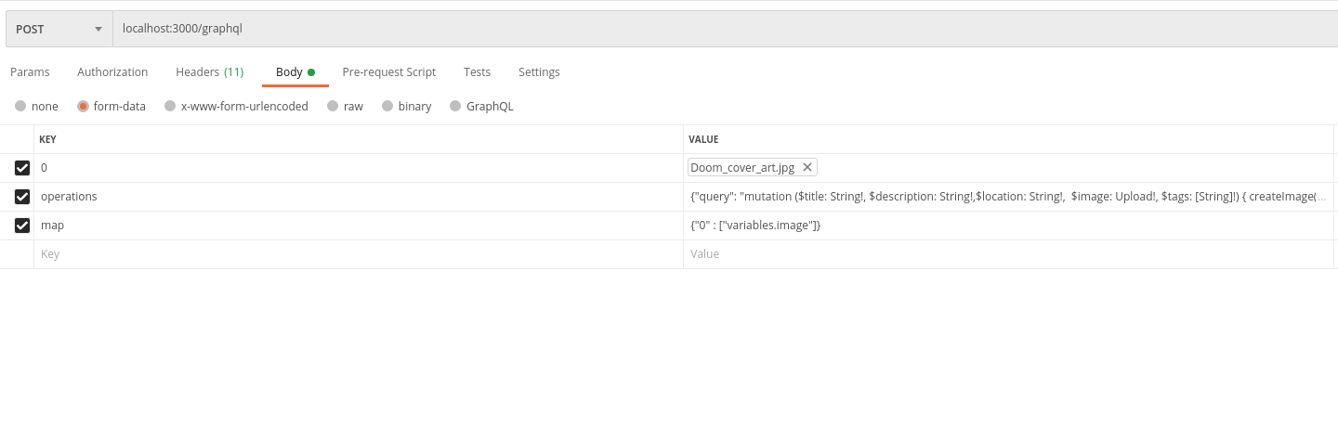

This one is sent in the form data panel so an image file can be uploaded. The operations value looks like this.

{"query": "mutation ($title: String!, $description: String!,$location: String!, $image: Upload!, $tags: [String]!) { createImage( input: { title: $title description: $description location: $location image: $image tags: $tags}) { errors } }", "variables": { "title": "doom6", "description": "a good game", "location": "hell", "image": null , "tags": ["hrllssssdo", "dsadasdasda"]}}

**Query for user Images:**

Run the following command to get the users images.

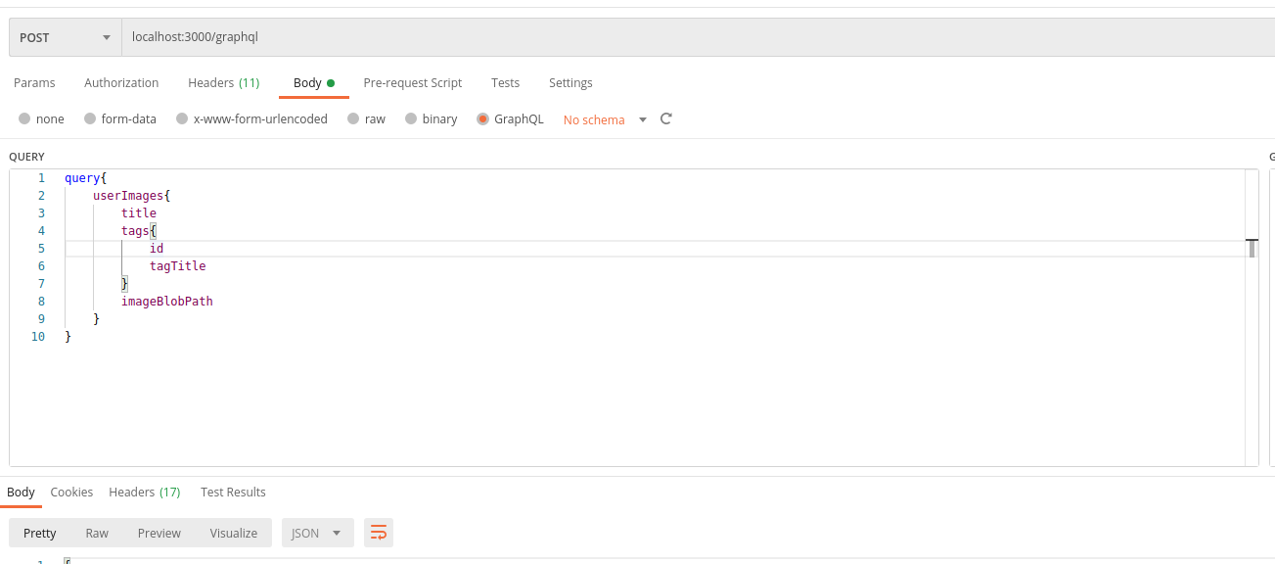

**Search by Tag:**

You can search for images by their tags as well.

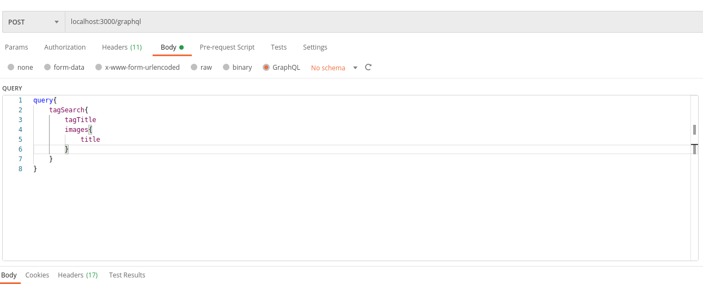

**Get all users:**

You can search for all the users with the following command.

