MediArch: A Decision System for Healthcare Architecture Based on Multi-Agent and Knowledge Graph Collaboration
Yi Qi⁽⁾, Shi Li Hu², Yan Na Chen³, Zhuo Xuan Zhou³, Si Ning Wang⁴
¹ School of Architecture & Urban Planning, Shenzhen University, 10590, ShenZhen, China
qiyi@szu.edu.cn
² School of Architecture & Urban Planning, Shenzhen University, 10590, ShenZhen, China
820643316@qq.com
³ School of Architecture & Urban Planning, Shenzhen University, 10590, ShenZhen, China
1819360462@qq.com
³ School of Architecture & Urban Planning, Shenzhen University, 10590, ShenZhen, China
1295639966@qq.com
⁴ School of Architecture & Urban Planning, Shenzhen University, 10590, ShenZhen, China
siningwang@szu.edu.cn

Abstract: Design knowledge reuse lags material circularity in architecture. In healthcare architecture, fragmented regulations and spatial relationships make design reasoning hard to reuse across projects. We present MediArch, a decision-support framework that organizes healthcare design knowledge into a knowledge graph and uses graph-vector retrieval and multi-agent orchestration for evidence-grounded question answering. On a benchmark derived from nine healthcare-architecture documents, MediArch improves evidence grounding, answer accuracy, and response completeness over lexical retrieval and vector-only baselines. The study suggests that structured reuse of design knowledge can support healthcare architecture decision-making.

Keywords: Healthcare Architecture · Knowledge Graph · Multi-Agent Systems · Evidence-Based Design Support

1 Introduction
Within the paradigm of Circular Intelligence, built-environment research has focused more on material circularity than on the reuse of design knowledge [1,2]. We refer to this gap as Intellectual Circularity: the systematic capture and reuse of design expertise across project lifecycles [3]. The challenge is particularly evident in healthcare architecture, where design decisions must coordinate clinical, spatial, and safety requirements, while existing AI applications remain fragmented and fail to support reusable design logic [4-6].
Recent advances in LLMs, knowledge graphs, RAG, and multi-agent systems provide new opportunities for structured knowledge reuse [7,8]. Existing studies have demonstrated hybrid RAG frameworks for building engineering knowledge management and multi-agent KG-RAG frameworks in other engineering domains [9-15]. However, these studies are not primarily designed for healthcare architectural decision-making, where clause-level regulatory evidence, spatial-functional dependencies, and source-level provenance need to be jointly represented. To address this gap, we propose MediArch, a decision-support framework whose overall architecture is shown in Fig. 1. By structuring, retrieving, and reusing evidence across heterogeneous sources, MediArch suggests a practical pathway toward intellectual circularity in healthcare architecture and contributes to SDG 9 and SDG 12 by supporting digital knowledge infrastructure and reducing redundant verification effort in architectural decision-making.

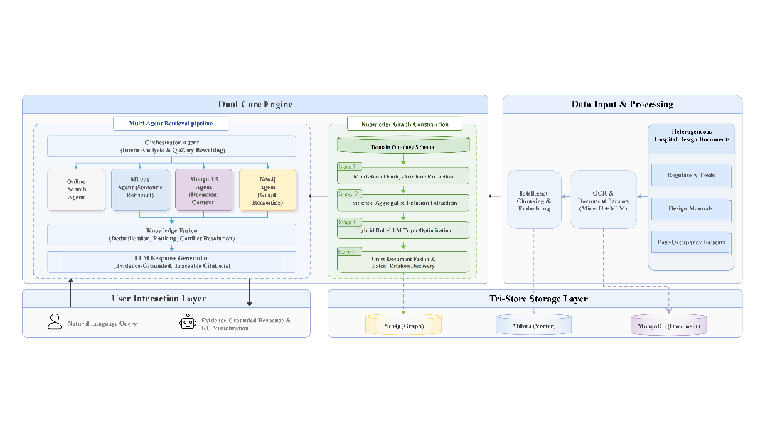
Fig. 1 Overall architecture of the MediArch framework

2 Methodology
This section introduces the two core components of MediArch: a schema-guided knowledge engineering pipeline that transforms heterogeneous healthcare design documents into a structured, queryable knowledge graph, and an Orchestrator-Worker multi-agent retrieval architecture that combines symbolic graph reasoning with neural semantic retrieval for design decision support.

2.1 Knowledge Engineering Pipeline
Healthcare design knowledge is scattered across regulations, manuals, and reports, with the same concept often expressed under different names and levels of granularity. MediArch therefore adopts a schema-guided pipeline grounded in a domain ontology for healthcare architecture. The pipeline consists of four stages: multi-round entity-attribute extraction, evidence-aggregated relation extraction, hybrid rule-LLM triple optimization, and cross-document entity disambiguation with latent relation discovery (Fig. 2).

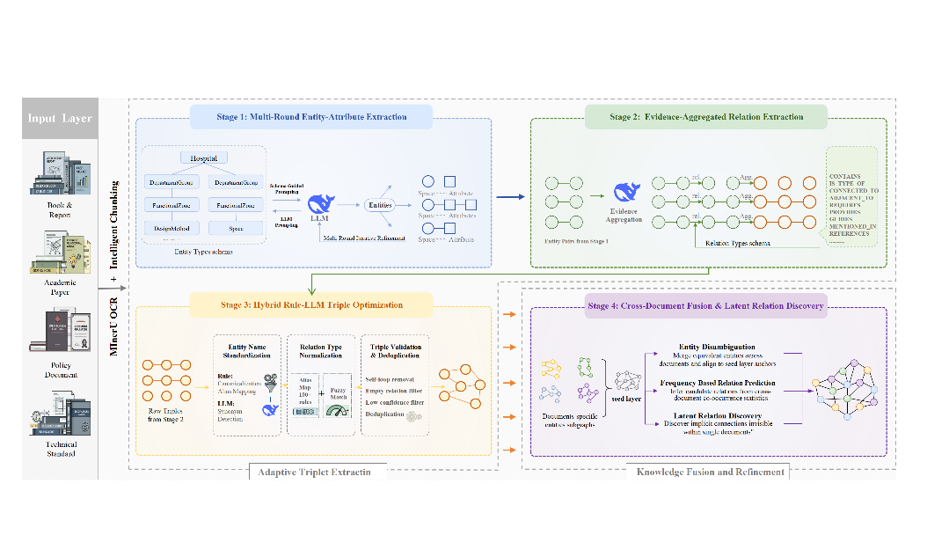
Fig. 2 Overview of the MediArch Knowledge Graph Construction pipeline

2.1.1 Ontology and Schema Design
To address terminological inconsistency and structural heterogeneity, MediArch defines a domain ontology including entity types, relation types, attribute mappings, and structural constraints. The ontology both constrains LLM extraction and validates graph structure during persistence. It follows three design principles: hierarchical spatial decomposition, multi-dimensional design representation, and provenance traceability. The ontology models the built environment from hospital to department group, functional zone, and individual space, while encoding design principles, clinical functions, and regulatory intent.Table 1 summarizes the schema, which includes 11 entity types across four semantic layers and 14 relation types in five semantic groups. These relations cover hierarchical containment, spatial adjacency, functional dependencies, design-guidance mappings, and provenance links.

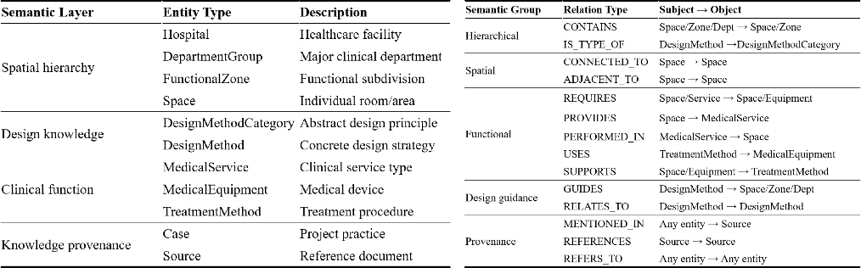
Table 1 Entity Types and Semantic Layers and Relation Types and Semantic Groups

To stabilize graph construction, MediArch initializes a seed layer from national building codes (Fig. 3). This layer contains about 90 standardized space types in a four-level hospital hierarchy and serves as an anchor for new entities.

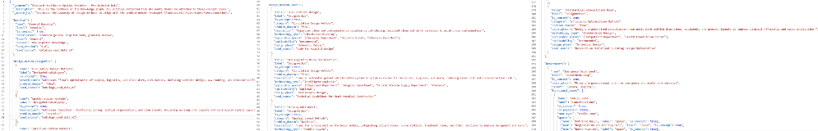
Fig. 3 Excerpt of the Ontology Seed Layer Used to Bootstrap the Knowledge Graph

2.1.2 Adaptive Triplet Extraction
Directly extracting complete triplets in a single LLM pass often produces incomplete coverage because entity identification, attribute attribution, and relation inference compete for the same context window. MediArch therefore decomposes extraction into three stages.
Stage 1: Multi-Round Entity-Attribute Extraction The first stage focuses on entities and their intrinsic attributes, while deferring relation inference. For each text chunk, the LLM receives the chunk together with the schema-defined entity list and returns entity-attribute (E-A) pairs. Accumulated results are fed back in later rounds to recover missed entities, and iteration stops when the number of newly discovered pairs falls below a convergence threshold. Extracted entities are then canonicalized and merged across chunks by aggregating compatible attributes.
Stage 2: Evidence-Aggregated Relation Extraction Given the E-A pairs, relation extraction is formulated as constrained classification over the schema-defined relation types, which narrows the search space and reduces spurious links. The LLM receives enriched entity context and generates candidate triplets. Because the same triplet may recur across chunks, MediArch maintains an evidence set $C_{t}$ for each triplet $t$, with confidence defined as:
$$\begin{aligned}\text{conf}\left(t\right)=\max_{c_{i}∈C_{t}}{\{}{\text{conf}}_{i}\left(t\right)\}\#\left(1\right)\end{aligned}$$
Each triplet keeps chunk and document references for provenance.
Stage 3: Hybrid Rule-LLM Triple Optimization Raw triplets are normalized through a hybrid process that applies deterministic rules whenever possible and invokes LLM reasoning only for ambiguous cases. This stage includes entity standardization through alias lookup and synonym resolution, relation normalization through cascading mapping with fallback to RELATED_TO, and noise filtering for self-loops, invalid relations, low-confidence triplets, and duplicates. The output is a schema-compliant triplet set for graph-level fusion.

2.1.3 Knowledge Fusion and Refinement
Because the first three stages operate at the chunk level, they cannot fully resolve cross-document redundancy or recover implicit inter-document relations. MediArch addresses this limitation through a final fusion stage.
Step 4a: Cross-Document Entity Disambiguation Entities are first grouped by ontology type, and pairwise name similarity is computed only within the same type. Candidate pairs satisfy:
$$\begin{aligned}\text{cand}\left(e_{i},e_{j}\right)=\text{sim}\left(e_{i},e_{j}\right)≥δ \text{where }τ\left(e_{i}\right)=τ\left(e_{j}\right)\#\left(2\right)\end{aligned}$$
This type constraint reduces false merges between similarly named but semantically different entities. Candidate pairs are then verified by the LLM, and confirmed matches are merged under a canonical name.
Step 4b: Latent Relation Discovery Entity pairs that co-occur in related source documents but lack direct edges are submitted to the LLM for relation assessment. If a valid schema-defined relation is inferred, a new edge is added with an inferred flag to distinguish it from directly extracted triplets.
Step 4c: Graph Persistence The fused triplets and inferred relations are written to Neo4j together with confidence scores, chunk identifiers, and document references. As a result, every node and edge remains traceable to its textual evidence. The resulting graph serves as the structured knowledge base for the downstream multi-agent retrieval framework.

2.2 Agentic Retrieval Framework
This section presents MediArch's multi-agent retrieval framework, which coordinates heterogeneous storage backends through staged retrieval, deterministic fusion, evidence grounding, and quality-gated response synthesis. The design follows recent AEC studies that combine hybrid RAG over vectors, property graphs, and keywords with LLM-driven multi-agent workflows for knowledge management and design coordination [16,17]. Fig. 4 illustrates the overall architecture.
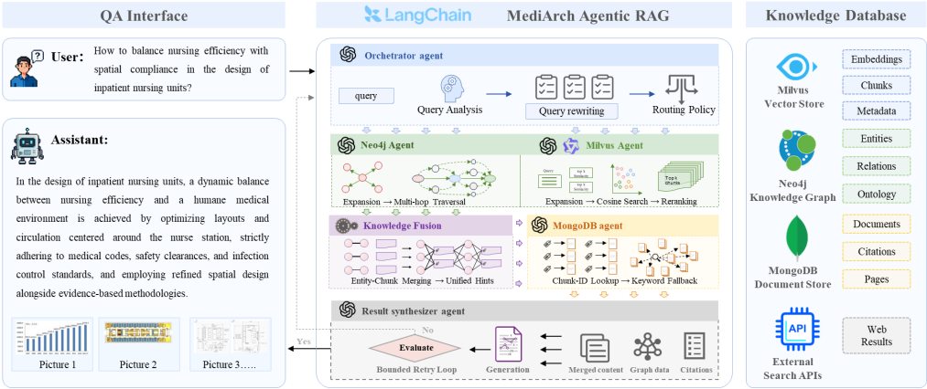
Fig. 4 Architecture of the MediArch agentic retrieval framework

2.2.1 Hybrid Indexing and Synergistic Storage
MediArch uses three complementary backends managed by dedicated retrieval agents. Neo4j and Milvus support parallel recall-oriented retrieval, while MongoDB provides citation-grade evidence grounding.
The Neo4j agent retrieves structured knowledge through LLM-driven concept expansion, full-text matching, and multi-hop graph traversal, returning subgraphs grouped by ontology label. The Milvus agent performs semantic retrieval over vectorized document chunks, followed by cross-encoder reranking and compact knowledge-point extraction. The MongoDB agent verifies source documents by direct chunk lookup when identifiers are available, or by keyword retrieval otherwise, returning page numbers, section headings, and source identifiers for traceable responses.

2.2.2 Collaborative Reasoning and Synthesis
The retrieval workflow is implemented as a LangGraph state machine and proceeds in four phases (Fig. 5)

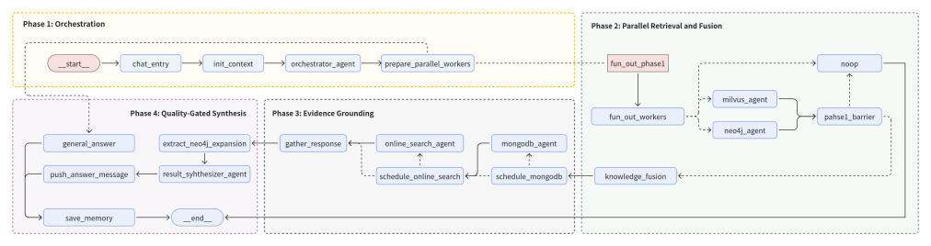
Fig. 5 Architecture of the MediArch agentic retrieval graph

Phase 1: Orchestration The orchestrator agent analyzes query intent, resolves coreferences from the conversation history, rewrites the query for retrieval, and selects the retrieval agents to activate. Off-topic or purely conversational requests are answered directly without invoking the full pipeline.
Phase 2: Parallel Retrieval and Fusion Neo4j and Milvus run in parallel. A deterministic, LLM-free module merges their outputs into unified hints and an answer graph, and scores retrieval quality by entity coverage, chunk coverage, relation richness, and cross-modal complementarity.
Phase 3: Evidence Grounding The MongoDB agent uses the unified hints to retrieve source passages with page-level precision, converting high-recall retrieval outputs into citation-ready evidence.
Phase 4: Quality-Gated Synthesis The synthesizer combines graph evidence, semantic passages, and citation metadata into a response. An evaluation loop checks completeness, citation adequacy, and domain consistency, and regenerates if needed within the retry budget.

3 Experiments and Evaluation
We evaluate MediArch from two perspectives: knowledge graph construction and end-to-end question answering. The experimental corpus consists of nine source documents, including three research papers, two professional books, two national normative documents, and two policy documents. After data processing, the corpus contains 1,708 chunks in total. The first part evaluates the scale, structural coverage, and provenance support of the constructed healthcare-architecture knowledge graph. The second part examines whether the graph-supported multi-agent pipeline improves downstream evidence retrieval, answer accuracy, and response completeness.

3.1 Knowledge Graph Quality
This subsection summarizes the construction quality of the MediArch knowledge graph. The resulting graph contains roughly 7.2k nodes and 8.7k relationships, with most nodes and edges retaining chunk-level provenance. It also covers the full set of predefined entity and relation categories in the schema, which suggests that the pipeline can capture not only isolated design concepts but also the structural dependencies among spaces, functions, and regulatory constraints. Taken together, these results provide a useful foundation for downstream retrieval and evidence-grounded question answering.

3.2 End-to-End Retrieval and QA
To evaluate the downstream utility of MediArch, we construct an end-to-end QA benchmark from the full experimental corpus of nine healthcare-architecture documents. The corpus includes technical standards, policy documents, academic papers, and books and reports, covering 801 pages in total and providing heterogeneous design knowledge for retrieval and answer generation. Based on this corpus, we manually curate 18 benchmark questions for evaluation. As shown in Table 3, the benchmark is organized by source coverage rather than strict proportional sampling, including four questions from technical standards, two from policy documents, six from academic papers, and six from books and reports. This design ensures coverage of regulatory constraints, planning and management guidance, research-based evidence, and practice-oriented design knowledge. The questions further span four representative QA demands in healthcare architectural decision support: fact verification, spatial-functional reasoning, cross-document synthesis, and design recommendation. For each question, we prepare a compressed expected answer, one key reference source, and a short evidence note.

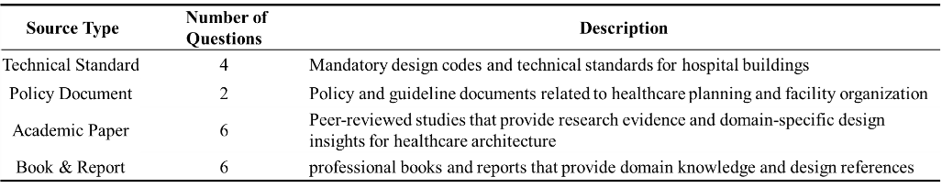
Table 3 Source-type distribution of benchmark questions for end-to-end QA evaluation

As shown in Table 4, the three settings exhibit clear differences in QA quality. Compared with R0, R1 improves evidence coverage by incorporating graph retrieval, while R2 further improves answer accuracy and completeness through source-grounded retrieval and controlled synthesis. In particular, R0 mainly relies on semantic similarity and therefore performs reasonably on straightforward factual lookup, but it remains limited when the question requires structural understanding or integration across multiple documents. By introducing graph-based retrieval, R1 improves the system's ability to surface relationally relevant knowledge, which is especially beneficial for spatial-functional reasoning tasks. Building on this, R2 achieves the best overall performance because grounded evidence retrieval and quality-controlled synthesis reduce unsupported responses and improve citation consistency. These results suggest that healthcare architectural QA cannot be adequately supported by vector retrieval alone, but instead requires a collaborative mechanism that combines semantic recall, graph-structured reasoning, and source-level evidence grounding. Overall, the results support the effectiveness of the full MediArch pipeline for evidence-grounded design question answering. Nevertheless, the benchmark size remains limited, and future evaluation should include larger multi-institutional corpora and more fine-grained task settings to further test the generalizability of the framework. Fig. 7 shows the evaluated QA result returned by the full MediArch pipeline.

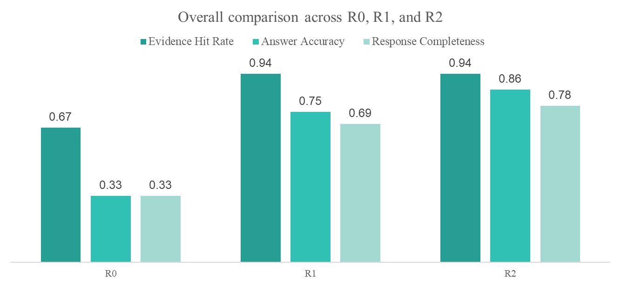
Table 2 QA Performance Comparison Across R0, R1, and R2

4 Conclusion
This paper presented MediArch as an exploratory framework for reusable healthcare architectural knowledge within the paradigm of Circular Intelligence. By combining an LLM-driven adaptive knowledge graph, hybrid Neo4j-Milvus retrieval, and multi-agent orchestration, the framework structures fragmented design knowledge into computable decision support. Experimental results suggest that MediArch can improve retrieval quality and response completeness in hospital design scenarios.More broadly, this work contributes to ongoing efforts to integrate digitalization and circularity in architectural practice through the reuse of design knowledge. In this sense, MediArch offers a practical pathway for reducing intellectual waste and supporting more informed healthcare design processes, with relevance to the broader aims of the United Nations Sustainable Development Goals, particularly SDG 9 and SDG 12.

References
- UNEP (2024) 2023 Global Status Report for Buildings and Construction, doi: 10.59117/20.500.11822/45095
- Munaro M, Tavares SF, Braganca L (2020) Towards circular and more sustainable buildings: A systematic literature review on the circular economy in the built environment. Journal of Cleaner Production 260:121134, doi: 10.1016/j.jclepro.2020.121134
- Schoormann T, Hansen MRP, Moller F (2025) Advancing Design Knowledge Reuse: A Framework for Circular Design Principles. Communications of the Association for Information Systems 56(18), doi: 10.17705/1cais.05618
- Halawa F, Madathil SC, Gittler A, Khasawneh M (2020) Advancing evidence-based healthcare facility design: a systematic literature review. Health Care Management Science 23:453–480, doi: 10.1007/s10729-020-09506-4
- Ransolin N, Saurin TA, Zani C, et al (2022) The Built Environment Influence on Resilient Healthcare: A Systematic Literature Review of Design Knowledge. HERD 15(2):249–272, doi: 10.1177/19375867221077469
- Tjebane MM, Musonda I (2025) Artificial intelligence in healthcare facilities asset information management: mixed review. Infrastructure Asset Management 12(2):94-109. doi: 10.1680/jinam.23.00033
- Pan S, Luo L, Wang Y, Chen C, Wang J, Wu X (2024) Unifying Large Language Models and Knowledge Graphs: A Roadmap. IEEE Trans. Knowl. Data Eng. 36(7):3580-3599. doi: 10.1109/TKDE.2024.3352100
- Zhu Y, Wang X, Chen J, Qiao S, Ou Y, Yao Y, Deng S, Chen H, Zhang N (2024) LLMs for knowledge graph construction and reasoning: recent capabilities and future opportunities. World Wide Web 27:61. doi: 10.1007/s11280-024-01297-w
- Li D, Shi Y, Schwartz M, Kapadia M (2026) Early-stage architecture design assistance by LLMs and knowledge graphs. Automation in Construction 182:106756. doi: 10.1016/j.autcon.2025.106756
- Kamalipour AA, Asadi S, Amiri Chimeh MM (2026) From vectors to knowledge graphs: A comprehensive analysis of modern retrieval-augmented generation architectures. Computer Science Review 61:100925. doi: 10.1016/j.cosrev.2026.100925
- Thomsen AMS, Bjornskov J, Jradi M (2026) Ontology-driven digital twins for optimized recommissioning of hospital building operations. Journal of Building Engineering 121:115627. doi: 10.1016/j.jobe.2026.115627
- Ali M, Taha Z, Morsey MM (2026) Ontology-grounded knowledge graphs for mitigating hallucinations in large language models for clinical question answering. Journal of Biomedical Informatics 175:104993. doi: 10.1016/j.jbi.2026.104993
- Lin J, Chen C, Wang T, Wang Z, Cheng L (2026) A Multi-Agent and synergistic Knowledge Graph retrieval-augmented generation framework for intelligent maintenance. Journal of Manufacturing Systems 85:557-570. doi: 10.1016/j.jmsy.2026.02.016
- Wang Z, Liu Z, Lu W, Jia L (2025) Improving knowledge management in building engineering with hybrid retrieval-augmented generation framework. Journal of Building Engineering 103:112189. doi: 10.1016/j.jobe.2025.112189
- Dong Y, Zhan Z, Hu Y, Doe DM, Han Z (2025) AI BIM coordinator for non-expert interaction in building design using LLM-driven multi-agent systems. Automation in Construction 180:106563. doi: 10.1016/j.autcon.2025.106563
- Li M, Wang Z (2025) BuildingGPT: query building semantic data using large language models and vector-graph retrieval-augmented generation. Building and Environment 271:113855. doi: 10.1016/j.buildenv.2025.113855
- Yin M, Tang L, Webster C, et al (2023) Two-stage Text-to-BIMQL semantic parsing for building information model extraction using graph neural networks. Automation in Construction 152:104902. doi: 10.1016/j.autcon.2023.104902

Yi Qi () School of Architecture & Urban Planning, Shenzhen University, 10590, ShenZhen, China e-mail:qiyi@szu.edu.cn

