Setup
The experiment implements the GCNext model as described in (Wang, Cui, Chen, & Liu, 2024). The model has been locally retrained as closely as possible to authors. While the performance slightly deviates from the reported performance by the authors, this model has been used as a proof of concept for the implementation of a framework that allows new frames to be added to the model step wise.
Note that the model expects a consistent number of frames to predict 25 frames into the future. This model expects 50 frames of past data. A visual example of this is shown here, where the red-blue skeletons are the predicted motion and the green-brown skeletons are the input motion used by the model to create predictions.
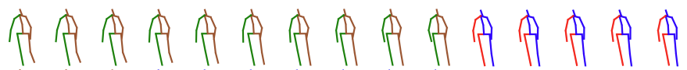
For clarity sake, call this complete motion sequence the full motion.
For real-time applications, the number of input frames will not be consistent for the first few timesteps, thus needing some kind of mechanism to ensure a constant number of frames is fed to the model. For this a padding mechanism is added, which repeats the first frame of observed motion.
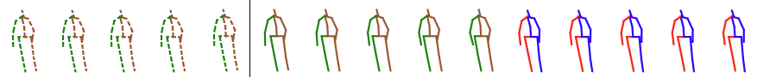
The hypothesis is that as more data becomes available to the model, the predictions will become more and more accurate.
Additionally it is hypothesized that for more “static” actions (i.e. Sitting, SittingDown, Posing) the initial performance will be better compared to “dynamic” actions (i.e. Walking, WalkingTogether, WalkingDog, Greeting). However, as more time steps are fed to the model, it is hypothesized that the accuracy of the predictions for the dynamic actions will relatively increase more.
To test these hypotheses, the model has been fed samples of data. This can be done in two separate ways: back-to-front & front-to-back. This is repeated for all samples of data in the evaluation set for each type of action. More specifically, this evaluation set contains 256 samples of the actions for Eating, Sitting, SittingDown, Discussion, Waiting, Phoning, Greeting, Posing Walking, WalkingTogether, WalkingDog, Directions, TakingPhoto, Purchases. The predictions are then compared to the ground truth motion using the Mean Per Joint Positions Error (MPJPE), which is the average Euclidean distance between the predicted and ground truth joint positions. The MPJPE for each sample in a set of actions is then averaged, to get an average performance index for an action at 4 different prediction horizons.

Back-to-front
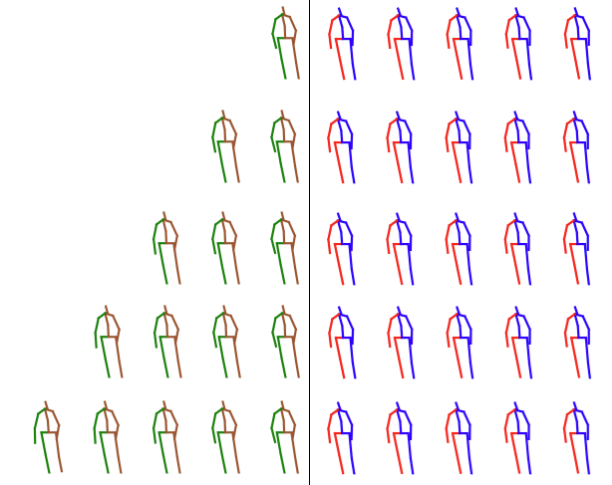
In this version, the data “anchors” itself on the end of the input movement and aims to predict the same motion every time. Over time, more “previous” data is fed to the model, given it more data step by step. This is visually shown here (without the padding).
This way of evaluating the data is more in line with the literature, since the predicted motion is always the same.

Front-to-back
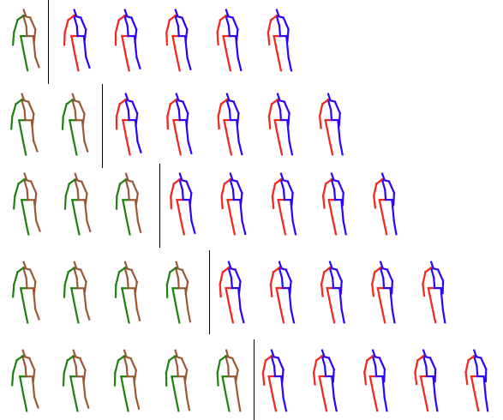
In this version, the data anchors itself on the start of the input movement and aims to predict the subsequent motion. Over time, more new data is fed to the model. This means that the predicted motion is slightly different every time a new frame of data is added. This is visually shown here (without the padding).
This way of evaluating the data is more in line with how real-time data acquisition will take place.

Results

Static vs Dynamic
The reported performance for both back to front & front-to-back are shown in the following plots. In these plots the average MPJPE for the different prediction horizons are plotted against the number of observed frames, grouped by static and dynamic actions.
When the model is given fiver or fewer input frames, the average MPJPE for static actions at prediction horizons up to 560ms is lower than for dynamic actions. This indicates a better performance.
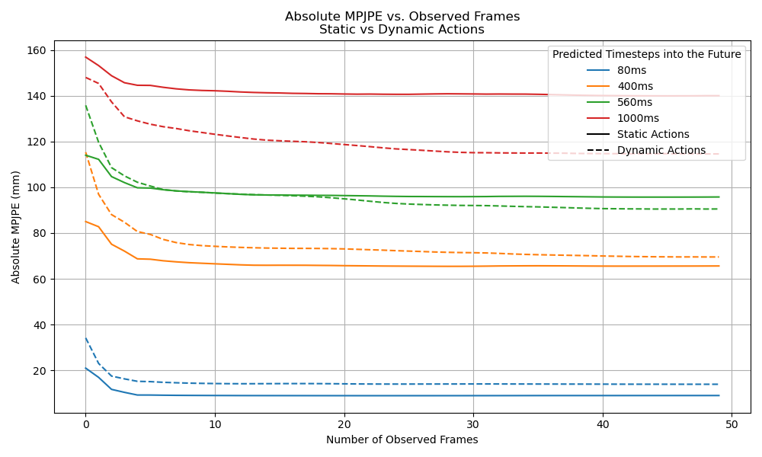
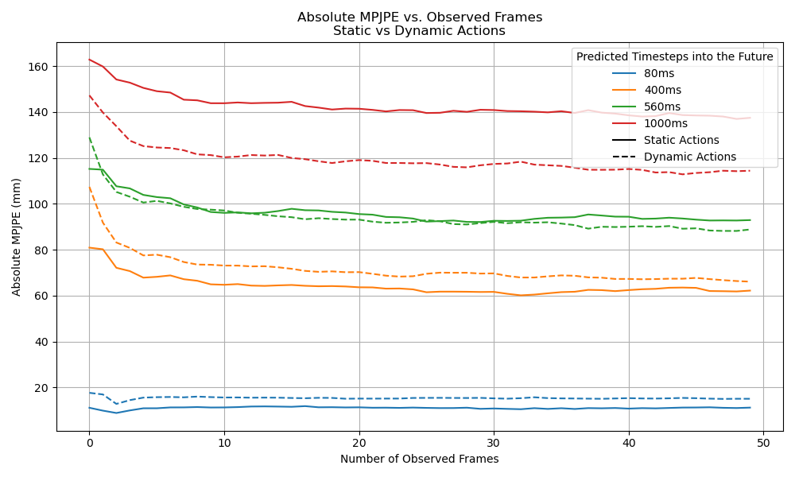
This increased performance for static actions continues for the lower prediction horizons. However for longer prediction horizons (red and green plots), the prediction accuracy for dynamic actions is better. One explanation for this could be that since dynamic actions are inherently more cyclic (think of walking), the model might be able to implicitly infer the intended action. Additionally, visual analyzation of the static actions reveals that the movements are a lot more erratic, especially since these movements are mainly centered above the torso. This could also be a leading cause of the underperformance of these models on more “static” movements. To test this hypothesis, it is possible to evaluate the performance of the model’s prediction separated by upper and lower body predictions.
It is also noted that the separation between static and dynamic movements are not fully black and white; since there are 256 samples of each type of movement, only a small subset have been reviewed to determine whether an action is static, dynamic or somewhere in between. A good example is the action “waiting”, which intuitively would belong in the “static” group, but the reviewed samples shows that samples in this group range from fully static, to dynamically moving around.
This leads to the conclusion that this distinction between static and dynamic movements might not have been the best grouping tactic.

Upper vs lower
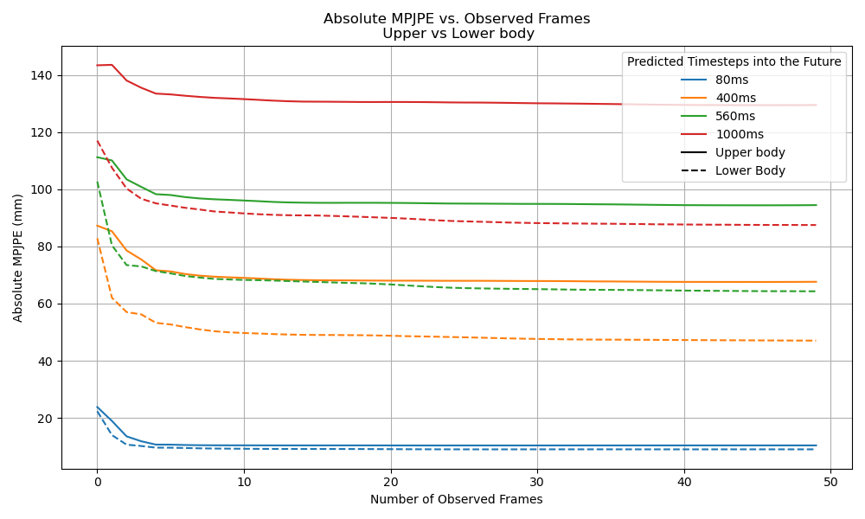
The separation of the data between upper and lower body shows that over all the actions, the accuracy of the predictions of the lower body is better.

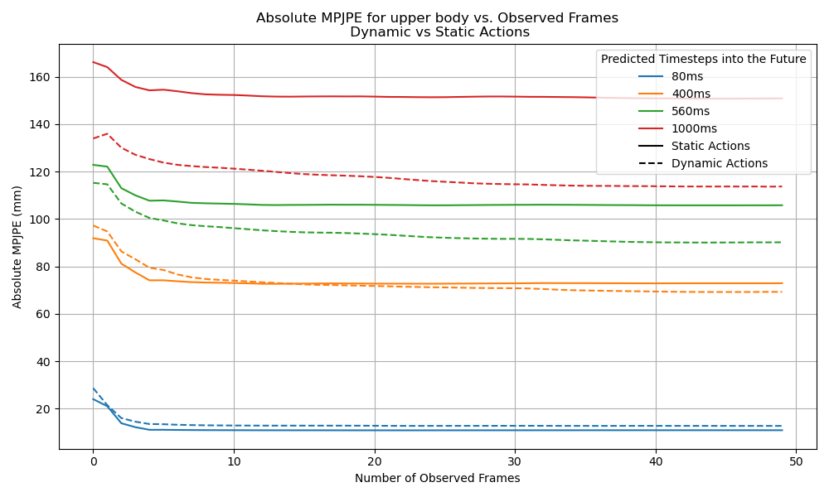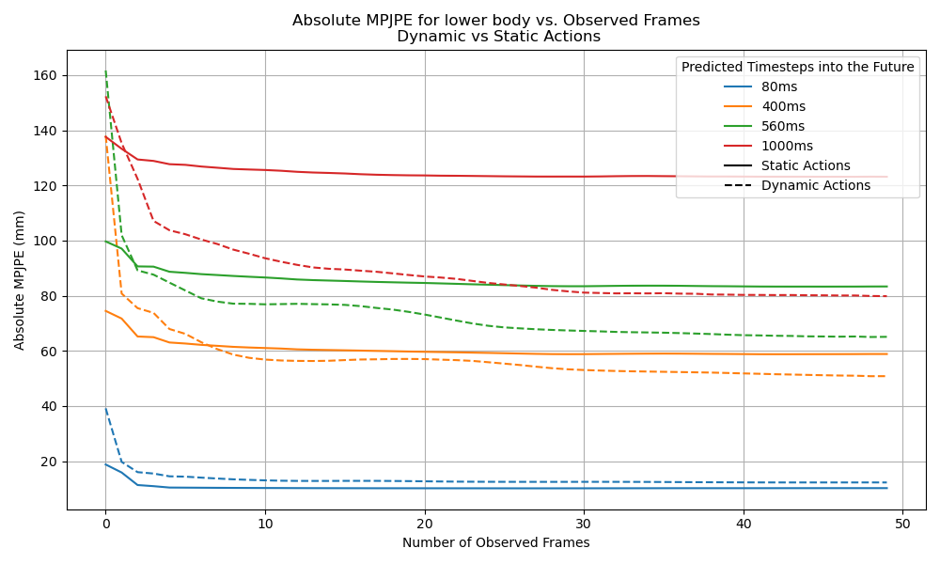
When looking at the distinction between static and dynamic actions for the upper and lower body separately, it becomes visible that the lower body is still outperforming the predictions for longer horizons. What is even more visible now is that for dynamic actions, the predictions of the lower body increase rapidly as more timesteps are given to the model. This strengthens the hypothesis that the model is able to estimate different aspects of a gait cycle, such as frequency and pace.
This plateau in performance is likely not correlated to number of observed frames, but rather displays the limitations of the model itself; given that the average MPJPE is also significantly higher than for shorter predictions, the conclusion is that the model is simply not capable of accurately prediction human motion that far into the future. As the prediction horizon increases, the task of prediction human motion becomes more challenging, and given the autoregressive nature of this model, small errors tend to propagate and balloon for further prediction horizons. As a result, the model cannot make reliable predictions for these prediction horizons, regardless of how many past frames are provided.

PhysMoP

Physics branch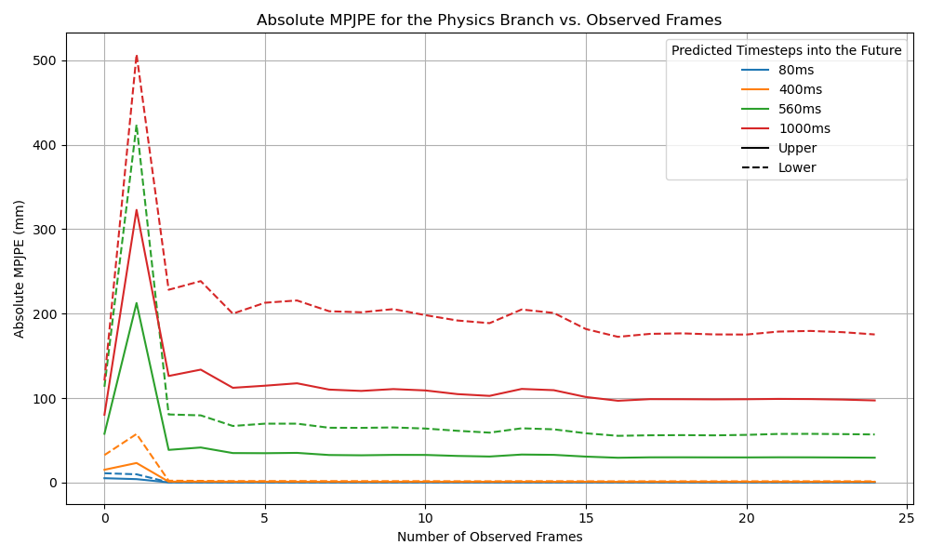
When looking at the performance for the physics model, it is notable that the performance for the shorter prediction horizons is a lot better. Comparing this to the GCNext model, the MPJPE approaches 0 for the two shortest prediction horizons. Additionally, it is visible that the predictions for the upper body are significantly better than the predictions for the lower body. (NOTE: Hoezo is dit?)
Moreover, when using less than 3 frames, the performance is a lot worse than with 3 or more frames. This is because this physics model only ever uses 3 frames, meaning that when the model has access to more than 3 frames, only the most recent 3 frames are used to predict the future movement.
This is directly related to the model’s architecture and the implementation of the classical mechanics principles. Rather than directly predicting the future movement of each joint, the model learns to estimate the parameters of the Euler-Lagrange equations of motion; specifically the model estimates the mass matrix (M), Coriolis matrix (C), and the joint actuation forces (\tau)
$$M(q)\ddot{q}+C(q, \dot{q})= τ$$
The model requires exactly three frames of joint positions and velocity data to estimate these parameters. Once these parameters are determined from the 3-frame window, the model uses Verlet integration to recursively predict future poses. This explains why performance stabilizes after exactly 3 observed frames and additional frames provide minimal improvement as the model's physics branch is specifically designed around this 3-frame structure.
x(t+Δt) = 2x(t) - x(t-Δt) + a(t)·Δt²

Data Branch
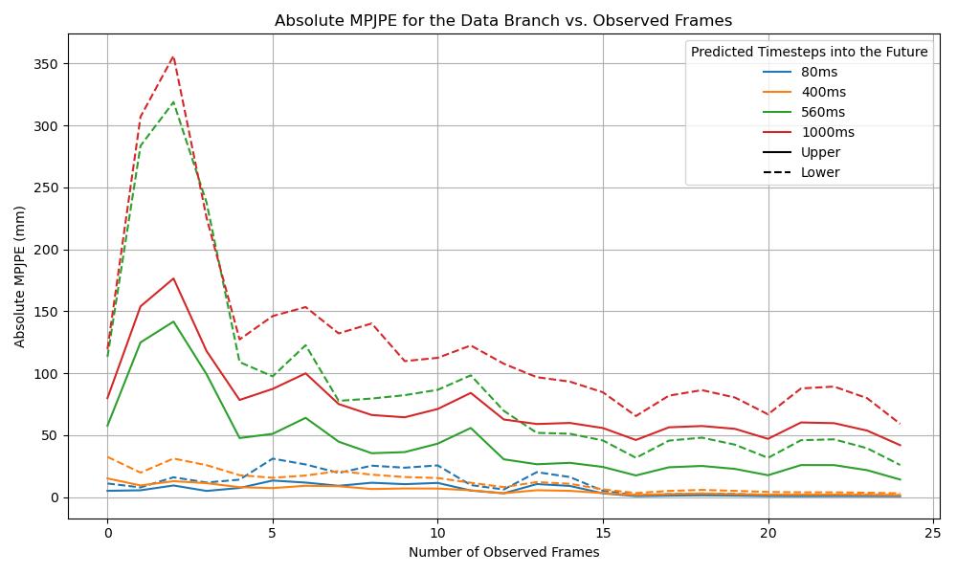
For the Data-Driven branch, we observe the same phenomenon where the upper body is performing quite a bit worse compared to the upper body (where this is the other way around for the GCNext model)
What is consistent with the GCNext model, is the dramatic decrease in prediction error as the observation length increases. More specifically, there is a large decrease in performance as the number of observed frames reaches 10-15, but notable plateaus after that. This can suggest that the model only requires 15 frames as a context window to make reasonable predictions.
Additionally, comparing the data-driven and physics-based branches, it is visible that for longer prediction horizons, the data-driven model outperforms the physics-based branch; for the 1000ms prediction horizon, the data-driven branch stabilizes around a MPJPE of 50mm for the upper body and 80mm for the lower body, where the physics-based branch stabilizes around 100mm and 180mm respectively. This is most likely the case due to the error propagation in the physics branch, where small inaccuracies in physical parameters grows over time.

Real-time prediction metrics
To evaluate both models on the how suited they are for real-time deployment, several metrics have been defined. These metrics have all been evaluated on a single continuous sample, that contains a walking sample.
First is the prediction time: this is the time it takes for the model to make the actual prediction. This does not include any of the preprocessing required for each model. To gain an average prediction time, the models have been run on one continuous sample, adopting a sliding window principle to feed the model the correct amount of data.
Second is the latency: this is the time between the model receiving the input and producing the output, including any preprocessing, smoothing etc. This metric represents the true end-to-end response time.
Jitter: This metric represents the variability in prediction latency, denoting the consistency of the model (?) (STD of latency)
Average MPJPE
Metric | GCNext | PhysMoP
Metric | GCNext | Data | Physics | Fusion
Prediction time [ms] | 76.8 | 7.04 | 77.4 | 78.2
Latency [ms] | 82.7 | 30.2 | 105 | 205
Jitter in latency [ms] | 6.27 | 1.93 | 11.0 | 23.7

