**Run Application & $0 Total Balance To Start**

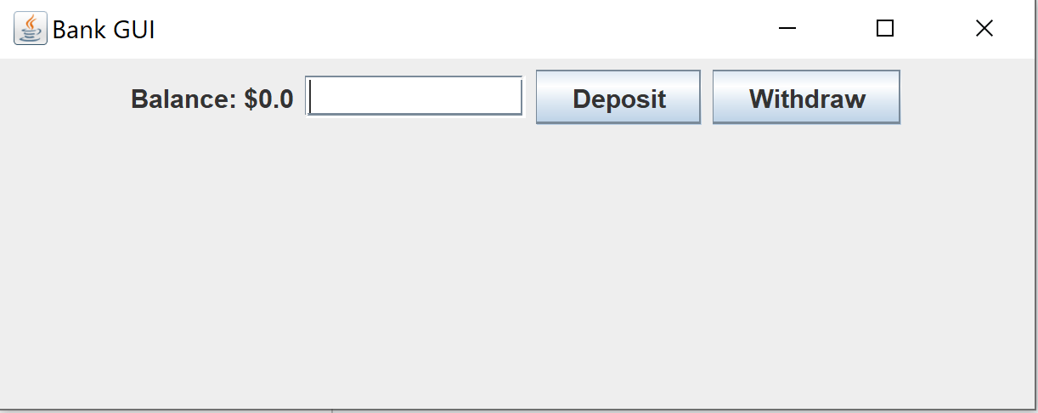

**Deposit $1500 & $1500 Total Balance**

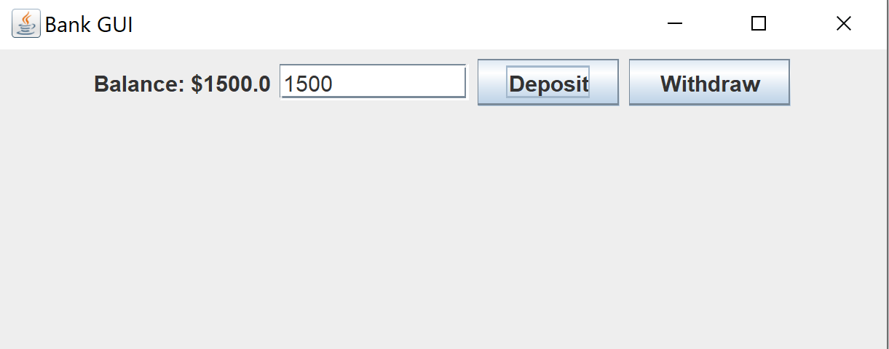

**Withdraw $250 & $1250 Total Balance**

