**Music Programs, Masters & Certificates**

Program and Labor Market Overview

Prepared by Andrew Thomas, Enrollment Analyst

Office of Graduate Education

Andrew.J.Thomas@du.edu

## **Report Overview & Summary**

The following report was prepared by the Office of Graduate Education to provide a high-level overview of master’s and certificate programs classified using the following CIP codes: Music Performance, General (CIP Code: 50.0903), Voice and Opera (CIP Code: 50.0908), Music Theory and Composition (CIP Code: 50.0904), Stringed Instruments (CIP codes: 50.0911), Music, Other (CIP codes: 50.0999), Jazz/Jazz Studies (CIP codes: 50.0910), Visual and Performing Arts, General (CIP codes: 50.0101), Religious/Scared Music (CIP codes: 39.0501), Music Management (CIP codes: 50.1003) and Conducting (CIP codes: 50.0906). All data is current as of the 2020 academic year and is provided by EMSI (See page 9 for more detail).

Below are some highlights from this Analysis

* Almost all 2020 completions were from on-ground programs (92% on-ground Vs. 8% online)
* The median number of completions for all institutions was 5 students, the 25th percentile was 1 student, the 75th percentile was 18 completions, and the 90th percentile was 42.
* The median salary for the associated occupations was $53K per year.
* The labor market is roughly evenly split between men and women (55% male – 45% female); about 76% white, 9% Black or African American, 8% Hispanic or Latino and 5% Asian; and a little older (56% where 45 or older).

## **Program Overview**

As of 2020, 92% of completions came from non-distance offered programs. In this case “distance offered” is defined as any program that can be completed entirely online.

## **Completions by Institution**

The following table lists the schools with the largest share of the market. YOY growth is calculated using 2020 completions compared to 2019 completions.

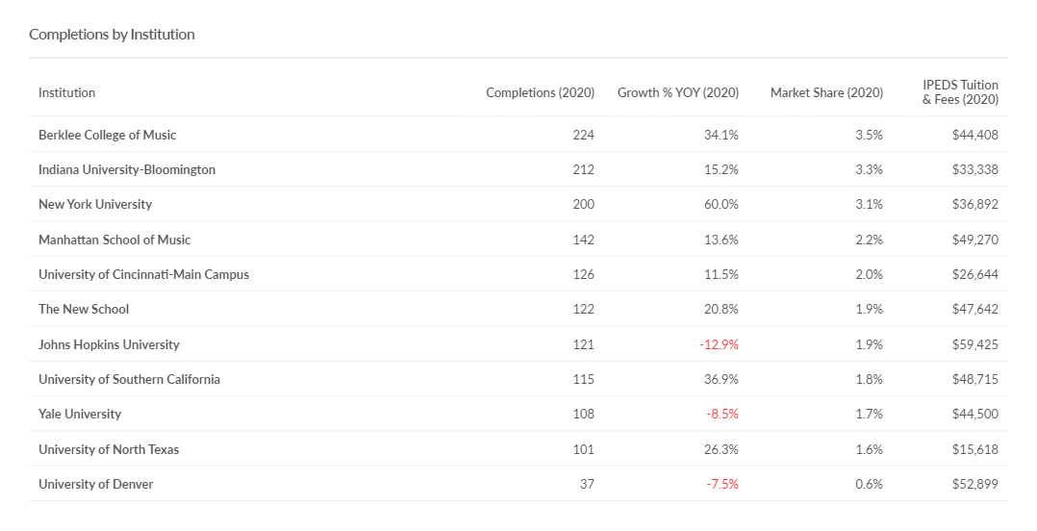

## **Completions by Institution (Cont.)**

The following chart displays 2020 YOY growth rates against 2020 completions. The vertical red line represents the average number of completions (18) and the horizontal line represents 0% growth.

**Completions by Institution (Cont.)**

The histogram below displays 2020 completions for all institutions with the relevant CIP codes. The median number of completions for all programs was 5 students, the 25th percentile was 1 completion, the 75th percentile was 18 completions and the 90th percentile was 42.

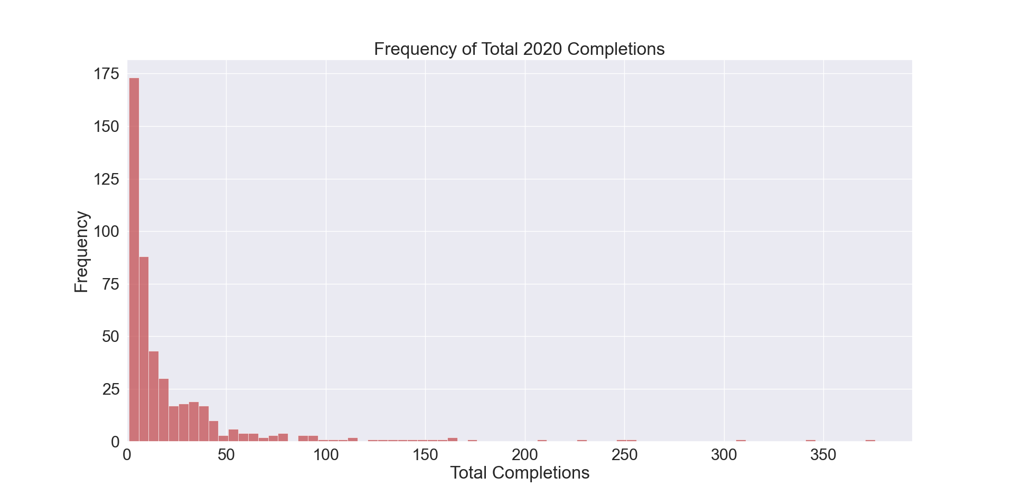

**Completions Over Time**

The following trend shows completions for both online and on ground completions with the relevant CIP codes.

**Labor Market Demand**

Occupational data is taken from the Bureau of Labor Statistics and is current as of 2020. **It is important to recognize that earnings data include professionals at all stages of their careers** and are therefore often inconsistent with the experiences reported by recent graduates.

**Occupation Demographic Breakdowns**

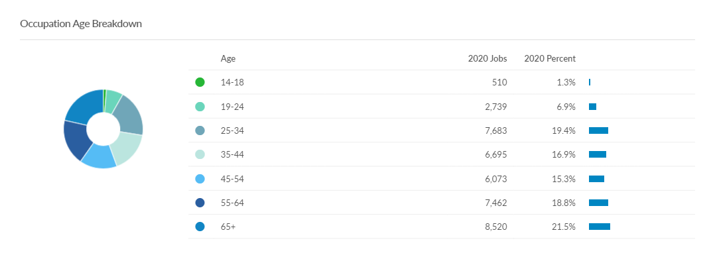

**Top Hard Skills**

**Top Soft Skills**

About Emsi

#### Emsi—an affiliate of the Strada Education Network—is a labor market analytics firm that is passionate about providing meaningful data for colleges and their students.

#### Our data is trusted by a breadth of users including researchers at colleges and universities, economic development organizations, and Fortune 500 companies.

#### Emsi data offers a three-pronged approach to labor market information:

#### Our traditional LMI combines dozens of government sources from agencies like the Bureau of Economic Analysis, U.S. Census Bureau, and Bureau of Labor Statistics into one dataset that details industries, occupations, demographics, academic programs, and more.

#### Emsi’s job posting analytics give a real-time look into the needs of employers in today’s labor market. Each month, millions of postings are scraped from employer sites and job boards, de- duplicated, and compiled into an actionable dataset.

#### Emsi also leverages workforce profiles—an innovative database of more than 100 million resumés and professional profiles that are aggregated from the open web. These profiles unify information for workers—such as education, employment history, skills, and more—to reveal robust detail on what is happening in today’s workforce.

#### Together, these data related to labor market demand, relevant skills, and the competitive landscape help colleges and universities make informed decisions about their program offerings.