**263 Modern Art**

1. 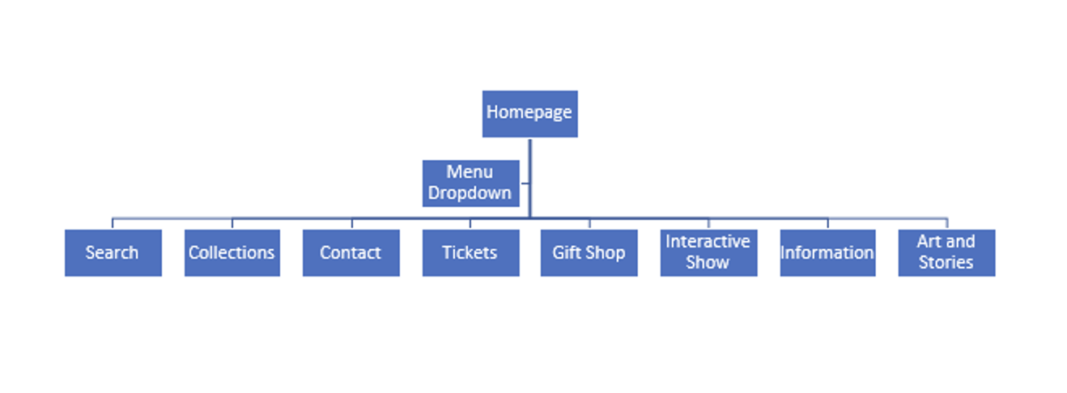
   1. Menu - makes everything easy to navigate
   2. Search - allows for an easy way to find specific items
   3. Collections - all the museums had this to allow for people to browse galleries of types of art
   4. Contact - for support and a way to get in touch with the museum
   5. Tickets - a place for people to buy tickets to the museum
   6. Gift shop - a lot of times they have a gift shop of items and memorabilia that has to do with the museum
   7. Interactive show - an interactive experience of art where you can click through and get information about the pieces and and have fun browsing
   8. Information - info about the museum and and people who made it come to life
   9. Art and stories - info about the artists, art, and other stories that have to do with how the art was made and how it came to be
2. 1. Body background color - #F8F0E5
   2. Text color - #102C57
   3. Link color - #EC8F5E
   4. Heading color - #9FBB73
   5. Site Navigation Background - #E48F45
   6. Site Navigation Highlight Color - #FF6000
   7. Site Navigation Link Color - #CEE6F3
3. <https://andrewkassel.github.io/ist263/lab7/>
4. <https://html5.validator.nu/?doc=https%3A%2F%2Fandrewkassel.github.io%2Fist263%2Flab7%2F>