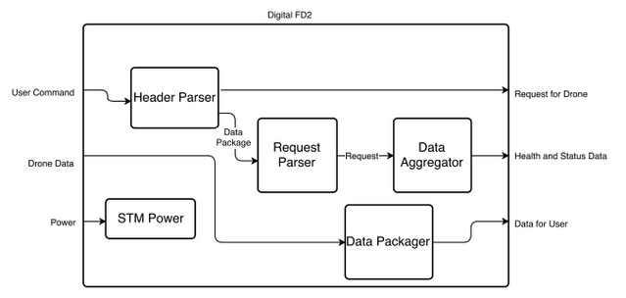

|  |  |
| --- | --- |
| **Module** | Header Parser |
| **Inputs** | * User Command |
| **Outputs** | * Request for drone * Data package for request parser |
| **Functionality** | The header parser examines the user command and pulls off the header. It then determines what interface the package was intended for and sends it onward accordingly. |

|  |  |
| --- | --- |
| **Module** | Request Parser |
| **Inputs** | * Data Package |
| **Outputs** | * Request |
| **Functionality** | The request parser will take data packages intended for the phased array and determine whether they are functional commands like (Turn Off, Turn On, etc) or data requests. If they are functional commands, the request parser will service them. If they are data requests, the request parser will prepare them for the data aggregator and send them on. |

|  |  |
| --- | --- |
| **Module** | Data Aggregator |
| **Inputs** | * Data Request |
| **Outputs** | * Health and Status Report |
| **Functionality** | The data aggregator collects data from its sensors and packages the data into a health and status report which is then sent back to the user. |

|  |  |
| --- | --- |
| **Module** | STM Power |
| **Inputs** | * Power |
| **Outputs** | None |
| **Functionality** | The power will service the STM and keep it running so that all the other functions can be fulfilled. |

|  |  |
| --- | --- |
| **Module** | Data Packager |
| **Inputs** | * Drone Data |
| **Outputs** | * Data for User |
| **Functionality** | The data packager will be ready to receive data from the drone. Upon receiving data, the data packager will put a header on the package so that it can get back to the end user through the app. It will then send the data onward. |

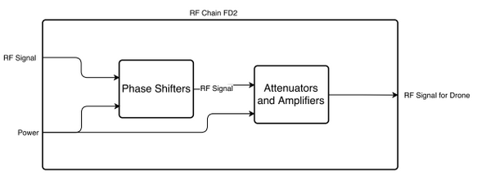

|  |  |
| --- | --- |
| **Module** | Phase Shifters |
| **Inputs** | * RF Signal * Power |
| **Outputs** | * Shifted RF signal |
| **Functionality** | The phase shifters take the signal intended for the final user and shift the phase of that signal. The input is a single signal and the output is 6 signals, each independently shifted. |

|  |  |
| --- | --- |
| **Module** | Attenuators and Amplifiers |
| **Inputs** | * RF Signal * Power |
| **Outputs** | * Amplified or attenuated RF Signal |
| **Functionality** | This takes the 6 RF inputs and then amplifies or attenuates those signals independently and outputs the modified signals. |