“Kyiv specialized College of Communications”

Commission of computer engineering

**REPORT ON THE IMPLEMENTATION**

**LABORATORY WORK №4**

From the discipline: "Operating systems"

**Topic: "Linux commands for process control"**

The students

performed Groups RPZ-03

Team 3:

Kanavets K.S.,

Kryvenko A.I.,

Kulikovska M.V.

Checked by the teacher

Sushanova V.S.

Кyiv 2023

***The material was prepared by student Кryvenko Andrew (AndrewKryvenko)***

2.1. Linux has several commands that can be used to monitor the status of processes. Here are some of them:

ps: This command shows information about the currently running processes. By default, it shows information about processes owned by the current user. You can use additional options to specify which processes to show and how to display the information.

top: This command shows a dynamic view of the system's processes in real time. It shows the current CPU and memory usage of each process, as well as other information such as process ID, owner, and status.

pstree: This command displays a tree diagram of the processes running on the system, showing how they are related to each other.

2.2 Yes, the ps command can be used to monitor the status of processes in real time using the "watch" command. For example, the following command will execute ps every 5 seconds and show the results in real time:

watch -n 5 ps aux

2.3. The top command can sort processes by several parameters, including CPU usage, memory usage, and process ID. To switch between the sorting options, you can press the following keys:

"P" to sort by CPU usage.

"M" to sort by memory usage.

"N" to sort by process ID.

"T" to sort by process execution time.

2.4. In Linux, there are several commands that can be used to terminate processes. Here are some examples:

kill: This command sends a signal to the process asking it to shut down.

pkill: This command sends a signal to one or more processes that match the specified name or other criteria. For example, the following command will send a SIGTERM signal to all processes with "firefox" in their name:

killall: This command is similar to pkill, but it sends a signal to all processes whose name matches the specified name exactly.

***The material was prepared by student Kulikovska Maria (@Smith5004)***

1. Beginning work in CLI mode in the Linux OS of the Linux family:

1.1. Start the VirtualBox virtual machine, select CentOS, and start it.

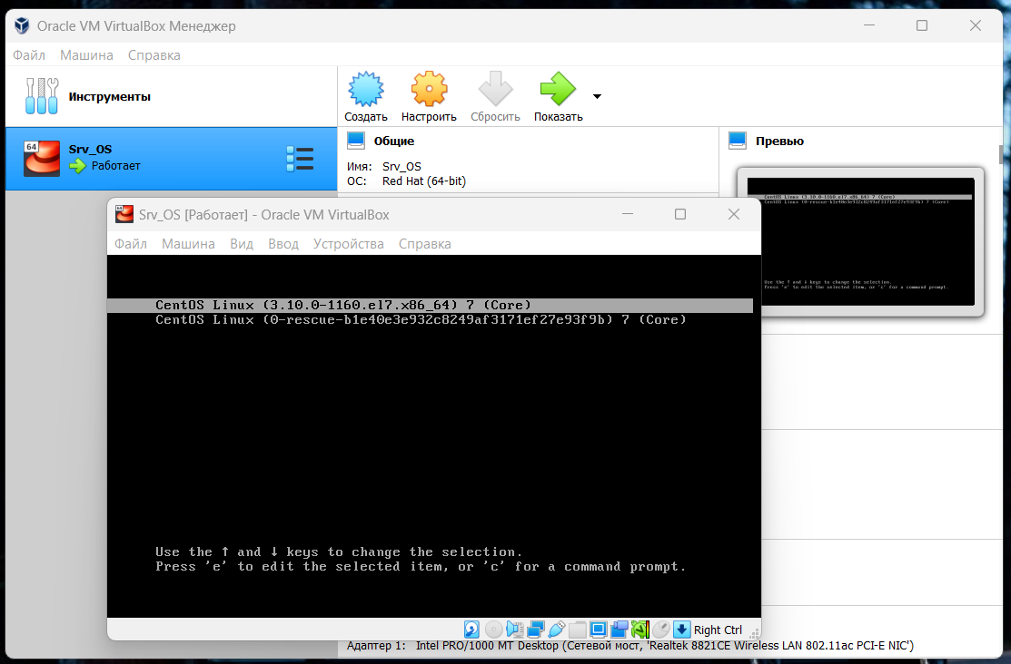

1.2. Open the Ubuntu_PC virtual machine

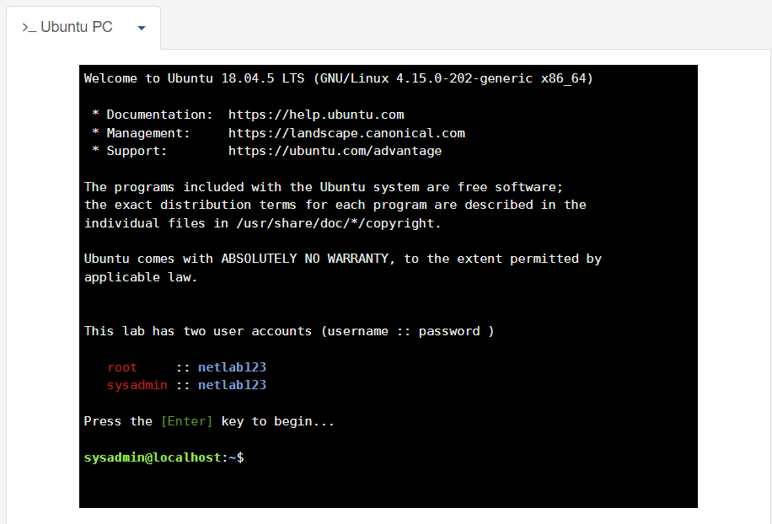

***The material was prepared by student Kanavets Kateryna (@kanavetsk)***

2.Answer the following questions:

- How do I display the contents of the /proc directory? Where is it located and what is it used for?

Describe the information about its contents?

To display the contents of the /proc directory, open a terminal and enter the following command:

ls /proc

The /proc directory on Linux contains virtual files and folders that provide information about processes and the system. This information can be accessed from the command line.

This command will list all folders and files in the /proc directory. Each folder corresponds to a process, and contains virtual files with information about the process.

Please note that the contents of /proc change in real time, so if you run the ls /proc command, the list may be different from the previous run.

- How to display information about current user sessions. What command can I use to do this?

Information about current user sessions can be displayed using the w command. It displays a list of users who are currently logged in to the system, their terminals, login time, idle time, and the names of running processes. To use the w command, open a terminal and type.

This command displays information about the current user sessions.

You can also use the who command, which also displays information about logged-in users, but does not indicate running processes.

- What actions can be performed in the terminal using the keyboard shortcuts Ctrl + C, Ctrl + D, and Ctrl + Z?

In the terminal, you can perform the following actions using the keyboard shortcuts Ctrl + C, Ctrl + D, and Ctrl + Z:

Ctrl + C: This combination stops the current command from executing. The command is canceled and you are returned to the command line character you were supposed to enter.

Ctrl + D: This combination ends terminal input. If you use it at the beginning of a new line, you exit the standard input and the command you entered is executed.

Ctrl + Z: this combination stops the current process, but does not close it. The command will continue to run in the background, and you will see the command line character you were supposed to enter again. This combination is usually used when you need to pause a command to perform another action and return to it later. To continue executing a paused process, use the fg command.

- The difference between a background process and a regular process. Where are they used?

The main difference between background processes and regular processes is that background processes do not wait for user input and do not block the command line, but continue to run in the background after the user exits the terminal or starts them with the & symbol at the end of the command. Background processes do not have access to the terminal, so their output and input are redirected to file descriptors, respectively.

Background processes are usually used when you want to run a process that takes a long time to execute or wait for input/output, and you don't want to block work in the terminal. For example, you might want to run a background process to perform database preparation or report a large amount of data.

- Describe the following commands and explain what they do - jobs, bg, fg.

The jobs command displays a list of all current background processes that have been launched in the current terminal session. Each process is assigned a job ID number, which can be used to identify and control the process using the fg and bg commands. For each process, its status, process ID (PID), and the command that was used to start the process are also displayed.

The bg command allows you to start a stopped background process and continue its execution. This command takes as an argument the job number, which can be obtained from the jobs command. If no number is specified, the last stopped job is executed by default. After the process is started, the command returns control to the user.

The fg command allows you to make a stopped background process active and continue its execution in the foreground. This command also takes the task number as an argument. If no number is specified, the last stopped task is executed by default. Once a process is started, the command locks the command line until the process is completed or stopped again by pressing Ctrl+C.

These commands are very useful for managing background processes, such as putting them in the background or resuming them in the foreground after they have been stopped. They can also be used to check the current status of processes running in the terminal and to stop an unwanted process.

- What command can I use to view information about background processes and tasks running in the system?

and tasks running in the system?

Information about background processes and tasks running in the system can be viewed using the ps command. By default, this command displays information about all running processes in the current terminal session, including background processes.

To view only background processes, you can use the -j switch, which displays information in a format that complies with the Job Contro standard.

In addition, the -u switch allows you to specify the user for whom you want to display information about processes.

The -f switch displays more detailed information about processes, such as the process identifier (PID), parent process identifier (PPID), process start time (START), execution time (TIME), and other parameters.

- How do I pause a background process, resume it, and restart it if necessary?

To pause a background process, you can use the key combination Ctrl + Z. This will cause the process to be stopped and transferred to the stopped state, i.e. suspended, but not closed.

To resume a paused process, you can use the bg command, which will put the process in the background. For example, if the suspended process has an identifier of 1, you can resume its execution as follows:

bash

bg 1

If you need to restart a paused process, you can first close it with the kill command and then restart it again. For example, if the paused process has ID 1, you can first close it as follows:

bash

kill 1

Then you can start the process again using the command you used to start the process the first time. For example, if you started the process with the python command my_script.py, you can start it again with the following command:

python my_script.py &

where the & symbol allows you to run the process in the background.

***The material was prepared by student Kulikovska Maria (@Smith5004)***

3. Launch the terminal, and in the command line, perform the following steps to familiarise yourself with the processes:

- launch the top command, review the result of this command, and characterise the most active processes in the system;

The first two columns are the process number (PID) and the name of the user running it (USER).

The next 2 columns show what priority the process currently has (PR) and the priority assigned to it by the NICE command (NI).

The information contained in the other columns describes the level of resource consumption. They are decoded in the following way:

* VIRT - virtual memory used by the process
* RES - physical memory used by the process
* SHR - total amount of memory shared by the process
* S - current status of the process: R - running; S - sleeping, Z - zombie
* %CPU - percent CPU time used
* %MEM - percentage of RAM used by the process
* TIME+ - process running time since it started
* COMMAND - name of the command (program) that initiated the process.

Useful information about resource usage can be found not only in the table itself, but also in the five lines preceding it. They are a kind of summary of all processes.

The first line (top) gives us an overview of the system load. Here you can see:

* current time
* up - the duration of the system since startup
* user - current number of users in the system
* load average - the average load of the system one minute ago, five minutes ago, and 15 minutes ago, respectively.

The most active processes are:

Rsyslog is a Linux log management service that allows you to filter log content, transmit logs over the network.

Named is an Internet domain name server.

Login is used when logging in and is used to switch from one user to another at any time.

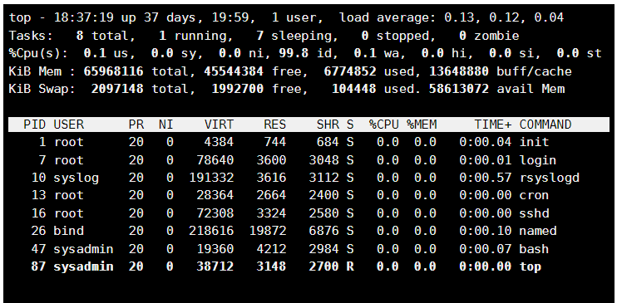

- pause the execution of the top command (use the key combination

Ctrl + c);

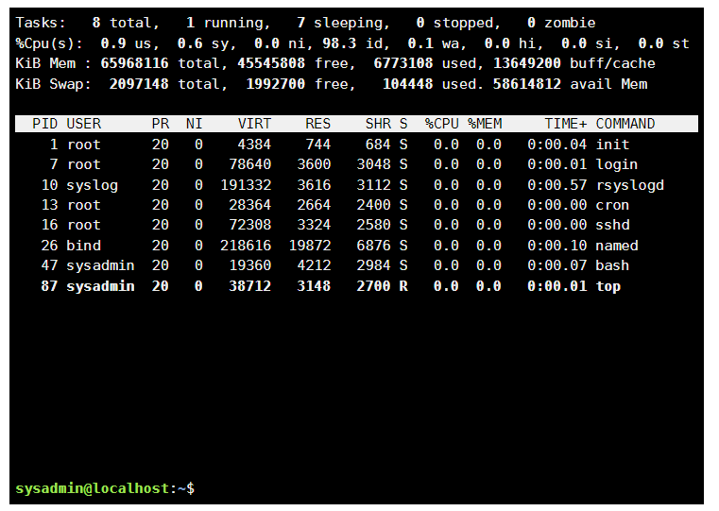

- To display information about the processes using the ps command;

Four columns are labeled PID , TTY , TIME and CMD .

▪PID - process identifier.

▪TTY - control terminal name for the process.

▪TIME - cumulative CPU time of the process in minutes and seconds.

▪CMD - name of the command that was used to start the process.

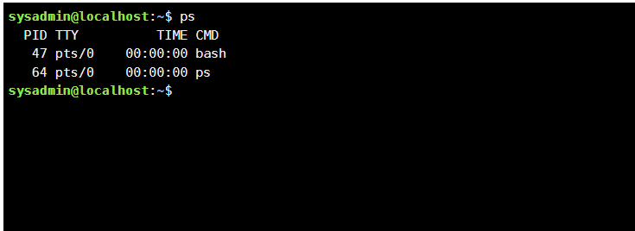

- Provide 5 examples using different options of the ps command:

1. ps -e (Display information about all processes)

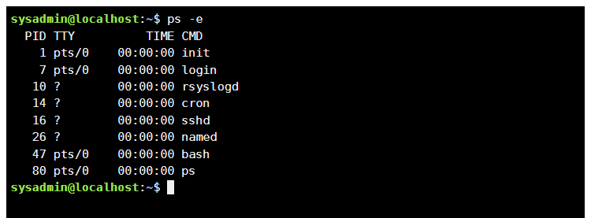

1. pstree(The command outputs the processes in a tree form. One advantage of this is that you can immediately see which process is the parent of which process.

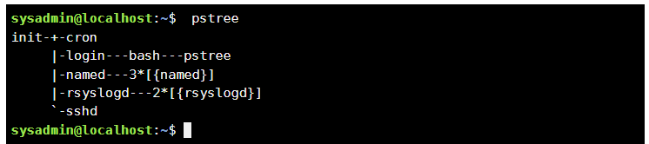

1. ps aux (The option a instructs the ps command to display the processes of all users, except those processes that are not associated with the terminal and leader group processes. The u stands for user-oriented format, which provides detailed information about the processes. The x option in ps lists processes without a controlling terminal.

The command will display information in the eleven columns USER, PID, %CPU, %MEM, VSZ, RSS, STAT, START, TTY, TIME and CMD.)

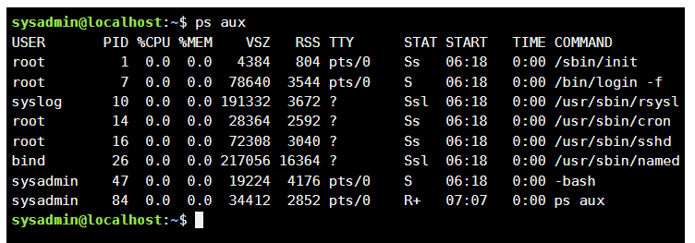

1. ps -l (Displaying information in a long format)

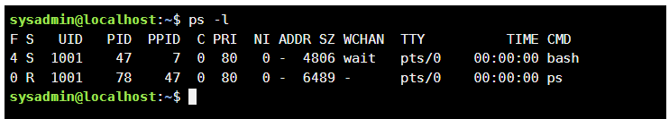

1. ps -eF (This example uses two parameters: the -e parameter, which shows all processes running on the system, and the -F parameter, which expands the output.)

This option adds the following columns:

•SZ - this is the size of the process in memory;

•RSS - the real size of the process in memory;

•PSR - processor core on which the process is running

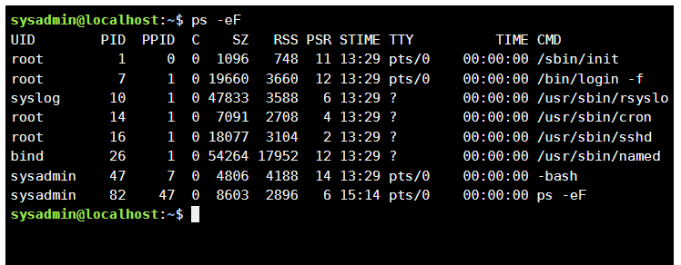

- check if you have any background processes running, which ones?

To list your background processes we use the command: jobs.

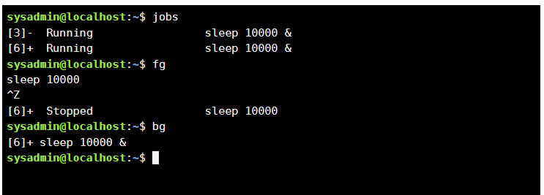

-resume execution of the suspended background process first in the foreground position, then pause it again, and then resume its execution in the background position.

To bring the background process to the foreground, use the command fg

To stop the process press Ctrl+Z.

To move the stopped process to the background, use the command bg .

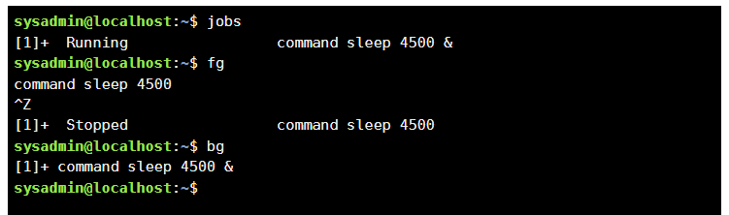

- complete the work of this process

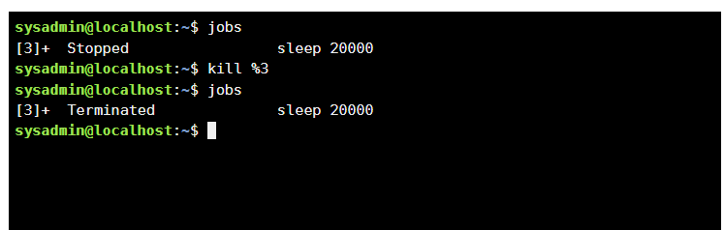

Glossary of terms

Robustness comes complexity - з надійністю приходить складність

Determining priorities - визначення пріоритетів

Examine - досліджувати

Subset - підмножина

Gleaning - збирання

***The material was prepared by student Кryvenko Andrew (AndrewKryvenko)***

**Checklist questions**

1. **What is the purpose of the /proc directory in Linux systems. What information does it store?**

The /proc directory is a virtual file system that provides information about running processes and system resources. It contains files and directories that represent different aspects of the system, such as the status of processes, hardware information, and network statistics.

1. **How among any three processes to dynamically determine which of them at the current time uses the largest amount of memory at the current time? What percentage of memory does it consume of the total?**

The "top" command can be used to dynamically determine which processes are using the most memory. To see the top three processes sorted by memory usage, we can run "top" and then press "M" to sort by memory usage. The percentage of memory used by each process is shown in the "%MEM" column.

1. **How to get the hierarchy of parent processes in Linux systems? Give its structure and characterize it.**

The "pstree" command can be used to display the hierarchy of parent processes in a Linux system. The structure is a tree-like diagram, with each process represented by a node and its parent process represented by a branch. The root of the tree is the init process, and all other processes are descendants of this process. The structure shows the relationship between processes and how they are created and terminated.

1. **What is the difference between the command top and ps?**

The "top" command provides a real-time, dynamic view of the system's processes and resource usage. It updates the display periodically and can be sorted by various criteria, such as CPU usage or memory usage.

The "ps" command displays information about running processes, including their process ID, owner, status, and resource usage. It can be used to display a snapshot of the system's processes at a given time.

1. **What additional features does htop implement in comparison with top?**

The "htop" command is an interactive process viewer that provides additional features compared to "top". These include the ability to scroll horizontally and vertically through the process list, tree view of processes, color-coded display of process information, and the ability to search for specific processes.

1. **Describe the components of your mobile OS for monitoring processes running in the system?**

Mobile operating systems typically have built-in tools for monitoring processes, such as the "Activity Monitor" on iOS or the "Developer Options" on Android. These tools allow users to view information about running processes, including CPU and memory usage, as well as manage and terminate processes.

1. **Does your mobile OS support terminal control of processes, describe how exactly.**

Both iOS and Android support terminal control of processes through third-party apps or by enabling developer options. This allows users to use command-line tools to manage and monitor processes running on the system.

1. **Is it possible to install third-party software that allows you to organize the management and monitoring of processes in your mobile phone. Briefly describe them.**

Yes, there are many third-party apps available for iOS and Android that allow users to monitor and manage processes on their mobile devices. Some popular examples include Process Monitor on iOS and Process Manager on Android. These apps provide detailed information about running processes and allow users to manage and terminate them as needed.