“Kyiv specialized College of Communications”

Commission of computer engineering

**PERFORMANCE REPORT**

**WORK-CASE №3**

From the discipline: "Operating systems"

The students

performed Groups RPZ-03

Team 3: Kanavets K.S.,

Kryvenko A.I.,

Kulikovska M.V.

Checked by the teacher

Sushanova V.S.

Київ 2023

***The material was prepared by student Кryvenko Andrew (AndrewKryvenko)***

1. **In the Virtual Box, VMWare Workstation (or another virtual machine of your choice), you need to run:**

- Clone your virtual desktop OS (Work-case 2). How can this be done? Let's demonstrate all the steps;

To clone a virtual machine in VirtualBox, follow these steps:

1. Start VirtualBox and select the virtual machine you want to clone.

2. Right-click on the virtual machine and select Clone.

3. In the "Clone Virtual Machine" window, type a new name for the clone and select cloning options, such as disk type, disk format, and clone type.

4. Click the Next button and edit the virtual machine settings as needed, for example, correct the MAC address of the network card if the clone is to run on the same network as the original virtual machine.

5. Click the Create button to complete the cloning of the virtual machine.

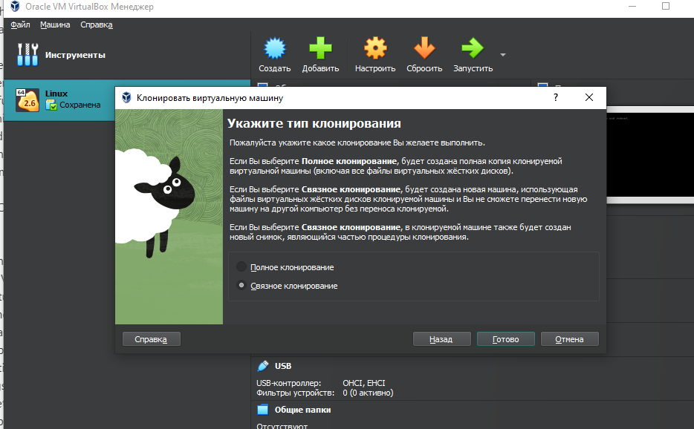

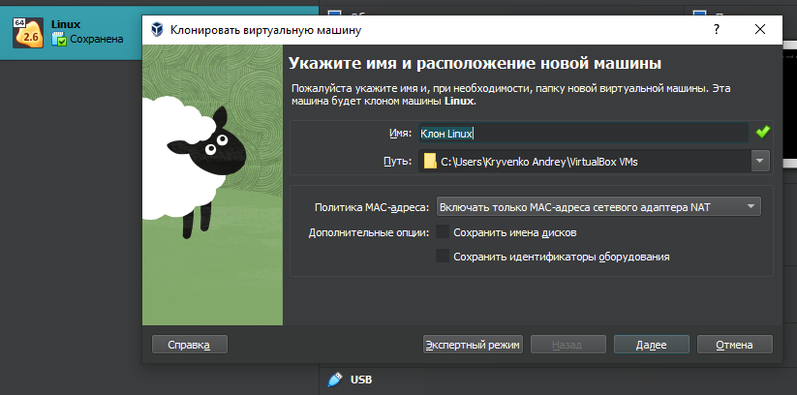

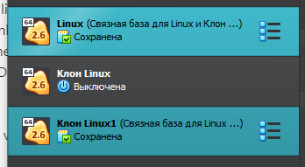

- You may need to transfer (clone) the OS to another virtual environment. What steps do I need to take to export my virtual desktop OS?

To export a virtual machine from VirtualBox, you need to perform the following steps:

1. Start VirtualBox and select the virtual machine you want to export.

2. Right-click on the virtual machine and select Export.

3. In the Export Virtual Machine window, select a location to save the export file and export options, such as file format and whether to include/exclude virtual disks and other files.

4. Click the "Next" button and the following buttons to confirm the settings and start the virtual machine export process.

5. After the virtual machine export is complete, you can copy the export file to another machine and import it into VirtualBox on that machine.

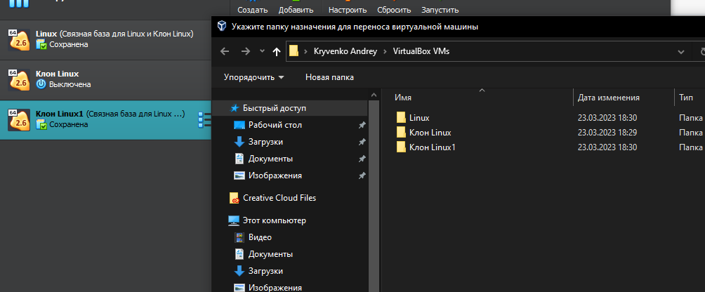

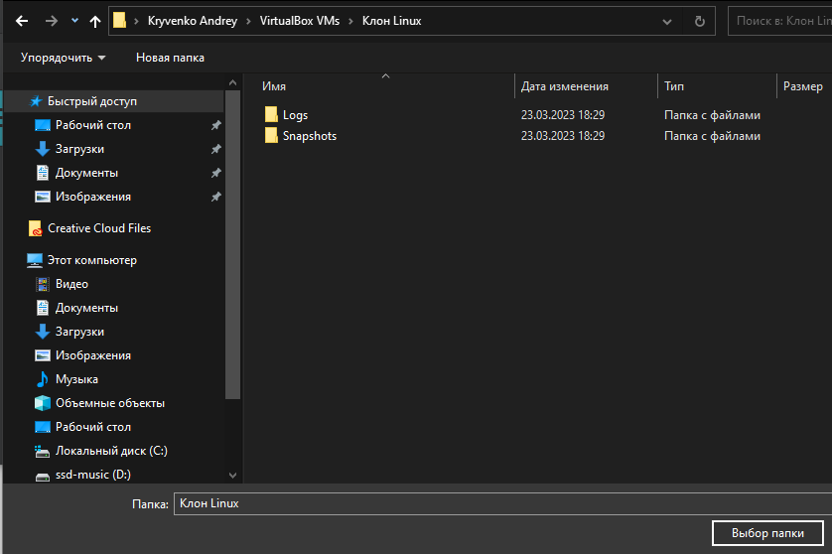

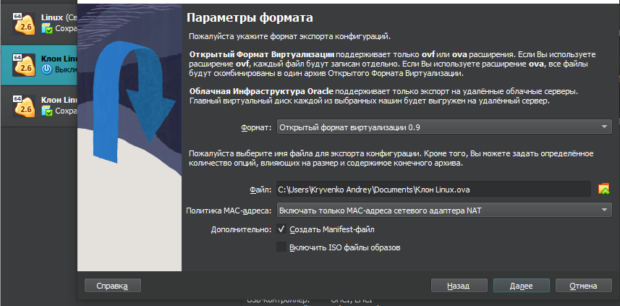

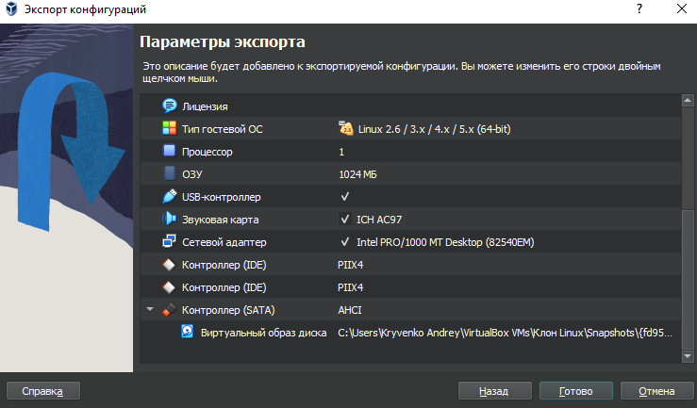

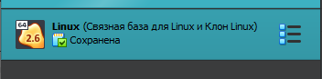

***The material was prepared by student Maria Kulikovska (@Smith5004)***

1. **During operation, one working virtual machine can interact with**

**another. For this, it is necessary to deploy a network between them.**

To network two virtual machines using Virtual Box for networking using NAT network mode you need:

1) Open VirtualBox Network Manager by selecting File > Tools > Network Manager .

2) Open the "NAT Network" tab. , then click "New" at the top to create a new network. Fill in the necessary information here, such as the network name and IPv4 prefix, and make sure "Enable DHCP" is checked.

3) Click the "Apply" button to save your network.

4) Go to the virtual machine settings, click the "Network" tab and select "NAT Network" from the "Connected to" drop-down list .

5) Select the NAT network you just created from the "Name" drop-down list.

6) Click OK to save your settings.

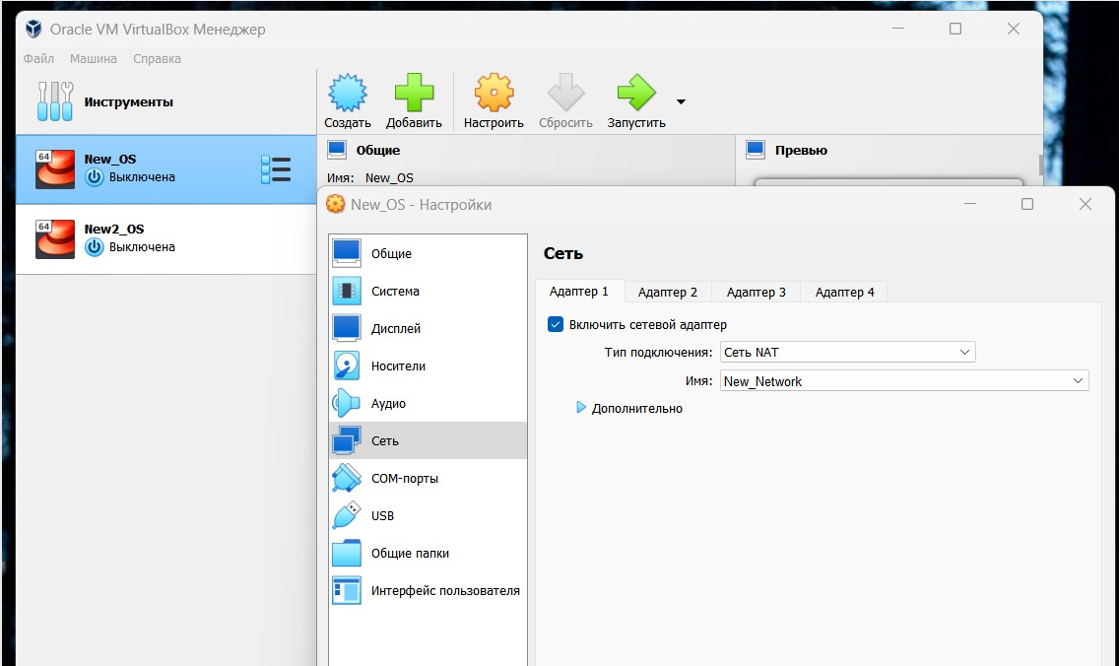

Describe what types of organization of network connections are supported in the environment of virtual machines, what is the peculiarity of each of them:

● Network Address Translation

The default connection type assigned to each virtual machine. It meets the minimum requirements for working on the Internet and does not require initial configuration.

The NAT protocol allows a guest operating system to access the Internet using a private IP that is not accessible from the external network or to all machines on the local physical network. Such network setup allows to visit web-pages, download files, browse e-mail. And all this using a guest operating system. However, it is not possible to connect directly to such a system from the outside if it uses NAT.

NAT simulates a connection to a router. The router is the Virtualbox network module, which processes outgoing packets and forwards them to the host system, and handles incoming traffic in the same way. A router is created between each virtual machine and the host system. Through this separation, the virtual machine becomes protected from contact with other machines and intrusions from the outside network.

In other words, it allows the virtual machines to access the Internet, but not to communicate with each other.

● Network bridge

In a "Network Bridge" connection, the virtual machine works just like any other computer on the network. In this case, the adapter acts as a bridge between the virtual network and the physical network. On the external network side it is possible to connect directly to the guest operating system.

The adapter in "Network Bridge" mode connects, bypassing the host, to the device that distributes IP addresses within the local network to all physical NICs. VirtualBox connects to one of the installed NICs and passes packets through it directly; you get the work of a bridge, over which data is transmitted. As a rule, the adapter in the "Network Bridge" model gets a standard address from the range 192.168.x.x from the router. Therefore, the virtual machine on the network looks like a normal physical device, indistinguishable from the rest.

Network bridge mode, is used so that your virtual machines can access the Internet, exchange data with each other and be seen from the outside.

● Host-only virtual adapter

The mode creates a network between the host system and the virtual machine, bypassing the physical network card. A software network interface appears on the computer that serves to exchange data between the virtual machines and the host system. Virtual machines can connect to each other and to the host system as if connected through a switch. As in Internal Network mode, no physical interface is provided to the virtual machine, so the machines cannot communicate with the external network.

Unlike other virtualization products, the NAT adapter in VirtualBox cannot act as a bridge between the default network device on the hosts. Therefore, there is no direct external access to the machines "hidden" behind NAT - neither to the programs running on them, nor to the data residing on the hosts themselves.

Virtual network interface is created in host machine and guest system's network connection is bridged to it. The difference from bridge is that it is not a physical interface, but a virtual, additional interface.

● Internal Network

The connection type simulates a closed network, accessible only to its member machines. The network is completely closed to the host system and other external devices.

The internal network is similar to network bridge mode. As in bridge mode, a machine can communicate with other machines on its network, but has no access outside of it. Since neither machine has direct access to the physical network adapter of the host system, the network is completely closed, outside and inside. The network itself is created automatically when you select this type of connection. The mode has no additional settings, the user can only change the network name.

***The material was prepared by student Kanavets Kateryna (@kanavetsk)***

1. **Deploy a network between your working OS and its clone (Task 1):**

- Demonstrate the basic commands for configuring OS network settings and explain what they do.

Basic commands for configuring OS network settings:

ifconfig - This command allows you to view and configure network interfaces on your computer, such as IP addresses, MAC addresses, and netmasks.

ping - This command allows you to check the availability of other computers on the network. It sends data packets to the specified IP address and receives a response.

traceroute-This command allows you to trace the path of data packets sent to the specified IP address using network routes.

netstat - This command allows you to view the active network connections and ports used on your computer.

ipconfig (for Windows) or ifconfig (for Linux/MacOS) - these commands allow you to view and configure network settings such as IP addresses, DNS servers, and netmasks.

These commands can be useful for configuring the OS's network settings, such as setting the IP address, netmask, and default gateway. These settings help your computer connect to and communicate with other computers on the network. In addition, these commands can help you identify problems on your network, such as a lost connection or a slow data routing path.

- Configure and demonstrate the exchange of messages between two operating systems over a local network. What commands do you need to enter in the terminal?

You can use different protocols and programs to exchange messages between two OSes over a local network, for example, ping, ssh, scp, netcat, etc. Here are some sample commands:

ping is the easiest way to check the availability of a computer on the network.

Screenshot_1

ssh is a protocol for securely connecting to another computer over a network. To establish a connection to another OS, enter the command in the following format:

Screenshot_2

scp - allows you to copy files between devices on the network.

Screenshot_4

- Set up a shared network folder for both operating systems. Try copying files from this folder to the user's home directory (virtual desktop) and desktop (virtual desktop clone).

Here are the steps to set up a shared folder between two Ubuntu virtual machines:

On one of the operating systems, install the samba package, which allows you to set up sharing of folders and files:

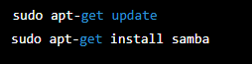

Create a new shared folder:

Screenshot_1

Configure samba for this folder by opening the /etc/samba/smb.conf file and adding the following lines to the end of the file:

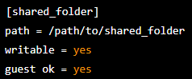

Start the samba service:

Screenshot_4

On the second OS, connect to the shared folder by opening the file manager and selecting "Connect to Server" or "Connect to Server" (depending on your localization), and enter the IP address of the first OS and the path to the shared folder.

After successfully connecting to the shared folder, open a terminal and enter the following command to copy files from the shared folder to the user's home directory:

Screenshot_5

***The material was prepared by student Кryvenko Andrew (AndrewKryvenko)***

**4. How can you organize the exchange of information between your main OS (e.g. Windows) and virtual OSes? Copy an arbitrary audio file from your main OS to the desktop of the virtual OS and its clone. How do I do the opposite when I want to copy a document from the virtual OS desktop to your main operating system?**

You can use the shared folder that VirtualBox creates by default to organize the exchange of information between the main OS and virtual OSes. For this, do the following:

1. In VirtualBox, open the settings of the virtual machine from which you want to access the shared folder. Select the "Shared Folder" tab.

2. In the Shared Folders list, click the button with the "+" sign and select the path to the folder on the main OS that you want to share.

3. Select the name of the folder and the virtual machine's access settings.

4. In the virtual machine, start the operating system and open Explorer. The shared folder should appear in the Network list.

5. Open the shared folder and copy the file to the virtual machine desktop.

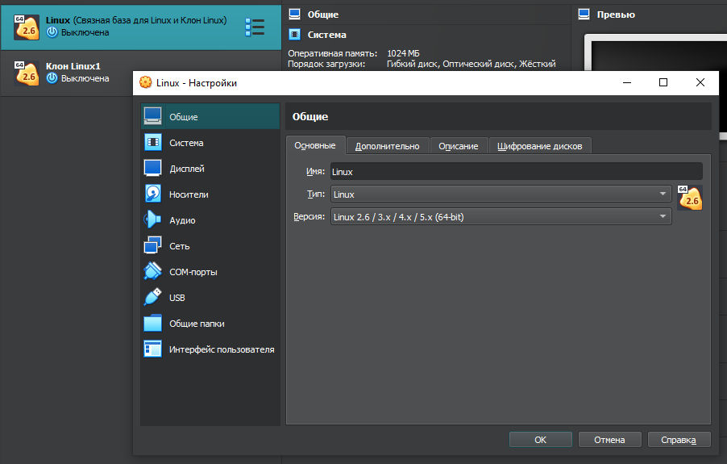



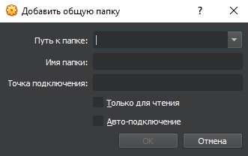

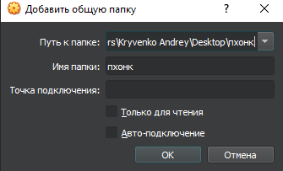

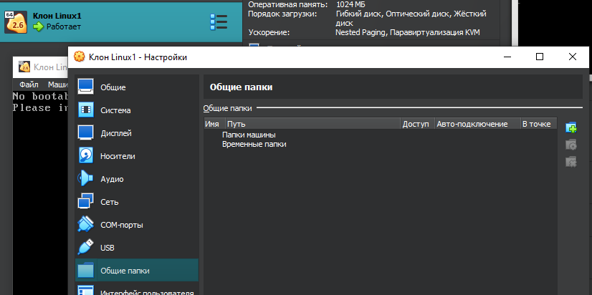

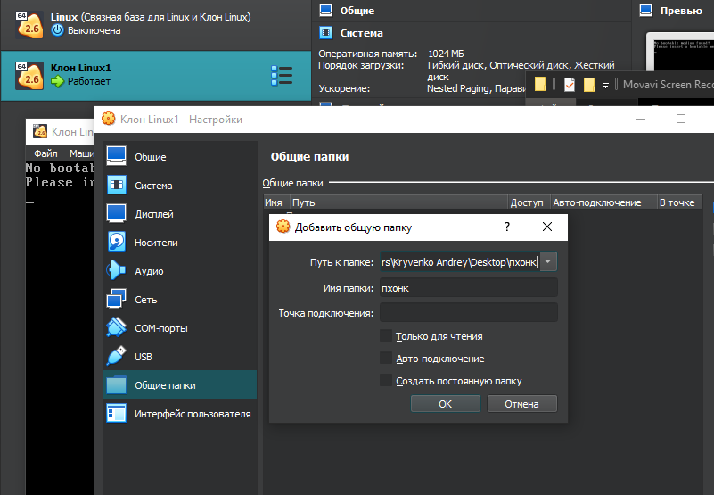

To copy a document from the virtual machine desktop to the main OS, do the following:

1. Open the shared folder in the virtual machine and copy the file to the desktop.

2. Open the Explorer of your main OS and go to the folder with the shared folder that we specified in the VirtualBox settings.

3. Copy the file from the virtual machine desktop to this folder.

4. Open the file on the desktop of your main OS.