“Kyiv specialized College of Communications”

Commission of computer engineering

**PERFORMANCE REPORT**

**WORK-CASE №4**

From the discipline: "Operating systems"

The students

performed Groups RPZ-03

Team 3: Kanavets K.S.,

Kryvenko A.I.,

Kulikovska M.V.

Checked by the teacher

Sushanova V.S.

The material was prepared by student **Kryvenko Andrew (@AndrewKryvenko)**

In the course of your work, you often need to install new programs and applications. To do this, you need to be able to work with package managers in the terminal:

**- Define the terms "package" and "repository" in detail.**

A package is a collection of software that contains executable files, configuration files, documentation, and other components that are required for the program to function. A package may also contain information about the dependencies required for the program to work.

A repository is a centralized storage of packages provided by a software vendor. A repository can contain different versions of packages and their dependencies.

**- Provide a brief overview of existing package managers in Linux. Describe their main features.**

APT is a standard package manager in Debian, Ubuntu and their derivative distributions. It can install, update and remove packages from repositories, as well as search for packages and their dependencies. Simple and reliable package manager, easy to use from the command line.

YUM is a package manager for distributions that use RPM packages. It allows you to install, update and uninstall packages from repositories, as well as search for packages and their dependencies. It is considered the standard package manager for CentOS and Fedora users.

Pacman is a package manager for the Arch Linux distribution. It allows you to install, update and remove packages from repositories, as well as search for packages and their dependencies. Pacman is simple and fast to use, but may require some user training.

Zypper is a package manager for distributions that use the RPM package format. It allows you to install, update, and uninstall packages from repositories. surveyors, as well as search for packages and their dependencies. Zypper has a fairly simple and user-friendly interface and can also work with cache storage for quick access to packages.

DNF is a package manager for distributions that use the RPM package format, such as Fedora, Red Hat Enterprise Linux, and their derivative distributions. DNF is an improved version of YUM, with faster and more efficient package search, a user-friendly interface, and support for containerization technologies.

Snap is a package manager that uses the Snap package format, which provides portability and autonomy of programs. It downloads packages from its own Snap Store repository, which allows you to install packages regardless of the distribution version. Snap also has an automatic package update mechanism and integration with AppArmor for security.

The material was prepared by student **Kanavets Kateryna (@kanavetsk)**

3. **Install it in the terminal through the package manager on your system:**

- **A new video or audio player.**

**- The environment for the programming language you are learning.**

To install a new video or audio player, you may need additional software for your operating system. For example, if you have Ubuntu Linux, you can install VLC Media Player by running the following command at a terminal:



As for the environment for a programming language, it all depends on the specific programming language and operating system you are using. For example, you can install the Python environment by running the following commands in a terminal:



These commands will install Python 3 and its optional libraries on your computer.

The material was prepared by student **Kryvenko Andrew (@AndrewKryvenko)**

4. **How can you install new programs through application stores and package managers in a graphical environment. Give your own examples.**

One example of an application store in Linux is the Ubuntu Software Center, which is available in the Ubuntu operating system. Users can search for and browse available applications, view ratings and reviews, and install them with just a few clicks. Another example is GNOME Software, which is the default software center in the GNOME desktop environment used by many Linux distributions.

Package managers are another way to install new programs in Linux. Many Linux distributions have a default package manager that can be accessed through the graphical interface. For example, in Ubuntu, the Synaptic Package Manager allows users to search for and install software packages, as well as manage software repositories and dependencies. Another popular package manager is the Discover software center, which is used in KDE Plasma desktop environment.

The material was prepared by student Maria Kulikovska (@Smith5004)

1. Identify which package manager your Linux distribution uses.

(Operating system - MX Linux )

Describe the basic commands for working with it:

MX Linux supports at least three package managers or external interfaces. In addition to command line based APT, there are also Synaptic applications with graphical user interfaces as well as the MX Package Installer .

The latter even allows the installation of newer Debian and various antiX kernels. You can also use Debian backports and the MX test repository. The free Flathub store is also supported.

- Search, download, and install necessary packages that are not on your system.

Apt-cache search web browser (search for the packages we want to download)

Sudo apt-get install midori (uploading)

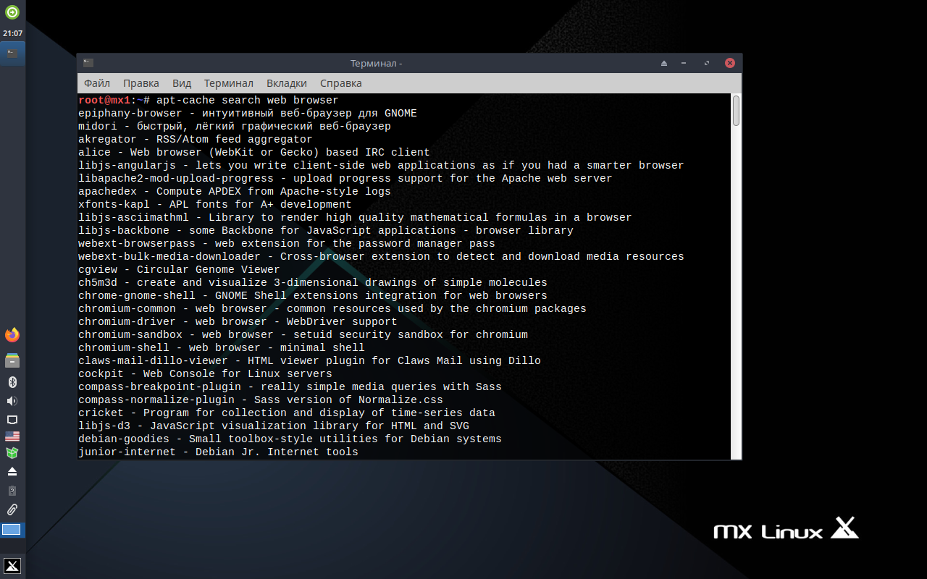

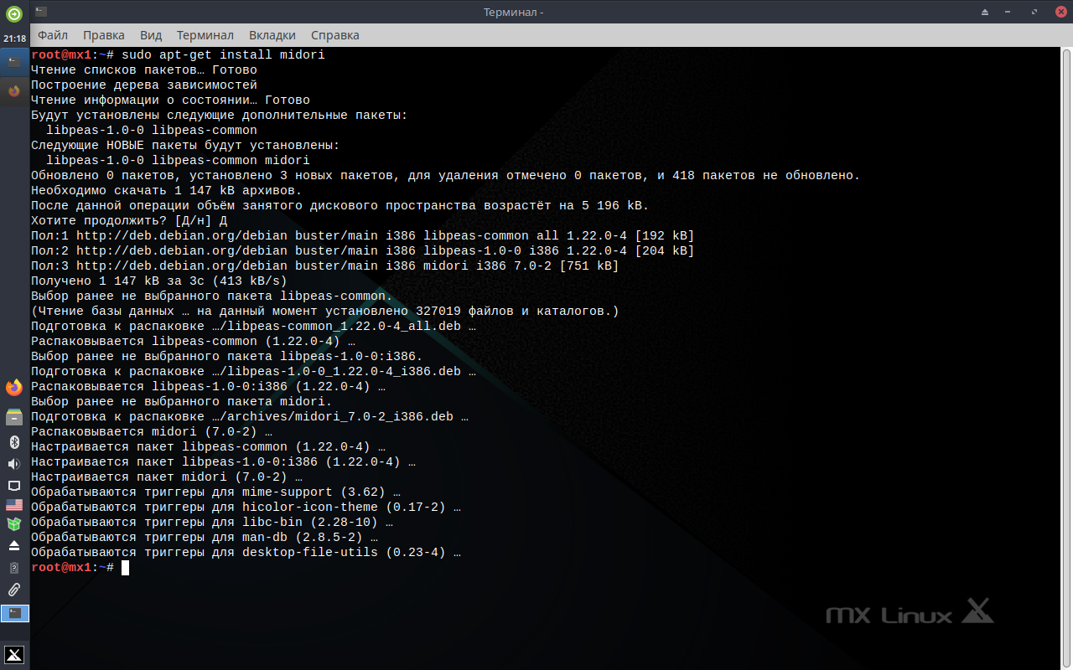

- View information about installed and available packages. (dpkg -l)

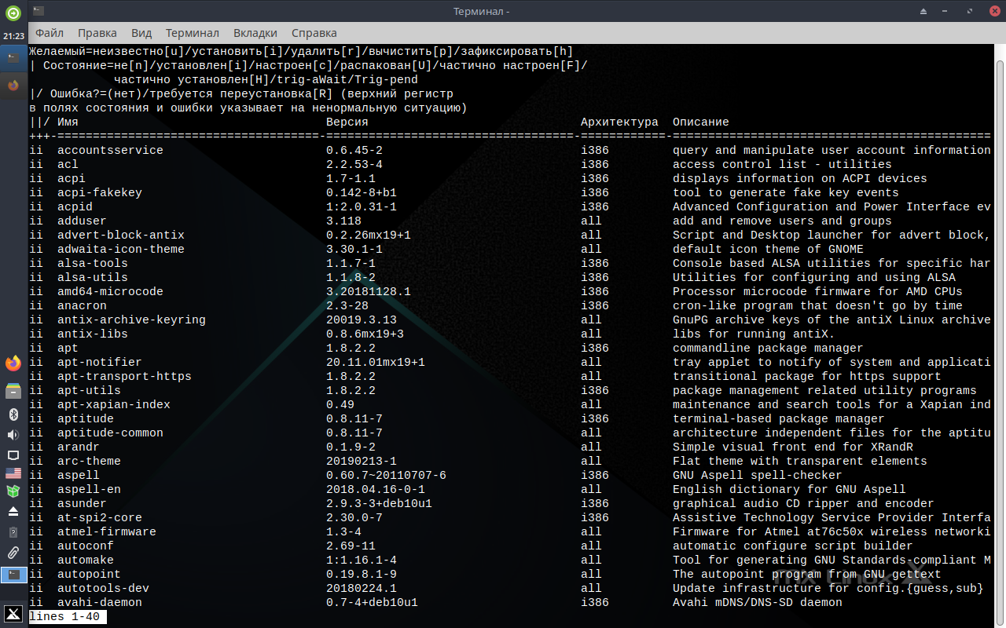

- Remove unnecessary or outdated packages. (apt-get autoremove)

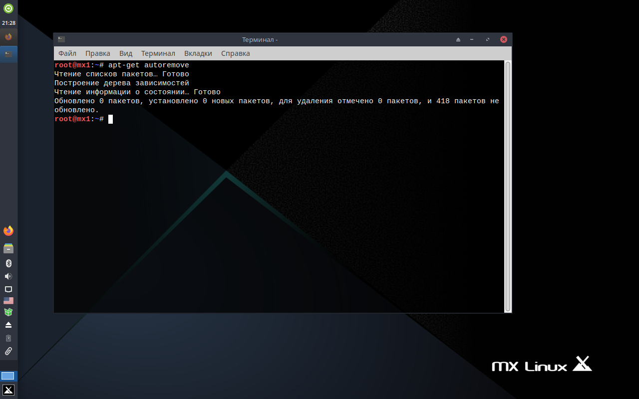

- Update the package manager. (sudo apt-get update)

