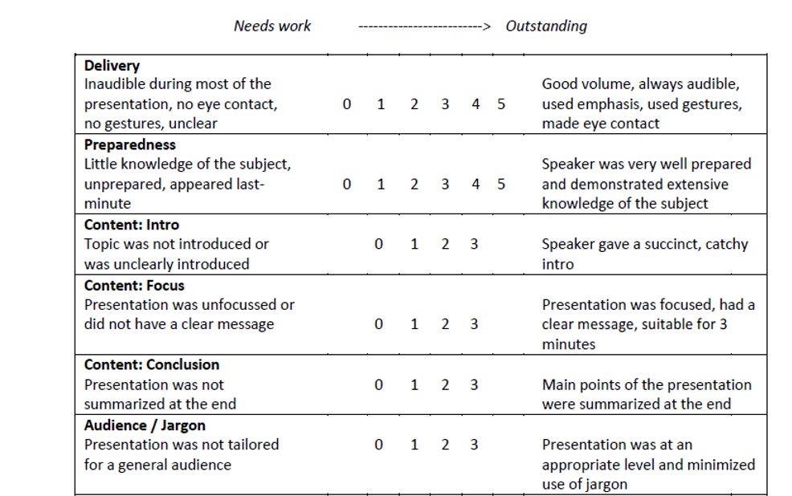

Evaluator: Andrew

|  |  |  |  |  |  |  |
| --- | --- | --- | --- | --- | --- | --- |
| **Student** | **Delivery** | **Preparedness** | **Content: introd.** | **Content: focus** | **Content:**  **conclusion** | **Audience/**  **Jargon** |
| Jenny | 3 | 5 | 5 | 4 | 5 | 5 |
| Luigi | 5 | 5 | 4 | 5 | 5 | 4 |
| Lloyd | 5 | 5 | 4 | 5 | 5 | 3 |
| Vaji | 5 | 5 | 5 | 5 | 5 | 4 |
| Lian | 5 | 5 | 5 | 4 | 5 | 4 |
| Brandon | 5 | 5 | 4 | 5 | 5 | 5 |
| Andrew |  |  |  |  |  |  |
| Madri | 4 | 5 | 5 | 4 | 5 | 5 |
| Nealan | 4 | 5 | 5 | 5 | 5 | 5 |
| Antao | 5 | 5 | 5 | 5 | 5 | 5 |
| Mahsa | 4 | 5 | 5 | 4 | 4 | 3 |
| Chenjingyi | 5 | 4 | 5 | 5 | 5 | 4 |
| Jiahua | 4 | 5 | 4 | 5 | 4 | 3 |
|  |  |  |  |  |  |  |