**EOSC 213**

**Mixing calculations**

**ODEs and Euler’s method**

The objective of this assignment is to create a python program that computes the concentration of sulfate in time in the water in a tailings management facility (TMF) at a mine site.

**Problem description and conceptual model**

Sulfate $SO_{4}^{2-}$ is one of the “major” dissolved constituents in most terrestrial waters (the others being sodium, calcium, magnesium, bicarbonate and chloride). Sulfate is not poisonous, but much in the same way that too much salt makes water undrinkable, too much sulfate can be too and is thus an environmental concern.

To compute the concentration of sulfate in the TMF water, we need to know where it is coming from and going to and use that knowledge to develop a conceptual model and then computational model.

The figure below is a conceptual sketch of the main sources and losses of sulfate in the TMF water:

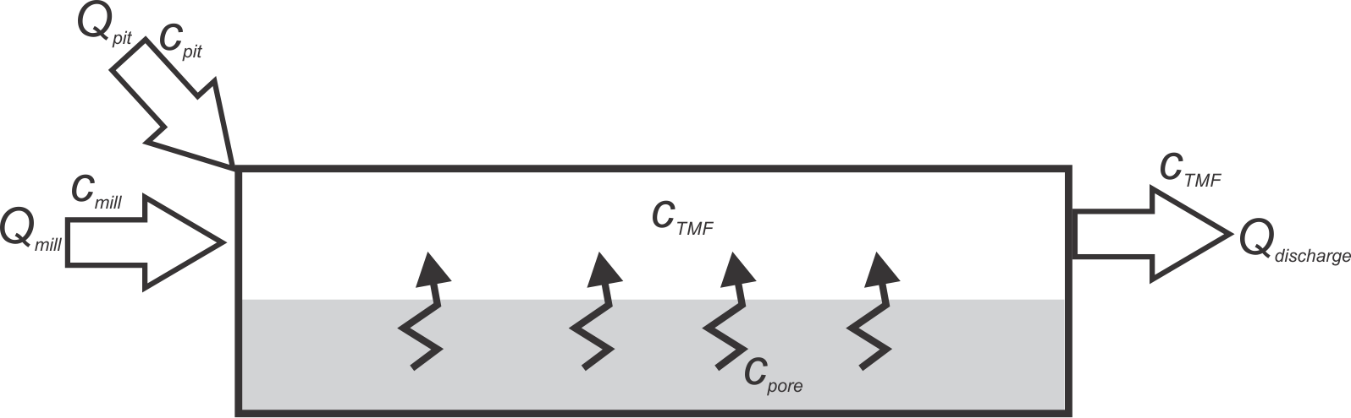

1. From the pit. To keep the pit dry, water is constantly pumped out of the pit and put into the TMF at a rate $Q_{pit}$ $m^{3}/s$ The pit water has a sulfate concentration of $c_{pit} mg/L$.
2. From the mill. The tailings are pumped into the TMF as a slurry of tailings particles (fine, sand-size ground rock) and water. Assume that the water from the mill enters the TMF at a rate of $Q_{mill} m^{3}/s$ (of water), with a sulfate concentration of $c_{mill} mg/L.$
3. Diffusing from the tailings porewater at the bottom of the TMF into the water column above. Sulfate dissolves from the tailings particles into the adjacent porewater by oxidation of the sulfide minerals in the particles. Because the ratio of rock to water is high in the tailings sediments at the bottom, the porewater sulfate concentration in the tailings, $c_{pore}$, is always higher than in the water in the TMF. Accordingly, sulfate tends to diffuse into the TMF water from the bottom porewater at a rate proportional to the difference in concentration between the porewater concentration and the concentration in the TMF, $c_{TMF}.$ That is, the flux of sulfate from the bottom can be written (a positive quantity when sulfate is entering into the TMF):

$$j_{pore}=k\left(c_{pore}-c_{TMF}\right)$$

where $j_{pore} mg/(s⋅m^{2})$ is the flux rate of sulfate per unit area of the bottom of the TMF and $k$ is the flux coefficient with units of $L/(s⋅m^{2})$. To compute $J_{pore,}$ the total mass flux rate for the whole TMF, with units of $\frac{mg}{s}$, we must multiple the rate per unit area $j_{area}$ by the total area of the TMF bottom $A_{bottom}$ in $m^{2}$:

$$J_{pore}=A_{bottom}{×j}_{pore}$$

1. Leaving via the discharge ditch. Sulfate leaves the TMF with the water that is discharged at a rate $Q_{discharge} m^{3}/s$ from the TMF to the environment. SIMPLIFYING ASSUMPTION: if we assume that the water in the TMF is well mixed at all times, then the concentration in the TMF, $c_{TMF}$ is the same at all points in the TMF, and therefore the water leaving the TMF has that same concentration $c_{TMF}$.

**Parameters**

You will need these parameters for your model

|  |  |  |  |
| --- | --- | --- | --- |
| Symbol | Units | Description | Value |
| $$c_{pit}$$ | $$mg/L$$ | Concentration of sulfate in pit water (assume constant) | $$50$$ |
| $$Q_{pit}$$ | $$m^{3}/s$$ | Flow rate of water from the pit into TMF (assume constant) | 0.030 |
| $$c_{mill}$$ | $$mg/L$$ | Concentration of sulfate in mill water (assume constant) | $$700$$ |
| $$Q_{mill}$$ | $$m^{3}/s$$ | Flow rate of water from mill into TMF (assume constant) | 0.014 |
| $$Q_{discharge}$$ | $$m^{3}/s$$ | Flow rate of water from TMF to environment (assume constant) | 0.044 |
| $$c_{pore}$$ | $$mg/L$$ | Concentration of sulfate in porewater at bottom of pond | 2000 |
| $$k$$ | $$L/(s⋅m^{2})$$ | Flux coefficient from porewater to water column | $$2.5×{10}^{-5}$$ |
| $$A_{bottom}$$ | $$m^{2}$$ | Total area of TMF bottom | $$3×{10}^{5}$$ |
| $$V_{TMF}$$ | $$m^{3}$$ | Volume of water in TMF at start of simulation | $$8.1×{10}^{6}$$ |
| $$c_{0}$$ | $mg/L$ | Concentration of sulfate in TMF water at start of simulation | $$93$$ |

**Model**

(to be finished)

Assume all parameters are constant

Use Euler’s method with daily time steps

Compute concentrations for 3 years

Plot concentration in TMF versus time

Plot cumulative sulfate discharged to environment versus time