## EOSC 211: Interpolation

**Group #: _______ Name: ___________________________________________________________**

**Interpolation:**

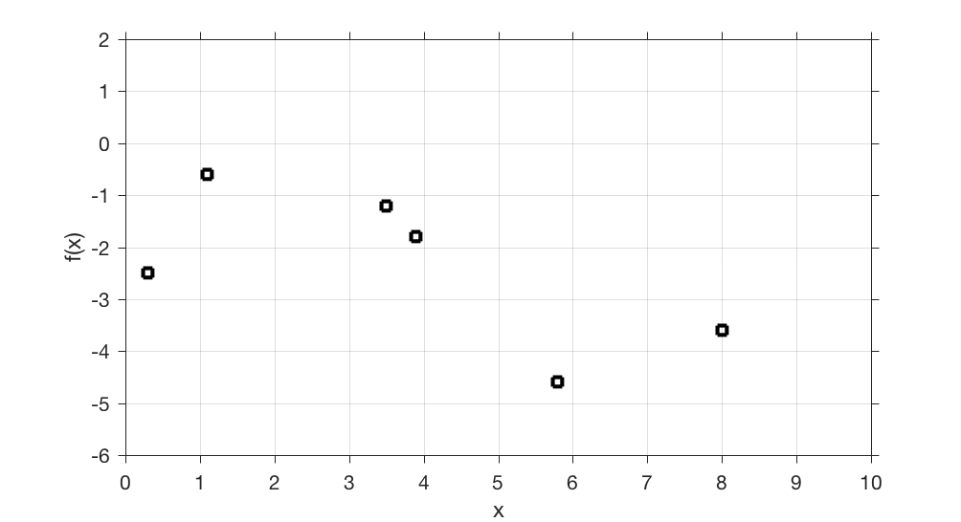

The figure above contains estimates, fi, of a function f(x) taken at data points xi. The values of xi, fi are given in Table 1 below.

Table 1:

|  |  |  |  |  |  |  |
| --- | --- | --- | --- | --- | --- | --- |
| xi | 0.3 | 1.1 | 3.5 | 3.9 | 5.8 | 8.0 |
| fi | -2.5 | -0.6 | -1.2 | -1.8 | -4.6 | -3.6 |

1. **Using the graph only** estimate the values of f(x) at evenly spaced points x=1,2,3,…8. Plot the points on the graph and enter the estimated values of f(x) from the graph in table 2 below

|  |  |  |  |  |  |  |  |  |
| --- | --- | --- | --- | --- | --- | --- | --- | --- |
| xi | 1 | 2 | 3 | 4 | 5 | 6 | 7 | 8 |
| fi |  |  |  |  |  |  |  |  |

1. Now we will use math and find an “exact” value of f(x) at the point x=7 by linearly interpolating between the 2 nearest points.
   1. What are the two x values in Table 1 that are closest to x=7? Call these two points xj and xj+1.

xj =

xj+1 =

* 1. What is the slope of the line joining these two points? Call this *m*

*m =*

* 1. How would you estimate the value fnew of f(x) at a point xnew that is part way between xi and xi+1.  Write down the formula you would use to estimate fnew and calculate its value at xnew = 7.