Screenshots or program listings must be copied into appropriate cells in the following table.
Save this evidence document as evidence_ followed by your centre number_ candidate number, for example, evidence_ zz999_9999 and insert your name, centre number and candidate number into the header above.
Examiners must be able to read the contents including any screenshots without the use of a magnifying glass. Answers that are not readable or are missing will not be awarded any marks.
Save this evidence document at regular intervals, for example every 10 minutes.
Question 1
Part 1(a)
{Copy and paste program code listing for Question 1(a) here}

BeverageQueue = ["None" for _ in range(10)] # array[0 : 9] of string
BeverageFrontPointer = 0 # integer
BeverageRearPointer = 0 # integer

Part 1(b)(i)
{Copy and paste program code listing for Question 1(b)(i) here}

def DisplayMenu():
file = open("C:/Users/62818/OneDrive/A Level CS/AndrewCL_CheckpointAssessment/BeverageData.txt", "r") # STRING
line = file.readline().strip() # STRING
while line != "":
print(line)
line = file.readline().strip()

file.close()

Part 1(b)(ii)
{Copy and paste program code listing for Question 1(b)(ii) here}

def TakeOrder(selection):

Items = selection.split(",") # ARRAY OF STRING

Beveragefile = open("C:/Users/62818/OneDrive/A Level CS/AndrewCL_CheckpointAssessment/BeverageData.txt", "r")
OrderFile = open("C:/Users/62818/OneDrive/A Level CS/AndrewCL_CheckpointAssessment/Order.txt", "w")

line = Beveragefile.readline().strip()

while line != "":

for i in range(len(Items)): # i : INTEGER

if line == Items[i]:
print(f"{Items[i]} found!")
OrderFile.write(f"{Items[i]}/n")

line = Beveragefile.readline().strip()

Beveragefile.close()
OrderFile.close()

Part 1(b)(iii)
{Copy and paste program code listing for Question 1(b)(iii) here}

def EnqueueBeverage(DataToEnqueue):

global BeverageFrontPointer, BeverageQueue, BeverageRearPointer

if BeverageRearPointer == 10:
return False
else:
BeverageQueue[BeverageRearPointer] = DataToEnqueue
BeverageRearPointer = BeverageRearPointer + 1
return True

Part 1(b)(iv)
{Copy and paste program code listing for Question 1(b)(iv) here}

def ReadOrderData():

file = open("C:/Users/62818/OneDrive/A Level CS/AndrewCL_CheckpointAssessment/Order.txt", "r")
line = file.readline().strip()
while line != "":
EnqueueBeverage(line)
line = file.readline().strip()

Part 1(c)(i)
{Copy and paste program code listing for Question 1(c)(i) here}

def DequeueBeverage():

global BeverageFrontPointer, BeverageQueue, BeverageRearPointer

if BeverageFrontPointer == BeverageRearPointer:
return ""
else:
ReturnData = BeverageQueue[BeverageFrontPointer]
BeverageFrontPointer = BeverageFrontPointer + 1
return ReturnData

Part 1(c)(ii)
{Copy and paste program code listing for Question 1(c)(ii) here}

def ServeItem():

return_result = DequeueBeverage()
if return_result == "":
print("No more orders to serve")
else:
print(f"You ordered {return_result}.")

Part 1(d)(i)
{Copy and paste program code listing for Question 1(d)(ii) here}

DisplayMenu()
TakeOrder("Tea,Coffee,Apple Juice,Cold Tea,Smoothie")
ReadOrderData()
ServeItem()

Part 1(d)(ii)
{Copy and paste the screenshot for Question 1(d)(ii) here}

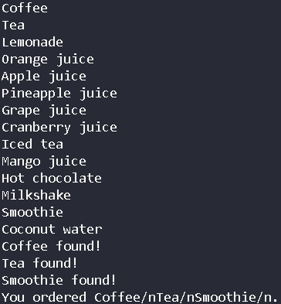

Question 2
Part 2(a)
{Copy and paste program code listing for Question 2(a) here}

Data = [[-1 for _ in range(4)] for _ in range(5)] # 2D ARRAY OF INTEGER
Row = 0 # INTEGER

Part 2(b)
{Copy and paste program code listing for Question 2(b) here}

def SetUp():

global Data, Row

Row = int(input("Please enter the number of rows you would like to enter : ")) # INTEGER
if Row >= 1 and Row <= 5:
print("Valid input!")
pass
else:
print("Invalid input!")
return

for row in range(Row): # row : INTEGER
for col in range(4): # col : INTEGER
number = int(input("Enter the number for the column : ")) # INTEGER
Data[row][col] = number

Part 2(c)(i)
{Copy and paste program code listing for Question 2(c)(i) here}

SetUp()
print(Data)

Part 2(c)(ii)
{Copy and paste the screenshot for Question 2(c)(ii) here}

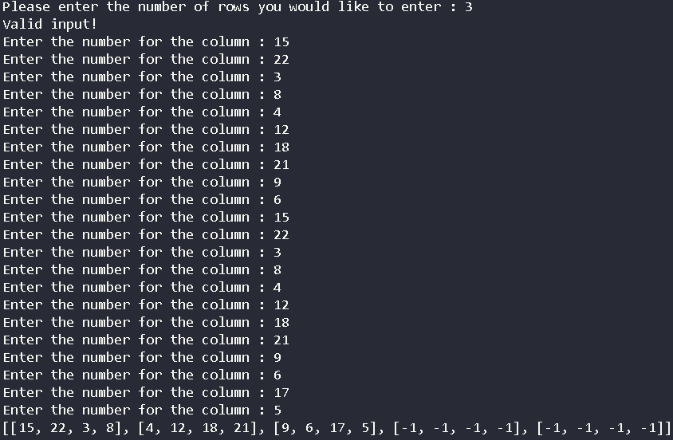

Part 2(d)(i)
{Copy and paste program code listing for Question 2(d)(i) here}

def BubbleSort():

global Row, Data

for row in range(Row):
for col in range(3):
if Data[row][col] > Data[row][col + 1]:
temp = Data[row][col + 1]
Data[row][col + 1] = Data[row][col]
Data[row][col] = temp

Part 2(d)(ii)
{Copy and paste program code listing for Question 2(d)(ii) here}

BubbleSort()
print(Data)

Part 2(d)(iii)
{Copy and paste the screenshot for Question 2(d)(iii) here}

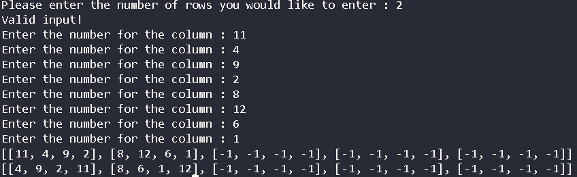

Part 2(e)(i)
{Copy and paste program code listing for Question 2(e)(i) here}

def RecursiveBinarySearch(RowNum, DataToFind, Low, High):

global Data

if Low < High:
return -1
else:
Mid = (Low + High) // 2
if Data[RowNum][Mid] < DataToFind:
return RecursiveBinarySearch[RowNum, DataToFind, Mid + 1, High]
elif Data[RowNum][Mid] > DataToFind:
return RecursiveBinarySearch[RowNum, DataToFind, Low, Mid - 1]
else:
return Mid

Part 2(e)(ii)
{Copy and paste program code listing for Question 2(e)(ii) here}

RowNum = int(input("Please enter a row number : "))
DataToFind = int(input("Please enter a data to find"))
return_result = RecursiveBinarySearch(RowNum, DataToFind, 0, 3)
if return_result == -1:
print("Number not found")
else:
print(f"Number found at column {return_result} in row {RowNum}")

Part 2(e)(iii)
{Copy and paste both the screenshots for Question 2(e)(iii) here}

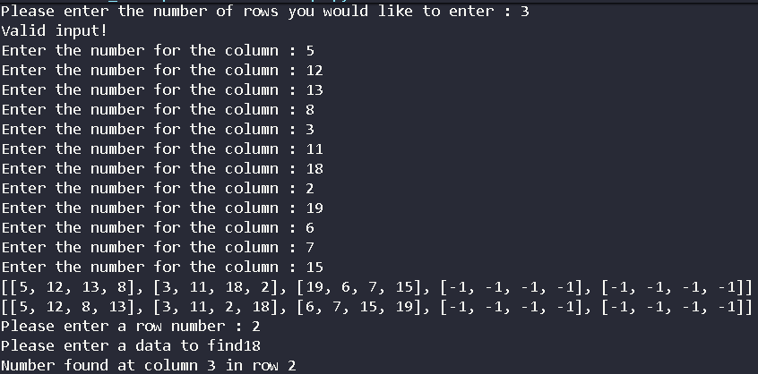

Question 3
Part 3(a)(i)
{Copy and paste program code listing for Question 3(a)(i) here}

class Device():
def __init__(self, device_name : str, brand : str, battery_life : int, price : float):
self.__device_name = device_name
self.__brand = brand
self.__battery_life = battery_life
self.__price = price

def get_device_name(self):
return self.__device_name

def get_brand(self):
return self.__brand

def get_battery_life(self):
return self.__battery_life

def get_price(self):
return self.__price

def print_details(self):
print(f"Device name : {self.__device_name}")
print(f"Brand : {self.__brand}")
print(f"Battery Life : {self.__battery_life}")
print(f"Price : {self.__price}")

Part 3(a)(ii)
{Copy and paste program code listing for Question 3(a)(ii) here}

class Phone(Device):

def __init__(self, device_name : str, brand : str, battery_life : int, price : float, storage : float):
super().__init__(device_name, brand, battery_life, price)
self.__storage = storage

def get_storage(self):
return self.__storage

def print_details(self):
print(f"Device name :{Device.get_device_name(self)}")
print(f"Brand : {Device.get_brand(self)}")
print(f"Battery Life : {Device.get_battery_life(self)}")
print(f"Price : {Device.get_price(self)}")
print(f"Storage : {self.__storage}")

Part 3(a)(iii)
{Copy and paste program code listing for Question 3(a)(iii) here}

class Laptop(Device):

def __init__(self, device_name : str, brand : str, battery_life : int, price : float, ram : int):
super().__init__(device_name, brand, battery_life, price)
self.__ram = ram

def get_storage(self):
return self.__ram

def print_details(self):
print(f"Device name :{Device.get_device_name(self)}")
print(f"Brand : {Device.get_brand(self)}")
print(f"Battery Life : {Device.get_battery_life(self)}")
print(f"Price : {Device.get_price(self)}")
print(f"RAM : {self.__ram}")

class Tablet(Device):

def __init__(self, device_name, brand, battery_life, price, screen_size):
super().__init__(device_name, brand, battery_life, price)
self.__screen_size = screen_size

def get_storage(self):
return self.__screen_size

def print_details(self):
print(f"Device name :{Device.get_device_name(self)}")
print(f"Brand : {Device.get_brand(self)}")
print(f"Battery Life : {Device.get_battery_life(self)}")
print(f"Price : {Device.get_price(self)}")
print(f"Screen Size : {self.__screen_size}")

Part 3(b)
{Copy and paste program code listing for Question 3(b) here}
def ReadDeviceData():
DeviceArr = [] # ARRAY OF Device
file = open("C:/Users/62818/OneDrive/A Level CS/AndrewCL_CheckpointAssessment/Devices.txt", "r") # STRING
line = file.readline().strip() # STRING
store = line.split(",") # ARRAY OF STRING
while line != "":
match store[0]:

case "Phone":
DeviceArr.append(Phone(store[1], store[2], int(store[3]), float(store[4]), float(store[5])))
case "Laptop":
DeviceArr.append(Laptop(store[1], store[2], int(store[3]), float(store[4]), int(store[5])))
case "Tablet":
DeviceArr.append(Tablet(store[1], store[2], int(store[3]), float(store[4]), float(store[5])))

line = file.readline().strip()
store = line.split(",")

file.close()

return DeviceArr

Part 3(c)
{Copy and paste program code listing for Question 3(c) here}

def PrintDevices(arr):
for i in range(len(arr)): # i : INTEGER
arr[i].print_details()

Part 3(d)(i)
{Copy and paste program code listing for Question 3(d)(i) here}

ret_value = ReadDeviceData() # ARRAY OF Device
PrintDevices(ret_value)

Part 3(d)(ii)
{Copy and paste the screenshot for Question 3(d)(ii) here}

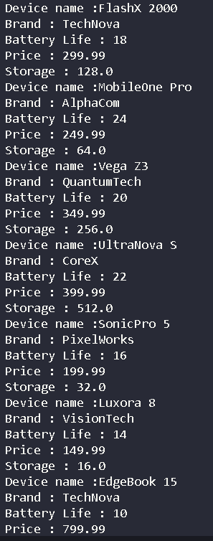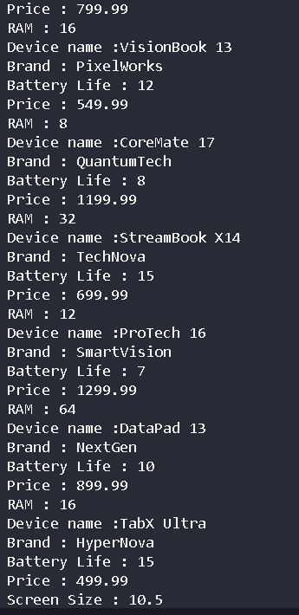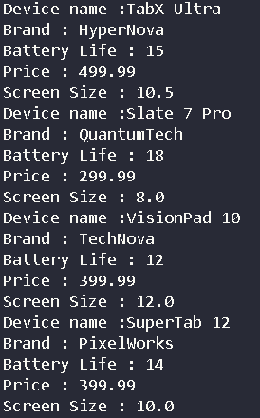

Part 3(e)(i)
{Copy and paste program code listing for Question 3(e)(i) here}

def ChooseDevice(arr, budget, brand, minBatteryLife):

newArr = [] # ARRAY OF Device
Found = False # BOOLEAN
for i in range(len(arr)):
if arr[i].get_price() <= budget and arr[i].get_brand() == brand and arr[i].get_battery_life() >= minBatteryLife:
newArr.append(arr[i])
Found = True

if Found == False:
print("No devices found that match the criteria")
return -1
else:
return newArr

Part 3(e)(ii)
{Copy and paste program code listing for Question 3(e)(ii) here}

PrintDevices(ChooseDevice(ret_value,500, "TechNova", 10))

Part 3(e)(iii)
{Copy and paste the screenshot for Question 3(e)(iii) here}

