Graph Network Analysis of Idiosyncratic Supply-Side Shocks

Andrew Ma

[andrew_c_ma@berkeley.edu](mailto:andrew_c_ma@berkeley.edu)

Economic Graph Networks Team

20 March 2022

**Abstract**

The permeation of macroeconomic shocks through economic networks results in large macroeconomic fluctuations, whose effect can be measured through Input-Output relationships. We first implement and validate the economic network model utilizing Leontief Inverses proposed by Acemoglu et. al (2015) before investigating the short run propagation of two externally induced industry-level supply shocks: drastic drops in the housing market supply and federal spending. In each case, we hope to see associated output decreases in strongly associated industries and attempt to connect our results to general macroeconomic intuition and theory – the results of preliminary tests conducted imply that transmissions of different shocks through economic network linkages have significant implications for the macroeconomy; these effects can be quantitively calculated and compared to arrive at concrete conclusions of the impact of idiosyncratic supply-side shocks.

**Introduction**

**In a sentence, the objective of our project is to simulate and explore how supply-side shocks travel and amplify through the United States Economy through its representation as a graph network.** This will be done by introducing pre-defined perturbations in the supply of industries we are interested in - note the spotlight on disruptions of the supply rather than demand – Acemoglu et.al (2015) have shown that demand-side shocks only result in upstream shocks not felt by consumers. Thus, studying supply-side shocks will provide more practical and interpretable results, as supply side shocks are ultimately felt by consumers.

Initially proposed by economists in the 1970’s, the idea of examining small shocks from firms & disaggregated industries in relation to the overall economy was trivialized by American **economist** Robert **Lucas**'s work on macroeconomic policymaking, where Lucas argues that the consequences idiosyncratic shocks are “washed away” through the law of large numbers and irrelevant for serious economic research [1]. Recently, theoretical interest in this area has spiked due to the availability of computing resources for the large matric calculations involved; economists have discovered that the force of large numbers is not necessarily present as simulated shocks hitting vital supplier industries have resulted in aggregate and amplified fluctuations in the macroeconomy [1].

Motivation for this study is numerous – originally intended to provide a coherent and comprehensive picture of the nation’s economy, I-O tables are the building blocks for economic accounts such as gross domestic product (GDP). One important use of I-O tables is the estimation of direct and indirect network effects that changes in industry supply & demand cause; I-O tables have found themselves as the framework for preparing the national and other economic accounts used for policy analysis, business planning, and other purposes. In this study, we will construct a graph network of the U.S. economy through I-O tables and conduct experiments of shocks to the housing industry and dispersed shocks across federal spending.

**Data**

To accomplish this task, we will be working with Input-Output tables over the period of 1997-2020 containing 71 industries. Specifically, we are interested in the Total Requirements Table, which shows **total output of a product (row) generated by a unit increase in the final demand of a product (column)**. Note that the Total Requirements Matrix here is analogous to (I-A)-1, the Leontief Inverse, and can be constructed from the basic Use and Supply Tables. The first five rows of the Total Requirements Table alongside their Total Output Requirement (sum of requirements from all industries) are shown below – the complete Total Requirements Matrix is found in **Appendix A and** a detailed derivation of the Leontief Inverse matrix from basic I-O Use/Supply Tables can be found in **Appendix D**.

Table 1. BEA Total Requirements Table, Industry-by-Industry (U.S. Economy, 2020)

|  |  |  |  |  |  |
| --- | --- | --- | --- | --- | --- |
| **Industries** | **Farms** | **Forestry, Fishing, & Related Activities** | **Oil & Gas Extraction** | **Mining (except Oil & Gas)** | **…** |
| **Farms** | 1.2340 | 0.023236   |  | | --- | |  | | 0.001630   |  | | --- | |  | | 0.002204 | **…** |
| **Forestry, Fishing, & Related Activities** | 0.072096 | 1.110935 | 0.000673 | 0.001968 | **…** |
| **Oil & Gas Extraction** | 0.016900 | 0.005253   |  | | --- | |  | | 1.126379 | 0.019905   |  | | --- | |  | | **…** |
| **…** | **…** | **…** | **…** | **…** | **…** |
| **Total Industry Output Requirement** | 2. 400916   |  |  | | --- | --- | |  |  | | 1.471436 | 2.324612 | 2.062204 | **…** |

From the construction of the Total Requirements Table (shown in **Appendix D**), there are three main assumptions we must keep in mind:

1. **Homogeneity:** Each industry’s output is produced using a unique set of inputs.
2. **Principle of Proportionality**: The ratio of each input to one unit of output remains constant over a wide range of output levels. That is, there are no economies of scale. For example, if the demand for a given product increases by 50 percent, all the inputs required for the product will also increase by 50 percent.
3. **Consistency:** Economic statistics are organized and presented in a uniform manner. The use of a common classification system enables users to effectively compare and analyze data across the broad spectrum of U.S. economic statistics.

Before moving onto the methodology of our study, let’s explore two more interesting measures of our economy: cross correlation between industries & network centrality. With respect to the context of our problem, cross correlation is a measure of similarity among input-output relationships between industries; on the other hand, network centrality is calculated by ; i.e., a centrality score of 1 indicates that the industry is connected to every single other industry in the network.

Figure 1. Cross Correlation Table (U.S. Economy, 2020)

Figure 2. Degree Centrality of U.S. Industries (2020)

From **Fig. 1** above where warmer colors represent higher levels of cross-correlation, that there is insignificant intra-industry cross correlation - this is good and what we expect because then we know there are no "hidden" shocks or effects we can't catch. **Figure 2.** depicts increasing centrality scores as warmer colors - from this network plot, we notice that the United States Economy has a high level of average centrality in the year of 2020 – perhaps this speaks to the consequences of the massive globalization wave of the current century. These exploratory observations are important to explore as they describe the intra-industry behavior of economic networks.

**Methods**

The model we will be implementing is directly referenced in Acemoglu et.al [1], and a short summary of it will be detailed here; consider a static perfectly competitive economy with n industries, and suppose that each industry i = 1, ..., n has a Cobb-Douglas production function of the form:

where represents the quantity of goods produced by industry j used as inputs by industry, is labor, is the total output of industry i, & zi is the output of Hicks-neutral productivity shock (representing both technological and other factors affecting productivity).

To ensure that the production function of each industry exhibits constant returns to scale, we have the following constraints:

From the Cobb-Douglas productivity function, we see that the output of each industry is used as input for other industries or consumed in the final good sector. Incorporating the demand from other industries, the market-clearing condition for industry i can be written as:

where is the final consumption of the output of industry i, Gi is the denotes government purchases of good i. We introduce government purchases to be able to model demand-side shocks in a simple fashion. The preference side of this economy is summarized by a representative household with a utility function

where βi ∈ (0, 1) designates the weight of good i in the representative household’s preferences (with the normalization βi = 1) & γ(l) is a decreasing (differentiable) function capturing the behavior of labor supply. The government imposes a lump-sum tax, T, to finance its purchases. Denoting the price P of the output of industry i by pi , this implies T = piGi. Since its income comes only from labor, *wl*, the representative household’s budget constraint can be written as

We focus on the competitive equilibrium of this static economy, which is defined in the usual fashion, so that all firms maximize profits and the representative household maximizes its utility, in both cases taking all prices as given, and the market-clearing conditions for each good and labor are satisfied. The amount of government spending and taxes are taken as given in this competitive equilibrium. We also choose the wage as the numeraire (i.e., set w = 1).

The Cobb-Douglas production functions in (1), combined with profit maximization, imply

Let A denote the matrix of aij’s

Then define H ≡ (I − A) −1 as the Leontief inverse of the input-out matrix A. From the definitions above, we can derive the following proposition, whose complete proof can be found in **Appendix F.**

**Proposition 1.** The impact of sectoral productivity (supply-side) shocks on the output of sector i is

dln(Y) = H ∗ (dZ)

where H is the Total Requirements Matrix (Leontief inverse of A), Y is the output vector where are output industries, and Z is the output productivity vector where is output of Hicks-neutral productivity shock.

**Preliminary Results**

In this section, I will present an example where a supply side shock is induced into the ‘Primary Metals’ industry in the year 2020; we artificially propagate this supply shock into the metals industry through altering the productivity vector dZ = [0, … , 0 , -0.6, 0, …, 0], where = -0.6 is the **only** non-zero element; i.e., only the metals industry is affected by this 60% decrease in output productivity. After applying **Proposition 1.**, we arrive at the results:

|  |  |
| --- | --- |
| Industry | log(Output change) |
| Primary Metals | -0.845561 |
| Wholesale Trade | -0.122471 |
| Mining, Except Oil & Gas | -0.042747 |
| Fabricated Metal Products | -0.040744 |
| Truck Transportation | -0.031992 |

1. The industries most affected are those we would automatically associate with metals – however, their absolute difference is hard to measure as we are on the log-scale.
2. Largest change to log Output is to the ‘Primary Metals’ Industry itself – this pattern seems consistent when applying this experiment to other industries such as Farms, Forestry, Automotive, etc.

In the example above, an induced supply-side shock into the metal industry represented by a sudden drop of output productivity by ~60%, resulted in largest log output losses in the associated industries of trade, mining, fabricated metal products, and truck transportation. These results align with our intuition: industries closely associated with metals would suffer most from unexpected decreases in metal supply.

**Conclusion & Next Steps**

In combination with research already conducted by Acemoglu et.al (2015), the proposed methodology of economic shock simulation has yielded fruitful results in terms of interpretability and connection to macroeconomic knowledge. Moving forward, our team is currently considering the optimal representation of (1) Housing Crisis & (2) Changes in Federal Expenditure in terms of the industry productivity gradient dZ.

Before concluding our discission of economic network analysis, let’s consider limitation & challenges associated with future work. The main challenges associated with this project is in the analysis of our results – since output is given as a log change of output, we can only compare changes in industry output relative to each other; thus, we are sure that certain industries are more affected than others but are uncertain about the difference of these impacts and their absolute value with respect to GDP contribution or dollar value. Nevertheless, this model looks promising as an addition to other concrete economic methods when conserving macroeconomic conditions.

**References**

1. Acemoglu, D., Akcigit, U., & Kerr, W. (2016). Networks and the macroeconomy: An empirical exploration. *NBER Macroeconomics Annual*, *30*(1), 273–335. https://doi.org/10.1086/685961
2. Bureau of Economic Analysis. (n.d.). *Total Requirements Derivation*. bea.gov. Retrieved March 17, 2022, from https://apps.bea.gov/industry/pdf/TotalRequirementsDerivation.pdf
3. Choi, Jason and Forester, Andrew, (2017), The Changing Input-Output Network Structure of the U.S. Economy, Economic Review, (Q II), 23-49
4. Karen J. Horowitz & Mark A. Planting, 2006. "[**Concepts and Methods of the U.S. Input-Output Accounts**](https://ideas.repec.org/p/bea/papers/0066.html)," [BEA Papers](https://ideas.repec.org/s/bea/papers.html) 0066, Bureau of Economic Analysis.
5. Sekhon, Rupinder, and Roberta Bloom. Applications – Leontief Models. De Anza College, 4 Sept. 2021, https://math.libretexts.org/@go/page/37851.

**Appendix**

**Appendix A: Complete Total Requirements Table**

**Appendix B: Cross Correlation Table for Table 1**

**Appendix C: Degree Centrality of U.S. Economy, 2020 (71 Industries)**

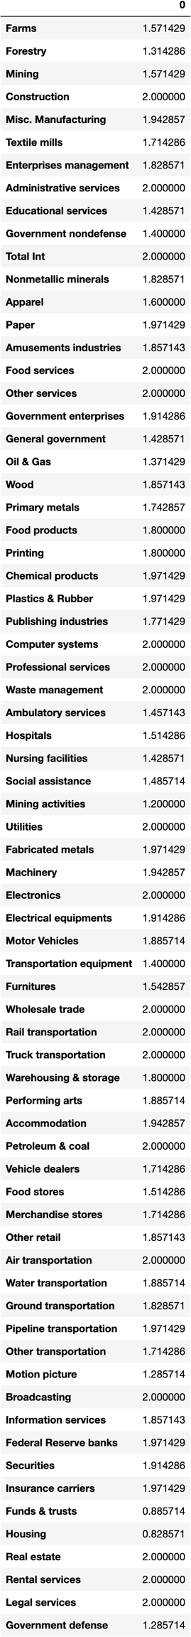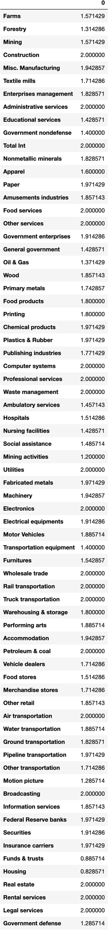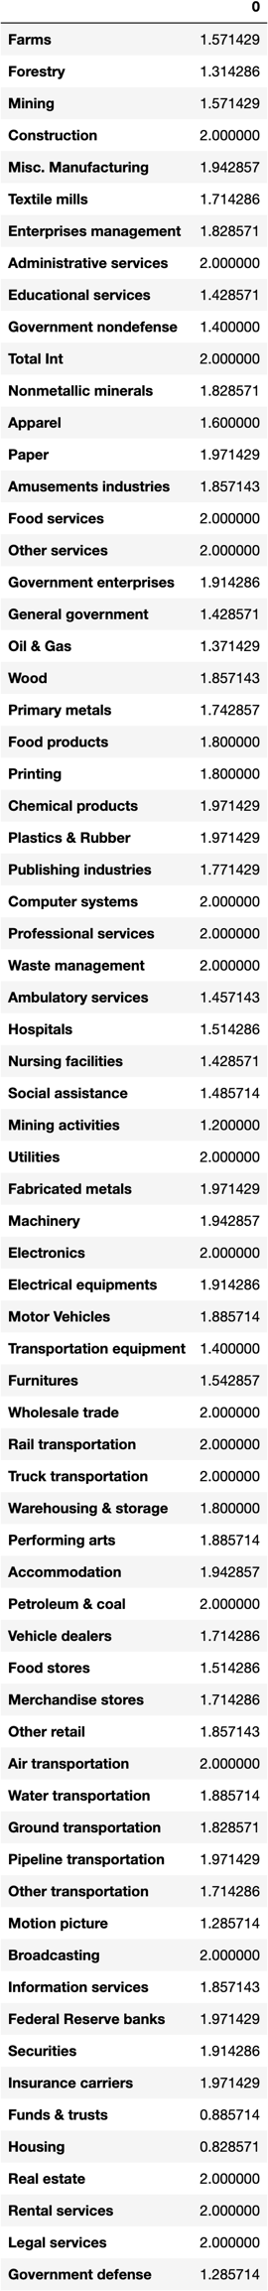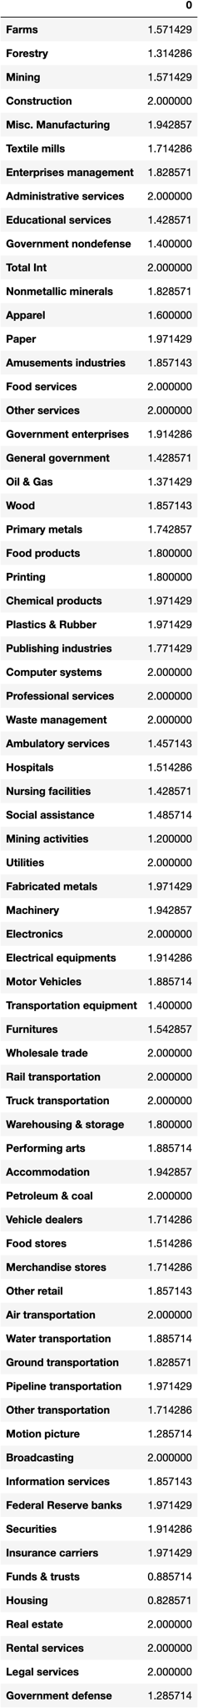

**Appendix D: Derivation of Total Requirements Table from Make & Use Tables**

From make and use tables, the following are defined:

**^:** A symbol that, when placed over a vector, indicates a square matrix in which the elements of the vector appear on the main diagonal and zeros elsewhere.

**q:** A column vector in which each entry shows the total amount of each commodity’s output.

**g:** A column vector in which each entry shows the total amount of each industry's output.

1. **U:  Intermediate portion of the use matrix** in which the column shows for a given industry the amount of each commodity it uses, including noncomparable imports and used and secondhand goods. This is a commodity-by-industry matrix.
2. **V:  Make matrix** in which the column shows for a given commodity the amount produced in each industry. This is an industry-by-commodity matrix. V has columns showing only zero entries for noncomparable imports and used and secondhand goods.

**B: Direct input coefficients matrix** in which entries in each column show the amount of a commodity used by an industry per dollar of output of that industry. This is a commodity- by-industry matrix.

*B* = *U g*ˆ − 1 **(1)**

**D:** A matrix in which entries in each column show, for a given commodity, the proportion of the total output of that commodity produced in each industry. In the model, it is assumed that each commodity is produced by the various industries in fixed proportions. This is an industry-by-commodity matrix. D is also referred to as the market share matrix or transformation matrix.

*D* = *V q*ˆ − 1 **(2)**

i: Unit (summation) vector containing only l's.

**I:** Identity matrix, where I = *i*ˆ.

**e:** A column vector in which each entry shows the total final demand purchases for each commodity from the use table.

From the above definitions, the following identities are derived: *q = Ui + e* **(3)**

*g = Vi* (**4)**

The model expressed in equations **(1)** through **(4)** thus involves two constants (*B, D*) and five variables (*U, V, e, q, g*). The model solution is derived as follows: From **(1)** and **(3),** we derive:

*q = Bg + e* **(5)**

From **(2)** and **(4)**, we derive:

*g = Dq* **(6)** Substituting **(6)** into **(5)** and solving for *q* gives:

*q* = *B*(*Dq*) + *e* (*I* − *BD*)*q* = *e*

*q* = (*I* − *BD*)−1 *e*

The matrix (*I* − *BD*)−1 is known as the commodity-by-commodity total requirements matrix and it shows, on a per-dollar basis, the commodity output the economy generates in order to provide commodities to final users.

Substituting **(5)** into **(6)** and solving for *g* gives:

*g = D(Bg + e)*

*(I - DB)g =D e*

*g* = (*I* − *DB*)−1 *De* ( 8 )

The matrix (*I* − *DB*)−1 is known as the industry-by-industry total requirements matrix and it shows, on a per-dollar basis, the industry output the economy generates in order to provide an industry’s commodities to final users. The vector De is a final demand vector where each entry shows the final demand for an industry’s output.

**Appendix E: Complete Graph Network of U.S. Economy (2020)**

**Appendix F: Proof of Proposition 1.**

**Note:** This proof has been directly taken from Acemoglu et.al (2015); due to its length of ~4 pages, I have decided not to include it here. For those interested, it can be found under **Appendix A: Proof of Proposition 1.** in the Acemoglu paper.