Neolaod Git Guideline

If you have got a SSH key pair,please start from step 3  
**1. Download a git desktop tool and install**

**2. Generate a SSH key pair**  
To generate a new SSH key pair, use the following command:

***Git Bash on Windows / GNU/Linux / macOS:***  
ssh-keygen -t rsa -C ["your.email@example.com](mailto:%22your.email@example.com)" -b 4096

Other ways can refer to “<https://gitlab.dev.activenetwork.com/help/ssh/README>”

**3. Add publish key to git account**

*a. Copy publish key*

**macOS**:

pbcopy < ~/.ssh/id_rsa.pub

**GNU/Linux (requires the xclip package)**:

xclip -sel clip < ~/.ssh/id_rsa.pub

**Windows Command Line**:

type %userprofile%.ssh\id_rsa.pub | clip

**Git Bash on Windows / Windows PowerShell**:

cat ~/.ssh/id_rsa.pub | clip

*b. Add to git account in webpage*

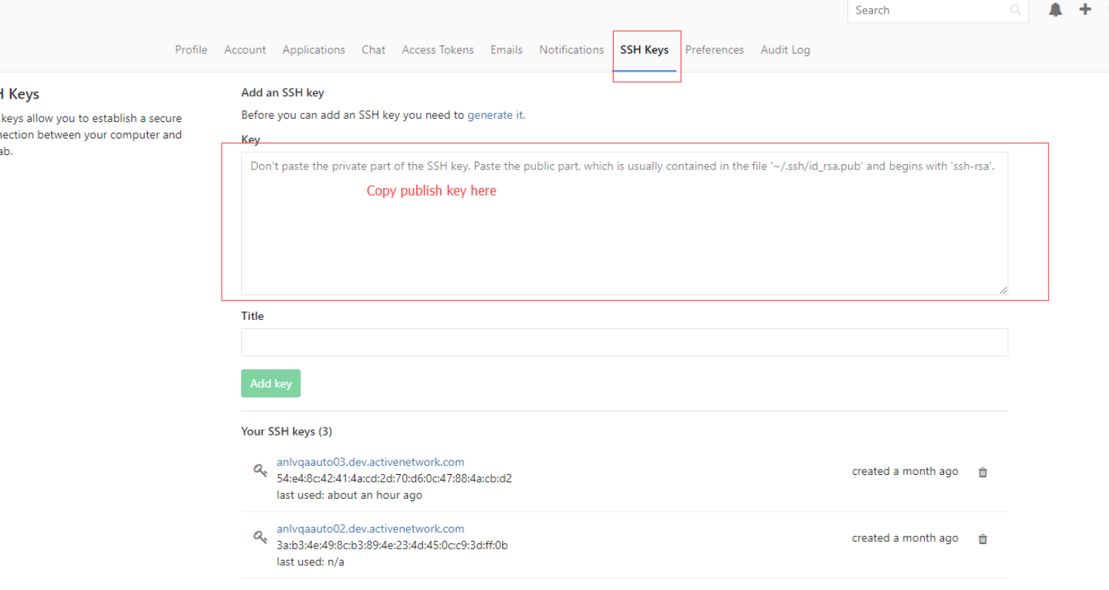

**4.** **Neotys Team Server**

Add Neotys Team Server information in “Neoload – Edit – Preferences “

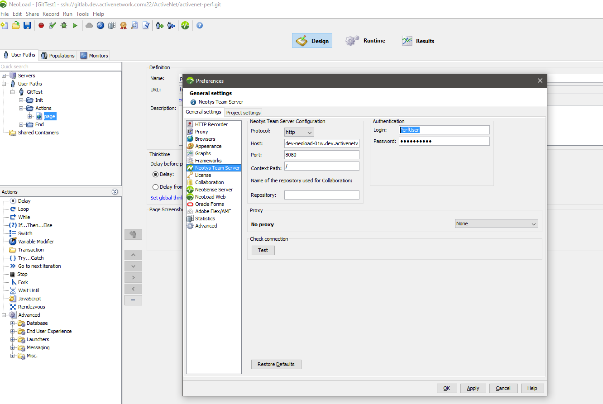

Protocol: http:

Host: dev-neoload-01w.dev.activenetwork.com

Port: 8080

Context Path:/

Authentication

Login: PerfUser

Password: Please context administrator to get the password

**5.Collaboration**

Add Collaboration information in “Neoload – Edit – Preferences “

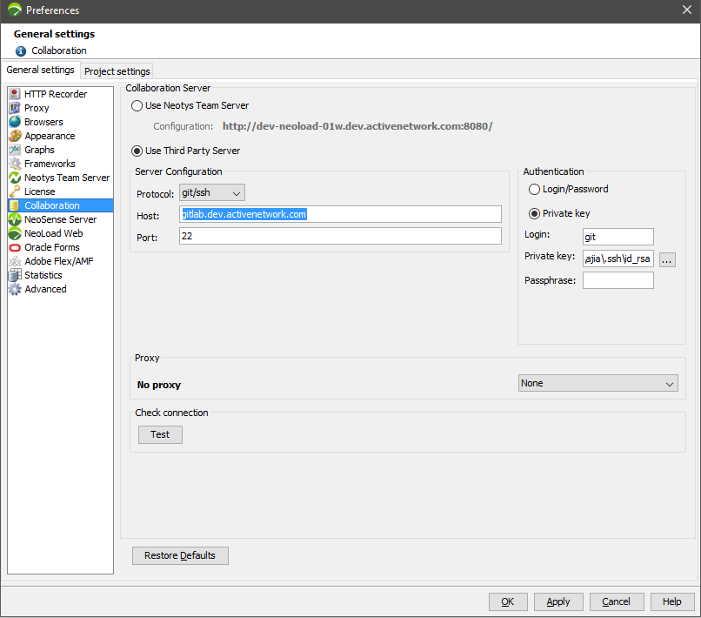

Potorol:git/ssh

Host: gitlab.dev.activenetwork.com

Port: 22

Authentication(Use private Key)

Login: git

Private key:choose your private key generated on step 2

Passphrase: fill the passphrase if you set on step 2

6.Start to share your project to git

Repository path: ActiveNet/activenet-perf.git

