Lab 11 Report

Andrew McCrary

Vitta Silberberg

Richard Roberts

(All contributions equal)

**Testing program:**

**DFS and BFS :**

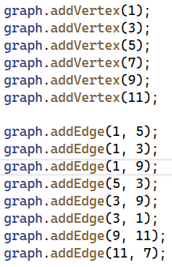

**Explain in your lab report how you implemented depth first and breadth first searches.**

**More importantly explain what data structures you chose to implement them and the**

**reasoning behind them. Discuss the performance and memory consumption of DFS**

**versus BFS. When searching a graph when does one choose DFS/BFS?**

* **DFS: the way we implemented the DFS was by taking a base and a destination, and adding each visited location (including the original base) to a vector. Then, we use a loop to make a recursive DFS call using the vertices connected to the current base by edges to try and visit every possible vertex until we reach our intended end vertex. When our intended destination becomes the based value of our current call, all reachable vertices are visited and added to the vector, or all vertices edges have been explored, the vector is returned. The performance is usually O(n) because it intends to visit every possible node, with the best case being O(1). DFS is a better choice than BFS if you know a solution/path exists but the map is very large because it will use less memory and time when exploring the paths/edges from the base.**
* **BFS: We implemented breadth first search very similarly to depth first search, the only difference is that instead of using the first path found, it takes the shortest from all available paths. This should result in O(NLog(N)) performance for worst/average case, and O(1) for best case. BFS would also be less memory efficient since it requires that multiple stack frames are left open for more possible paths (that could be shorter).**
* **One would use DFS when they know a path exists, and just want to find the quickest path. This would also be coupled with any requirement on performance. BFS would be used when the “best” or shortest path is required and performance for finding that path doesn’t matter as much.**

**A description of the objectives/concepts explored in this assignment including**

**why you think they are important to this course and a career in CS and/or**

**Engineering.**

* **In this lab we primarily explored the concept of a graph data structure. Graphs are used throughout business implementations and this knowledge will likely be used in our future careers.**
* **We also reimplemented our testing program, and blocks of code like these are commonly used to debug applications in business.**