Course: JavaScript DOM & UI

Telerik Software Academy

Assignment Timeframe:

18 – 31 Jul 2015

**Team Work: JavaScript DOM & UI**

***Endless Worms Game***

**Team Horse’s Neck:**

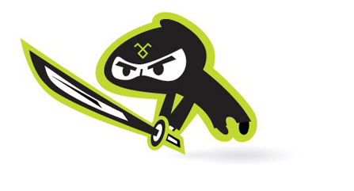[AndreyMitev93] – Andrey Mitev

[Curiosity] – Yane Yosifov

[krasi.totev] – Krasimir Totev

[loderunner] – Nikola Bogomirov

[pliok] - Lyuba Gerassimova

[shunobaka] – Veselin Minev

[Y.Maltsev] – Yani Maltsev

**Application**: Game

**Git Repository**: http://github.com/shunobaka/JS-UI-and-DOM-Teamwork-Project

**Application Purpose:**

Endless Worms is a fun and simple game, solving the problem of boredom. Up to four players can play the game, and the minimum is, naturally, two players.

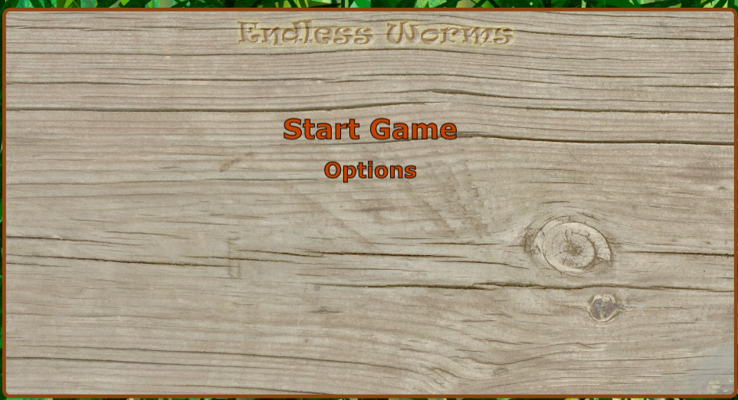

From the menu, names for the first two players can be edited. The controls are set for these two. Up to two other players can be added, with their own names and keys for turning left and right.

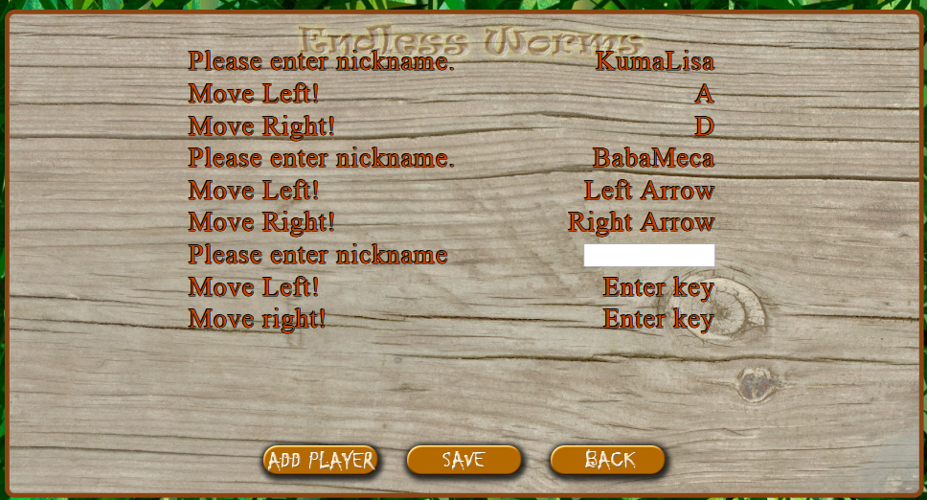

The main goal of the game is to not bump into one of the other worms or the slowly spreading fire. The game round finishes once someone collides with another object, and the players who are still crawling receive a score accordingly. After several rounds, the player with the least collisions wins.

The worms can turn left and right. They do not enjoy any other special skills.

**Game Features:**

* Adding players
* Setting name for all players
* Setting direction control keys for player 3 and 4
* Scoring until a winner is determined
* Fun sounds
* SVG fire and Canvas worms; SVG and image backgrounds

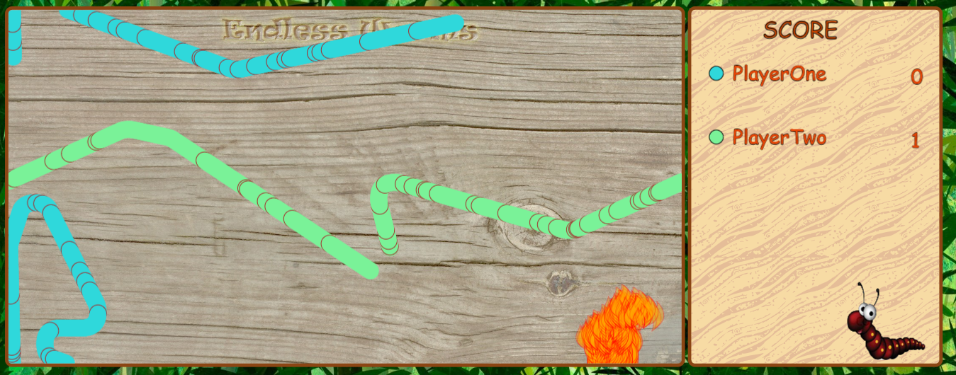

**Commits Log:**

