Andrew Morris

Professor John

IT-230

February 23rd 2025

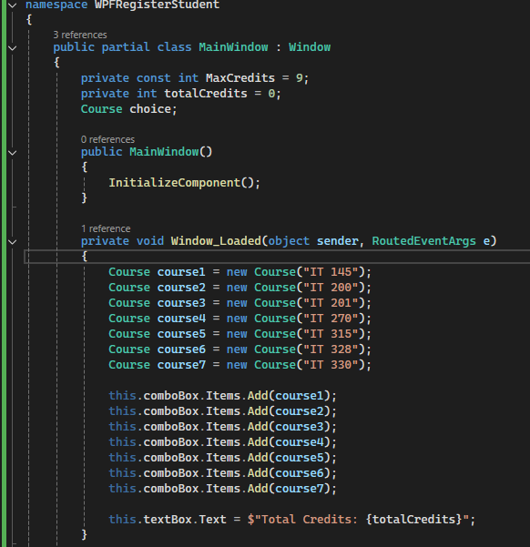

For this part of the code this goes over the course selection that the user can select when applying for new classes this would include IT 145, 200, 201, 270, 315, 328, 330. Then after the set of code that goes over the courses that can people can select, we have the code that adds the courses to the combobox. Finally, the last bit of code that initializes the text box with the total credits that the user currently has using the this.textbox.Text.

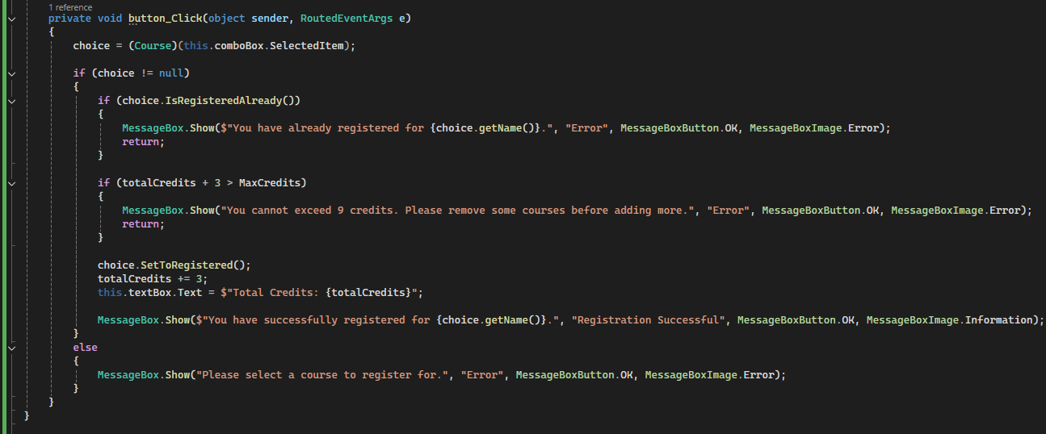For this next section we have the second line of code in this image that gets the selected course from the ComboBox. Afterwards using if else statements we have code that checks if the course has been selected and if adding the course would exceed the 9 credits. Then we have the part where it updates the current amount of the credits someone has after registering for a class. Finally, there’s just a line of code to show an error if no course is selected just for safety.

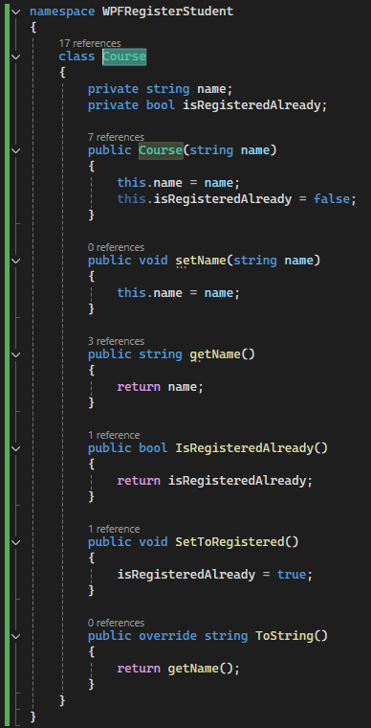

There wasn’t much changes within this code when it comes to this image. This was the Course.cs file that is mainly here so the Course variable can work within the code and also having setName working as a string within the code. That’s not even mentioning the other strings of getName, IsRegisteredAlready, and SetToRegistered that also work within the code so it can get the inputs people add.



Finally, we have the outputs and with this it shows that the user can select the class they would want to be in and if they go over 9 credits, they get an error saying they cannot add any more credits within the program!

The code:  
  
Main  
namespace WPFRegisterStudent

{

public partial class MainWindow : Window

{

private const int MaxCredits = 9;

private int totalCredits = 0;

Course choice;

public MainWindow()

{

InitializeComponent();

}

private void Window_Loaded(object sender, RoutedEventArgs e)

{

Course course1 = new Course("IT 145");

Course course2 = new Course("IT 200");

Course course3 = new Course("IT 201");

Course course4 = new Course("IT 270");

Course course5 = new Course("IT 315");

Course course6 = new Course("IT 328");

Course course7 = new Course("IT 330");

this.comboBox.Items.Add(course1);

this.comboBox.Items.Add(course2);

this.comboBox.Items.Add(course3);

this.comboBox.Items.Add(course4);

this.comboBox.Items.Add(course5);

this.comboBox.Items.Add(course6);

this.comboBox.Items.Add(course7);

this.textBox.Text = $"Total Credits: {totalCredits}";

}

private void button_Click(object sender, RoutedEventArgs e)

{

choice = (Course)(this.comboBox.SelectedItem);

if (choice != null)

{

if (choice.IsRegisteredAlready())

{

MessageBox.Show($"You have already registered for {choice.getName()}.", "Error", MessageBoxButton.OK, MessageBoxImage.Error);

return;

}

if (totalCredits + 3 > MaxCredits)

{

MessageBox.Show("You cannot exceed 9 credits. Please remove some courses before adding more.", "Error", MessageBoxButton.OK, MessageBoxImage.Error);

return;

}

choice.SetToRegistered();

totalCredits += 3;

this.textBox.Text = $"Total Credits: {totalCredits}";

MessageBox.Show($"You have successfully registered for {choice.getName()}.", "Registration Successful", MessageBoxButton.OK, MessageBoxImage.Information);

}

else

{

MessageBox.Show("Please select a course to register for.", "Error", MessageBoxButton.OK, MessageBoxImage.Error);

}

}

}

}  
  
Course

namespace WPFRegisterStudent

{

class Course

{

private string name;

private bool isRegisteredAlready;

public Course(string name)

{

this.name = name;

this.isRegisteredAlready = false;

}

public void setName(string name)

{

this.name = name;

}

public string getName()

{

return name;

}

public bool IsRegisteredAlready()

{

return isRegisteredAlready;

}

public void SetToRegistered()

{

isRegisteredAlready = true;

}

public override string ToString()

{

return getName();

}

}

}