CAN THO UNIVERSITY
COLLEGE OF INFORMATION AND COMMUNICATION TECHNOLOGY
OPERATING SYSTEMS (CT104H)
FINAL LAB
Declaration of own work
I, YOUR FULL NAME (ID student) , certify that this assignment is my own work, is not copied from any other person's work

Submission: Students submit these following files to the class on Elearning system (where StudentName is the student’s name, and ID is the student’s ID).
* 01 file named StudentName_ID_CT104H_FinalLab_report.pdf
* 01 file named StudentName_ID_CT104H_FinalLab_code.rar (containing all codes)
Instructions on how to present in the report file
  - Student creates an Ubuntu Virtual machine named UbuntuID (ID is the student’s ID). For example, we have a virtual machine named Ubuntu20043, such that the student ID is 20043.
  - For each question, students MUST provide the commands/scripts AND screenshots of the commands used and/or the content of files/scripts, CLEARLY. Note: the screenshots need to show the name of the Ubuntu Virtual machine.
  - Do not change the directory
  - Replace YourName with your full name

Question 0: Navigate to your home directory
Answer: $cd
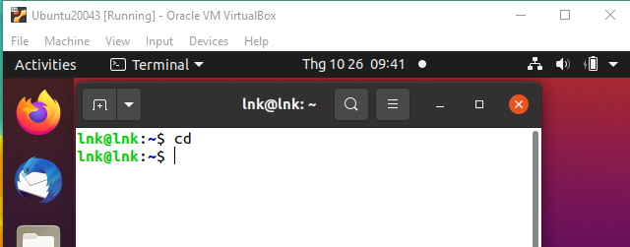

Question 1 (1.0 point - Use 1 command): List all information about your kernel system.
Question 2 (1.0 point - Use 2 commands to solve this question): Create a folder named YourNameCT104H that contains a list of folders, each of which is named by the title of the chapter you have studied in the CT104H class (e.g., Introduction, OperatingSystemStructures, Processes…)
Question 3 (1.0 point - Use 1 command to solve this question, and do not use any text editors): Inside the folder Processes, create a file named ProcessOverview such that the content of the file is the states of a process, and a brief explanation of the state. Note that, each state is presented in a single line.
Question 4 (1.0 point - Use 1 command to solve this question): Print the occurrence count of the string “process” (regardless of uppercase or lowercase) in the file ProcessOveriew.
Question 5 (1.0 point - Use 1 command to solve this question, and do not use any text editors): Add the following 2 lines to the end of the file ProcessOverview:
Remember to press the submit button
I, YourName, try my best for the final test which will be given on theDateOfYourOSFinalTest

(Note: Please check the date of your final exam on the Elearning system.)
Question 6 (5.0 points): Write a shell script, named YourStudentID, that allows a user to input a number N, and then performs the following check:
- If N is empty or an odd number, then ask the user to reinput N
- Otherwise, print a matrix NxN such that all elements are $, except the elements on the diagonal line, each of which has a value of [i][i]=i², In addition, each line will appear after 4 seconds.
1 | $ | $ | $ | $ | $
$ | 4 | $ | $ | $ | $
$ | $ | 9 | $ | $ | $
$ | $ | $ | 16 | $ | $
$ | $ | $ | $ | 25 | $
$ | $ | $ | $ | $ | 36

---------GOOD LUCK---------

