leboncoin.fr

lobstr.io

The purpose of this case is to test your abilities through 3 main area of competences :

- XPath

- Regular Expression (Regex)

- Requests/LXML with Python

You will find a doc named sample.html which is the source code of the following URL : <https://www.leboncoin.fr/recherche/?category=9&locations=Cassis_13260>.

**1. XPATH**

Find the right XPath to find the very element in **sample.html**

<https://www.w3schools.com/xml/xpath_intro.asp>

Google Sheet (IMPORTXML)

1.a. (Example) Find the total number of “Annonces”

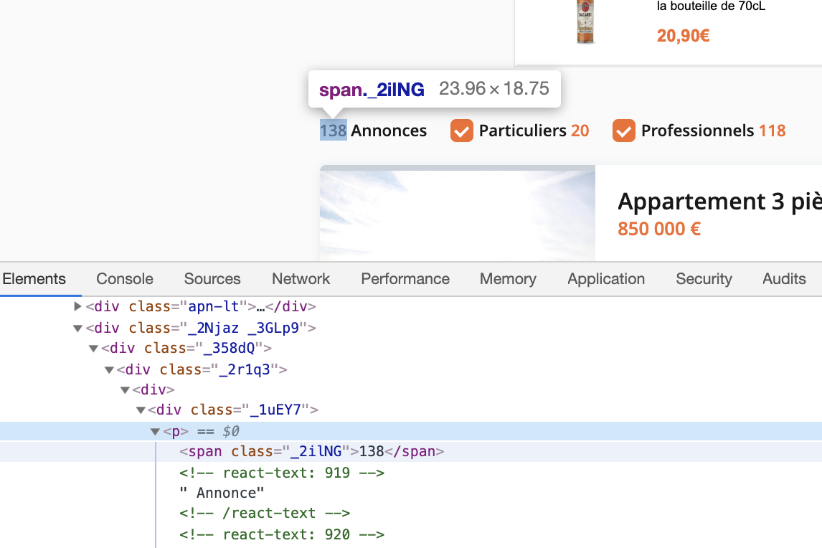

**//span[@class=”_2ilNG”]/text()**

1.a Find XPath for title of annonce

1.b Find XPath for price of annonce

1.c Find XPath for kind of annonce (“Pro”, bold)

1.d Find XPath for type of annonce (“Ventes Immobilières”)

1.e Find XPath for city of annonce

1.f Find XPath for zip code of annonce

1.g Find XPath for date

NB : one XPath must work for at least 2 URLs, and return a list of values for every annonce

**2. REGEX**

Find the right Regex to find the element we are looking for in **sample.json**

[**https://regex101.com/**](https://regex101.com/)

2.a. (Example) Find the total number of “Annonces”

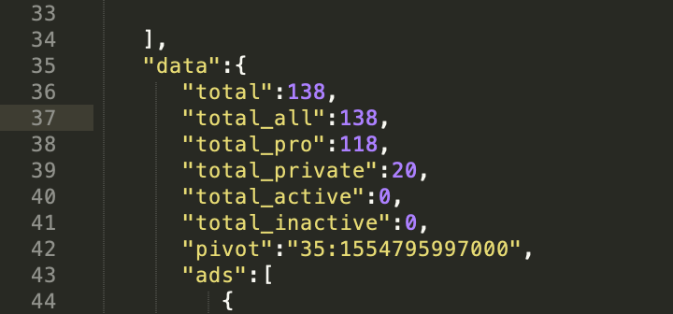

**(?<=\"total\"\:)\d+**

2.b. Find the total number of private “Annonces” : “total_private”

/* ECRIRE LE REGEX ICI */

2.c. Find the total number of pro “Annonces” : “total_pro”

2.d. Find all the unique IDs of “Annonce” : “list_id”



2.e. Find the prices : “price”

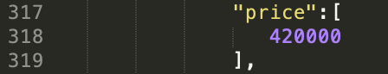

2.f. Find the subject : “subject”



2.g. Find the number of rooms : “rooms”

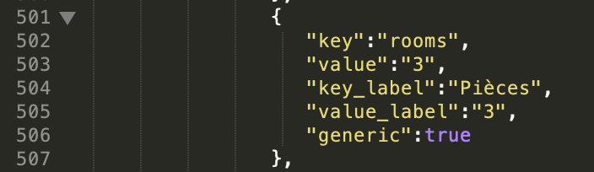

2.h.a Find lat

2.h.b Find lng

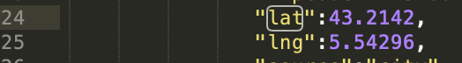

**3. REQUESTS/LXML**

In this final case, you have to build a script, in Python, using **REQUESTS/LXML**, that will scrape annonces data from <https://www.leboncoin.fr/recherche/?category=9&locations=Cassis_13260>, from page 1 to page 4.

- write script.py able to scrape data

- save data in .csv file

- host your script on Github

- send to us : )

An already made extract is available : **output.xlsx**.