LnuCampaign

The goal of this project is to provide convenient and comfortable way for entrance university campaign. System allows entrants to do self-registration with a complete documentation file, make a review of registered people, accept or decline applications.

**Roles**: Guest, User, Admin.

| Role | Description |
| --- | --- |
| Guest | User who cannot log in before signing up. Can check an entrance table. |
| User | Fill registration page, apply to desired faculty, upload required documents/info, cancel their action till particular time moment, check a registration table. |
| Admin | Can view info about users, accept or decline applications, cancel their action, approve their entrance status. |

**Entrance Management System**

| № | Role | Use case | Description | Action name | Tests |
| --- | --- | --- | --- | --- | --- |
| **1** | **User** | Apply to faculty | Apply to the faculty in system | CreateApplication | TST14, TST19 |
| **2** | Check registration table | Check registration table in system | GetAllApplications | TST15, TST20 |
| **3** | Cancel application untill particular time | Cancel application untill particular time in system | DeleteApplication | TST13, TST18 |

**User Management System**

| № | Role | Use case | Description | Action name | Tests |
| --- | --- | --- | --- | --- | --- |
| **1** | **Guest** | Sign up | Sign up in system | SignUp | TST1, TST6 |
| **2** | **User** | Log in | Log in to the system | LogIn | TST2, TST7 |
| **3** | Log out | Log out from the system | LogOut | TST3, TST8 |

**User Management System**

| № | Role | Use case | Description | Action name | Tests |
| --- | --- | --- | --- | --- | --- |
| **1** | **Admin** | View information about users | View all the details about users | ViewUserInfo | TST4, TST9 |
| **2** | Accept user | Accept applications in system | AcceptUserApplication | TST11, TST16 |
| **3** | Decline user | Decline applications in system | DeclineUserApplication | TST12, TST17 |
| **4** | Delete user applications | Delete user application anytime | DeleteUserApplication | TST13, TST18 |
| **5** | Approve user status | Approve user status after all user registration | ApproveUserStatus | TST5, TST10 |

**Tests**

| № | Test class | Test method | Code coverage |
| --- | --- | --- | --- |
| **TST1** | UsersServiceTests | RegisterTest | 90% |
| **TST2** | SignInTest |
| **TST3** | LogOutTest |
| **TST4** | ViewUserInfoTest |
| **TST5** | ApproveUserTest |
| **TST6** | UsersControllerTests | RegisterTest |
| **TST7** | SignInTest |
| **TST8** | LogOutTest |
| **TST9** | ViewUserInfoTest |
| **TST10** |  | ApproveUserTest |  |
| **TST11** | ApplicationsControllerTests | AcceptApplicationTest |
| **TST12** | DeclineApplicationTest |
| **TST13** | DeleteApplicationTest |
| **TST14** | CreateApplicationTest |
| **TST15** | GetAllApplicationsTest |
| **TST16** | ApplicationsServiceTests | AcceptApplicationTest |
| **TST17** | DeclineApplicationTest |
| **TST18** | DeleteApplicationTest |
| **TST19** | CreateApplicationTest |
| **TST20** | GetAllApplicationsTest |

**Use case diagrams**

**Guest role use case diagram:**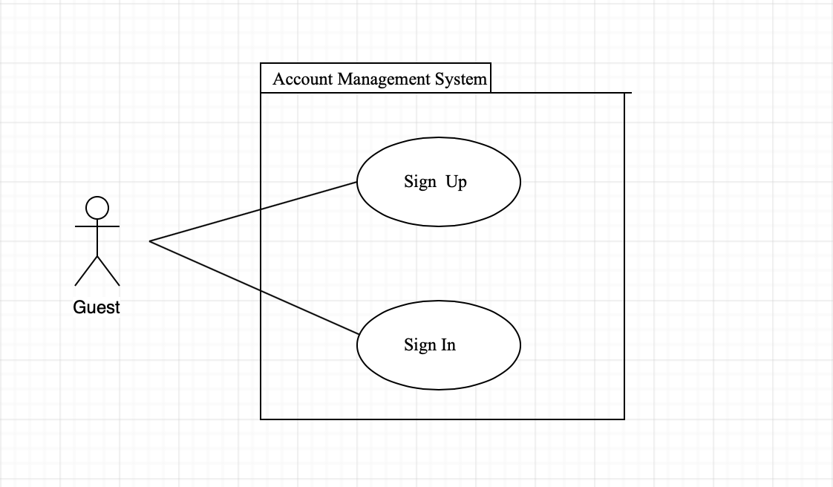

**User role use case diagram:**

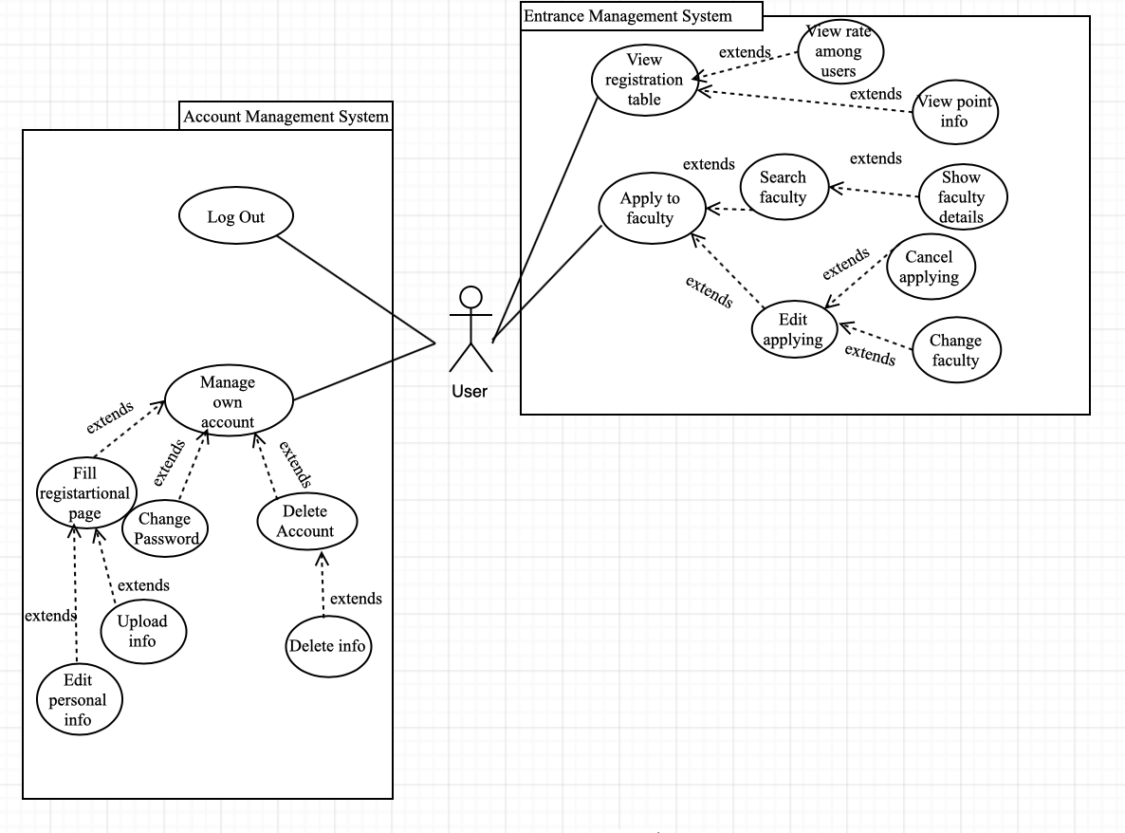

**Admin role use case diagram:**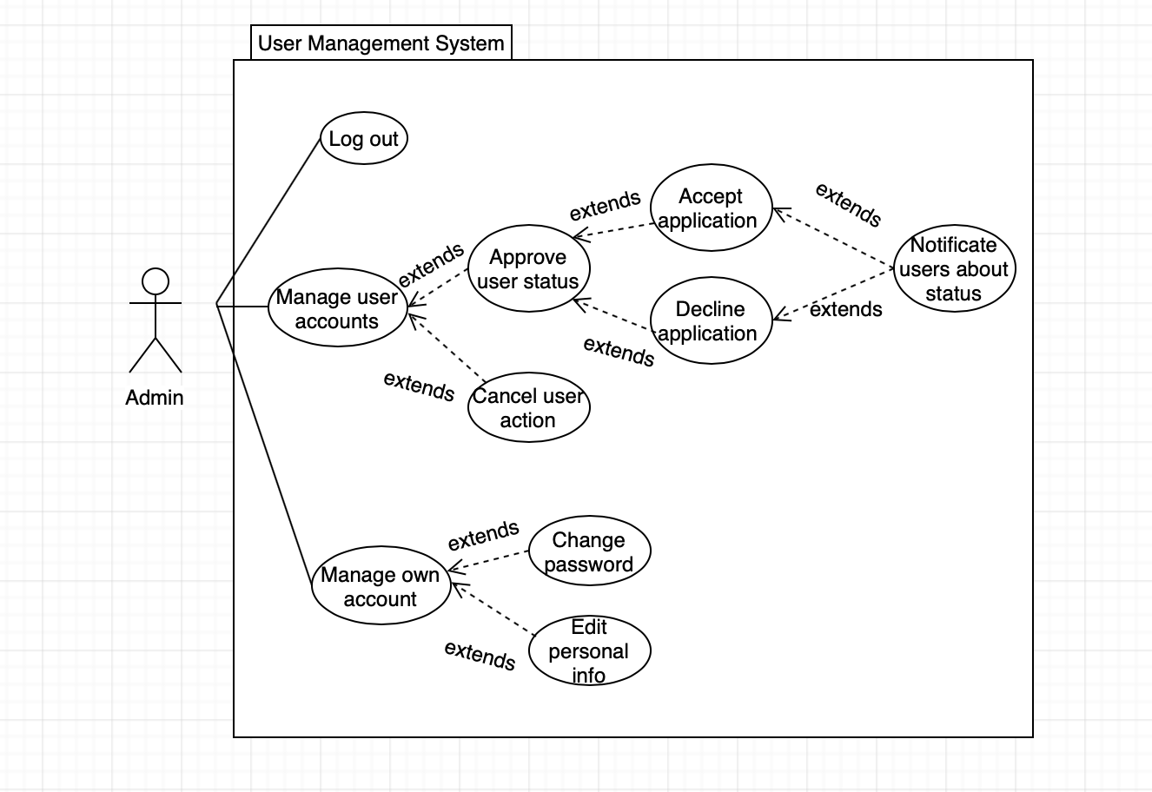

**Sequence diagram:**

