**g-e discrimination**

**Intuition for Integration weights optimization:**

Let’s say we are playing a readout pulse to the readout resonator. The pulse is reflected, downconverted with an IQ mixer and digitized at the inputs of the OPX. So we have a vector of complex numbers in time resolution of 1ns.

$$x_{IF}\left[m\right]=I_{1}\left[m\right]+jI_{2}[m]$$

If we will demodulate it, we will get:

$$x\left[n\right]=x_{IF}\left[n\right]\exp\left(-jω_{IF}t_{n}\right)=x_{I}\left[n\right]+jx_{Q}[n]$$

Expected signal for qubit in ground and excited states are $x_{g}\left[n\right] \& x_{e}\left[n\right]:$

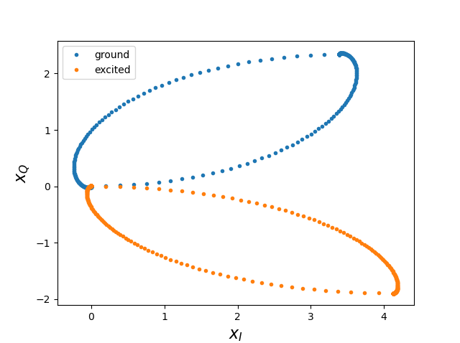

The most probable state is:

⬄

So in order to discriminate we would like to perform a dot product of the demodulated signal with a pre-defined vector, and compare the results to a threshold. The pre-defined vector is the integration weights!

**Complex numbers ⬄ OPX demodulations ⬄ Matrix form:**

$$x_{I}\left[m\right]+jx_{Q}\left[m\right]=\left(I_{1}\left[m\right]+jI_{2}\left[m\right]\right)\left(cosω_{IF}t_{m}-jsinω_{IF}t_{m}\right)\left(cosϕ_{m}+jsinϕ_{m}\right)=I_{1}\left[m\right]\left(cosω_{IF}t_{m}cosϕ_{m}+sinω_{IF}t_{m}sinϕ_{m}\right) +jI_{1}\left[m\right]\left(cosω_{IF}t_{m}sinϕ_{m}-sinω_{IF}t_{m}cosϕ_{m}\right)+I_{2}\left[m\right]\left(-cosω_{IF}t_{m}sinϕ_{m}+sinω_{IF}t_{m}cosϕ_{m}\right)+jI_{12}\left[m\right]\left(cosω_{IF}t_{m}cosϕ_{m}+sinω_{IF}t_{m}sinϕ_{m}\right)=\left[\begin{matrix}cosϕ_{m} & -sinϕ_{m} \\ sinϕ_{m} & cosϕ_{m}\end{matrix}\right]\left[\begin{matrix}cosω_{IF}t_{m} & sinω_{IF}t_{m} \\ -sinω_{IF}t_{m} & cosω_{IF}t_{m}\end{matrix}\right]\left({I_{1}[m] \atop I_{2}[m]}\right)$$

**Optimal weights proof:**

$$x=s_{j}+n, j∈\left\{1, …,C\right\}$$

$$p\left(x | j=i\right)=\frac{1}{πσ^{2}}exp\left(-\frac{{\left\|x-s_{i}\right\|}^{2}}{σ^{2}}\right)=\frac{1}{πσ^{2}}exp\left(-\frac{{\left\|x\right\|}^{2}-2Re\left\{s_{i}^{H}x\right\}+{\left\|s_{i}\right\|}^{2}}{σ^{2}}\right)$$

The Maximum-Likelihood estimator is given by:

$$\underset{i}{argmax}{p\left(x | c=i\right)}=\underset{i}{argmax}{Re\left\{s_{i}^{H}x\right\}-\frac{{\left\|s_{i}\right\|}^{2}}{2}}$$

If $C=2$, this is equivalent to:

$$Re\left\{s_{1}^{H}x\right\}-\frac{{\left\|s_{1}\right\|}^{2}}{2}≶Re\left\{s_{2}^{H}x\right\}-\frac{{\left\|s_{2}\right\|}^{2}}{2}$$

Or, by denoting $b≜s_{1}-s_{2}$:

$$Re\left\{b^{H}x\right\}=Re\left\{{\left(s_{1}-s_{2}\right)}^{H}x\right\}≶\frac{{\left\|s_{1}\right\|}^{2}}{2}-\frac{{\left\|s_{2}\right\|}^{2}}{2}$$

**Implementation on the OPX:**

$$x\left[n\right]=x_{IF}\left[n\right]\exp\left(-jω_{IF}t_{n}\right)$$

$$x\left[n\right]=\left(I_{1}\left[n\right]+jI_{2}\left[n\right]\right)\left(\cos{ω_{IF}t_{n}}-j\sin{ω_{IF}t_{n}}\right)$$

$$Re\left\{b^{H}x\right\}=Re\left\{\sum_{n}{\left(b_{r}-jb_{i}\right)}x\left[n\right]\right\}$$

$$=Re\left\{\sum_{n}{\left(I_{1}\left[n\right]+jI_{2}\left[n\right]\right)\left(b_{r}\left[n\right]-jb_{i}\left[n\right]\right)}\left(\cos{2πft_{n}}-j\sin{2πft_{n}}\right)\right\}$$

$$=\sum_{n}{I_{1}\left[n\right]\left(b_{r}\left[n\right]\cos{ω_{IF}t_{n}}-b_{i}\left[n\right]\sin{ω_{IF}t_{n}}\right)}+\sum_{n}{I_{2}\left[n\right]\left(b_{i}\left[n\right]\cos{ω_{IF}t_{n}}+b_{r}\left[n\right]\sin{ω_{IF}t_{n}}\right)}$$

|  |  |  |
| --- | --- | --- |
|  | **Demod 1** | **Demod 2** |
| **Input** | $$I_{1}$$ | $$I_{2}$$ |
| **Cos weights:** | $$b_{r}$$ | $$b_{i}$$ |
| **Sin weights:** | $${-b}_{i}$$ | $$b_{r}$$ |
| **Result:** | $$R_{1}$$ | $$R_{2}$$ |

$$\left(,,,,\right)\left(\cos{2πft_{n}},\sin{2πft_{n}},-\sin{2πft_{n}},\cos{2πft_{n}}\right){\left(s1,s2\right)}^{T}=\left(c,s,-s,c\right)\left(s_{1}\cos{2πft_{n}}+s_{2}\sin{2πft_{n}},-s_{1}\sin{2πft_{n}}+s_{2}\cos{2πft_{n}}\right)=[c\left(s_{1}\cos{2πft_{n}}+s_{2}\sin{2πft_{n}}\right)-s\left(s_{1}\sin{2πft_{n}}-s_{2}\cos{2πft_{n}}\right),]$$

$$\left(I-jQ\right)\left[n\right]=r_{n}\left(s_{1}\left[n\right]-js_{2}\left[n\right]\right)\left(\cos{2πft_{n}}+j\sin{2πft_{n}}\right)\left(cosϕ_{n}-jsinϕ_{n}\right)=s_{1}\left(\cos{2πft_{n}}cosϕ+\sin{2πft_{n}}sinϕ\right)-js_{1}\left(-\sin{2πft_{n}}cosϕ+\cos{2πft_{n}}sinϕ\right)+s_{2}\left(+\sin{2πft_{n}}cosϕ-\cos{2πft_{n}}sinϕ\right)-js_{2}(\cos{2πft_{n}}cosϕ+\sin{2πft_{n}}sinϕ)$$