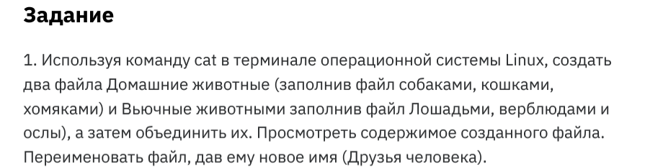

**mkdir control_work**

**cd control_work/nano pack_animalsnano pets**

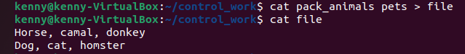

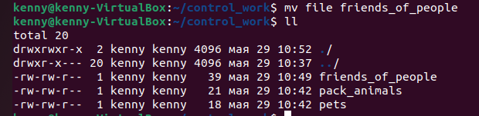



mkdir new_directory

