Andrew Plum

Professor Bolden

CS 270

11/2/2022

Assignment #2 Summary

Pictures of scripts being executed and their effects:

1. 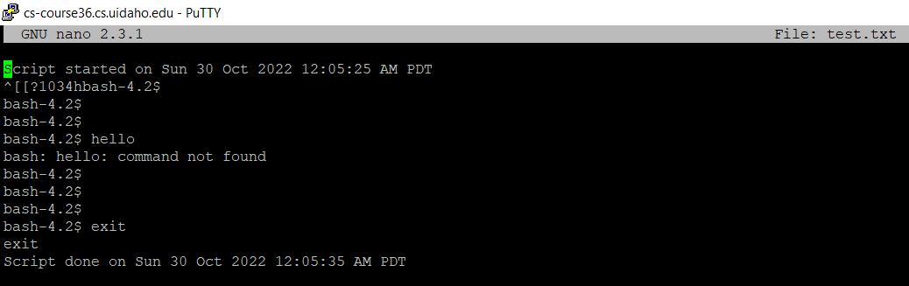Number line script:

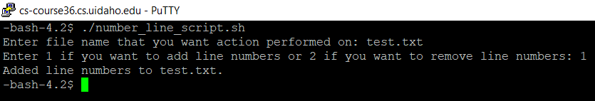Figure 1: Text written in test.txt file.

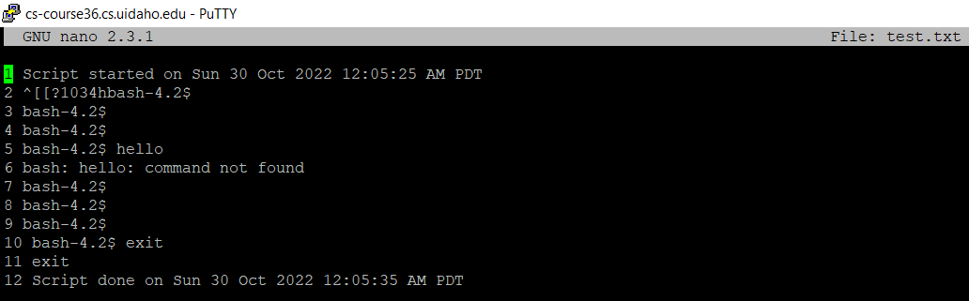Figure 2: Execute script and add line numbers.

Figure 3: Text written in test.txt file after line numbers added.

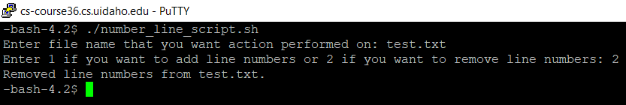Figure 4: Execute script and remove line numbers.

Figure 5: Text written in test.txt file after line numbers removed.

1. Change file name script:

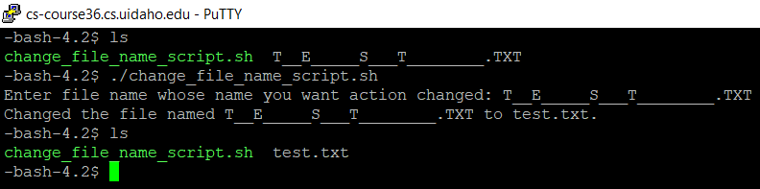Figure 6: Before and after executing the change file name script. File named T__E_____S___T________.TXT change to being named test.txt

1. 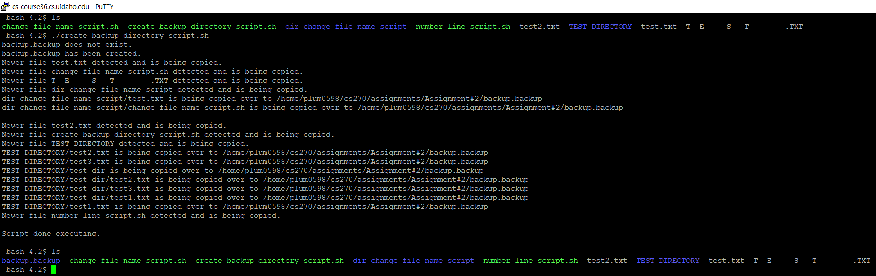Create backup directory script:

Figure 7: Create backup directory script ran. All files are listed before and after script is ran.

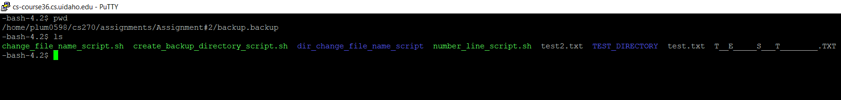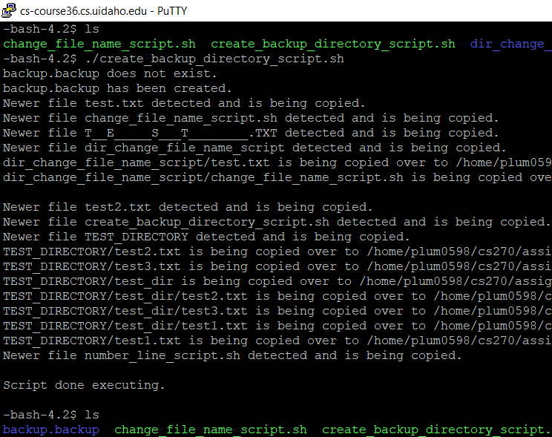Figure 8: Figure 7 zoomed in to show backup directory named backup.backup is created.

Figure 9: Files listed in backup directory named backup.backup

Figure 10: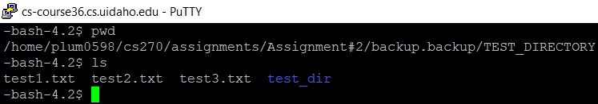 Files listed in directory named TEST_DIRECTORY that is in the backup directory. Shows the files inside the directory were copied along with the directory they are in to the backup directory.

Summary:

I probably spent more time on this assignment than most of the other students but for good reason. I learned a lot of new things I had never worked with before. Bash scripting was new to me and took a while to get a feel of how to do it. This was one of the reasons the first script I did which was the line numbering script took me so long to do. I initially reviewed the lecture notes and looked at websites and videos online to learn about the topic.

The first script also took me a while to do because not only did I do it twice trying two different implementations (the first time I used the awk programming language and was told it wasn’t allowed – I learned the basic ideas of how to use awk though), but I also actually found it to be the most difficult of the three scripts to do. It was relatively easy to get the script to number the lines of a file, but for me it was more difficult to remove the line numbering from the file because it was difficult to find something I thought I could use to do it. It took me a while, but eventually I figured out how to remove the numbering.

The other two scripts were mostly easy to for me to write. I had no significant issues with the second script. Although the code was probably the most complex of the three scripts, the third and last script I did which was the script that made a backup directory and transferred files into it, took me the least time to do because I think I had a better idea of how to do the scripting by then than when I initially started the assignment. The only problem I had with the third script was solving an issue where it would create backup directories with the newly created backup directories. But in general, I would say that I improved at scripting relative to where I started, and that I’ll continue to get better.