**GUIDE TO SORTING AND FILTERING FUNDED GRANTS BY TYPE AND COMPONENT**

We have installed dropdown menus that allow you to filter grants by type and by specific components (budget, letters, etc.) each grant file may contain.

**Sort**

You can sort grants by PI last name, grant title, grant number ([NIH guide to deciphering grant numbers](https://era.nih.gov/sites/default/files/Deciphering_NIH_Application.pdf)), NIH format (current or prior to 2010), and NIH submission date.

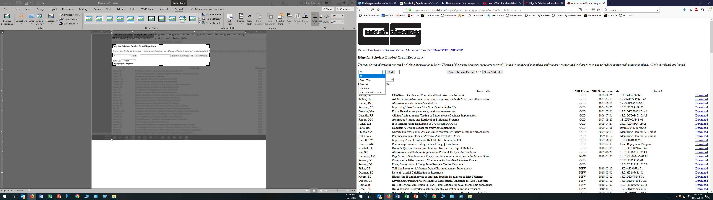

**Filter by Grant Type and Component**

You can filter to show only K awards, R awards (includes R01, R03, R21), VA Merit awards, NIH Loan Repayment Program awards, and Miscellaneous awards (mostly foundation).

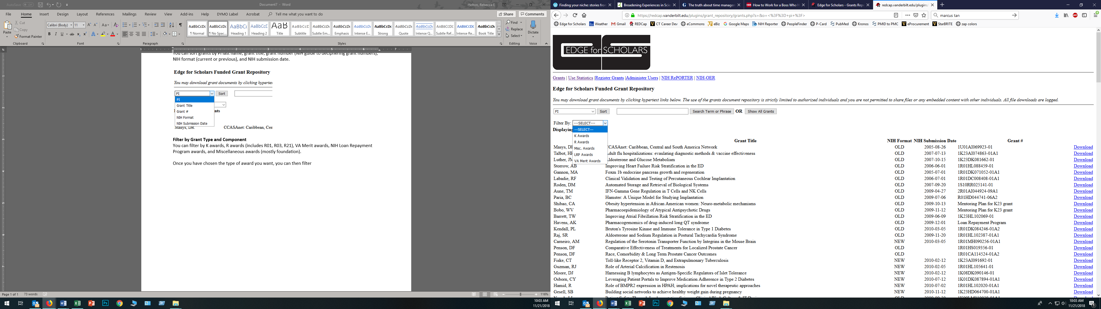

Once you have chosen the type of award you want, you can then filter by **grant component**. Not all grant files include all components. Some only include specific aims and research strategy, or only career development, or some other combination. If you are looking for something specific like budgets, letters, or environment, you can use this filter to see only grants containing that component.

Each funded grant will have documents from the original submission, the resubmission, or both. You can choose to view grants that have the original component of interest or the resubmitted component.

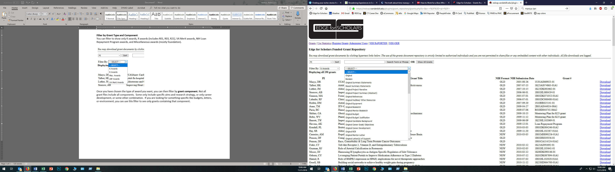

**Search**

The search bar allows you to find grants which contain your term of interest in the title, abstract, or keywords, which have all been taken from NIH RePORTER.

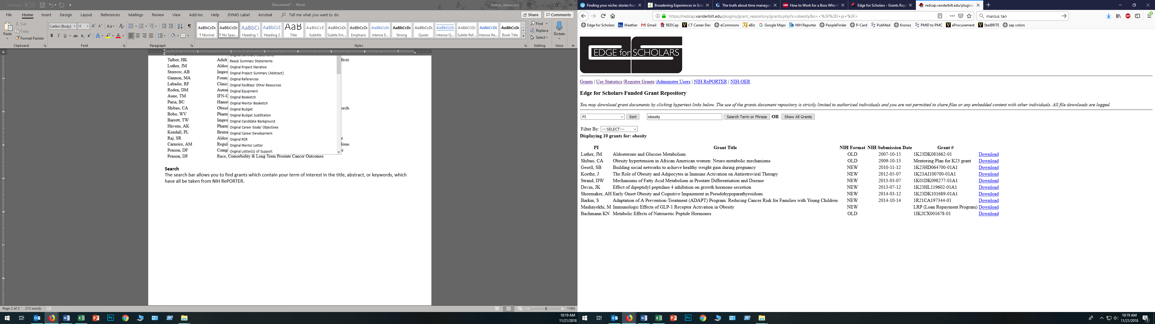

**Clearing Filters**

To clear any filters, sorting, or search terms you have applied, click the button “Show All grants,” which is always visible to the right of the search bar.

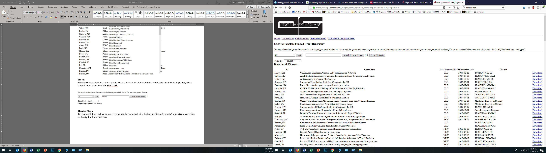

**Questions and Problems**

If you notice problems with these functions or that a grant has been miscategorized or had its components mislabeled, please let us know: [rebecca.helton@vumc.org](mailto:rebecca.helton@vumc.org)

* As soon as we receive a grant using the new (2018) human subjects forms, we will add that as a component on which to filter. If you find this repository useful, please consider submitting your funded grant(s) so that others may learn from them. Email [rebecca.helton@vumc.org](mailto:rebecca.helton@vumc.org) to submit grants.