Story: The Conterville Ghost

by Stephen Colbourn

STORY

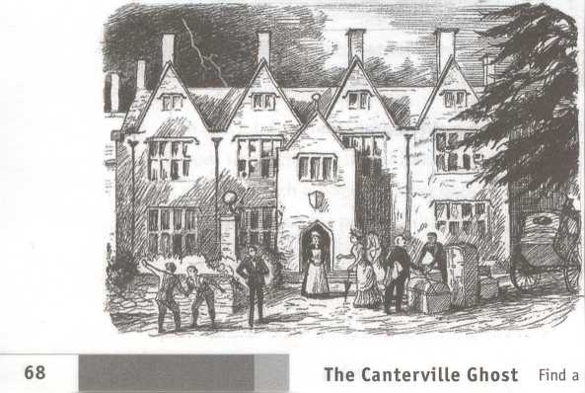

Mr Hiram B. Otis was a rich American from New York. He had come to live and work in England, but he did not want to live in London. He did not want to live in the city. He wanted to live in the countryside outside London.

Canterville Chase was a large and very old house near London. Lord Canterville, the owner, wanted to sell it. So Mr Hiram B. Otis visited Lord Canterville.

'I do not live in Canterville Chase/ Lord Canterville said to Mr Otis. 'I do not want to live there. The house has a ghost - The Canterville Ghost.'

1 come from America/ said Mr Otis. 'America is a modern country. I don't believe in ghosts. Have you seen this Canterville Ghost?'

'No/ said Lord Canterville, 'but I have heard it at night.'

'I don't believe in ghosts/ Mr Otis said again. 'No one has found a ghost. No one has put a ghost in a museum. And you haven't seen this ghost either.'

'But several members of my family have seen it/ said Lord Canterville. 'My aunt saw the ghost. She was so frightened that she was ill for the rest of her life. Also, the servants have seen it so they will not stay in the house at night. Only the housekeeper, Mrs Umney, lives in Canterville Chase. Mrs Umney lives there alone.'

T want to buy the house/ said Mr Otis. 'I'll buy the ghost as well. Will you sell Canterville Chase? Will you sell the ghost?'

Yfes, I will/ said Lord Canterville. 'But, please remember, I told you about the ghost before you bought the house.'

Mr Hiram B. Otis bought Canterville Chase. Then his family came to England from America. He had a wife called Lucretia, three sons and a daughter.

The eldest son, Washington, was almost twenty years old. He was good-looking and had fair hair. His two young brothers were twins. They were twelve years old. The daughter, Virginia, was fifteen years old. She had large blue eyes and a lovely face.

Mr Otis took his family to live at Canterville Chase. The old house was in the countryside west of London. Mr Otis and his family travelled from London by train. Then they rode to the house in a wagon pulled by two horses.

Canterville Chase was big and old. Trees grew all around the house. The Otis family wanted to stop and look at the outside of the house, but the sky darkened. A thunderstorm was coming. Rain started to fall, so the family went inside the house quickly.

Mrs Umney, the housekeeper, was waiting for them by the front door. She was an old woman and wore a black dress and white apron. She lived at Canterville Chase and looked after the house.

'Welcome to Canterville Chase/ said Mrs Umney. 'Would you like some tea?'

'Yes, please/ said Mrs Otis.

The Otis family followed Mrs Umney into the library. There was a big table in the centre of the room and many chairs. Mrs Umney put teacups on the table, then she brought a pot of tea.

The Otises sat in the library and drank their tea. They looked out of a large window at the rain. The rain was falling heavily and the sky was black. They heard thunder and they saw lightning.

Mrs Otis looked around the room. There were many books on bookshelves. There were paintings on the walls. There was also a red stain on the floor. The red stain was by the fireplace.

'What is this red stain?' Mrs Otis asked Mrs Umney.

'It is blood/ answered the old housekeeper in a quiet voice.

'I don't want a blood-stain in my library/ said Mrs Otis. 'Please remove the stain. Please clean the floor immediately.'

The old woman smiled. 'It is the blood of Lady Eleanore de Canterville. She was murdered by her husband, Sir Simon de Canterville, in 1575. The blood-stain has been here for over three hundred years. It cannot be removed.'

'Nonsense/ said Washington Otis. T have some Pinkerton's Stain Remover from America. It can remove any stain. Watch.'

Washington Otis took the stain remover from a bag. Pinkerton's Stain Remover looked like a small black stick. He rubbed the stick on the blood-stain. A minute later the floor was clean. The stick had removed the stain quickly and easily.

Mrs Umney looked at the floor. She was frightened. No one had removed the blood-stain for three hundred years. Mrs Umney was very frightened.

'Pinkerton's can remove anything/ said Washington Otis. 'The blood-stain has gone.'

Lightning flashed and lit the library. Thunder crashed over the house. Mrs Umney fainted.

Mr and Mrs Otis ran across the library. They helped the old housekeeper who lay on the floor. Mrs Umney's eyes were closed and her face was pale.

'Mrs Umney! Mrs Umney!' cried Mrs Otis. 'Can you speak?'

Mrs Umney opened her eyes. 'Trouble will come to this house/ she said. T have seen the ghost. The ghost will come to you.'

iplete list of all Macmillan Readers at [www.macmillanenglish.com/readers](http://www.macmillanenglish.com/readers)