Forecasting Monthly Museum and Historic Site Visitation Using Weather, Seasonality, Google Trends, and Machine Learning
SEIS 763-02 Machine Learning
Team Members: Chandu Esukula · Pachee Greenaway · Andy Miller · Tray Pescosolido · Glorien Roque · Stacy Smith
Professor: Dr. Chih Lai
Submission Date: May 15, 2026

Introduction / Project Overview
This project developed a monthly forecasting model for Avila Adobe, a historic site in Los Angeles, to evaluate whether machine learning could predict visitation using historical attendance, weather, calendar seasonality, Google Trends search-interest signals, and engineered lag features. The practical goal was to support staffing, programming, visitor services, and marketing timing by providing a more data-driven estimate of expected monthly demand.
Description of Data Sources and Web Links
- Museum Visitor Data: Monthly attendance data for Los Angeles museums, with Avila Adobe used as the focal site and monthly visitors as the target variable. Source: Kaggle Los Angeles Museums Visitors dataset.
https://www.kaggle.com/code/yasinnaal/los-angeles-museums-visitors
- Weather Data: Monthly Los Angeles weather aggregates, including average, minimum, and maximum temperature, total precipitation, and average wind speed. Source: NOAA Climate Data Online / Meteostat-style aggregation.
https://www.ncdc.noaa.gov/cdo-web/datasets
- Calendar / Holiday Data: Monthly calendar and seasonality features, including holidays, tourism seasons, school-year indicators, break periods, and cyclical month encodings. Source: Python holidays package.
https://pypi.org/project/holidays/

- Google Trends Data: Relative search-interest signals for museum, tourism, history, family activity, and benchmark attraction terms. Values are indexed from 0 to 100 and reflect relative interest rather than raw search volume. Source: Google Trends.
https://trends.google.com/trends/
Number of Records and Attributes
- Original Avila Adobe monthly series: 90 observations from January 2014 through June 2021.
- Merged final dataset: 90 rows and 72 columns after joining visitor, weather, calendar, and Google Trends features.
- Saved modeling dataset: 78 rows and 75 attributes after adding lag features. Twelve months were lost because visitors_lag12 and rolling_mean_3 require prior history.
- Final modeled dataset: 64 rows after removing COVID-affected closure months before fitting and evaluation. These rows were removed so the model would not learn a forced-closure pattern as normal demand.
General Statistics of the Dataset
After removing the COVID-affected closure months, the final modeled dataset better reflects normal visitation conditions. The target series still shows strong seasonal movement and substantial month-to-month variation, which made lag features central to the modeling strategy.
Measure | Final Modeled Dataset
Rows used for fitting/evaluation | 64
Mean monthly visitors | 21,286
Median monthly visitors | 20,868
Minimum monthly visitors | 3,710
Maximum monthly visitors | 41,242
Weather features were retained because they may affect visitor decisions, but their final contribution was weaker than the historical attendance and seasonality signals.
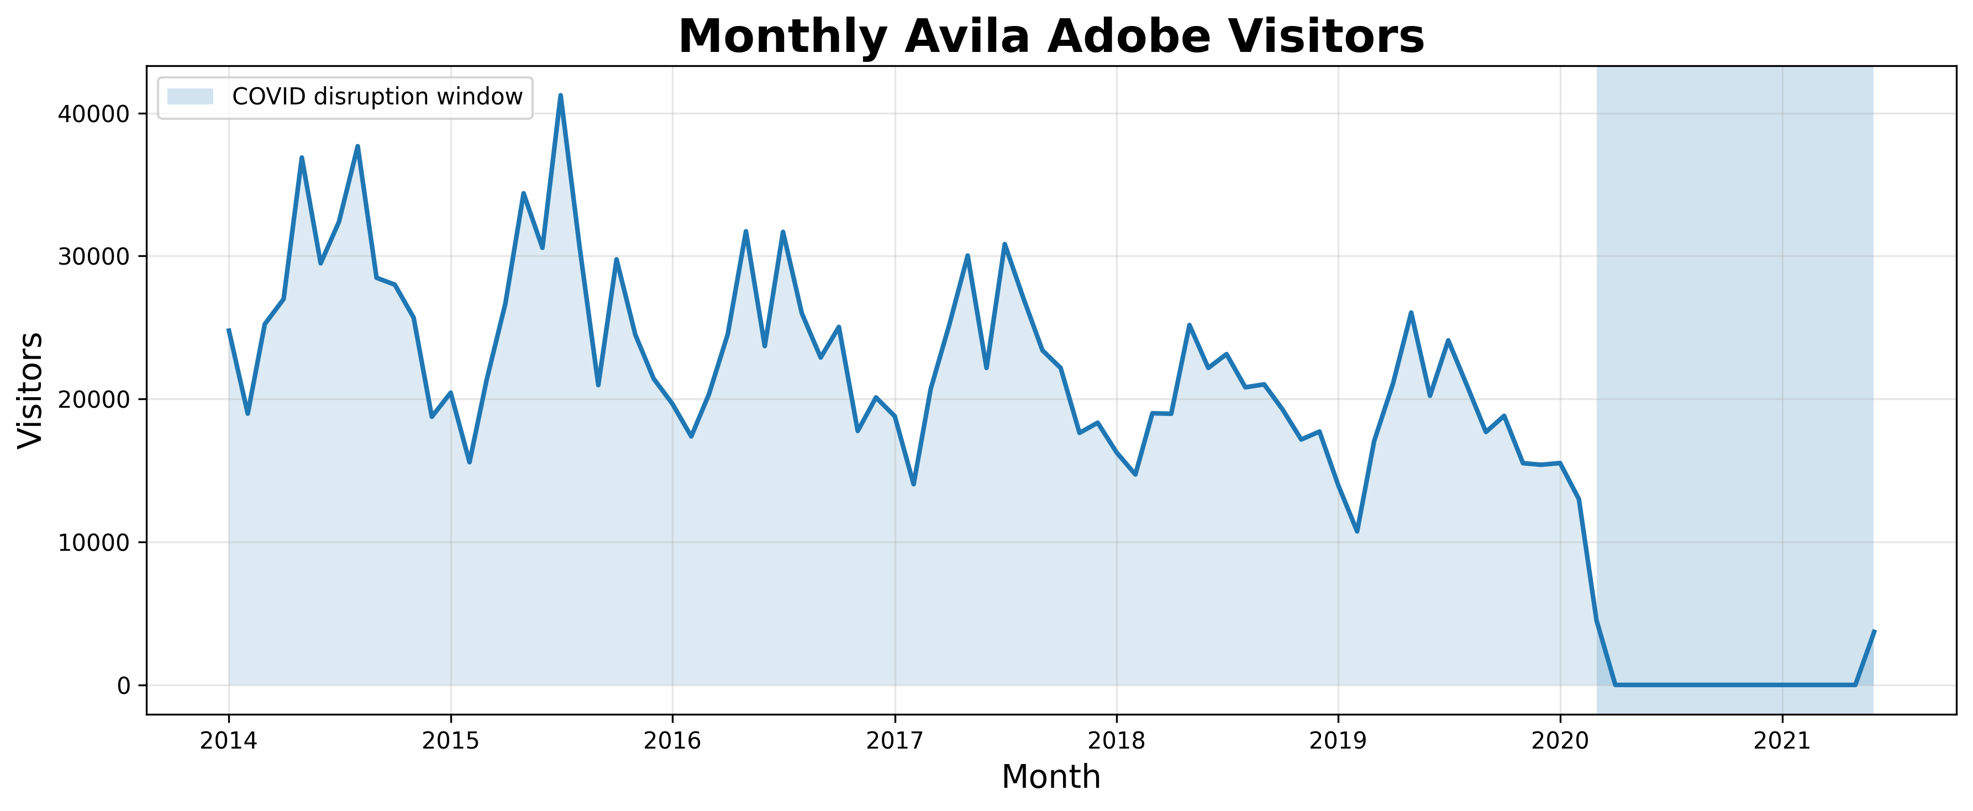
Figure 1. Monthly Avila Adobe visitors, 2014–2021. This figure shows the overall monthly visitation pattern, including recurring seasonality and the disruption caused by the COVID-19 closure period.
Tools and Methods Used
Tools / Libraries
- Python
- pandas
- numpy
- scikit-learn
- matplotlib
- Jupyter Notebook
- pytrends
- holidays
- GitHub
Models Tested
- Linear Regression
- Cleaned Linear Regression
- LASSO
- LASSO-LARS
- Random Forest
- Gradient Boosting
- SVR (Linear)
- SVR (RBF)
Evaluation Metrics
- RMSE: average prediction error measured in visitor-count units, with larger errors penalized more heavily.
- MAE: average absolute prediction error in visitors.
- R²: proportion of variance explained on the holdout set.
Workflow Summary
- Clean monthly Avila Adobe visitor data and aggregate weather data to the same monthly grain.
- Merge visitor, weather, calendar, and Google Trends features using a common YYYY-MM key.
- Engineer lag and rolling features, remove COVID-affected closure months, and split the data using a time-based holdout.
- Train and compare the final set of regression models using RMSE, MAE, and R².
Problems and Questions Studied
- Can monthly museum visitation be forecast with reasonable accuracy?
- How much do weather variables influence attendance?
- How important are seasonality and lag features?
- Can Google Trends serve as a proxy for public demand?
- Which model performs best for monthly visitor prediction?
Results
LASSO-LARS was the best-performing model, with RMSE = 2,982.044, MAE = 2,259.141, and R² = 0.783. In practical terms, the best model forecasted monthly visitation with reasonable accuracy for operational planning purposes after the COVID-affected closure months were removed from the final modeling dataset. Table 1 summarizes the final performance metrics for all tested machine learning models.

Rank | Model | RMSE | MAE | R²
1 | LASSO-LARS | 2,982.044 | 2,259.141 | 0.783
2 | LASSO | 2,986.711 | 2,258.057 | 0.782
3 | SVR (Linear) | 3,368.630 | 2,368.915 | 0.723
4 | Gradient Boosting | 5,001.671 | 3,340.323 | 0.389
5 | Random Forest | 5,533.448 | 3,604.140 | 0.252
6 | SVR (RBF) | 7,229.172 | 5,234.714 | -0.277
7 | Linear Regression | 8,769.045 | 6,205.897 | -0.879
8 | Cleaned Linear Regression | 8,769.045 | 6,205.897 | -0.879
Table 1. Final model comparison results for monthly museum visitation forecasting.
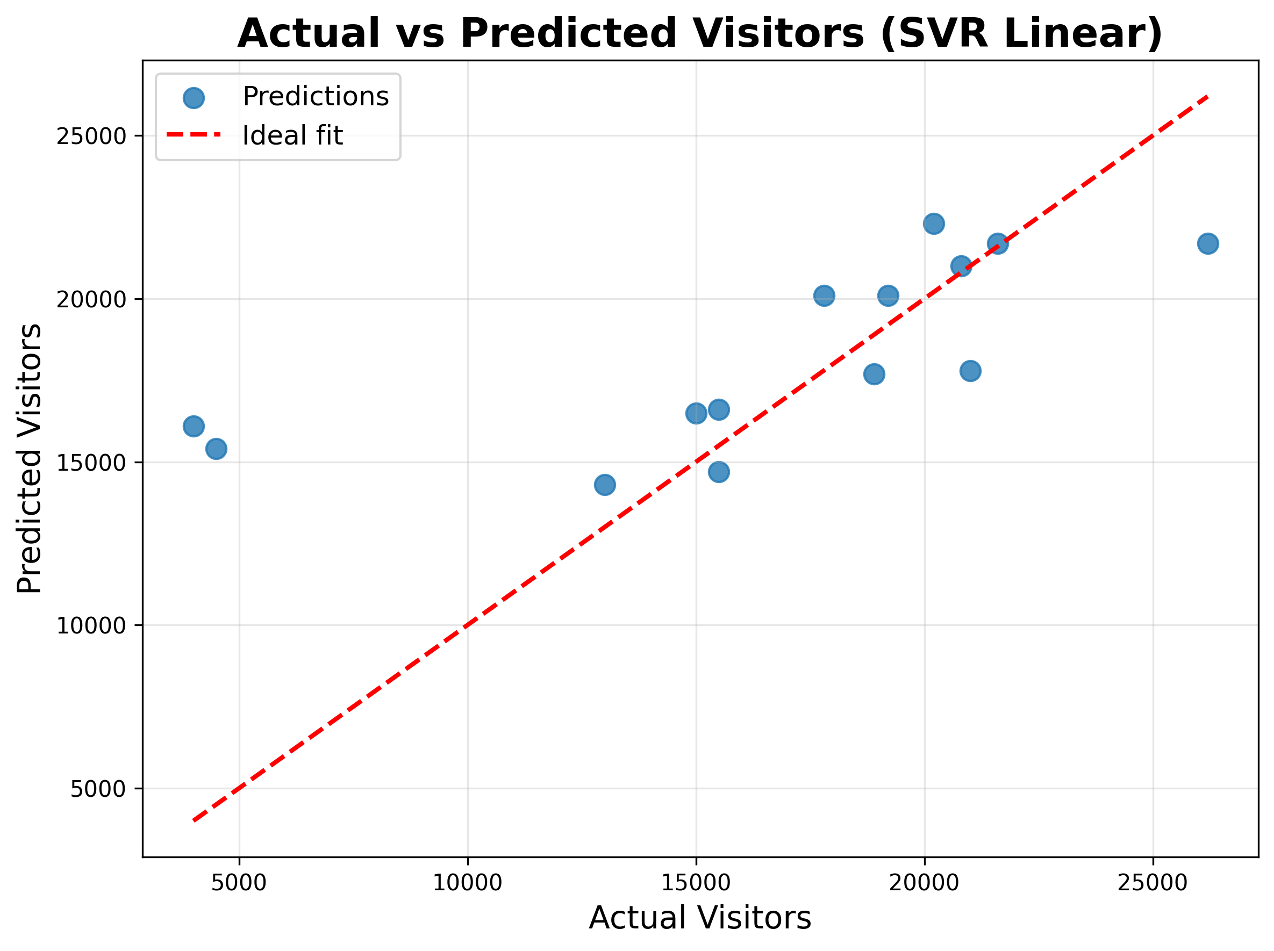
The ranking shows that regularized linear models performed best. LASSO-LARS slightly outperformed LASSO, while SVR with a linear kernel also performed well but did not surpass the LASSO-based models. SVR with an RBF kernel and the plain linear regression models performed poorly, suggesting that the small monthly dataset and correlated predictor pool favored a simpler regularized linear models over a more flexible nonlinear kernel.
Figure 2. Actual vs. predicted monthly visitors for the SVR (Linear) model. SVR with a linear kernel performed well and ranked third overall, showing that the visitation data retained a strong linear structure even though it did not outperform LASSO-LARS.
Support Vector Regression was also evaluated based on the instructor’s suggestion. The linear-kernel SVR performed well and ranked third overall, with RMSE = 3,368.630, MAE = 2,368.915, and R² = 0.723. As shown in Figure 2, the SVR (Linear) predictions generally followed the actual visitation pattern, although the model still underperformed LASSO-LARS. In contrast, the RBF-kernel SVR performed poorly, suggesting that the dataset was better represented by linear relationships than by a more flexible nonlinear kernel.
Key Takeaways
- Historical lag features were the strongest predictors overall. The latest presentation identifies visitors_lag1 as the strongest single signal in the best-model interpretation, while visitors_lag12 remains a major seasonal predictor and is especially prominent in Random Forest feature importance.
- Google Trends acted as a useful but secondary signal. Tourism, history, and discovery terms such as Los Angeles attractions, Olvera Street, Los Angeles history, and El Pueblo Los Angeles helped capture public demand, but lag features carried more of the predictive signal.
- Weather variables were included but were weaker contributors compared with lag features and seasonality. Temperature, precipitation, and wind may still matter operationally, but they were not the dominant model drivers.
Limitations
- The final modeled dataset is small, with 64 monthly observations after lag engineering and COVID closure-month removal.
- The analysis focuses on one site, Avila Adobe, so results should not be generalized to all museums or historic sites without additional testing.
- Monthly granularity misses week-of, day-of-week, event-day, and holiday-week effects that may matter for staffing.
- Google Trends values are relative indices, not absolute search counts.
- Correlated predictors, especially similar Google Trends terms and overlapping weather variables, created multicollinearity that hurt unregularized linear regression.
- The COVID disruption limits generalizability, even though COVID-affected closure months were removed before final modeling.
Future Work
- Add post-2021 visitor data to improve sample size and better capture recovery patterns.
- Expand the analysis to more museums, historic sites, and cities to test generalizability.
- Move from monthly data to weekly or daily data to capture short-term staffing and event effects.
- Improve Google Trends feature selection by removing duplicate or highly collinear terms and testing whether search terms lead to visitation.
- Compare additional time-series methods, such as rolling-origin validation, SARIMAX, Prophet-style forecasting, and tuned gradient boosting.
- Add operational data such as events, ticketing, marketing campaigns, school calendars, and weather forecasts.

Conclusion
Overall, this project demonstrates that machine learning models can forecast monthly museum visitation with useful accuracy when historical attendance, seasonality, weather, and Google Trends demand signals are combined. Regularized linear models, especially LASSO-LARS, performed best because they handled correlated predictors effectively while reducing overfitting on a relatively small dataset. The strongest predictors were historical lag features, showing that past visitation patterns and seasonality remain the most reliable indicators of future attendance, while Google Trends added meaningful public-interest context.
From an operational perspective, the results suggest that museums and historic sites could use similar forecasting models to improve staffing decisions, visitor services, exhibit planning, and marketing timing. Although the dataset and time range were limited, the project successfully demonstrated a complete end-to-end machine learning workflow and provided a strong foundation for future improvements in forecasting and expansion to larger cultural datasets.

Appendix
Additional plots, feature-importance charts, residual diagnostics, and modeling outputs are available in the project GitHub repository (https://github.com/Andy-FireClimWx/museum-visitation-project) and the accompanying Jupyter notebooks.

