Andrew T. Sullivan 109151173

*The Hurst Exponent in the Glucose-Insulin System*

**Introduction**

While the magnitudes of specific biological responses may vary significantly between individuals, it is often the case that the dynamic response of a given biological system follows similar trends in healthy individuals. Numerous methods exist to analyze response dynamics in both biological and non-biological systems, including detrended functional analysis (DFA), power spectrum scale invariance (PSSI), and the Lyapunov and Hurst exponents. These biological and non-biological systems exhibit fractality, in which scaling laws are valid over several orders of magnitude in time or space (or frequency), including heartbeat, blood pressure, spiking intervals, and glucose levels in biology, as well as physical time series including rainfall3, temperature, wind speed, and numbers of sunspots4.

The Hurst exponent was developed by Harold E. Hurst, a hydrologist, in order to examine dynamics of the water level of the Nile, but has recently become a valuable tool in examining trends, predictability, and self-similarity of financial markets6, and has also been extended to biomedical applications7. The Hurst exponent was initially formally defined as:

$E[\frac{R(n)}{S(n)}]=Cn^{H}$

in which *R(n)* is the range of the *n* data points (i.e. max(*Xi)*-min(*Xi)*) for *i=1,2,...,n*, and *S(n)* is the standard deviation of the time series, defined in the usual way as

$S(n)=\sqrt{\frac{1}{n}\sum_{i=1}^{n}{}{(X_{i}-μ)}^{2}}$*.*

The equation predicts that the expected value (mean) of the ratio of the range and standard deviation of the time series will grow according to a power law. The exponent of this power law, *H*, is the Hurst exponent.7 The procedure for estimating the Hurst exponent is known as rescaled range analysis and is calculated by dividing the time series into *n/t* non-overlapping groups of *t* data points, and for each one, calculating the rescaled range (*R/S*). The final value is averaged over the number of data sets for a given *t*. Plotting the logarithm of *R/S* with versus the logarithm of *t* should produce a linear trend with the slope equal to the Hurst exponent.6

The values of the Hurst exponent range between 0 and 1 with closer proximity to 0.5 (white noise/random series) indicating less regulated dynamics. A value less than 0.5 indicates an anti-persistent or mean-reverting series, in which an increase in the value of the series at one time point is more likely to be followed by a decrease at the next time point. Values closer to 0 indicate stronger anti-persistent behavior. Values larger than 0.5 indicate a persistent or trend-reinforcing series, in which an increase is more likely to be followed by another increase and a decrease is more likely to be followed by another decrease. Values closer to 1.0 indicate stronger persistence. Typically, financial markets are reported to exhibit persistent behavior.6

It has been shown that the glucose-insulin regulatory system exhibits fractality, and has been analyzed using DFA5,8 and power spectrum analysis8. In order to analyze the dynamics of the glucose-insulin response to an initial pulse into the digestive system, the time series of the glucose levels in the blood was extracted from a previously developed model in Stella Professional and the generalized Hurst exponent was calculated for each time series. Both single-pulse dynamics and the long-term behavior of the system were examined.

**Results & Discussion**

The model used was previously developed in Stella Professional to account for normal glucose-insulin dynamics and effects of diabetes. Briefly, the model considers glucose held at a baseline of 80 mg/dL, which receives input from the digestive tract with a fixed absorption rate constant. Insulin is secreted in proportion to the difference of glucose from its steady-state value, and is degraded at a fixed rate. Glucose is absorbed into the cells at a rate which is the sum of an insulin-dependent rate, a glucose-dependent rate, and an independent constant rate, and is converted to glycogen (and hydrolyzed) at an insulin-dependent rate. The glycogen is then converted to fat with the same rate constant in order to account for the effects of fat on insulin resistance, which is introduced as a ratio using experimental data for the free fatty acid (FFA) concentrations of healthy and obese individuals. This ratio decreases the response to insulin as the FFA concentration is increased. Another proportionality ratio is introduced to account for degradation of pancreatic beta cells, which secrete insulin. These are degraded at a fixed rate based on the percentage reduction of functioning cells over the course of a year obtained from experimental data. These two ratios underlie the mechanisms governing type II and type I diabetes, respectively.

*Single-Pulse Dynamics*

Initially, the Hurst exponent was calculated for single glucose responses as a function of the initial pulse magnitude. The Generalized Hurst exponent function genhurst.m was used for the calculations.1 The results are summarized in the figures below for three cases: i) the normal response of the system was evaluated for the range of initial pulses from 10-100 in increments of 10, from 100-1000 in increments of 100, and from 1000-10000 in increments of 1000; ii) the response of the system with the fraction of functional beta cells set to 0.1 (this value has been reported as being within the range at which the effects of type I diabetes initially manifest) for 10-100, 100-500, 1000, 5000, and 10000; and iii) the response of the system with the initial fat content set to 40 kg with normal beta cell response (this value was obtained from the study from which the FFA concentration ratio was established, in which the mean value of fat content for obese individuals was 40 kg) for 10-100, 100-1000, 5000, and 10000. Less values were taken for the latter two cases as the Hurst exponent changes most rapidly close to the initial values through pulse responses of up to 500, after which it levels off. Values were also checked for higher values of initial pulse, but remained approximately constant.

It is apparent from these images that there are differences in the dynamics of the system for each of the three cases, in terms of both the overall magnitude of the exponent as a function of initial pulse, and the shapes of the curve. The curve for the normal dynamics has the highest value over all pulse points, followed by the type I diabetic, and then the type II. In the context of the Hurst exponent, this indicates that the ratio of the range to the standard deviation increases most rapidly over time for a normal individual. While the diabetics will often experience larger absolute magnitudes of glucose responses than that of a non-diabetic individual, the pulses also take much longer to decay, leading to prolonged elevated blood glucose levels. It is likely that this prolonged elevation raises the standard deviation of the response more rapidly than the overall range is increased, leading to the observed behavior. The normal and type I diabetic curves also show initial inflections and small peaks in the value, while these are absent in the insulin-resistant individual. Additionally, the onset of overshoot-and-collapse behavior, characterized by a noticeable dip below the resting glucose value, follows the opposite pattern as the Hurst exponent; that is, the onset is latest for the type II diabetic and earliest for the normal individual. For all cases, this occurs after the curve has reached steady-state. In the context of financial systems, it has been reported that a drop in the Hurst exponent may act as an indicator of an upcoming market crash2. Though this may not directly translate into the glucose-insulin system, it is consistent with the conclusion that changes in the Hurst exponent may suggest dysregulation.

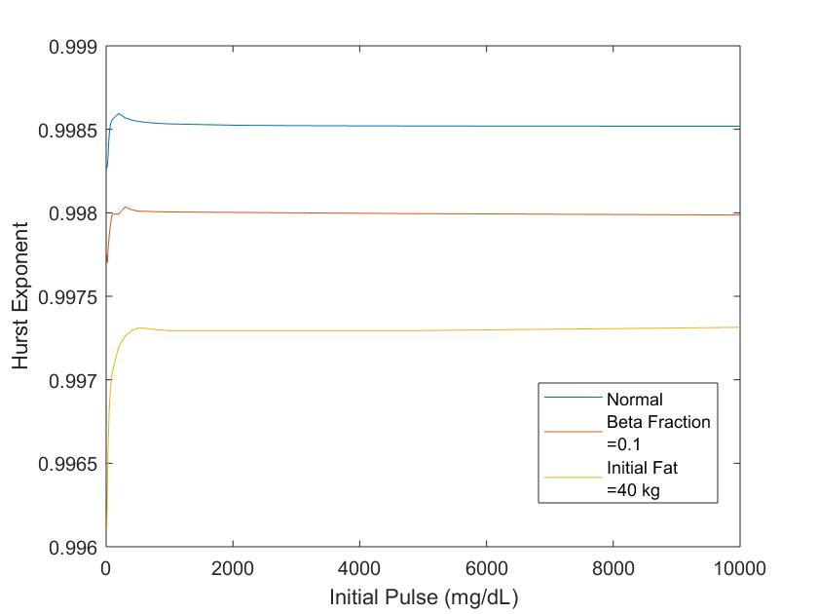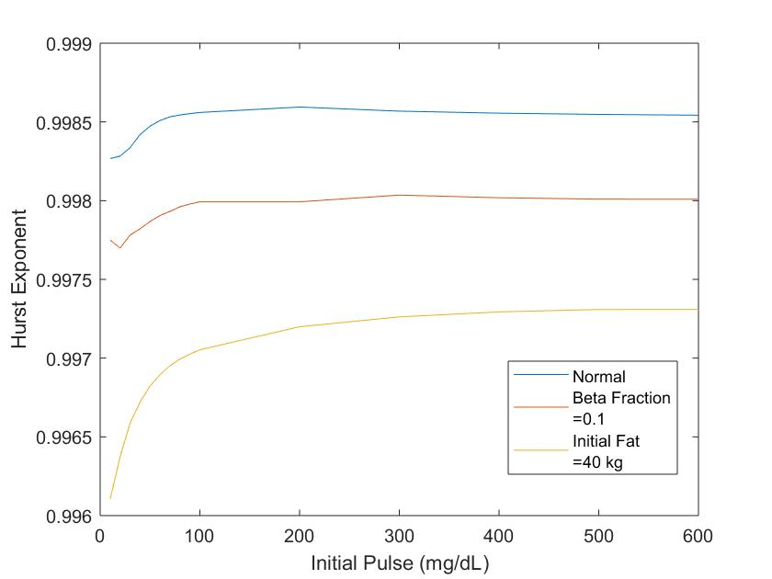

*Long-Term Response*

Though the individual response dynamics indicate differences in the behavior of the system as effects of diabetes are considered, the true worth of the Hurst exponent lies in predicting the long-term behavior of the system, rather than that of an individual pulse. In a system exhibiting complete fractality, these two cases should be identical, but experimental calculations based on the model show the opposite trend of values for the long-term case of the glucose-insulin system. In order to probe the long-term system response, it was desirable to provide a random input, in order to avoid sampling dynamics that only exist for a given input frequency. Thus, the input function was changed to a pulse using the “random” function in the Stella environment, which takes a minimum and maximum value and a seed value. The random function was used for the absolute value of the pulse, between 10 and 1000, and for the time between pulses, from 1 hour to 24 hours. The seed values were taken to be 1 and 12, respectively. The system was sampled over a year, and data was extracted for four cases: i) normal function; ii) beta cell fraction = 0.1; iii) initial fat concentration = 40 kg; iv) both conditions from ii) and iii). Note that the beta cell fraction here is set with an *initial* value of 0.1, while in the previous case, it was simply taken to be constant at 0.1. As the timescale of the changes is extremely long relative to the value of a single response, there are not significant differences between the two cases. The results are depicted below:

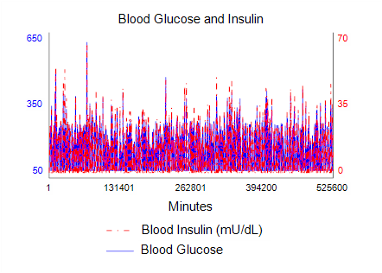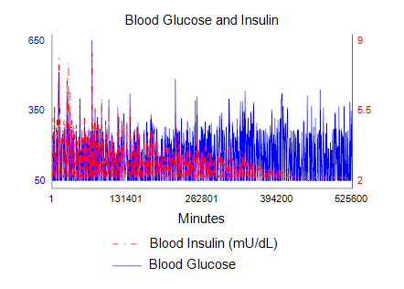

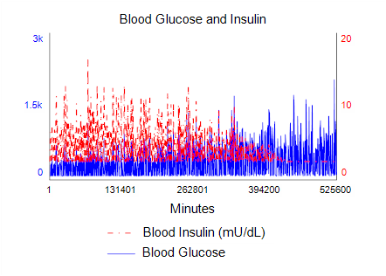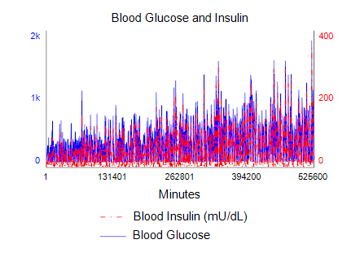

The normal data is displayed at the top right, and the next three, going clockwise, are decreased beta cell, insulin-resistant, and both. The trends in the above system are consistent with expected behavior in diabetes; that is, individuals with reduced beta cell fractions display decaying insulin response and larger glucose levels (though the difference here is small), those with elevated FFA concentrations display insulin resistance, characterized by both increased glucose levels and insulin levels, and those with both exhibit both decreased insulin levels and resistance to insulin, further exacerbating the elevation of glucose.

The time series were extracted for each and the Hurst exponents were calculated to be 0.9970, 0.9971, 0.9975, and 0.9975, respectively. This is interesting because, as previously mentioned, the trend is opposite that found for the single-pulse dynamics. Though this seems somewhat counterintuitive, it may be explained in the following way. Higher Hurst exponents suggest more persistent dynamical behavior. Thus, the larger exponents indicate that, in diabetic individuals, an increase in blood glucose is more likely to be followed by another increase, and a decrease by another decrease. The longer time course of a single glucose response pulse for diabetic individuals means that more data points exist where a decreasing value is followed by another decreasing value, as the overall magnitude of each decrement is smaller, since the system has trouble returning to its set point as a result of decreased insulin response or sensitivity. Thus, though the intuition may be to think of a larger Hurst exponent as a more well-regulated system, the increased persistent behavior may actually be detrimental to the overall functioning of the system. As an example, if one considers a system in which there is no removal of glucose, then an increase in glucose will be invariably followed by another increase. This translates to a Hurst exponent of 1.0. In biological systems, values of many quantities must be maintained between very precise limits for proper functioning, and deviations in either direction often cause undesirable responses. Based on the above results, it appears that the Hurst exponent for the glucose-insulin system is an example of such a quantity.

It has previously been found using DFA and other dynamical techniques that glucose regulation is impaired in diabetic patients, exhibiting power-law exponents suggesting more variable responses and a reduced ability to maintain glucose within a fixed range. It should be noted, however, that the data for these studies comes largely from experimental sources, rather than simulations, and the above simulation, while capturing the overall behavior of the glucose-insulin system from an isolated standpoint, does not consider the myriad other biological inputs that can affect this system, including, for example, physical activity, arousal, hormonal and metabolic fluctuations, or circadian rhythms8. These external inputs further randomize the glucose response, and will likely lead to consistently less well-regulated system dynamics, as indicated by Hurst exponents significantly closer to 0.5 than those obtained in this exercise. It is unknown how these external inputs will affect the system dynamics in diabetic versus normal individuals. It is possible that diabetic insulin-glucose dynamics will be more significantly perturbed by external cues, leading to an even lower Hurst exponent value than that predicted by the above analysis, though this cannot be stated with any certainty using the above data. However, given the above interpretation regarding the persistence of the behavior, it is entirely possible that the difference of the effects of external inputs between the two systems is insignificant, and the trend of a larger Hurst exponent will be found in experimentally observed data as well.

**References**

1. Aste, Tomaso. “Generalized Hurst exponent.” *MathWorks File Exchange*. 31 January 2013. Web. 27 March 2018.
2. Domino, K. (2011). "The use of the Hurst exponent to predict changes in trends on the Warsaw Stock Exchange." *Physica A: Statistical Mechanics and its Applications* 390(1): 98-109.
3. Hamed, K. H. (2007). "Improved finite‐sample Hurst exponent estimates using rescaled range analysis." *Water Resources Researc*h 43(4).
4. Kantelhardt, J. W. (2011). “Fractal and Multifractal Time Series.” *Mathematics of Complexity and Dynamical Systems*. R. A. Meyers. New York, NY, Springer New York: 463-487.
5. Ogata, H., et al. (2007). "Long-range Correlated Glucose Fluctuations in Diabetes." *Methods Inf Med* 46(02): 222-226.
6. Qian, B. and K. Rasheed (2004). *Hurst exponent and financial market predictability*.
7. Racine, R. (2018). *Estimating the Hurst Exponent*.
8. Weissman, A. and O. Binah (2014). "The fractal nature of blood glucose fluctuations." *Journal of Diabetes and its Complications* 28(5): 646-651.