ArcSOCOptimizer for ArcGIS Monitor

Contents

1 Get started 3

1.1 ArcSOCOptimizer.exe for windows 3

1.2 Using python code 3

2 Overview 3

3 SampleConfig.json 5

3.1 Server 6

3.1.1 url, username, passwrd 6

3.1.2 Password _encoding 6

3.1.3 paging_size 6

3.2 ArcSOCOptimizer 6

3.2.1 edit:false/true 6

3.2.2 past_days:number 6

3.3 low_usage 6

3.3.1 avg_sec/day:float 6

3.3.2 dedicated_to_shared: true/false 7

3.3.3 dedicated_instance_min:int 7

3.4 high_usage 7

3.4.1 avg_sec/day:float 8

3.4.2 shared_to_dedicated: true/false 8

3.5 component_address 8

3.6 arcgis_server 8

3.6.1 host_address:array 8

3.7 limits 9

3.7.1 memory_available_GB 9

3.7.2 min_ceil 9

3.7.3 max_min_diff 9

3.8 exclude 9

3.8.1 services 9

3.8.2 folders 9

4 Use case 10

4.1 edit=false 10

4.2 edit=true 10

4.2.1 Memory limit 11

5 Terms of use 11

# Get started

Always test in your non-production environment first.

ArcSOCOptimizer.exe is a python-based command line utility that can be run on demand or scheduled as a task, e.g., daily, weekly, or monthly depending on how dynamic the usage is.

## ArcSOCOptimizer.exe for windows

1. Unzip the ArcSOCOptimizer.zip and go to dist folder
2. Edit SampleConfig.json.
3. Open a command line and execute:

ArcSOCOptimizer.exe -f SampleConfig.json

1. View the output in the reports folder

## Using python code

Follow README.md.

# Overview

ArcSOC Optimizer can help administrators:

1. Reduce memory by identifying **low usage** services with dedicated pooling and reducing the overall number of arcsoc.exe processes:
   1. changing dedicated to shared instance pool, if supported
   2. reducing min instances for dedicated instance pool services
2. Improve performance by identifying **high usage** service and allocating dedicated arcsoc.exe processes if available memory:
   1. changing shared to dedicated instance pool
   2. increasing min instances for dedicated instance pool

For more information, see <https://enterprise.arcgis.com/en/server/latest/administer/windows/configure-service-instance-settings.htm>

*Shared instances are recommended for services that receive infrequent requests, particularly when the server site hosts many services. Dedicated instances, on the other hand, make a service always available to handle requests using one or more server processes and are ideal to use for services that receive constant or particularly compute-intensive requests.*

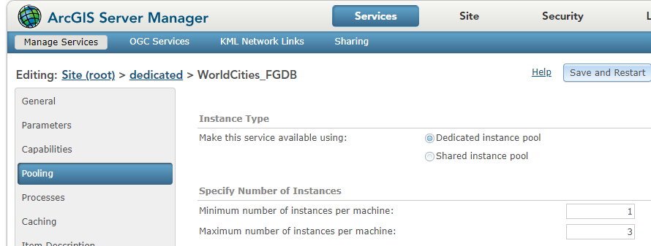

**Note**: ArcSOC Optimizer does not change the pooling number of shared instances. If CPU on the machine is available, use the following guidelines to increase it if need.

*By default, the number of shared instances in the pool is set to an appropriate number based on the number of physical CPU cores on each machine.*

*If most or all of your site's services use the shared instance pool, consider setting the number of service instances in the shared pool to twice the number of physical CPU cores on the individual machines in your ArcGIS Server site (for example, if you're using 4-core machines, consider setting the pool size to eight instances).*

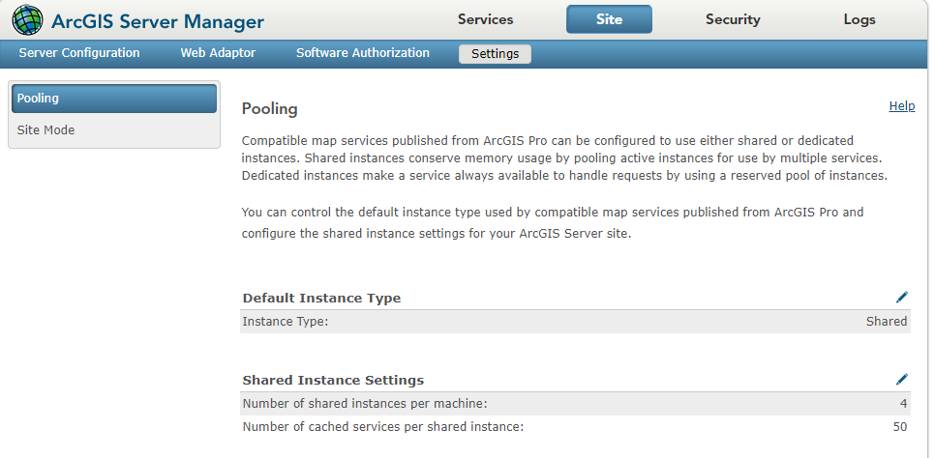

# SampleConfig.json

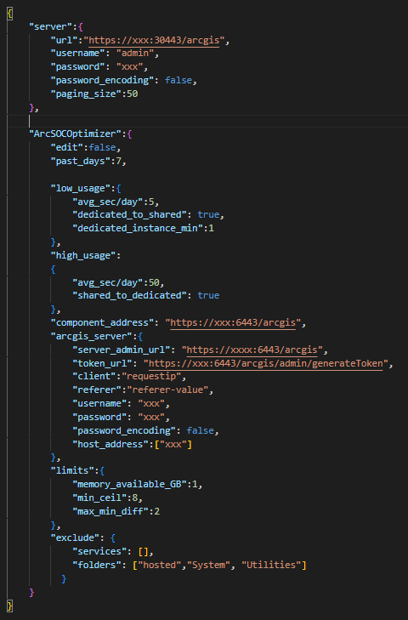

## Server

### url, username, passwrd

ArcGIS Monitor url and credential.

### Password _encoding

User can encrypt password with UTF-8 base64 encoding , e.g. <https://www.base64encode.org/> and set password_encoding: **True.** This is optional parameter.

### paging_size

This parameter controls the size of the queries ArcSOCOptimizer sends to ArcGIS Monitor.

When analyzing many services over long times, e.g., when past_day 30 and ArcGIS site has more than 200 services, the queries ArcSOCOptimizer sends to ArcGIS Monitor might time out. This is mainly related to In some cases, re-running the tool might address this problem because the data from the disk is moved to PostgreSQL memory. But if the problem continues, users should reduce the paging_size, e.g., 20, 10, etc.

## ArcSOCOptimizer

### edit:false/true

False executes in read only and produces a list of recommendation. Start with False, review and validate the results. Once validated, execute true.

### past_days:number

Number of past days to be analyzed to determine low and high usage.

The recommendations are based on historical data. You may choose to increase the 7 day default.

## low_usage

ArcSOC optimizer will compare avg_sec/day input with the historical service usage from ArcGIS Monitor. If this service usage is lower that avg_sec/day input, the tool will recommend

1. min instance equal to dedicated_instance_min
2. changing from dedicated to shared pool (if dedicated_to_shared is true)

In addition,

### avg_sec/day:float

Average number of seconds per day a service is used throughout all past_days. For example, if during the business hours service is used 10 seconds per day and 0 seconds during the weekend, the avg_sec/day=avg (10,10,10,10,10,0,0). This can be evaluate using the combination req/s and response time, e.g.

Avg Request Rate (req/s)*3600*24 * Avg Request Response Time Avg(s)=0.92*3600*24 * 0.15 = 11,923

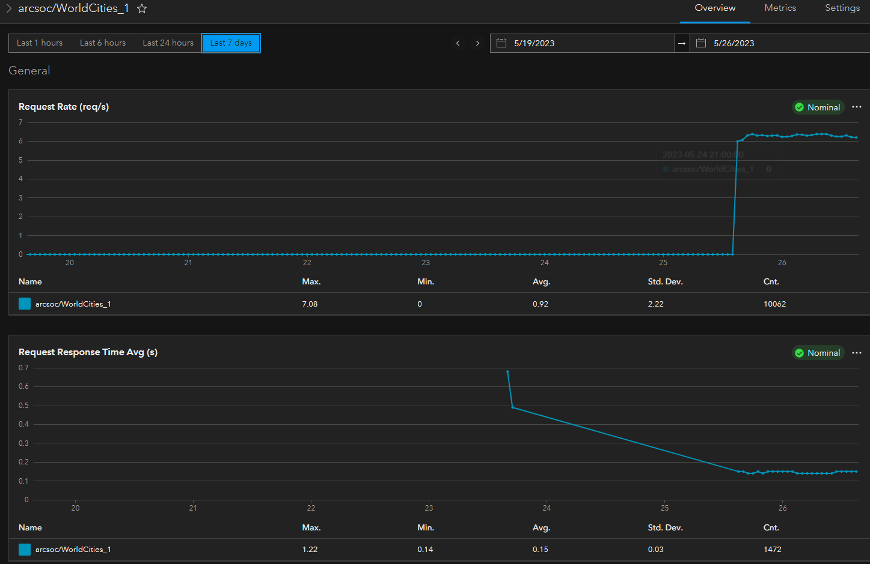

### dedicated_to_shared: true/false

Allows or disallows high usage services to be moved from shared to dedicated.

### dedicated_instance_min:int

Min instance value for low usage services

## high_usage

ArcSOC optimizer will compare avg_sec/day input with the historical service usage from ArcGIS Monitor. If this service usage is greater that avg_sec/day input, the tool will recommend

1. min instance equal to historical maximum instance used
2. changing from shared to dedicated pool (if shared_to_dedicated is true)

### avg_sec/day:float

See section under low_usage

### shared_to_dedicated: true/false

Allows or disallows low usage services to be moved from dedicated to shared.

## component_address

ArcGIS Server component name exactly as the Address of registered arcgis server, see below

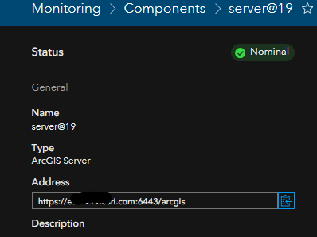

## arcgis_server

ArcGIS Server admin login information.

Password _encoding is optional. User can encrypt password with UTF-8 base64 encoding, e.g. <https://www.base64encode.org/> and set password_encoding: **True**

### host_address:array

Each arcgis server machine should be registered with ArcGIS Monitor as a host component. This parameter takes a list of hosts (in quotes) with the names exactly as the Address of registered host, see below.

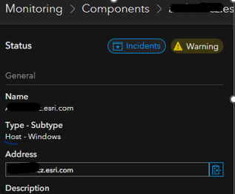

For example, if ArcGIS Server site has two machines and their addresses in ArcGIS Monitor are host_address1 and host_address2, the input should be: [“host_address1”, “host_address1”],

## limits

### memory_available_GB

In edit mode, after each service adjustment, ArcSOCOptimizer checks average memory available across all machines. If available memory is below this limit, the tool will stop execution.

### min_ceil

This is maximum (ceiling) value for min instance setting. In general, this value should be less than or equal the number of logical cores.

### max_min_diff

The max instance value is set as (min instance + max_min_diff). For example, if max_min_diff=2 and recommended min=4, the would be calculated as max=4+2=6

## exclude

### services

A list of service names, in quotes, to be excluded, e.g. [“SampleWorldCities”]

### folders

A list of folder names, in quotes, to be excluded, e.g. ["hosted","System", "Utilities"]

# Use case

Always test in your non-production environment first.

## edit=false

Start with edit=false (default). This will generate a report with recommendations, without making any changes. Review the recommendation and change the inputs if needed, especially avg_sec/day for low and high usage. Repeat the process as needed.

For example, in the following use case we have the following 4 services:

1. ID 1 and ID 2 have a low usage (<5s) and already recommended shared pool. Therefore, there is no change.
2. ID 3 has a low usage (<5s), but dedicated pool. Therefore, pool change from dedicated to shared is recommended.
3. ID 4 has a high usage and shared pool. Therefore, pool change to dedicated and min/max instances are recommended

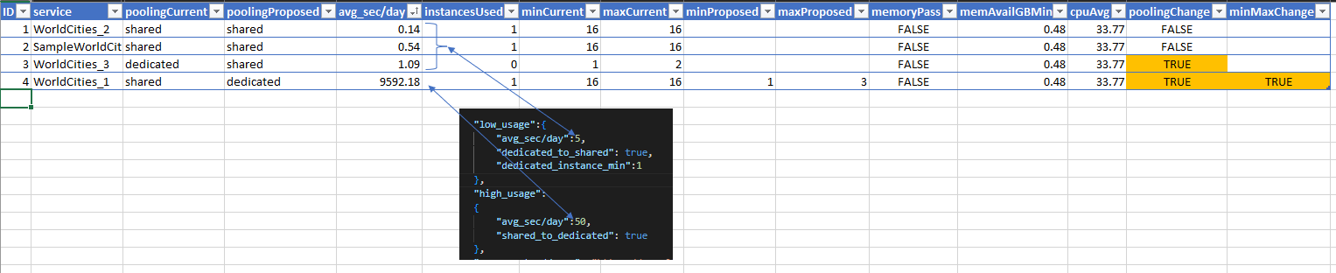

## edit=true

Once you validate the edit=false recommendation, test executing edit=true manullay. This mode will make changes to instances and pooling and restart services. If satisfied, user could schedule this as a daily job, using windows scheduled task.



Note, the minProposed is calculated as the ceiling of Instances Used Avg. In the case below, the ceiling of 1.21 is equal 2.

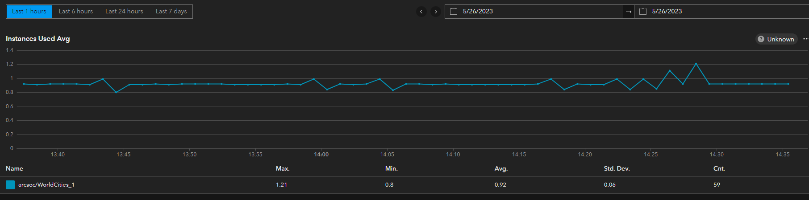

### Memory limit

If memory available is less then specified memory*_available_GB* limit, the edit will not be executed. In that case, user should lower this limit or free up memory manually.

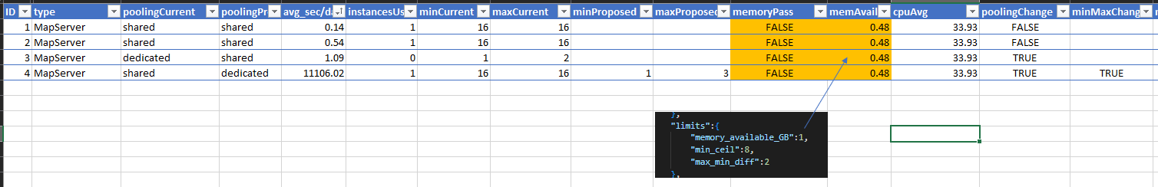

# Terms of use

This tool is not a supported feature of ArcGIS Monitor product or an Esri supported product.  Please do not contact Esri Tech Support. If need assistance in using this tool, please contact [Esri Consulting Services](https://www.esri.com/en-us/arcgis/services/consulting).