**Задача 1.**

**1.1 создаем таблицы в DBEAUER при помощи sql-скрипта**

**CREATE** **TABLE** students(

id BIGSERIAL **PRIMARY** **KEY**,

**name** **TEXT**,

total_score **INTEGER**,

scholarship **INTEGER**

);

**CREATE** **TABLE** activity_scores(

student_id **INTEGER**,

activity_type **TEXT**,

score **INTEGER**,

**FOREIGN** **KEY** (student_id) **REFERENCES** students (id)

);

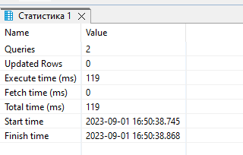

**1.2 создаем функцию update_total_score() и триггер update_total_score_trigger**

**CREATE** **OR** **REPLACE** **FUNCTION** update_total_score()

**RETURNS** **trigger** **AS**

**$$**

**BEGIN**

**UPDATE** students **SET** total_score = (**SELECT** **sum**(score) **FROM** activity_scores **WHERE** student_id = **NEW**.student_id) **WHERE** id = **NEW**.student_id;

**RETURN** **NULL**;

**END**;

**$$**

**LANGUAGE** 'plpgsql';

**CREATE** **OR** **REPLACE** **TRIGGER** update_total_score_trigger

**AFTER** **UPDATE** **OR** **INSERT** **OR** **DELETE**

**ON** "activity_scores"

**FOR** **EACH** **ROW**

**EXECUTE** **FUNCTION** update_total_score();

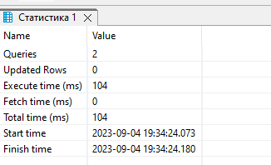

**Задача 2.**

**2. Создаем функцию calculate_scholarship() и триггер update_scholarship_trigger**

**CREATE** **OR** **REPLACE** **FUNCTION** calculate_scholarship()

**RETURNS** **trigger** **AS**

**$$**

**BEGIN**

**CASE** **WHEN** **NEW**.total_score >= 90 **THEN** **UPDATE** students **SET** scholarship = 1000 **WHERE** id = **NEW**.id;

**WHEN** **NEW**.total_score < 90 **AND** **NEW**.total_score >= 80 **THEN** **UPDATE** students **SET** scholarship = 500 **WHERE** id = **NEW**.id;

**ELSE** **UPDATE** students **SET** scholarship = 0 **WHERE** id = **NEW**.id;

**END** **CASE**;

**RETURN** **NEW**;

**END**;

**$$**

**LANGUAGE** 'plpgsql';

**create** **or** **replace** **TRIGGER** update_scholarship_trigger

**AFTER** **UPDATE** **OF** total_score **OR** **INSERT** **OR** **DELETE**

**ON** students

**FOR** **EACH** **ROW**

**EXECUTE** **FUNCTION** calculate_scholarship();

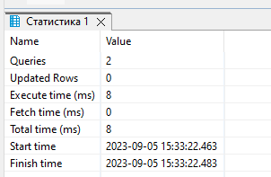

**3. Проверяем, что всё работает**

**SELECT** *

**FROM** activity_scores

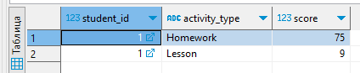

**SELECT** *

**FROM** students

